**Readme file for FEFLOW Plug-in: AutoBudgetGroupFixedHead**

Jinhui Zhang

S.S. Papadopulos & Associates, Inc.

Last update: January 12, 2017

# Introduction

**AutoBudgetGroupFixedHead** is a FEFLOW plug-in to calculate the water budget of a group of fixed‑head node. This is very useful if the rives are simulated using a fixed head, and need to calculate the baseflow of the river section to compare with derived baseflow from gauging data. This plug-in can be trigged in the following FEFLOW IFM methods:

* OnActivate()
* PostTimeStep()
* PostFlowSimulation()

# How to use this Plug-in

### To use the plug-in, one needs to follow the following steps

### Load and activate the plug-in to your FEFLOW model (this step is needed only for once, after that, the plug-in will load each time you open your model.

1. Under the same directory where the FEM/DAC file is located, one needs to prepare a text file named as **“AutoBudgetGroupFixedHead.inp”**. This file contains the definition of each group of fix-head nodes. The format of the input file is illustrated in Figure 1 in next page.
2. The plug-in can be activated by manually or automatically when running the model.
3. After running the plug‑in, two files are produced, one with the file extension of “def”, to store the definition of the each group (Figure 2), another one has a file extension of “out”, to store the result of the calculation (Figure 3).

The flow chart of the IFM plug-in is presented in Figure 1.

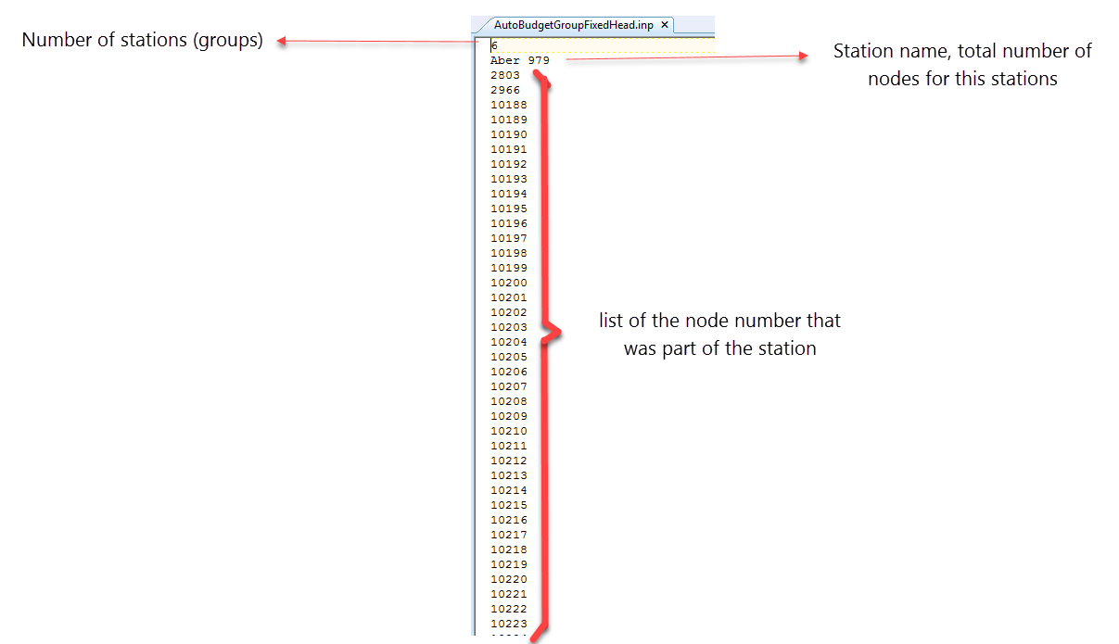

Figure Format of the input file for the plug-in

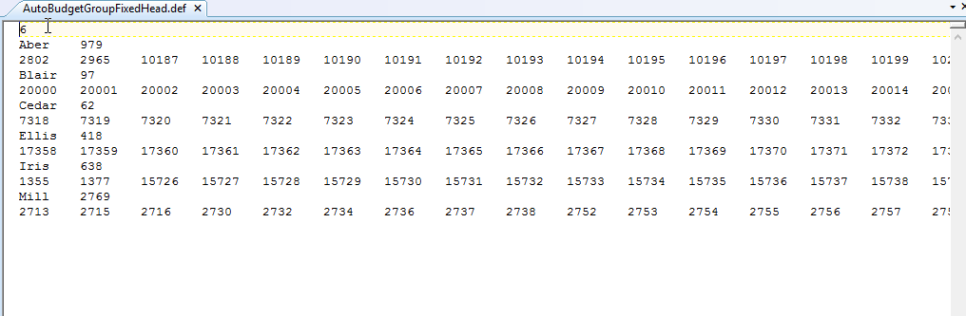

Figure 2 Example of the “DEF” result file

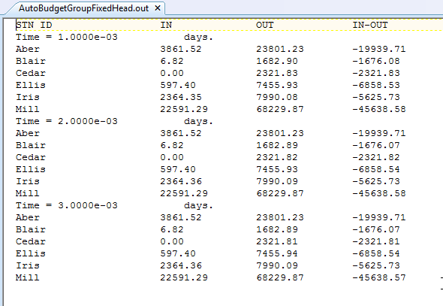

Figure 3 Example of the “OUT” result file

# Code structure

