**Readme file for FEFLOW Plug-in: AutoExportHeads_Trans**

Jinhui Zhang

S.S. Papadopulos & Associates, Inc.

Last update: January 18, 2017

# Introduction

**AutoExportHeads_Trans** is designed for a transient model; it is used to extract simulated head at the specified locations at each time step. The result data can be processed to make plots to show the water level change over time. This plug-in calls the following FEFLOW IFM methods:

* PreSimulation (): extract the initial head at the specified locations.
* PostTimeStep(): extract the calculated head at the specified location at the time step.
* OnActive(): Manually extract the calculated head at the specified location at the current time step when loading a DAC file into FEFLOW.

# How to use this Plug-in

### To use the plug-in, one needs to follow the following steps

### Load and activate the plug-in to your FEFLOW model (this step is needed only for once, after that, the plug-in will load each time you open your model.

1. Under the same directory where the FEM file is located, one needs to prepare a text file named as **“AutoExportHeads_Trans.inp”**. This file location and the screen elevation of the observation wells. The format of the input file is illustrated in **Figure 1** in next page.
2. The plug-in will be activated automatically when running the model.
3. After running the plug‑in, the results are written to **AutoExportHeads_Trans.out** for further processing. An example of the output file is presented in **Figure 2**.

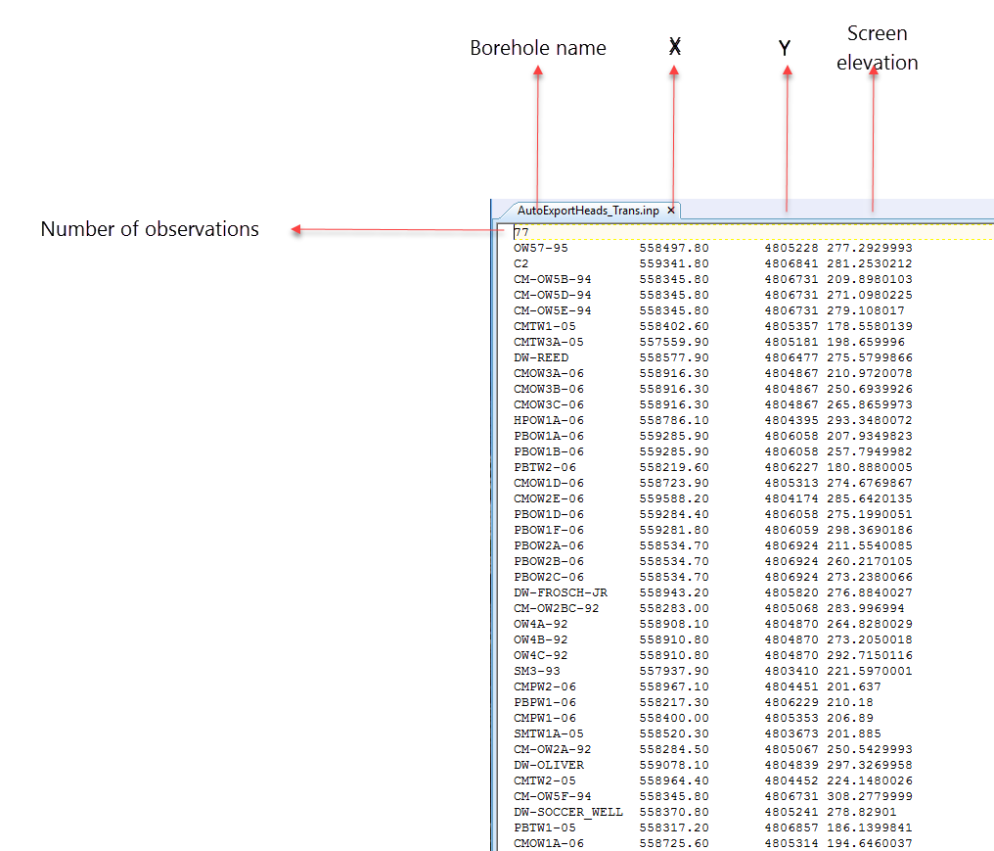

Figure Format of the input file for the plug-in

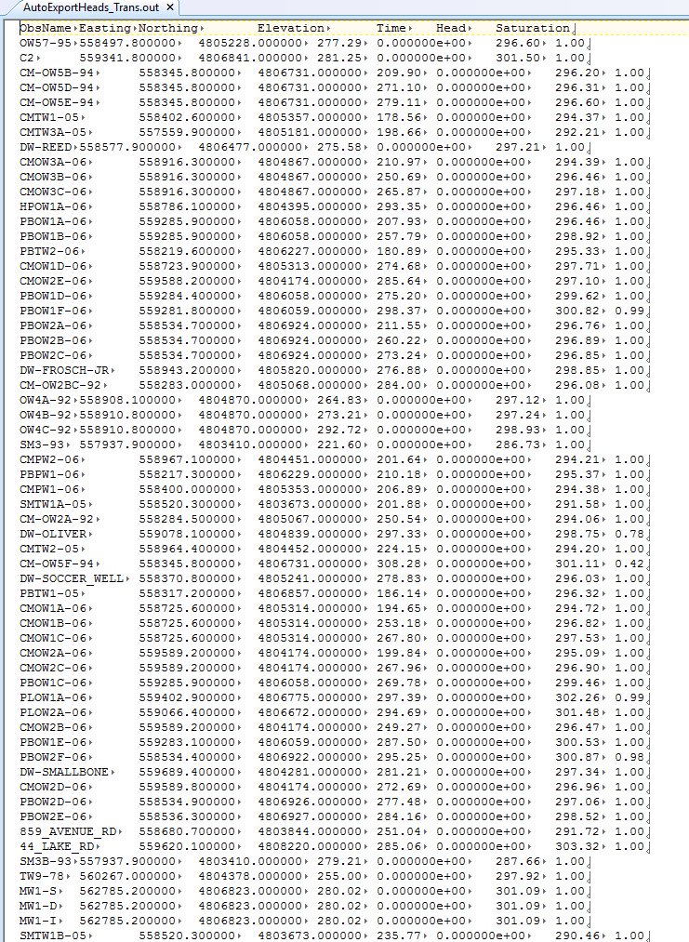

Figure 3 Example of the result file