**FEFLOW Plug-in: ExportSliceHeadAtXY**

Jinhui Zhang

S.S. Papadopulos & Associates, Inc.

Last update: January 17, 2017

# Introduction

**ExportSliceHeadAtXY** is a FEFLOW plug-in to export the calculated head data at selected location for a specific model slice. This plug-in is trigged in the following FEFLOW IFM methods:

* OnActivate()
* PostFlowSimulation ()

This plug-in is tested for both steady-state and transient models. When using for a transient model, the plug-in will export the simulated result after each time step.

# How to use this Plug-in

### To use the plug-in, one needs to follow the following steps

### Load and activate the plug-in to your FEFLOW model (this step is needed only for once, after that, the plug-in will load each time you open your model.

1. Prepare an input file, and named it ExportSliceHeadatXY.inp, the format of the input file will be given in the next section. The input file need to be located at the same directory as the feflow model. An example of the input file is presented in Figure 1.
2. The plug-in writes the result into a ASCII file, ExportSliceAtHeadXY.out. An example of output file for the steady-state is presented in Figure 2. An example of output file for the transient is presented in Figure 3.

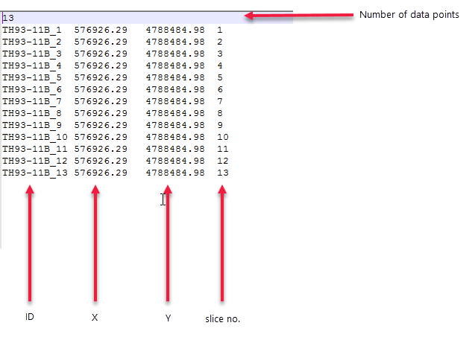

Figure 1 An Example of the input file, ExportSliceHeadAtXY.inp

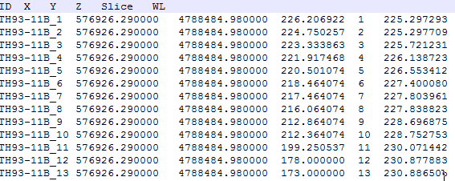

Figure 2 An Example of the out file for a steady-state model, ExportSliceHeadAtXY.out

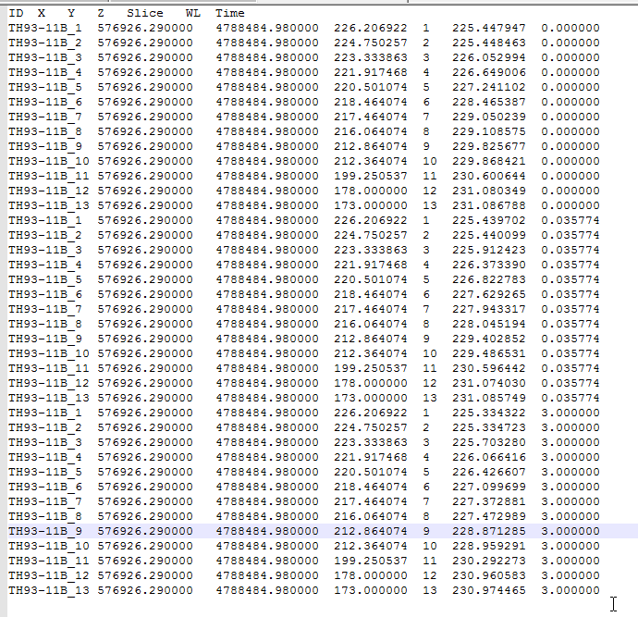

Figure 3 An Example of the out file for a transient model, ExportSliceHeadAtXY.out