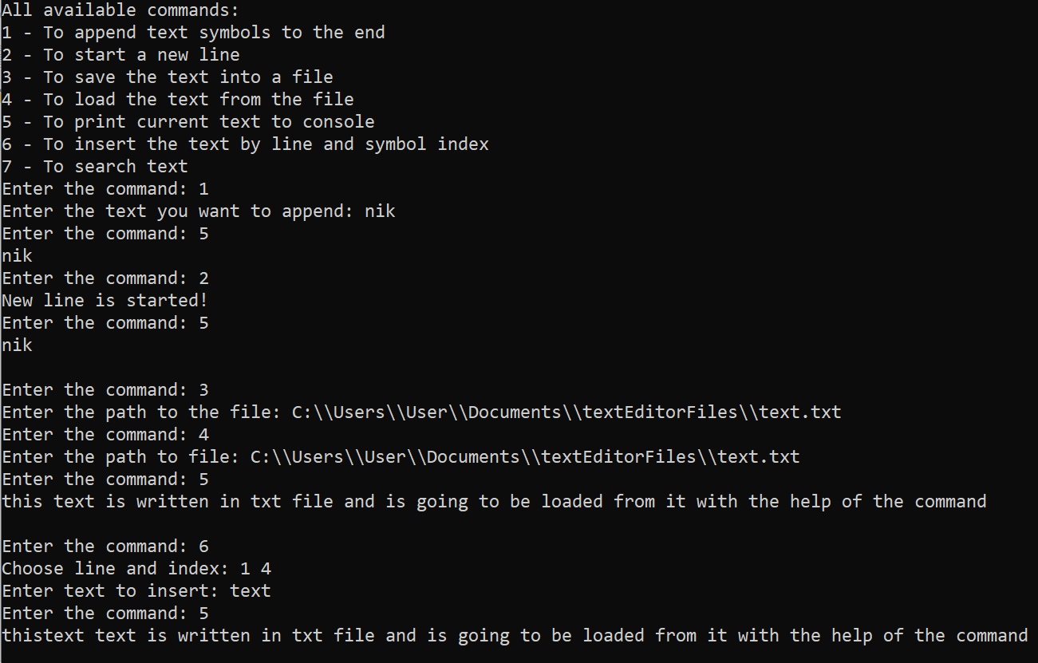

On the screenshot above you can see how the first six commands work with saving to file working proff on the photo below.

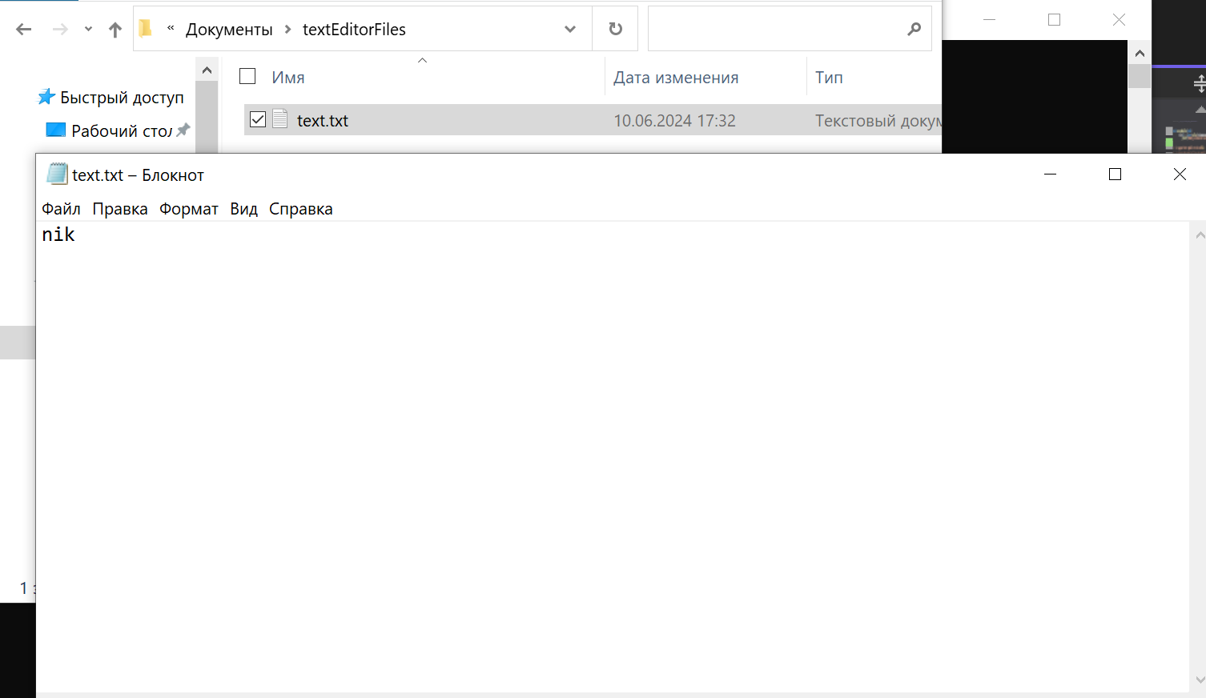

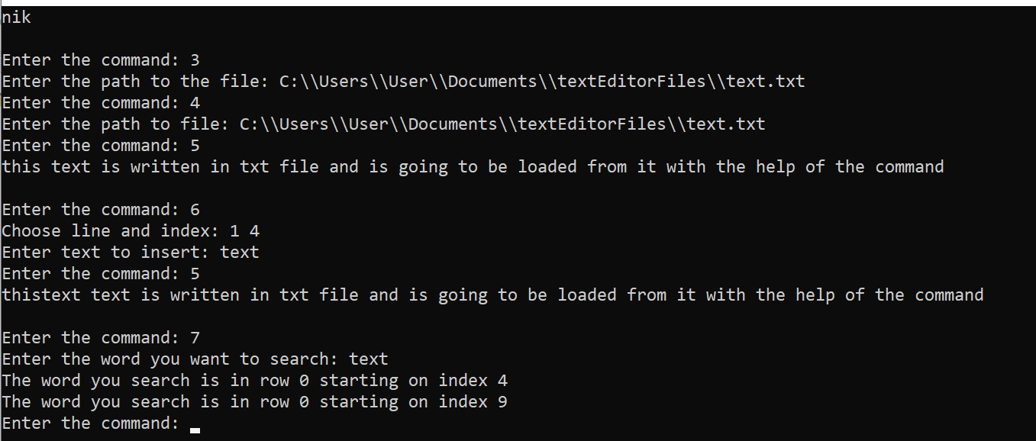

On the photo above you can see that search function works properly