安装Docker

略

拉取镜像

docker pull godmeowicesun/kingbase

下载license

<https://www.kingbase.com.cn/xzzx/index.htm>

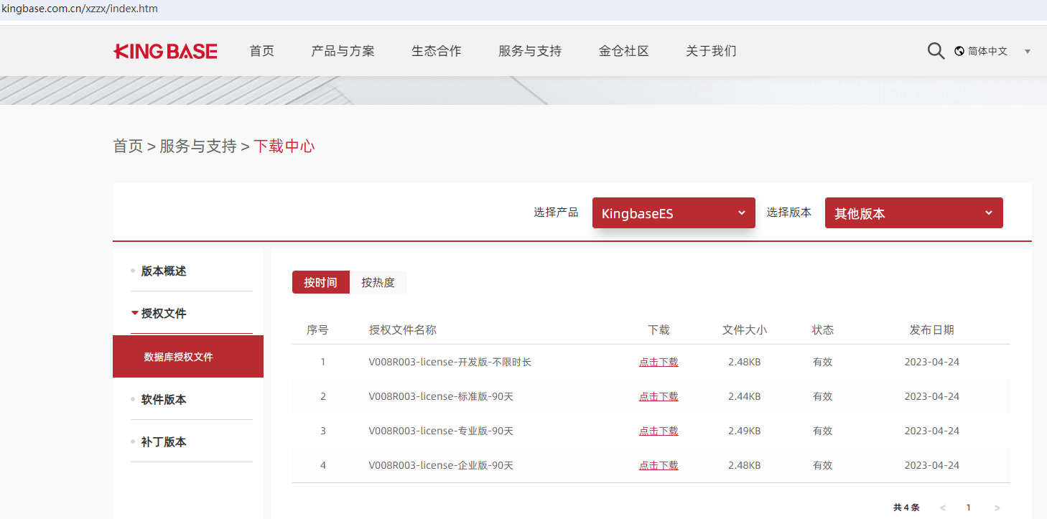

路径挂载

mkdir /your/path/kingbase/opt

chmod 777 /your/path/kingbase/opt

mkdir /your/path/kingbase/opt/license

cp /license/path/license_xx.dat /your/path/kingbase/opt/license/license.dat

启动容器

docker run -d -it --privileged=true -p 54321:54321 -v /your/path/kingbase/opt:/opt --name kingbase godmeowicesun/kingbase

进入容器

docker exec -it kingbase bash

软链接

ln -s /home/kingbase/ES/V8/Server/bin/kingbase /usr/local/bin

ln -s /home/kingbase/ES/V8/Server/bin/ksql /usr/local/bin

文件复制

复制许可证

mv /opt/license/license.dat /home/kingbase/ES/V8/Server/bin

复制data

mv /opt/data/db-default/* /opt/data/

切换到用户kingbase

su kingbase

启动

kingbase -D /opt/data

若启动失败

