Letyagina Yana
5130203/30102
Block_04
MongoDB aggregation pipelines with Node.js and Express
Two Node.js/Express servers demonstrate MongoDB Aggregation pipelines. Unlike simple find() queries, aggregation processes data through a sequence of stages each stage transforms the data and passes it to the next.
All endpoints accept parameters from the HTTP request URL and return results
in JSON (default) or XML format.
In the orders.js on port 3001 I connect to database shop collection orders and demonstrate stages $match $group $sort $project $limit.
Here are the examples of
GET /orders/stats?status=completed&minDate=2024-01-01&maxDate=2024-06-30:
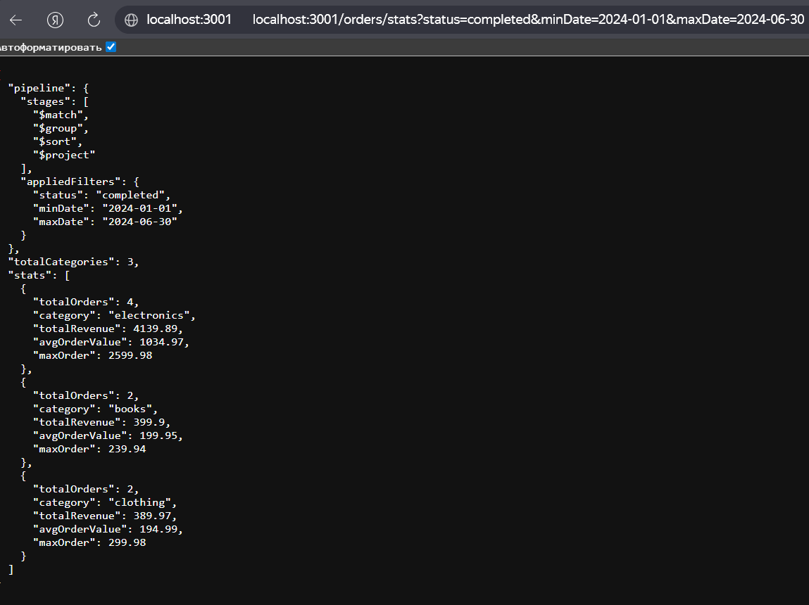
GET /orders/top-products?category=electronics&limit=1
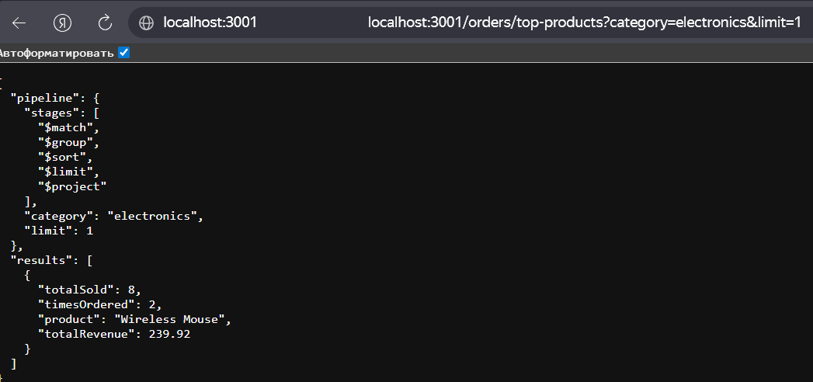
GET /orders/top-products?format=xml
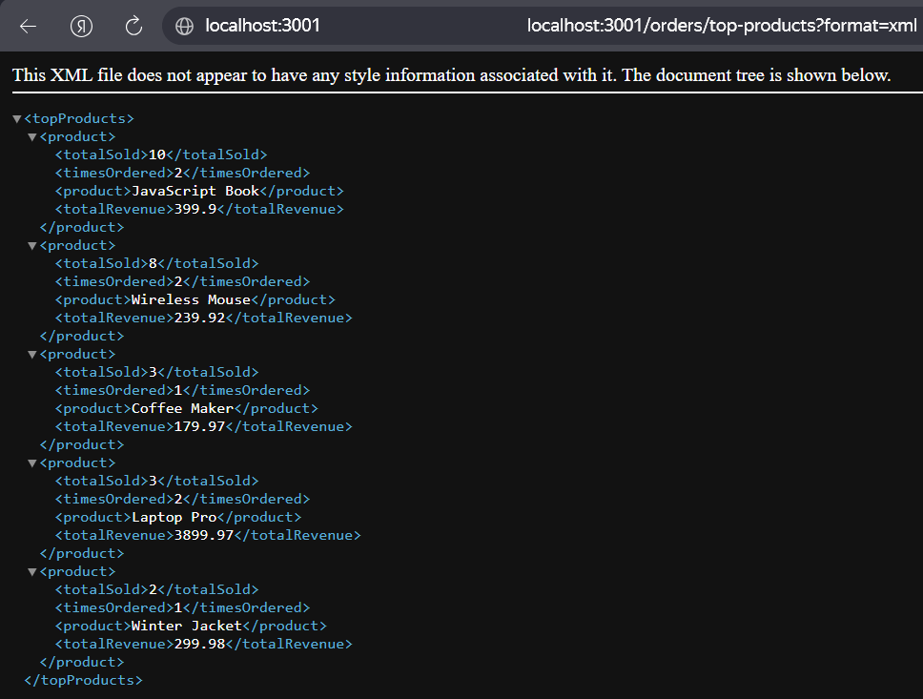

In the authors.js on port 3002 I use database “blog” and “articles” + “authors” collections. I use stages $match $lookup $group $project $sort.
GET /blog/articles-with-authors?category=tech&minViews=900&format=xml
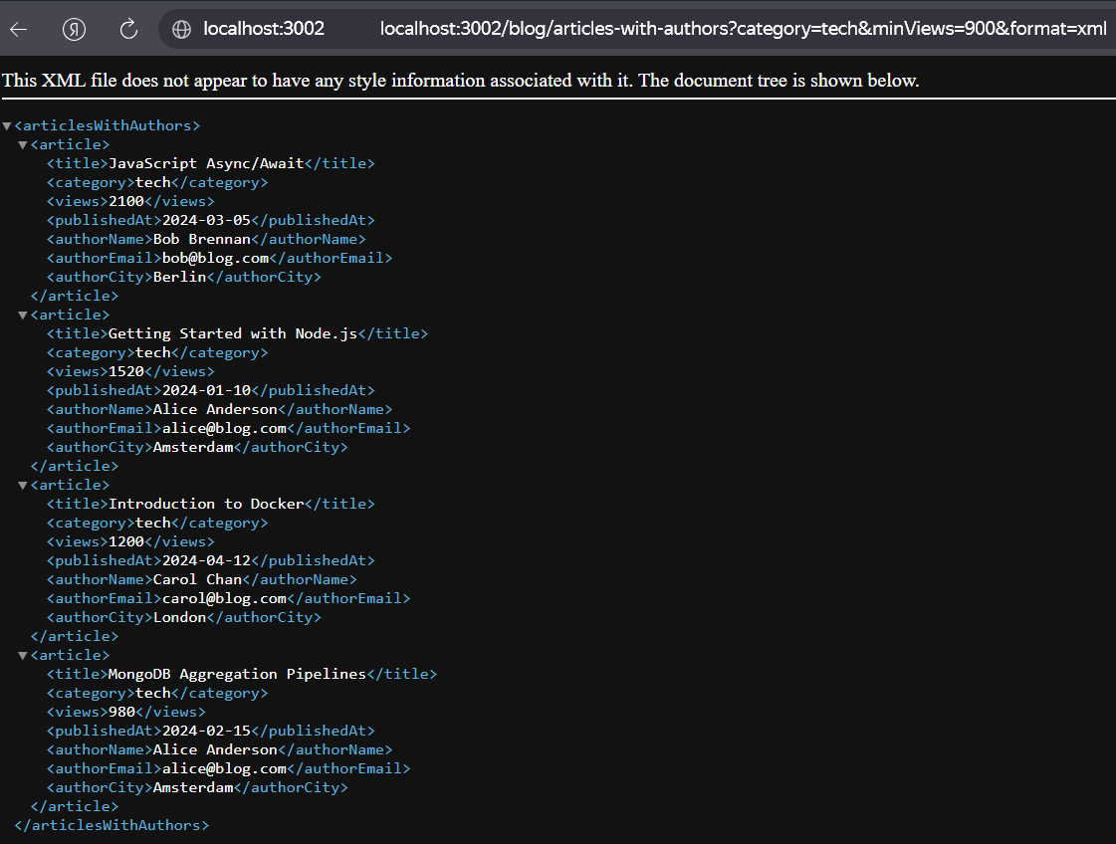
GET /blog/author-stats?category=tech&sortBy=views
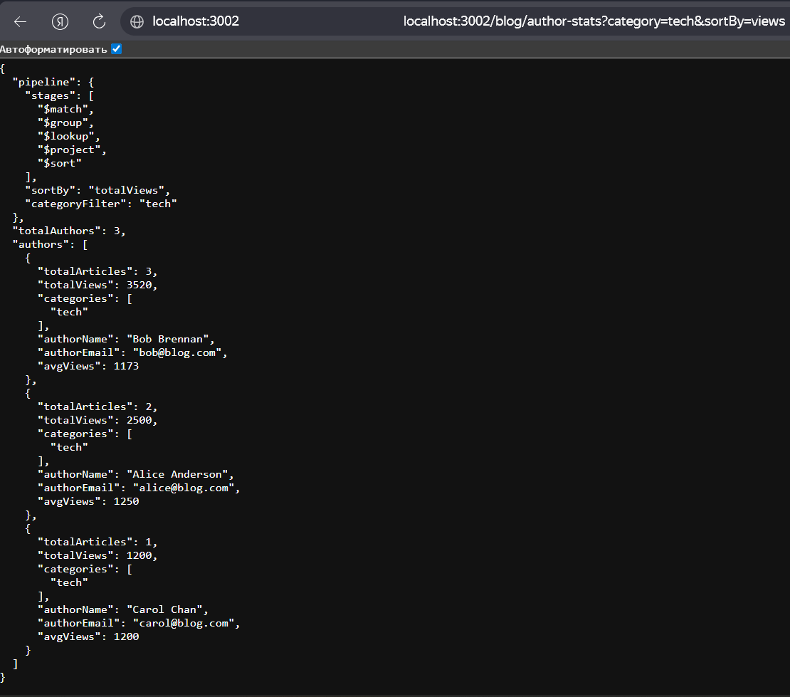

To test
Сначала запустить сервер монго # MongoDB must be running on localhost:27017
npm init -y
npm install express mongodb
node orders.js # → http://localhost:3001
node authors.js # → http://localhost:3002
http://localhost:3001/seed
http://localhost:3002/seed
И можно делать HTTP requestы.

