**A) User manual for Approve registration**

**1).** **login to the system by clicking on login**

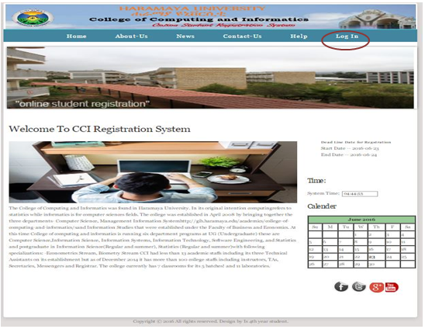

**2). Then fill the correct username and password and click on login button**

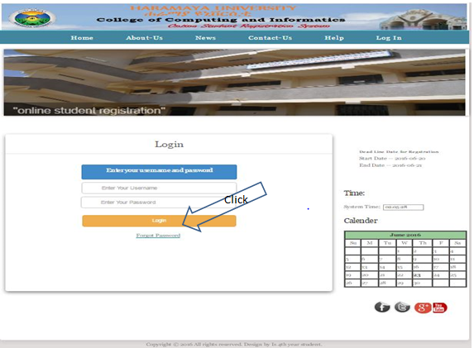

**3). After successful login in the home page of department will appear**

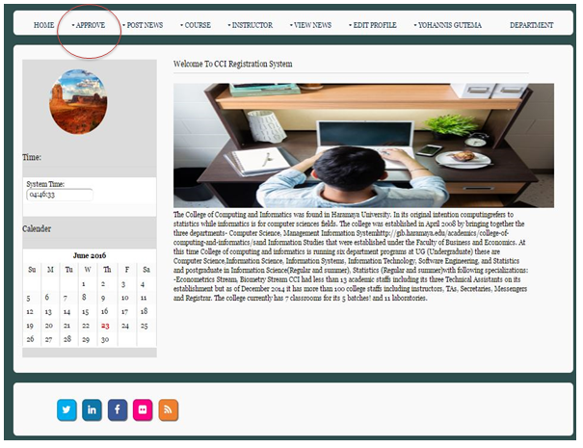

**4)After department page appear then select approve hover from navbar and click on approve registration**

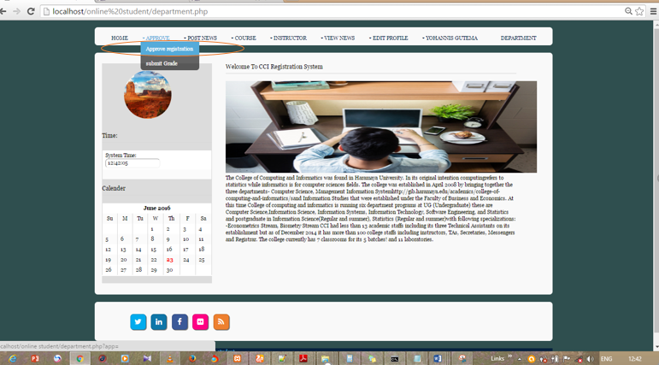

**5)** **Department must fill the form correctly click on save button**

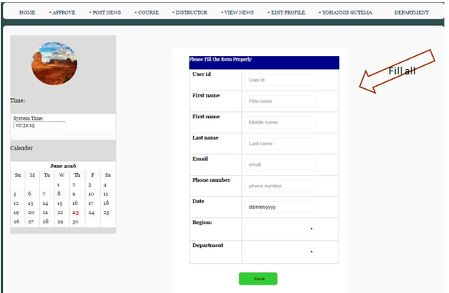

**6)Then the system sends to user email username and password**

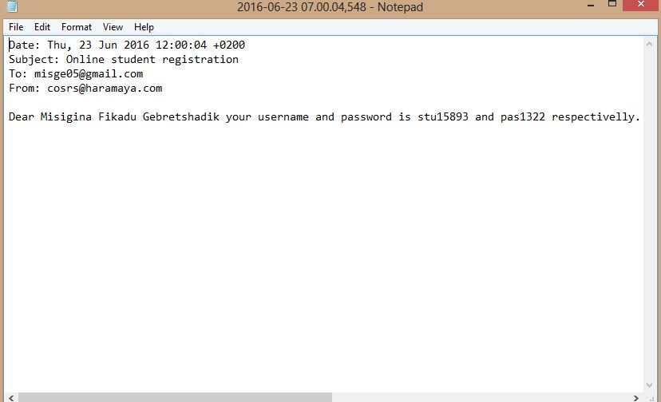

**B) User manual for register in course**

**1).** **login to the system by clicking on log in**



**2). Then fill the correct username and password and click on login button**



**3). After successful login in the home page of student will appear**

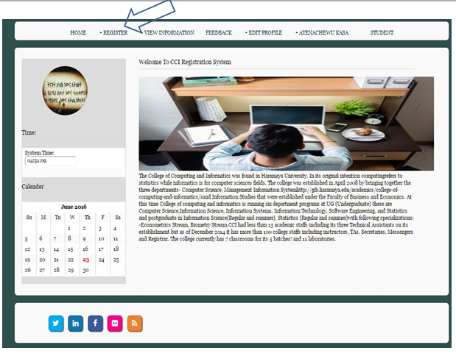

**4)After student page appear then select register hover from navbar and click on register in course hover.** 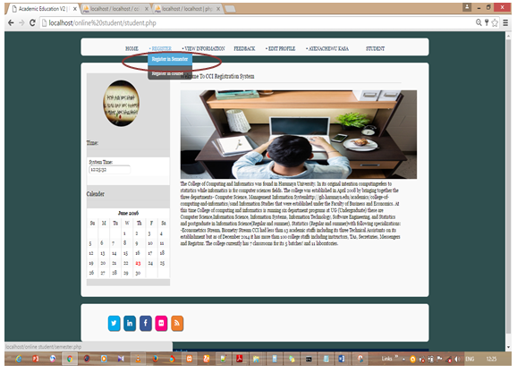

**5) Then select correct options or fill correct information and click on search button**

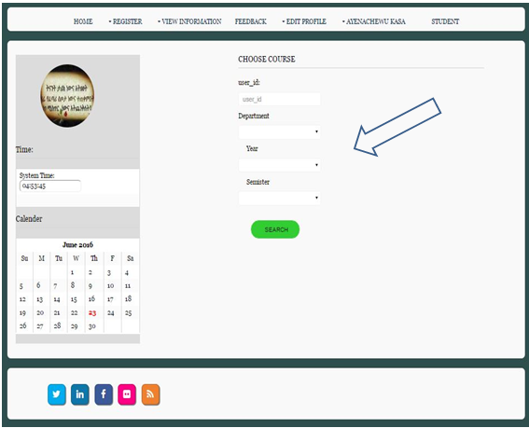

**6)Then the course is displayed after this select the course and click on save button.**

