CHIETA DATA LAB
Comprehensive Project Handbook
Chemical Industries Education and Training Authority
Data Science Solution & Prototype Development
Version 1.0 | 18-Month Programme Blueprint

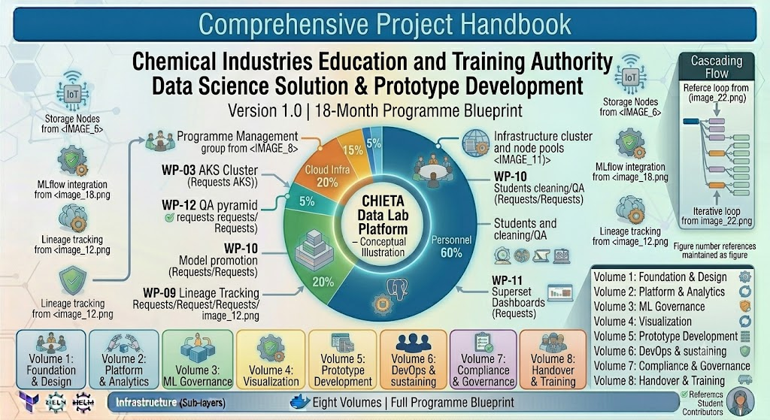
Eight Volumes | Full Programme Blueprint
Table of Contents
Table of Contents 2
Foreword: How to Use This Handbook 9
The Eight Volumes at a Glance 9
Volume I: Software Requirements Specification (SRS) 10
Document Control 10
1. Introduction 10
1.1 Purpose 11
1.2 Scope 11
2. Overall Description 12
2.1 System Architecture Overview 12
2.2 User Classes and Their Roles 12
3. Functional Requirements 13
Module 1: Authentication and Authorisation 13
FR-1: User Login 13
FR-2: Role-Based Access Control (RBAC) 13
Module 2: User Management 13
FR-3: Create User 13
FR-4: Disable User 13
Module 3: Dataset Management 14
FR-5: Dataset Upload 14
FR-6: Dataset Search 14
FR-7: Dataset Versioning 14
FR-8: Dataset Metadata Capture 14
Module 4: Data Engineering 14
FR-9: ETL Pipeline Support 14
FR-10: Data Cleaning 14
FR-11: Data Validation 15
FR-12: Data Lineage 15
Module 5: Data Storage 15
FR-13: Structured Data Storage 15
FR-14: Unstructured Data Storage 15
FR-15: Automated Backups 15
Module 6: Data Exploration 15
FR-16: Interactive Queries 15
FR-17: SQL Workspace 15
FR-18: Notebook Workspace 15
FR-19: Statistical Analysis 16
Module 7: Dashboarding 16
FR-20: Dashboard Builder 16
FR-21: Supported Chart Types 16
FR-22: Dashboard Export 16
FR-23: Dashboard Sharing 16
Module 8: Machine Learning 16
FR-24: Experiment Tracking with MLflow 16
FR-25: Model Registry 17
FR-26: Forecasting Capabilities 17
FR-27: Model Explainability 17
Module 9: Metadata Management 17
FR-28: Dataset Catalogue with OpenMetadata 17
FR-29: Business Glossary 17
FR-30: Data Classification 17
FR-31: Data Retention Policies 17
Module 10: Reporting 17
FR-32: Report Generation 17
FR-33: Scheduled Reports 18
Module 11: Audit and Monitoring 18
FR-34: Audit Logs 18
FR-35: Platform Monitoring 18
Module 12: API Management 18
FR-36: REST APIs 18
FR-37: Swagger/OpenAPI Documentation 18
Module 13: Student Participation 18
FR-38: Contribution Logs 18
FR-39: Digital Badges 18
Module 14: Prototype 18
FR-40: Prototype Module 18
4. Non-Functional Requirements 19
5. External Interfaces 19
6. Deliverable Mapping 20
Appendix A – Repository Structure 20
Volume II: Software Architecture Design Document (SADD) 21
1. Architectural Principles 21
2. Context Diagram (Level 0) 21
3. Container Architecture (C4 Model Level 2) 22
4. Component Architecture (C4 Level 3) 22
Frontend Components 22
Backend Components 22
Data Engineering Components 23
ML Components 23
5. Microservices Architecture 23
6. Sequence Diagrams 23
Dataset Upload Sequence 24
Dashboard Generation Sequence 24
Machine Learning Workflow Sequence 24
7. Database Architecture 24
8. Data Lake Architecture (MinIO) 25
9. API Architecture 25
Key API Families 25
10. Authentication and Security Architecture 26
11. Machine Learning Architecture 26
12. Dashboard Architecture 27
13. Infrastructure Architecture 27
14. CI/CD Architecture 27
15. Monitoring and Logging Architecture 28
Monitoring with Prometheus and Grafana 28
Logging with ELK Stack 28
16. Backup and Disaster Recovery Architecture 28
17. High Availability Architecture 28
18. Network Architecture 28
19. Technology Stack Summary 29
Volume III: Detailed Design Document (DDD) 30
1. C4 Model — Four Levels of Detail 30
2. UML Models 30
Use Case Diagram 30
Activity Diagram — ETL Pipeline 31
3. React Frontend Detailed Design 31
Repository Structure 31
4. FastAPI Backend Detailed Design 32
Repository: backend-fastapi 32
Service Catalogue 32
5. Airflow Data Pipeline Design 32
6. Apache Spark Processing Design 33
7. PostgreSQL Database Design 33
8. MinIO Object Storage Design 33
9. Apache Superset Dashboard Design 33
10. MLflow Machine Learning Design 34
11. Security Architecture 34
12. Repository and Coding Standards 34
Git Strategy: GitFlow 34
Coding Standards 34
Volume IV: Database and API Engineering Specification (DAES) 35
1. Database Architecture Overview 35
PostgreSQL — Structured Data 35
MinIO — Unstructured Data 35
2. Entity Relationship Model 35
3. Table Definitions 36
security.users 36
security.roles 36
catalog.datasets 36
audit.audit_logs 36
ml.experiments and ml.models 37
ml.predictions 37
4. Indexing Strategy 37
5. Data Dictionary 37
6. API Design Principles 37
7. Full API Catalogue 38
Authentication APIs 38
User Management APIs 38
Dataset APIs 38
Dashboard APIs 38
Machine Learning APIs 39
8. JSON Schemas 39
Dataset Upload Request 39
Prediction Request 39
9. Error Handling Standard 39
10. Pagination and Filtering Standards 40
Pagination 40
Filtering 40
11. Data Lineage Specification 40
12. Audit Specification 40
13. Naming and Versioning Standards 40
Volume V: DevSecOps, Infrastructure & Deployment Handbook 42
1. DevSecOps Architecture 42
2. Docker Architecture 43
3. Dockerfiles 43
React Frontend Dockerfile 43
FastAPI Backend Dockerfile 43
4. Docker Compose — Development Environment 43
5. Azure Kubernetes Service (AKS) Design 44
AKS Cluster: AKS-CHIETA-DATALAB 44
Kubernetes Namespaces 44
6. Kubernetes Manifests 44
7. Helm Charts 45
8. Terraform Infrastructure as Code 45
Terraform Modules 45
Environment Structure 45
9. Azure DevOps Pipelines 45
Frontend Pipeline 46
Backend Pipeline 46
Airflow Pipeline 46
ML Pipeline 46
10. Git Strategy: GitFlow 46
11. Secrets Management with Azure Key Vault 46
12. Production Deployment Strategy 47
13. Release Management 47
14. Performance Engineering 47
Volume VI: Testing, Quality Assurance & Validation Handbook 48
1. Test Strategy 48
The Testing Pyramid 48
2. Quality Framework 48
3. Unit Testing 49
4. Integration Testing 49
5. API Testing 49
6. UI Testing with Cypress 50
7. Data Quality Testing with Great Expectations 50
8. Machine Learning Validation 50
Model Performance Metrics 50
Explainability and Fairness 50
9. Performance Testing with JMeter 50
10. Security Testing 51
11. Accessibility Testing (WCAG 2.1 AA) 51
12. User Acceptance Testing (UAT) 51
13. Defect Management 52
14. Requirements Traceability Matrix (RTM) 52
15. Test Automation Pipeline 52
16. Key QA Metrics and KPIs 52
17. Sign-Off Procedure 53
Volume VII: Operations, Maintenance, Training & Handover Handbook 54
1. Operations Framework (ITIL v4) 54
2. System Administration Guide 54
User Administration 54
3. Platform Operations Manual 55
4. Backup Procedures 55
5. Monitoring Procedures 55
6. Incident Management 56
Severity Levels and Response Times 56
7. Problem Management 56
8. Change Management 56
9. User Manual 57
Analyst Functions 57
Viewer Functions 57
Student Contributor Functions 57
10. Video Training Framework 57
11. Train-the-Trainer Programme 57
12. Student Mentorship Framework 58
Student Roles 58
Mentorship Activities 58
13. Knowledge Transfer Plan 58
14. Support Model 58
15. SLA Framework 59
16. Maintenance Schedule 59
17. Post-Implementation Support Phases 59
18. Handover Deliverables 59
Volume VIII: Project Governance, PMBOK & Agile Delivery Handbook 61
1. Project Charter 61
Success Criteria 61
2. Governance Structure 62
3. Stakeholder Register 62
4. Work Breakdown Structure (WBS) 63
Major Work Packages (Level 1) 63
5. Resource Plan 64
6. RACI Matrix 64
7. RAID Register 65
Risks 65
Assumptions, Issues, Dependencies 65
8. Risk Register 65
9. Communication Plan 65
10. Quality Management Plan 66
11. Procurement Plan 66
12. Cost Baseline 66
13. Sprint Plan — 36 Sprints over 18 Months 67
14. Program Increment Planning 67
15. Azure DevOps Structure 68
Boards and Work Items 68
Repositories in Azure DevOps 68
Pipelines and Wiki 68
16. Change Management 68
17. Reporting Framework 68
18. Earned Value Management (EVM) 69
19. Escalation Framework 69
20. Closure and Benefits Realisation 70
Programme Closure Activities 70
Benefits Realisation 70
Master Blueprint Complete — Summary of All Eight Volumes 71

Foreword: How to Use This Handbook
Welcome to the CHIETA Data Lab Project Handbook — an eight-volume blueprint that documents every aspect of designing, building, testing, operating, and governing the CHIETA Data Lab platform from the first line of code to final handover.

This handbook was developed to serve both technical experts and non-technical readers. Whether you are a CHIETA executive who wants to understand what is being built, a project manager who needs to track progress, or a junior developer who needs implementation guidance, you will find your chapter here.

How to Read This Handbook: Each Volume is self-contained but cross-referenced. Readers are encouraged to start with Volume I (requirements), then follow their area of interest across subsequent volumes.

The Eight Volumes at a Glance
Volume | Title | Primary Audience
Volume I | Software Requirements Specification (SRS) | All Stakeholders
Volume II | Software Architecture Design Document (SADD) | Architects & Engineers
Volume III | Detailed Design Document (DDD) | Developers & Engineers
Volume IV | Database and API Engineering Specification (DAES) | Backend & Data Engineers
Volume V | DevSecOps, Infrastructure & Deployment Handbook | DevOps & Cloud Engineers
Volume VI | Testing, Quality Assurance & Validation Handbook | QA Engineers & Testers
Volume VII | Operations, Maintenance, Training & Handover Handbook | Admins & Trainers
Volume VIII | Project Governance, PMBOK & Agile Delivery Handbook | Project & Programme Managers

Important Note: Visual placeholders throughout this document indicate where diagrams, architecture drawings, Gantt charts, ERDs, and other visuals are to be inserted by the design team. Each placeholder carries a descriptive caption to guide production.
VOLUME I
Software Requirements Specification (SRS)
Defining What the CHIETA Data Lab Must Do

Volume I: Software Requirements Specification (SRS)
Version 1.0 | Methodology: Agile + DevOps | Architecture: Microservices

Document Control
The table below records the formal identity of this specification document.

Item | Description
Project Name | CHIETA Data Lab
Client | Chemical Industries Education and Training Authority (CHIETA)
Document | Software Requirements Specification (SRS)
Version | 1.0
Methodology | Agile + DevOps
Architecture | Microservices
Deployment | Docker + AKS (Azure Kubernetes Service)
Database | PostgreSQL + MinIO
Frontend | React
Backend | FastAPI
Data Platform | Apache Spark + Apache Airflow
BI Platform | Apache Superset
ML Platform | MLflow
Metadata | OpenMetadata

1. Introduction

1.1 Purpose
This Software Requirements Specification (SRS) defines every functional and non-functional requirement for the CHIETA Data Lab — a secure, browser-based platform designed to enable CHIETA to harness the power of its data.

Think of the CHIETA Data Lab as a digital science laboratory. Just as a physical laboratory provides chemists with equipment to conduct experiments, the Data Lab provides CHIETA's analysts and data scientists with a digital environment to upload data, clean it, analyse it, build visualisations, train predictive models, and manage information assets — all within a secure, governed platform.

Plain-Language Summary: The Data Lab is a web-based workspace where CHIETA staff can explore and understand their data, produce reports, and use artificial intelligence to predict future trends — for example, forecasting which learners might drop out of training programmes, or which skills sectors are growing.

The Data Lab shall enable:
- Dataset management — uploading and storing CHIETA's raw data files
- Data exploration — filtering, sorting and querying datasets
- Statistical analysis — computing averages, distributions, and correlations
- Predictive analytics — using machine learning to forecast future outcomes
- Interactive dashboards — visual summaries of key performance indicators
- Metadata management — cataloguing all datasets so they are discoverable
- Experiment tracking — recording machine learning experiments for reproducibility
- Student participation — enabling students to contribute to data cleaning and QA
- Governance and auditability — full audit trails of every action on the platform

1.2 Scope
The Data Lab is an independent environment and shall NOT replace any existing CHIETA operational systems. It sits alongside existing systems, drawing data from them to perform analysis and produce insights.

The system shall support:
Capability | What This Means in Simple Terms
Uploading datasets | Users can bring their data files (CSV, Excel, JSON) into the platform
Data cleaning and transformation | The system can fix messy data — fill in blanks, remove duplicates
Data storage | Cleaned data is stored safely in a structured database
Data lineage | The system tracks exactly where every piece of data came from
Machine learning | The platform can build predictive models — e.g., predict learner dropout
Dashboarding | Visual charts and graphs are produced automatically
Role-based access control | Only authorised people can see sensitive data
APIs | Other systems can exchange data with the platform programmatically
CI/CD | The platform updates itself automatically when developers push new code
Monitoring | The system watches itself for errors and performance problems
Documentation | All data assets are automatically documented and catalogued

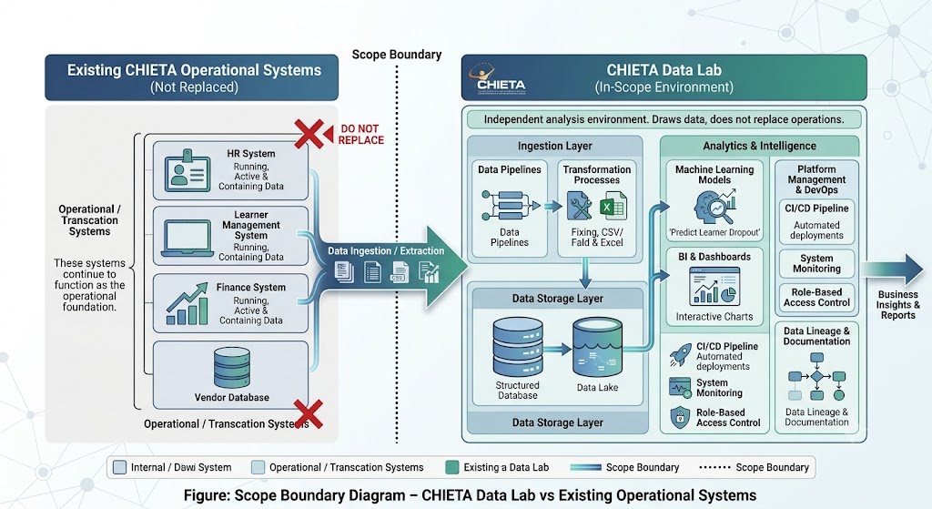

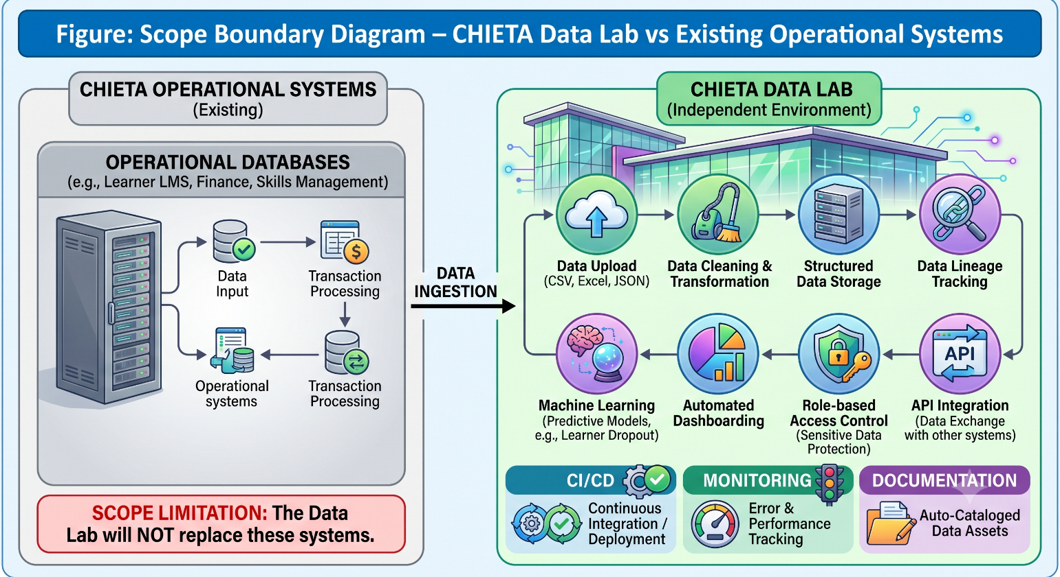

[ Figure / Chart: Scope Boundary Diagram – CHIETA Data Lab vs Existing Operational Systems ]
Figure: Scope Boundary Diagram – CHIETA Data Lab vs Existing Operational Systems

2. Overall Description

2.1 System Architecture Overview
The CHIETA Data Lab is built as a modern microservices architecture. This is an approach where instead of one giant, single application, the platform is composed of many smaller services, each responsible for one specific job. These services communicate with each other through well-defined programming interfaces (APIs).

Analogy: Think of a city's infrastructure. A city does not have one building that does everything — it has a power station, a water treatment plant, a hospital, schools, and roads. Each part is independently maintained but works together as a whole. The Data Lab microservices architecture works the same way.

The architecture stack flows from top to bottom as follows:
- React Frontend — the web interface that users see and interact with in their browser
- FastAPI Gateway — the secure gateway that receives all requests from the frontend
- Apache Airflow — the scheduler that orchestrates automated data pipelines
- Spark / Databricks — the high-performance engine that processes large datasets
- PostgreSQL + MinIO — the dual storage layer (structured data + raw file storage)
- Apache Superset — the dashboarding and charting platform
- MLflow — the machine learning experiment tracking and model registry
- OpenMetadata — the metadata catalogue that records information about all data assets
- Docker + AKS + Azure DevOps — the containerised cloud infrastructure and CI/CD pipeline

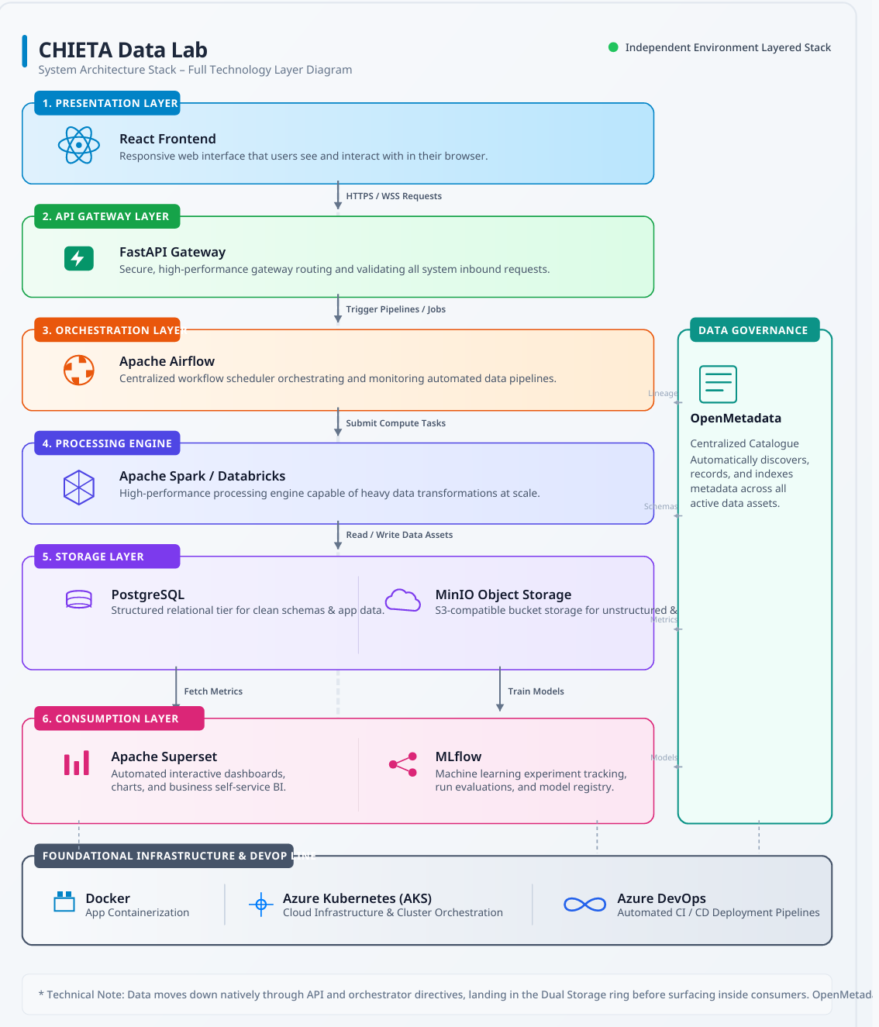

[ Figure / Chart: System Architecture Stack – Full Technology Layer Diagram ]
Figure: System Architecture Stack – Full Technology Layer Diagram

2.2 User Classes and Their Roles
The Data Lab serves four distinct types of users. Understanding who uses the system and what they need is fundamental to the requirements that follow.

User Class | Responsibilities | Access Level
Administrator | Manage users, configure permissions, monitor platform, manage metadata | Full
Analyst | Upload datasets, explore data, build dashboards, run ML experiments | High
Viewer | View dashboards, download approved reports | Read-Only
Student Contributor | Dataset cleaning, documentation support, QA testing | Limited

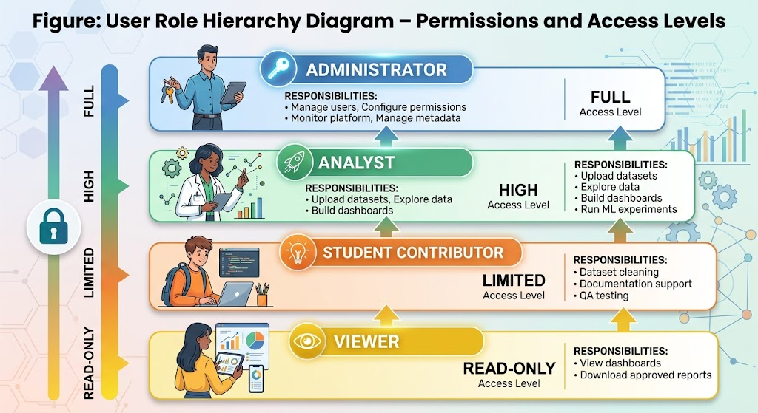
[ Figure / Chart: User Role Hierarchy Diagram – Permissions and Access Levels ]
Figure: User Role Hierarchy Diagram – Permissions and Access Levels

3. Functional Requirements
Functional requirements define exactly what the system must do. They are organised into 14 modules, covering every feature of the CHIETA Data Lab.

Module 1: Authentication and Authorisation
Before any user can access the platform, they must prove who they are (authentication) and the system must verify what they are allowed to do (authorisation). These two safeguards protect CHIETA's sensitive data.

FR-1: User Login
Attribute | Detail
Description | Users shall authenticate using a username and password
Priority | High
Actors | All users
Input | Username and password
Output | Authenticated session token
Acceptance Criteria | JWT token generated; session timeout supported; password encrypted

FR-2: Role-Based Access Control (RBAC)
Once logged in, the system restricts what each user can see and do based on their assigned role (Admin, Analyst, Viewer, Student). Unauthorised access shall be blocked automatically.

Plain-Language Explanation: RBAC is like a building access card system. A cleaner's card opens cleaning cupboards but not the server room. An executive's card opens the boardroom but not the server room either. Only the IT administrator can open everything.

Module 2: User Management

FR-3: Create User
Administrators can create new user accounts, assign roles, and reset passwords. This ensures only authorised individuals gain access.

FR-4: Disable User
Administrators can disable accounts when users leave the organisation or when suspicious activity is detected. Disabled accounts cannot log in.

Module 3: Dataset Management
This module handles the uploading, searching, versioning, and documentation of all datasets within the Data Lab.

FR-5: Dataset Upload
Attribute | Detail
Supported Formats | CSV, Excel (XLSX), JSON
Maximum Size | Configurable (set by Administrator)
Process | File validated, stored in MinIO, metadata recorded in OpenMetadata

FR-6: Dataset Search
Users shall search datasets by name, tag, category, and date of creation. Search results must return within three seconds.

FR-7: Dataset Versioning
The platform shall maintain version history for all datasets. If a dataset is updated, previous versions are retained and retrievable. This supports auditability and reproducibility.

FR-8: Dataset Metadata Capture
For every uploaded dataset, the system automatically captures: owner name, description, tags, source system, and creation date. This makes datasets discoverable and understandable by future users.

Module 4: Data Engineering
Data engineering is the process of transforming raw, messy data into clean, reliable data ready for analysis. Think of it like refining raw ore into pure metal.

FR-9: ETL Pipeline Support
ETL stands for Extract, Transform, Load — the three steps every data pipeline follows. The platform supports pipelines for:
- DG (Discretionary Grants) data
- MG (Mandatory Grants) data
- Learner enrolment and completion data
- ETQA (Education and Training Quality Assurance) data
- Skills development programme data

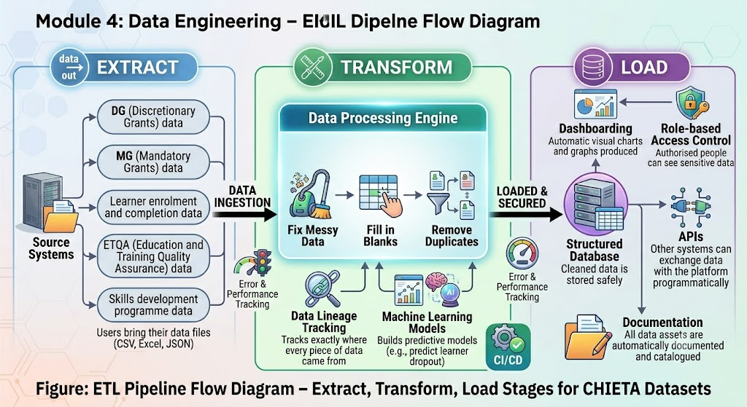
[ Figure / Chart: ETL Pipeline Flow Diagram – Extract, Transform, Load Stages for CHIETA Datasets ]
Figure: ETL Pipeline Flow Diagram – Extract, Transform, Load Stages for CHIETA Datasets

FR-10: Data Cleaning
The system provides automated tools to fix common data quality problems:
- Missing values — filling gaps with appropriate defaults or averages
- Duplicate records — identifying and removing exact copies
- Outliers — flagging unusually high or low values for review

FR-11: Data Validation
Before data is stored, automated quality checks verify that data meets expected formats, ranges, and rules. For example, a learner age of 200 would be flagged as invalid.

FR-12: Data Lineage
The platform records the complete journey of every piece of data — from its original source file, through every transformation, to its final dashboard. This is called data lineage and is critical for compliance and trust.

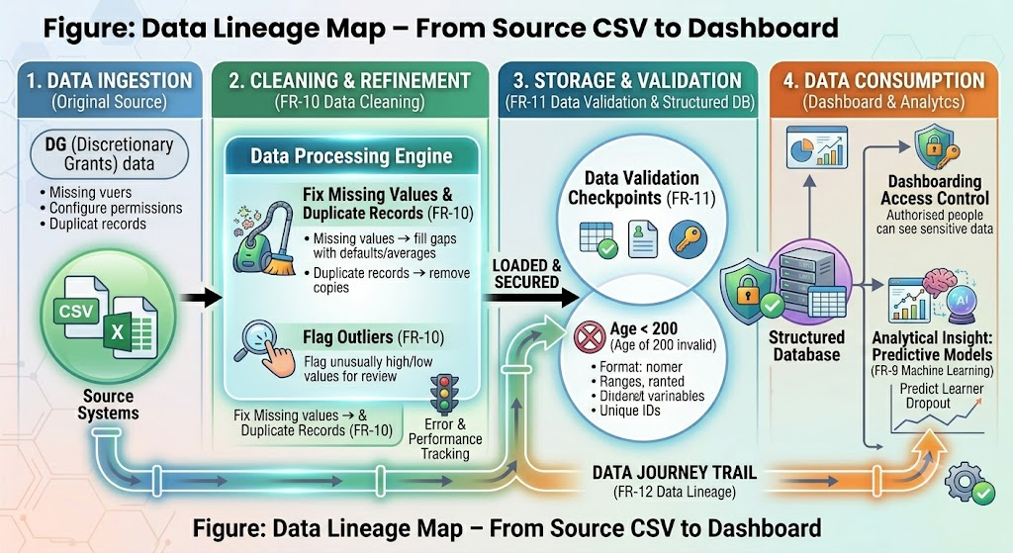

[ Figure / Chart: Data Lineage Map – From Source CSV to Dashboard ]
Figure: Data Lineage Map – From Source CSV to Dashboard

Module 5: Data Storage

FR-13: Structured Data Storage
All structured, tabular data (like database tables) is stored in PostgreSQL — an enterprise-grade relational database. PostgreSQL is trusted by organisations worldwide for its reliability and performance.

FR-14: Unstructured Data Storage
Raw files — CSV uploads, PDF reports, model artifacts — are stored in MinIO, a high-performance object storage system similar to Amazon S3 but deployable privately within CHIETA's own infrastructure.

FR-15: Automated Backups
Daily automated backups of all data shall be performed and retained for 30 days, ensuring data can be recovered in the event of accidental deletion or system failure.

Module 6: Data Exploration

FR-16: Interactive Queries
Analysts can filter, sort, and browse datasets through an intuitive web interface without needing to write code.

FR-17: SQL Workspace
Advanced users can execute SQL (Structured Query Language) queries directly on the data. SQL is the standard language used to ask precise questions of databases.
Analogy: SQL is like asking the database specific questions in a structured language. Instead of browsing a library randomly, you walk to the librarian and say: 'Give me all books published after 2020 by South African authors, sorted alphabetically.' SQL lets analysts ask equally precise questions of CHIETA's data.

FR-18: Notebook Workspace
The platform supports Python notebooks and Spark notebooks — interactive coding environments where analysts can write code, run it, and see results immediately. These are used for advanced data science work.

FR-19: Statistical Analysis
Built-in statistical functions include: mean (average), median, standard deviation (spread of data), and correlation (relationship between variables). These functions work without requiring any coding from the user.

Module 7: Dashboarding
Dashboards are visual summaries of key data, presented as charts and graphs on a single screen. They are the primary way CHIETA management will consume insights from the Data Lab.

FR-20: Dashboard Builder
Analysts can create custom dashboards by dragging and dropping charts, without needing programming knowledge.

FR-21: Supported Chart Types
- Bar charts — comparing quantities across categories (e.g., grants per province)
- Line charts — showing trends over time (e.g., learner enrolment per year)
- Pie charts — showing proportional breakdowns (e.g., percentage of learners per sector)
- Heatmaps — showing intensity across two dimensions (e.g., skills demand by region and qualification)
- Scatter plots — showing relationships between two numeric variables
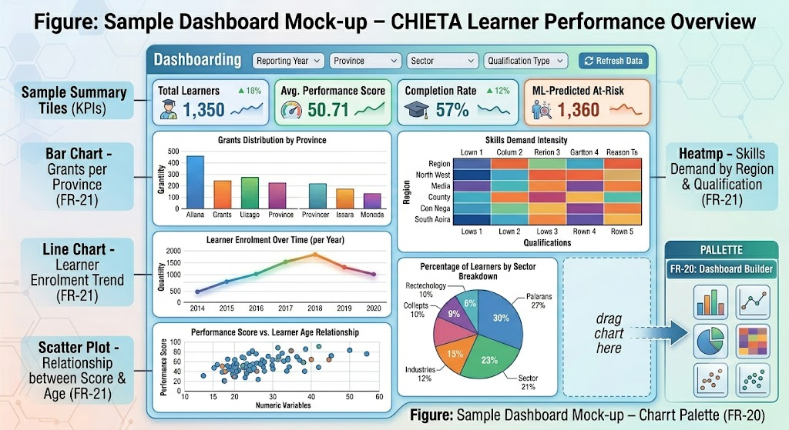

[ Figure / Chart: Sample Dashboard Mock-up – CHIETA Learner Performance Overview ]
Figure: Sample Dashboard Mock-up – CHIETA Learner Performance Overview

FR-22: Dashboard Export
Dashboards can be exported in three formats: PDF (for formal reports), Excel (for further analysis), and PNG (for presentations and emails).

FR-23: Dashboard Sharing
Users can share dashboards with other users inside the platform, or export them for external distribution.

Module 8: Machine Learning
Machine learning (ML) enables the Data Lab to learn patterns from historical data and make predictions about future outcomes. This is one of the most powerful capabilities of the platform.

Plain-Language Explanation: Machine learning is like teaching a child by showing them thousands of examples. After seeing enough examples of 'learner dropped out' and 'learner completed', the model learns to recognise warning signs and can predict which future learners are at risk — allowing CHIETA to intervene early.

FR-24: Experiment Tracking with MLflow
Every machine learning experiment — every model trained, every parameter tried, every result recorded — is tracked in MLflow. This ensures reproducibility: anyone can re-run an experiment and get the same result.

FR-25: Model Registry
Trained models progress through a lifecycle: Development → Staging → Production → Archived. The Model Registry manages this lifecycle, ensuring only validated models are used in production.

FR-26: Forecasting Capabilities
The platform supports three types of predictive modelling:
- Time series forecasting — predicting future values based on historical trends (e.g., future skills demand)
- Regression — predicting a numeric outcome (e.g., expected grant spend)
- Classification — predicting a category (e.g., will a learner complete or drop out?)

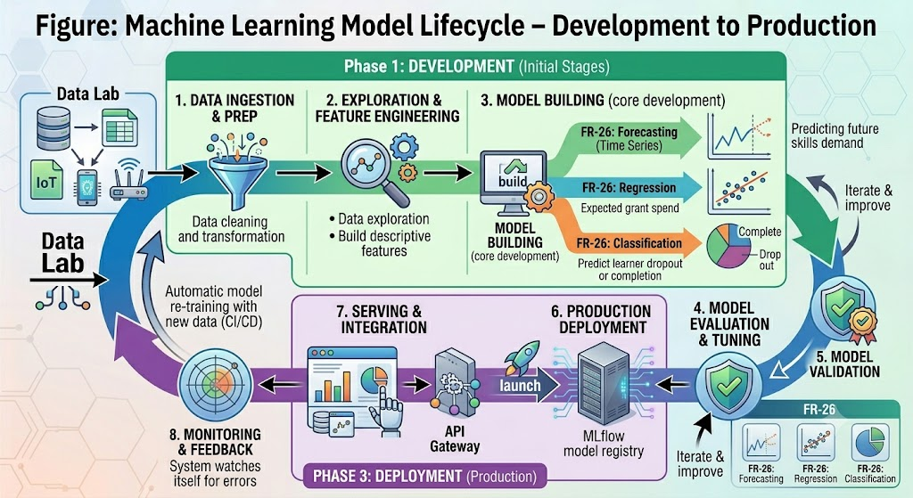

[ Figure / Chart: Machine Learning Model Lifecycle – Development to Production ]
Figure: Machine Learning Model Lifecycle – Development to Production

FR-27: Model Explainability
Using SHAP (SHapley Additive exPlanations) values and bias detection tools, the platform explains why a model made a specific prediction. This is critical for responsible AI and POPIA compliance.
Why Explainability Matters: If a model predicts that a specific learner is at risk of dropping out, CHIETA needs to know why — was it their age, their qualification level, their location? Without explainability, AI is a black box that cannot be trusted or audited.

Module 9: Metadata Management

FR-28: Dataset Catalogue with OpenMetadata
OpenMetadata provides a searchable catalogue of all data assets in the Data Lab. Think of it as a library catalogue — every dataset has a record describing what it contains, who owns it, when it was created, and where it came from.

FR-29: Business Glossary
A Business Glossary stores standard definitions of key business terms. For example, 'Learner' might be defined differently across different CHIETA departments; the glossary establishes one official definition.

FR-30: Data Classification
Every dataset is classified as: Public (shareable externally), Internal (for CHIETA staff only), or Restricted (sensitive data requiring special permissions). This supports POPIA compliance.

FR-31: Data Retention Policies
Administrators configure how long different categories of data are retained before automated deletion. This ensures compliance with POPIA's data minimisation principle.

Module 10: Reporting

FR-32: Report Generation
Users can generate formal reports from the Data Lab in PDF and Excel formats. Reports are branded, structured, and ready for distribution to management or external stakeholders.

FR-33: Scheduled Reports
Reports can be scheduled to generate and distribute automatically — for example, a weekly learner enrolment report sent every Monday morning.

Module 11: Audit and Monitoring

FR-34: Audit Logs
Every significant action on the platform is recorded in an audit log: login events, dataset access, report downloads, model executions. Audit logs are retained for seven years and cannot be deleted by regular users.

FR-35: Platform Monitoring
The system continuously monitors its own health: CPU usage, memory consumption, data pipeline status. Administrators receive automatic alerts when thresholds are exceeded.

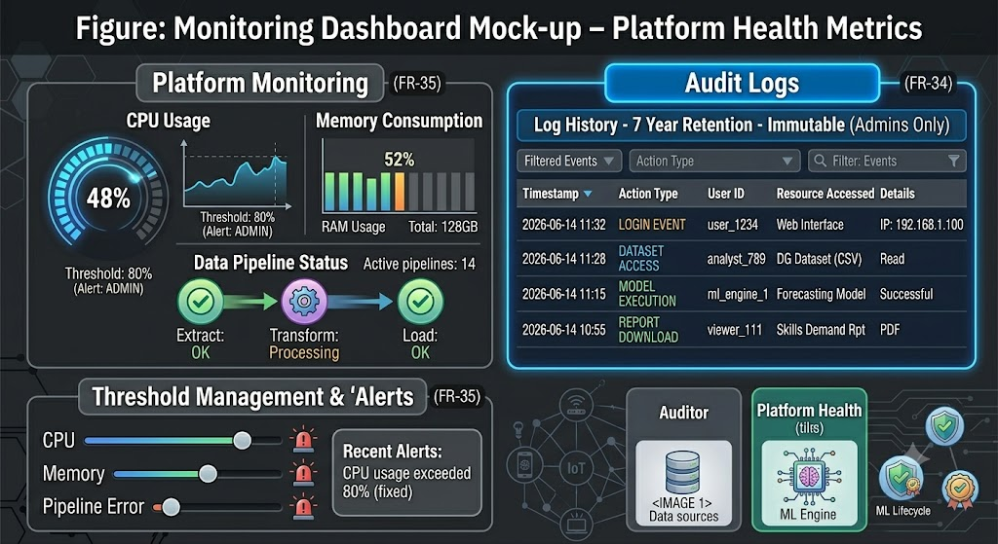

[ Figure / Chart: Monitoring Dashboard Mock-up – Platform Health Metrics ]
Figure: Monitoring Dashboard Mock-up – Platform Health Metrics

Module 12: API Management

FR-36: REST APIs
Every module exposes a REST API (Application Programming Interface), allowing external systems to integrate with the Data Lab programmatically. This means other CHIETA systems can query datasets, retrieve predictions, or export reports via code.

FR-37: Swagger/OpenAPI Documentation
API documentation is automatically generated in Swagger/OpenAPI format — an industry standard that allows developers to explore and test APIs through a visual interface without reading code.

Module 13: Student Participation

FR-38: Contribution Logs
Student contributions to data cleaning, documentation, and QA are tracked in the platform. This creates a formal record of each student's involvement.

FR-39: Digital Badges
Students receive digital badges and certificates for their contributions, providing formal recognition that can be included in portfolios and CVs.

Module 14: Prototype

FR-40: Prototype Module
The platform shall include at least one fully operational prototype demonstrating real analytical capability using CHIETA data. Example prototype options include:
- Learner Success Prediction — predict which learners will complete their programmes
- Grant Spending Intelligence — analyse and forecast how grants are utilised across sectors
- Skills Demand Forecasting — predict future skills shortages by region and occupation

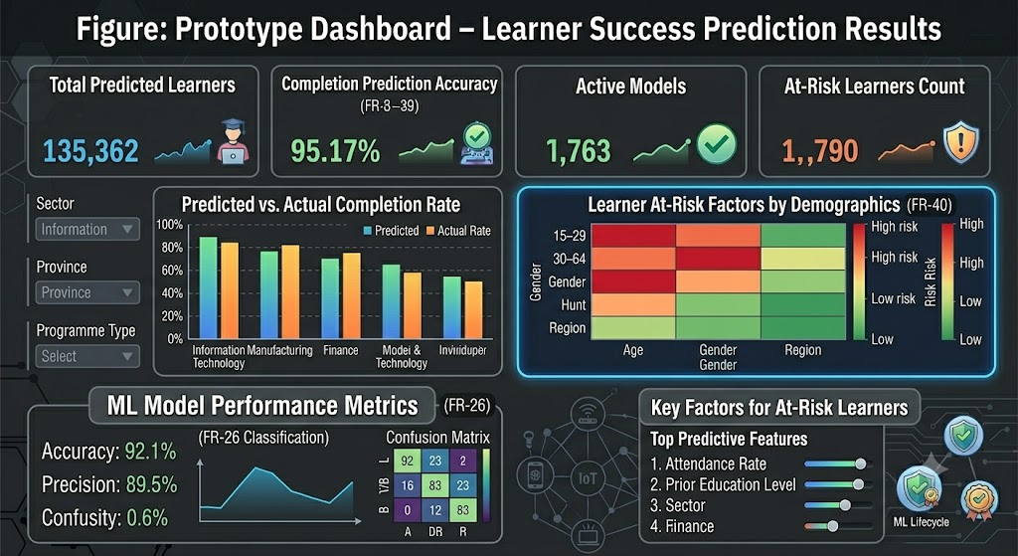

[ Figure / Chart: Prototype Dashboard – Learner Success Prediction Results ]
Figure: Prototype Dashboard – Learner Success Prediction Results

4. Non-Functional Requirements
Non-functional requirements define how the system must perform, not just what it must do. They govern speed, security, reliability, and scalability.

Requirement | Specification
NFR-1: Dashboard Response Time | All dashboards shall load within 3 seconds
NFR-2: Data Volume Support | Platform shall handle datasets with 500,000+ records
NFR-3: Availability | System shall maintain 99% uptime
NFR-4: Data Encryption at Rest | AES-256 encryption for all stored data
NFR-5: Encryption in Transit | TLS 1.3 for all data transmitted over the network
NFR-6: Role-Based Access | RBAC enforced at every endpoint
NFR-7: POPIA Compliance | Full alignment with South Africa's Protection of Personal Information Act
NFR-8: Containerisation | All services deployed as Docker containers
NFR-9: Horizontal Scaling | Platform scales using Azure Kubernetes Service (AKS)
NFR-10: Automated Backups | Daily automated backups with point-in-time recovery
NFR-11: Disaster Recovery | Full disaster recovery capability supported
NFR-12: Microservices | Independent, modular service architecture
NFR-13: CI/CD Pipeline | Continuous Integration and Deployment via Azure DevOps
NFR-14: Version Control | All source code managed in Git repositories
NFR-15: Accessibility | WCAG 2.1 AA compliance (accessible to users with disabilities)
NFR-16: Browser Support | Chrome, Edge, and Firefox
NFR-17: 24/7 Operation | Platform operates around the clock without scheduled downtime

5. External Interfaces
The Data Lab integrates with several external technologies. The table below summarises each interface:

Interface | Technology | Purpose
Frontend | React + Material UI | User-facing web application
Backend | FastAPI | API gateway and business logic
Database | PostgreSQL + MinIO | Structured and unstructured data storage
Data Platform | Apache Spark + Airflow | Data processing and orchestration
Dashboard | Apache Superset | Visual analytics and dashboarding
ML Platform | MLflow | Machine learning experiment tracking
Metadata | OpenMetadata | Data catalogue and lineage
Infrastructure | Docker + AKS + Azure DevOps | Containerisation, orchestration, CI/CD

6. Deliverable Mapping
The nine project deliverables (D1–D9) are mapped to the sections of this SRS:

Deliverable | Corresponding SRS Sections
D1 – Requirements | Sections 1–3 (Introduction, Description, Functional Requirements)
D2 – Architecture | Architecture and Interfaces
D3 – Functional Platform | All Functional Modules (FR-1 to FR-40)
D4 – Integrated Datasets | Module 4: Data Engineering
D5 – Dashboards | Module 7: Dashboarding
D6 – Prototype | Module 14: Prototype
D7 – Testing | Non-Functional Requirements, Monitoring
D8 – Documentation | Metadata Management, Audit
D9 – APIs and Deployment | API Management, External Interfaces

Appendix A – Repository Structure
The following repositories shall be created in Azure DevOps to house all source code:
- frontend-react — User interface components and pages
- backend-fastapi — API gateway, services, and business logic
- airflow-etl — Data pipeline DAGs and orchestration scripts
- spark-processing — Data transformation and feature engineering jobs
- ml-platform — Machine learning models, experiments, and registry
- superset-dashboards — Dashboard definitions and configurations
- metadata-platform — OpenMetadata setup and configuration
- infrastructure — Terraform, Kubernetes manifests, Helm charts
- integration-release — End-to-end integration tests and release scripts
VOLUME II
Software Architecture Design Document (SADD)
The Architectural Blueprint of the CHIETA Data Lab

Volume II: Software Architecture Design Document (SADD)
This document corresponds to Deliverable D2. It translates the requirements of Volume I into a scalable, secure, cloud-native microservices architecture blueprint.

1. Architectural Principles
Before describing the architecture in detail, it is important to understand the principles that guided every design decision. These principles are non-negotiable constraints that ensure the platform is built to last.

Principle | What It Means in Practice
Microservices | Each function (login, data upload, dashboards) is a separate, independently deployable service
Cloud Native | The platform is built to run in the cloud (Azure), taking full advantage of cloud scaling and resilience
Open Source First | All core technologies are open-source, avoiding vendor lock-in and licensing costs
API-First | Every function is exposed through a documented API — nothing is hidden inside the system
Event-Driven | Workflows are triggered automatically by events (e.g., a data upload triggers a cleaning pipeline)
Scalability | The platform grows horizontally by adding more server instances, not by buying bigger servers
Security by Design | Security is built in from day one — not added as an afterthought
DevSecOps | Security testing is integrated into the automated CI/CD pipeline

2. Context Diagram (Level 0)
The Context Diagram provides the highest-level view of the system. It shows how the Data Lab relates to its users and external environment.

Reading the Diagram: CHIETA users (Administrators and Analysts) interact with the system through a web browser. The browser communicates with the React Frontend, which in turn connects to the FastAPI Gateway. The gateway routes requests to the appropriate backend services.

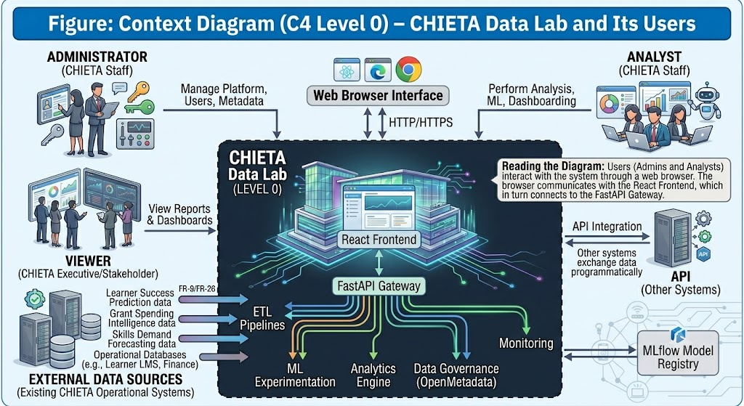
[ Figure / Chart: Context Diagram (C4 Level 0) – CHIETA Data Lab and Its Users ]
Figure: Context Diagram (C4 Level 0) – CHIETA Data Lab and Its Users

3. Container Architecture (C4 Model Level 2)
The Container Diagram breaks the system into its major deployable units — the 'containers' (not to be confused with Docker containers) that make up the platform.

The architecture flows from the user's browser through multiple layers:
- User opens the React Web Application in their browser
- React sends requests to the FastAPI Gateway
- The Gateway authenticates the user and routes the request to the appropriate service
- Services (Authentication, Dataset, Reporting, Metadata, User, Audit) process the request
- Services retrieve or store data via Airflow (orchestration), Spark (processing), PostgreSQL (database), or MinIO (file storage)
- Results are returned through the gateway to the user's browser

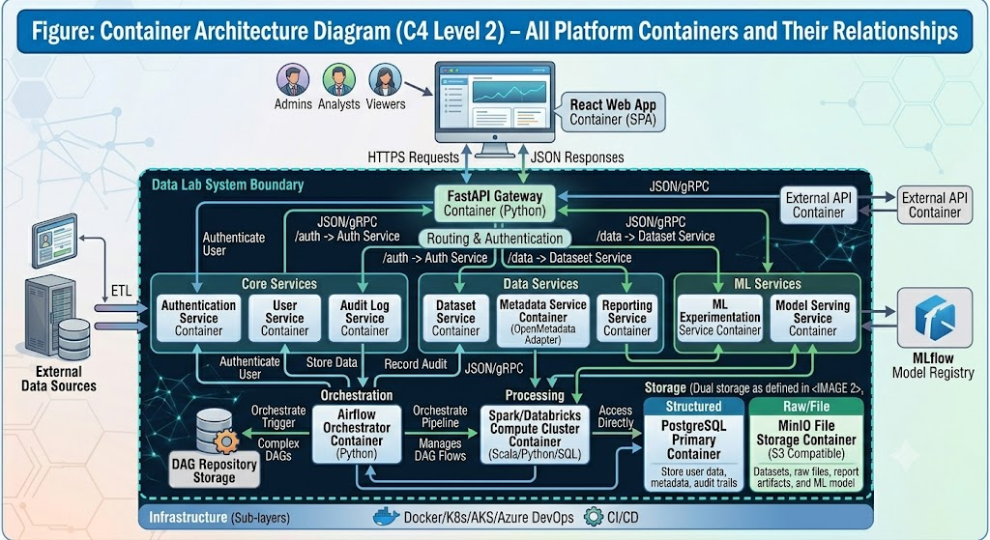

[ Figure / Chart: Container Architecture Diagram (C4 Level 2) – All Platform Containers and Their Relationships ]
Figure: Container Architecture Diagram (C4 Level 2) – All Platform Containers and Their Relationships

4. Component Architecture (C4 Level 3)

Frontend Components
- Authentication Module — login screen, session management, password reset
- Dataset Explorer — browse, search, filter, and preview datasets
- Dashboard Module — view, create, and export dashboards
- Experiment Module — launch ML experiments, view results
- Metadata Module — browse data catalogue, view lineage
- Report Module — generate and schedule reports
- Administration Module — manage users, roles, and platform settings

Backend Components
- Authentication Service — JWT token generation and validation
- User Service — create, update, disable users
- Dataset Service — upload, version, search datasets
- Report Service — generate and export reports
- Metadata Service — connect to OpenMetadata catalogue
- Audit Service — record and retrieve audit logs
- Notification Service — send email and Teams alerts

Data Engineering Components
- Airflow DAGs — workflows for Extract, Transform, Validate, Load, Monitor
- Spark Jobs — distributed data transformation and feature engineering

ML Components
- Experiment Tracking — MLflow integration for recording experiments
- Model Registry — promote models through Development → Staging → Production
- Bias Detection — SHAP and fairness analysis
- Model Serving — REST API for serving predictions

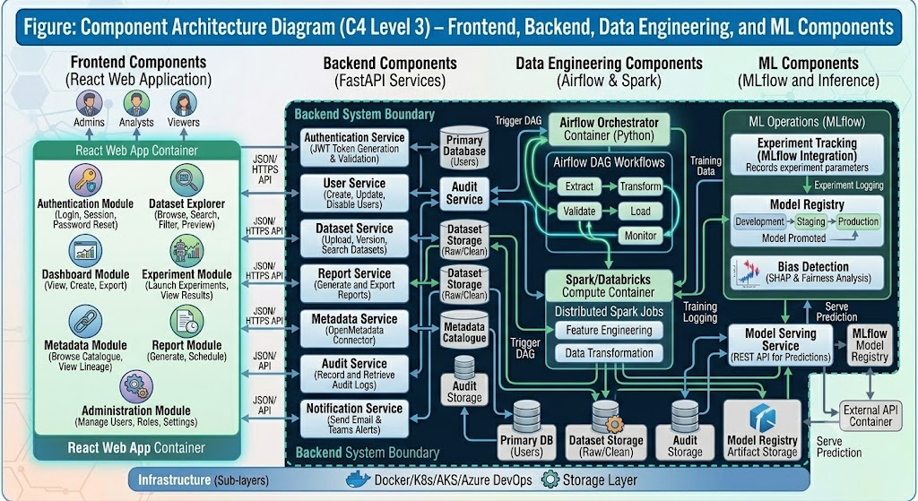

[ Figure / Chart: Component Architecture Diagram (C4 Level 3) – Frontend, Backend, Data Engineering, and ML Components ]
Figure: Component Architecture Diagram (C4 Level 3) – Frontend, Backend, Data Engineering, and ML Components

5. Microservices Architecture
The microservices architecture distributes the application across nine dedicated repositories, each building and deploying independently:

Repository | Responsibility | Technology
frontend-react | User interface | React + Material UI
backend-fastapi | API gateway and business logic | Python FastAPI
airflow-etl | Data pipeline orchestration | Apache Airflow
spark-processing | Large-scale data transformation | Apache Spark
ml-platform | ML experiments and model registry | MLflow + Python
superset-dashboards | Dashboards and visual analytics | Apache Superset
metadata-platform | Data catalogue and lineage | OpenMetadata
infrastructure | Cloud infrastructure as code | Terraform + Helm

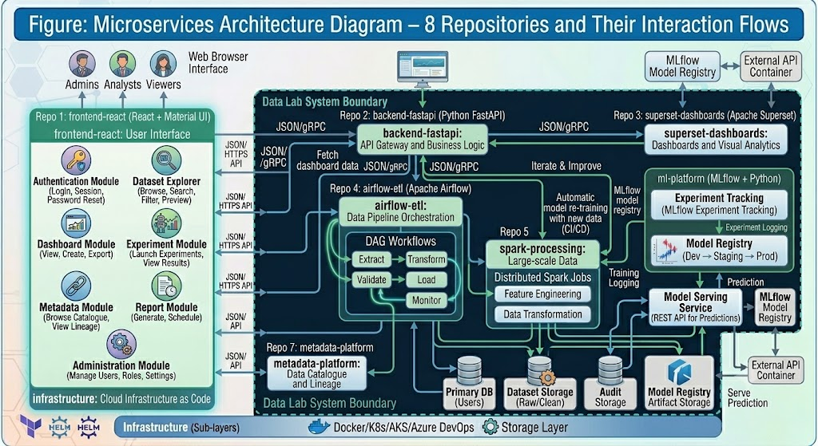

[ Figure / Chart: Microservices Architecture Diagram – 8 Repositories and Their Interaction Flows ]
Figure: Microservices Architecture Diagram – 8 Repositories and Their Interaction Flows

6. Sequence Diagrams
Sequence diagrams show the step-by-step messages exchanged between components when a user performs a specific action.

Dataset Upload Sequence
- User selects a file in the React frontend
- React sends POST /datasets/upload to FastAPI Gateway
- FastAPI validates the request and JWT token
- Dataset Service stores the raw file in MinIO
- Dataset Service records metadata in PostgreSQL
- Dataset Service registers the asset in OpenMetadata
- Success response returned to the user

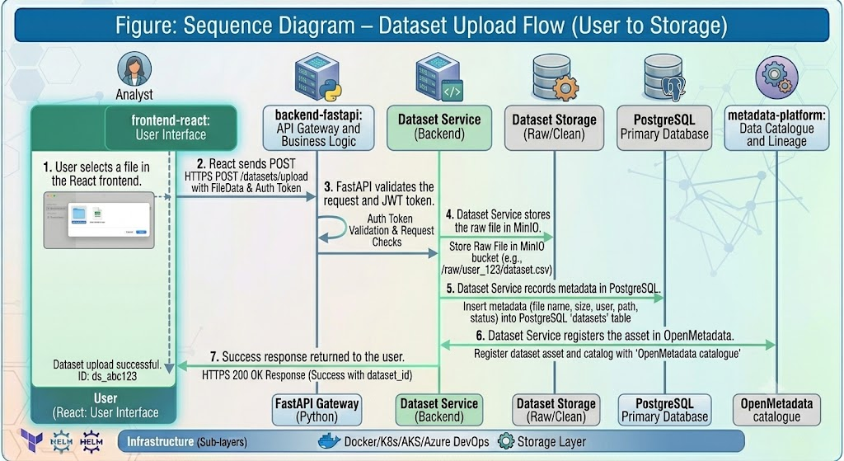
[ Figure / Chart: Sequence Diagram – Dataset Upload Flow (User to Storage) ]
Figure: Sequence Diagram – Dataset Upload Flow (User to Storage)

Dashboard Generation Sequence
- User opens a dashboard in React
- React sends a request to Apache Superset
- Superset queries PostgreSQL for the required data
- Superset generates chart visualisations
- Dashboard rendered in the user's browser

Machine Learning Workflow Sequence
- Airflow scheduler triggers a ML pipeline DAG
- Spark processes and engineers features from raw data
- MLflow logs the experiment parameters and metrics
- Model stored in MLflow Model Registry
- Prediction API endpoint becomes available
- Superset dashboard displays prediction results

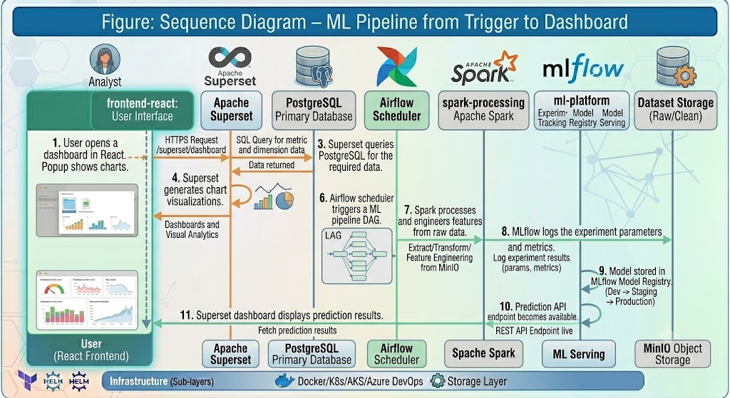

[ Figure / Chart: Sequence Diagram – ML Pipeline from Trigger to Dashboard ]
Figure: Sequence Diagram – ML Pipeline from Trigger to Dashboard

7. Database Architecture
PostgreSQL organises data into logical schemas — groupings of related tables. The CHIETA Data Lab uses the following schemas:

Schema | Contents | Purpose
users | User accounts, roles, permissions | Identity and access management
datasets | Dataset registry, tags, versions | Data asset catalogue
metadata | Dataset descriptions and lineage links | Data governance
audit_logs | All system events and user actions | Compliance and audit trail
reports | Report definitions and export history | Reporting management
models | ML model registry and lifecycle stages | Machine learning governance
experiments | ML experiment runs, parameters, metrics | Experiment tracking
notifications | Alert and notification history | Communication management

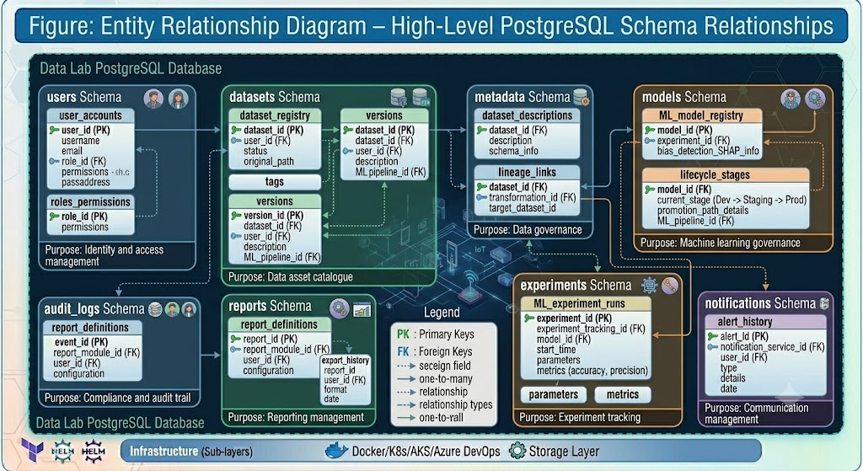
[ Figure / Chart: Entity Relationship Diagram – High-Level PostgreSQL Schema Relationships ]
Figure: Entity Relationship Diagram – High-Level PostgreSQL Schema Relationships

8. Data Lake Architecture (MinIO)
MinIO serves as the platform's data lake — the storage layer for all raw and processed files. It organises data into buckets (similar to folders):

Bucket | Contents
raw-data | Original uploaded files as received from source systems
processed-data | Cleaned and transformed data ready for analysis
reports | Generated PDF and Excel report files
models | Trained machine learning model artifacts
artifacts | Supporting files for ML experiments
documents | Technical documentation and operational guides
images | Charts and graph exports
logs | System and pipeline log files

9. API Architecture
All Data Lab APIs follow REST (Representational State Transfer) principles — the global standard for web APIs. Every API uses JSON (JavaScript Object Notation) for data exchange and JWT tokens for authentication.

Key API Families
- Authentication APIs: POST /login, POST /logout, POST /refresh-token
- User Management APIs: GET/POST/PUT/DELETE /users
- Dataset APIs: POST /datasets/upload, GET /datasets, GET /datasets/{id}, DELETE /datasets/{id}
- Report APIs: GET /reports, POST /reports/export
- Dashboard APIs: GET /dashboard/learners, GET /dashboard/grants, GET /dashboard/etqa, GET /dashboard/skills
- Metadata APIs: GET /catalog, GET /lineage, GET /glossary
- ML APIs: POST /models/train, GET /models, POST /predict, GET /experiments
- Audit APIs: GET /audit/logs
- Health APIs: GET /health, GET /readiness, GET /liveness

Swagger/OpenAPI documentation is auto-generated by FastAPI, providing an interactive API browser for developers.

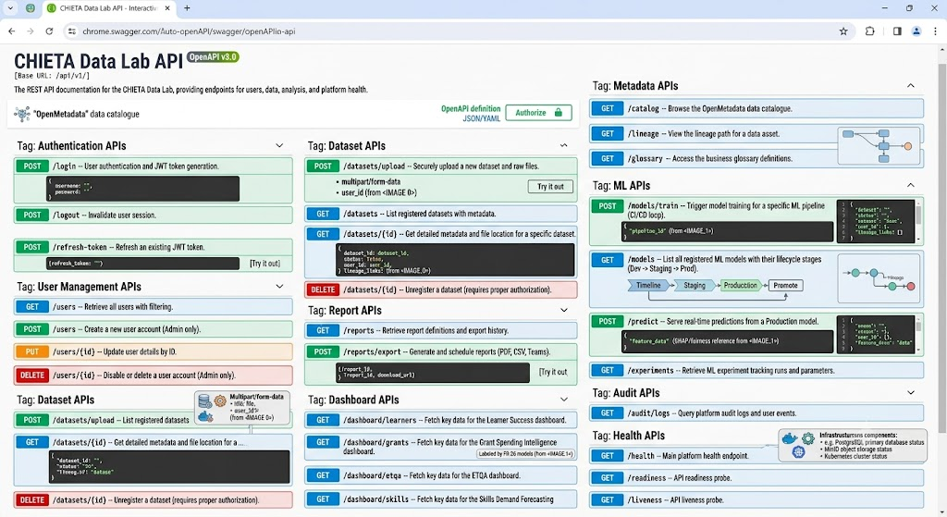
[ Figure / Chart: Swagger API Documentation Screenshot – Interactive API Browser Mock-up ]
Figure: Swagger API Documentation Screenshot – Interactive API Browser Mock-up

10. Authentication and Security Architecture
The platform supports four authentication mechanisms, providing flexibility for different enterprise environments:
- JWT (JSON Web Token) — default authentication for the Data Lab
- OAuth2 — standard open authorisation protocol
- Azure AD — integration with Microsoft's enterprise identity service
- Keycloak — open-source identity and access management

Security is enforced in four layers:
- React Frontend — restricts which UI elements are visible based on user role
- FastAPI Gateway — validates JWT tokens on every API request
- RBAC Engine — checks permissions for every operation
- Database — row-level and column-level security for sensitive data

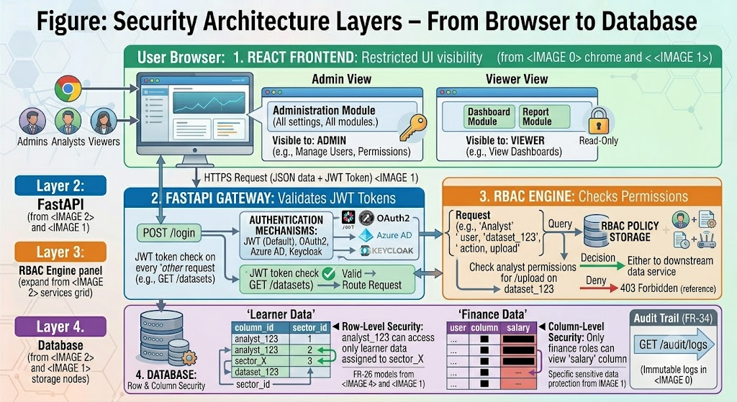
[ Figure / Chart: Security Architecture Layers – From Browser to Database ]
Figure: Security Architecture Layers – From Browser to Database

11. Machine Learning Architecture
The ML architecture follows a structured pipeline from raw data to deployed predictions:
- Apache Airflow triggers the ML pipeline on a schedule or event
- Apache Spark performs feature engineering (transforming raw data into ML-ready inputs)
- The ML model is trained and evaluated
- MLflow records all experiment parameters, metrics, and model artifacts
- The model is promoted to the MLflow Registry
- A prediction API endpoint is exposed for real-time scoring
- Results are visualised in Apache Superset dashboards

Supported model types include: XGBoost, Random Forest, Prophet, LightGBM, ARIMA. Explainability is provided via SHAP values and bias detection.

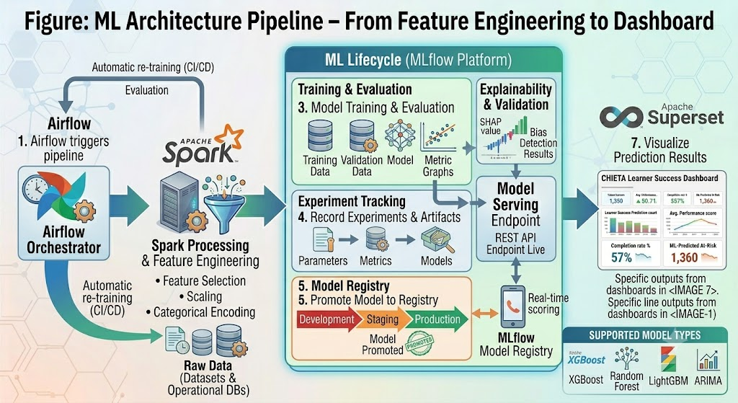

[ Figure / Chart: ML Architecture Pipeline – From Feature Engineering to Dashboard ]
Figure: ML Architecture Pipeline – From Feature Engineering to Dashboard

12. Dashboard Architecture
Apache Superset powers the dashboarding layer. Five core dashboards are defined:
Dashboard | Key Metrics / KPIs
Learner Dashboard | Completion rates, dropout rates, enrolment trends by sector
Grant Dashboard | DG and MG grant utilisation, sector distribution, spend trends
ETQA Dashboard | Accreditation status, APP targets, compliance metrics
Skills Dashboard | Scarce skills mapping, regional demand, qualification gap analysis
Executive Dashboard | Summary KPIs for CHIETA leadership — one-page strategic overview

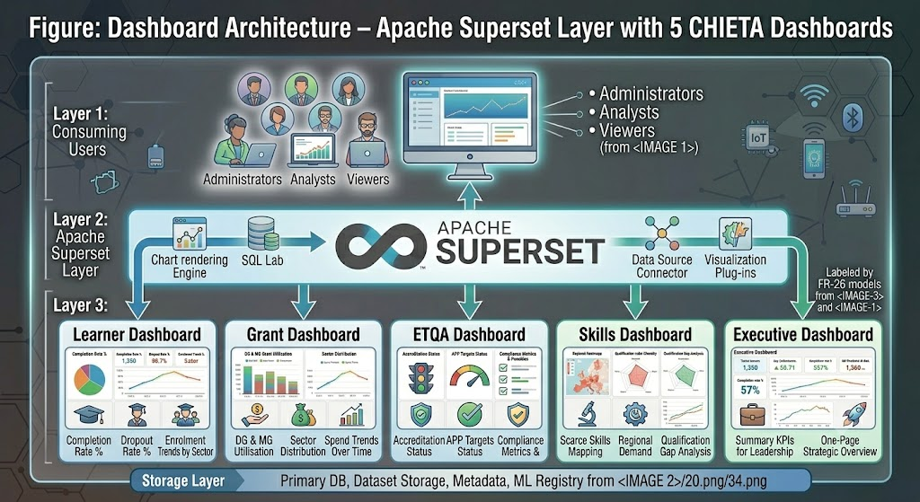
[ Figure / Chart: Dashboard Architecture – Apache Superset Layer with 5 CHIETA Dashboards ]
Figure: Dashboard Architecture – Apache Superset Layer with 5 CHIETA Dashboards

13. Infrastructure Architecture
The platform is deployed on Microsoft Azure using Azure Kubernetes Service (AKS). The infrastructure stack is:
- Docker Containers — each microservice packaged as a self-contained Docker image
- AKS Cluster — Kubernetes orchestrates all containers, handles scaling and self-healing
- Namespaces — logical isolation per service (frontend, backend, airflow, spark, etc.)
- NGINX Ingress — routes external traffic to the correct internal service
- Azure Load Balancer — distributes incoming traffic across multiple instances
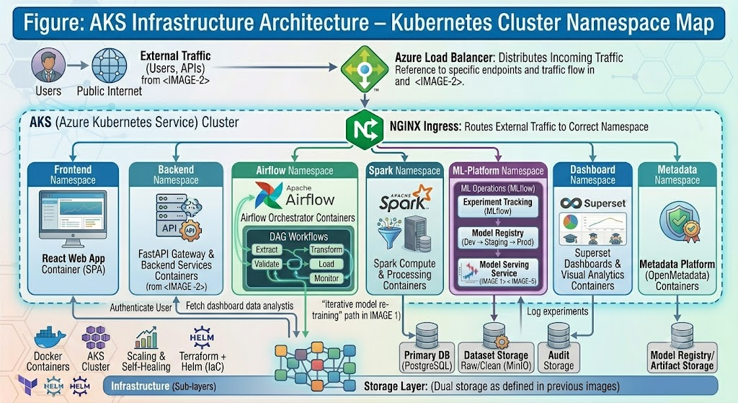

[ Figure / Chart: AKS Infrastructure Architecture – Kubernetes Cluster Namespace Map ]
Figure: AKS Infrastructure Architecture – Kubernetes Cluster Namespace Map

14. CI/CD Architecture
CI/CD stands for Continuous Integration and Continuous Deployment — the automated pipeline that takes code from a developer's laptop to the production server.

The CI/CD pipeline steps are:
- Developer commits code to a Git repository
- Azure DevOps triggers the build pipeline automatically
- Code is compiled and unit tests are run
- A Docker container image is built
- The image is pushed to Azure Container Registry
- The image is deployed to the AKS cluster
- Automated smoke tests verify the deployment
- Deployment promoted to production if all tests pass

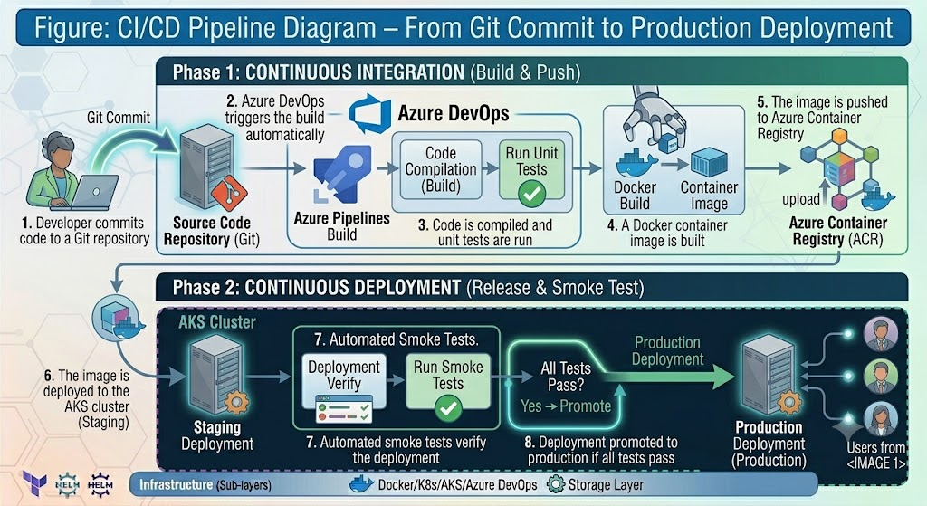
[ Figure / Chart: CI/CD Pipeline Diagram – From Git Commit to Production Deployment ]
Figure: CI/CD Pipeline Diagram – From Git Commit to Production Deployment

15. Monitoring and Logging Architecture

Monitoring with Prometheus and Grafana
Prometheus continuously collects performance metrics from all services. Grafana displays these metrics as real-time operational dashboards. Alerts are sent via email, Microsoft Teams, and SMS when thresholds are exceeded.

Logging with ELK Stack
All system logs flow into the ELK Stack — three open-source tools working together:
- ElasticSearch — stores and indexes all log entries
- Logstash — processes and transforms incoming logs
- Kibana — provides a visual interface for searching and analysing logs

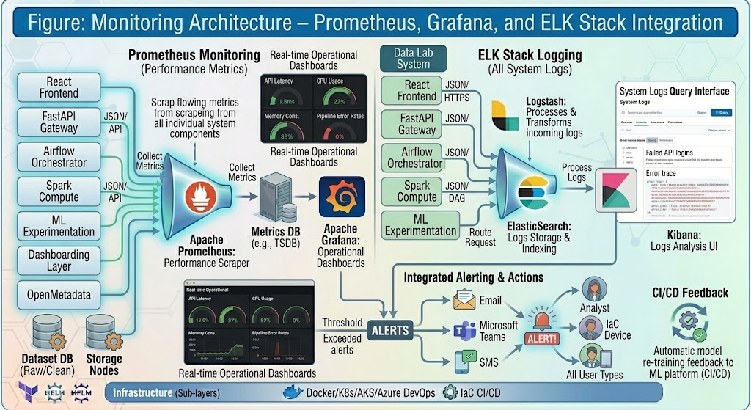
[ Figure / Chart: Monitoring Architecture – Prometheus, Grafana, and ELK Stack Integration ]
Figure: Monitoring Architecture – Prometheus, Grafana, and ELK Stack Integration

16. Backup and Disaster Recovery Architecture
The backup and disaster recovery strategy protects against data loss and ensures business continuity:

Recovery Metric | Target
RPO (Recovery Point Objective — maximum data loss) | Less than 1 hour
RTO (Recovery Time Objective — maximum downtime) | Less than 4 hours

What RPO and RTO Mean: RPO answers: 'If the system crashes right now, how much data could we lose?' RTO answers: 'If the system crashes right now, how long before it is running again?' CHIETA's targets are world-class: lose at most 1 hour of data, recover within 4 hours.

17. High Availability Architecture
The platform targets 99.9% availability — meaning no more than 8.7 hours of unplanned downtime per year. This is achieved through:
- Replica Sets — multiple copies of each service run simultaneously
- Load Balancers — traffic is distributed so no single instance is overwhelmed
- Rolling Updates — new versions deploy gradually, with no downtime
- Horizontal Pod Autoscaler — Kubernetes adds more instances automatically under load

18. Network Architecture
The platform runs within a secure Azure Virtual Network divided into three subnets:
- Subnet-App — application services (frontend, backend)
- Subnet-Data — data services (PostgreSQL, MinIO)
- Subnet-AKS — Kubernetes cluster

Private Endpoints and Azure Key Vault ensure that secrets (passwords, certificates, API keys) are never exposed in code or configuration files.

19. Technology Stack Summary
Layer | Technology
Frontend | React + Material UI
Backend | FastAPI (Python)
Data Orchestration | Apache Airflow
Data Processing | Apache Spark
Database | PostgreSQL
Data Lake | MinIO
Dashboarding | Apache Superset
ML Platform | MLflow
Metadata | OpenMetadata
Containerisation | Docker
Orchestration | Azure Kubernetes Service (AKS)
CI/CD | Azure DevOps
Monitoring | Prometheus + Grafana
Logging | ELK Stack (ElasticSearch, Logstash, Kibana)
Secrets | Azure Key Vault
VOLUME III
Detailed Design Document (DDD)
The Engineering Blueprint for Developers

Volume III: Detailed Design Document (DDD)
This document provides the detailed engineering blueprint used by the development teams and the Principal System Engineer. It translates the architecture of Volume II into specific designs for every component.

1. C4 Model — Four Levels of Detail
The C4 Model is a framework for describing software architecture at four levels of detail — moving from the big picture down to the code level.

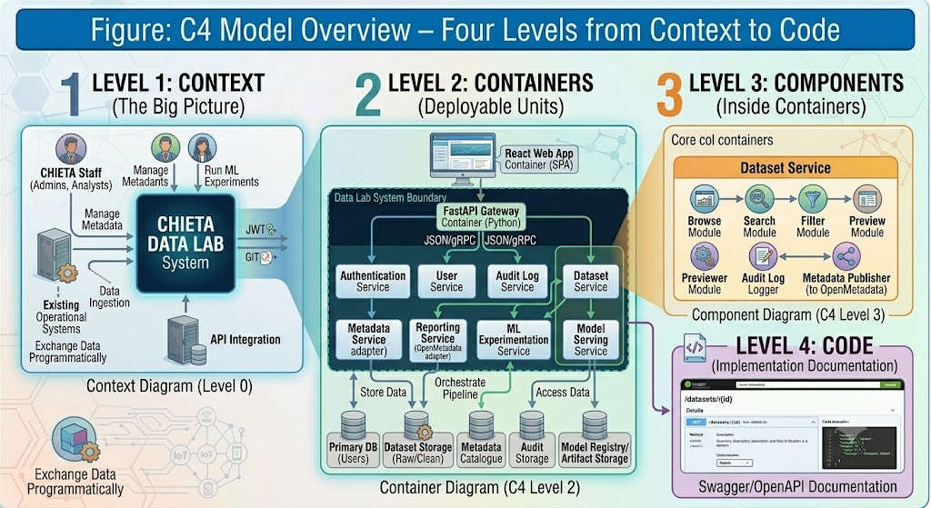
[ Figure / Chart: C4 Model Overview – Four Levels from Context to Code ]
Figure: C4 Model Overview – Four Levels from Context to Code

C4 Level | What It Shows | Audience
Level 1: Context | The system and its users | All stakeholders
Level 2: Container | Major deployable units and their interactions | Architects
Level 3: Component | The components within each container | Tech Leads
Level 4: Code | Classes, functions, and modules within a service | Developers

2. UML Models
UML (Unified Modelling Language) is the international standard for describing software designs. The Data Lab uses four UML diagram types:

Use Case Diagram
Describes what each type of user can do:

Actor | Key Use Cases
Administrator | Manage Users, Manage Roles, Manage Metadata, Monitor Platform, Generate Reports
Analyst | Upload Dataset, Explore Dataset, Create Dashboard, Run ML Models, View Reports
Viewer | View Dashboard, Download Reports
Student Contributor | Clean Dataset, Execute QA, Prepare Documentation

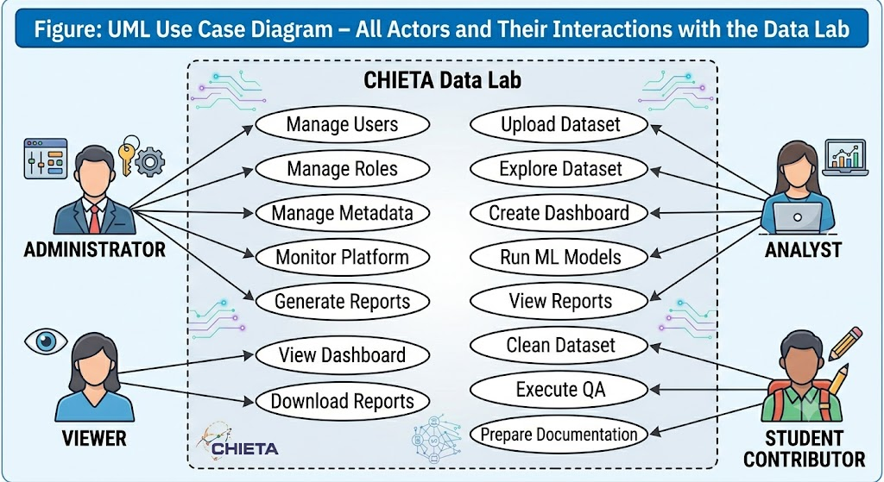
[ Figure / Chart: UML Use Case Diagram – All Actors and Their Interactions with the Data Lab ]
Figure: UML Use Case Diagram – All Actors and Their Interactions with the Data Lab

Activity Diagram — ETL Pipeline
The ETL pipeline follows these sequential activities:
- Extract — pull raw data from source systems
- Validate — check data against quality rules
- Clean — fix missing values, duplicates, outliers
- Transform — reshape data into the target schema
- Load — store processed data in PostgreSQL
- Metadata Registration — record asset in OpenMetadata
- Dashboard Refresh — update Superset dashboards with new data

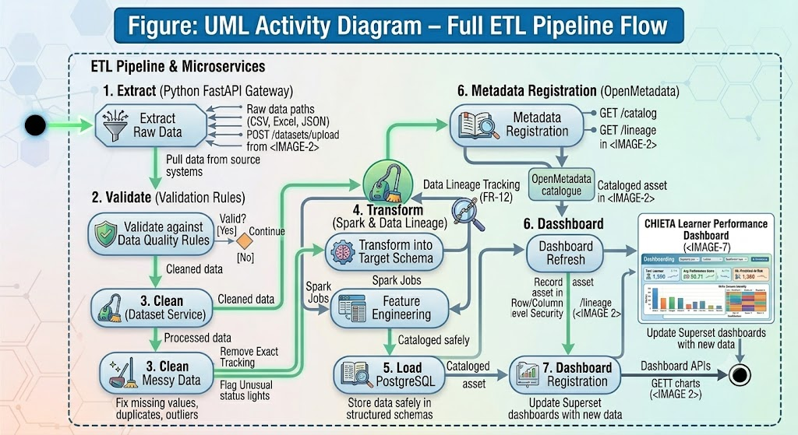
[ Figure / Chart: UML Activity Diagram – Full ETL Pipeline Flow ]
Figure: UML Activity Diagram – Full ETL Pipeline Flow

3. React Frontend Detailed Design
The frontend is built with React and organised using a component-based architecture:

Repository Structure
Folder | Contents
src/components | Reusable UI components: Navbar, Sidebar, Charts, Tables, Upload Widget, Filters, Pagination
src/pages | Full page views: Login, Dashboard, Dataset Explorer, Metadata, Reports, Experiments, Administration
src/hooks | Custom React hooks for data fetching and state logic
src/services | Axios API client for backend communication
src/store | Redux Toolkit for global application state management
src/assets | Images, icons, and static files
src/tests | Jest and React Testing Library unit tests

Analogy: Think of the React components as LEGO bricks. Each component (a chart, a filter, a table) is an independent brick that can be combined in different ways to build different pages. The same Chart component used on the Dashboard page is reused on the Experiments page.

4. FastAPI Backend Detailed Design

Repository: backend-fastapi
The FastAPI backend follows a clean three-layer architecture:
- Routers — define the API endpoints and HTTP methods
- Services — contain the business logic
- Repositories — handle all database interactions

Service Catalogue
Service | Key Endpoints
Authentication Service | POST /login, POST /logout, POST /refresh-token
User Service | GET/POST/PUT/DELETE /users, GET /roles
Dataset Service | POST /upload, GET /datasets, GET /datasets/{id}, GET /search
Metadata Service | GET /catalog, GET /lineage
Audit Service | GET /audit, GET /logs

All endpoints are automatically documented via Swagger/OpenAPI 3.0 at the /docs endpoint.

5. Airflow Data Pipeline Design
Apache Airflow uses DAGs (Directed Acyclic Graphs) to define data pipelines. Each DAG represents a workflow — a sequence of tasks that Airflow executes in order.

Five core DAGs are defined for CHIETA:
- DG Grants DAG — ingests and processes Discretionary Grant data
- MG Grants DAG — ingests and processes Mandatory Grant data
- Learner DAG — ingests and processes learner enrolment and completion data
- ETQA DAG — ingests and processes ETQA accreditation data
- Skills DAG — ingests and processes skills development programme data

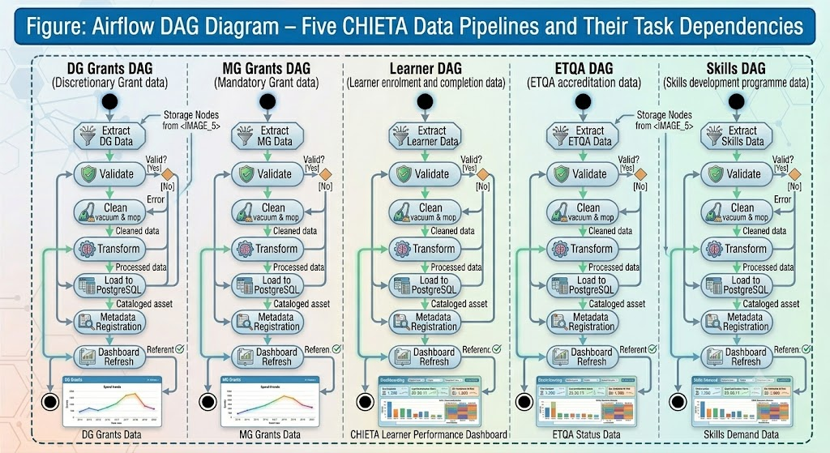
[ Figure / Chart: Airflow DAG Diagram – Five CHIETA Data Pipelines and Their Task Dependencies ]
Figure: Airflow DAG Diagram – Five CHIETA Data Pipelines and Their Task Dependencies

6. Apache Spark Processing Design
Spark handles large-scale data transformation. Six processing modules are defined:
- Cleaning Module — removes duplicates, fills missing values
- Feature Engineering Module — creates ML-ready features from raw data
- Aggregation Module — rolls up data to summary levels (monthly, provincial, sectoral)
- Validation Module — applies data quality rules at scale
- Masking Module — anonymises personally identifiable information (PII) for POPIA compliance
- Anomaly Detection Module — identifies statistically unusual records

7. PostgreSQL Database Design
The database is organised into six schemas:
Schema | Key Tables
security | users, roles, permissions
catalog | datasets, dataset_tags, dataset_owners
audit | audit_logs
analytics | processed datasets and aggregations
reporting | reports, dashboards
ml | experiments, models, predictions

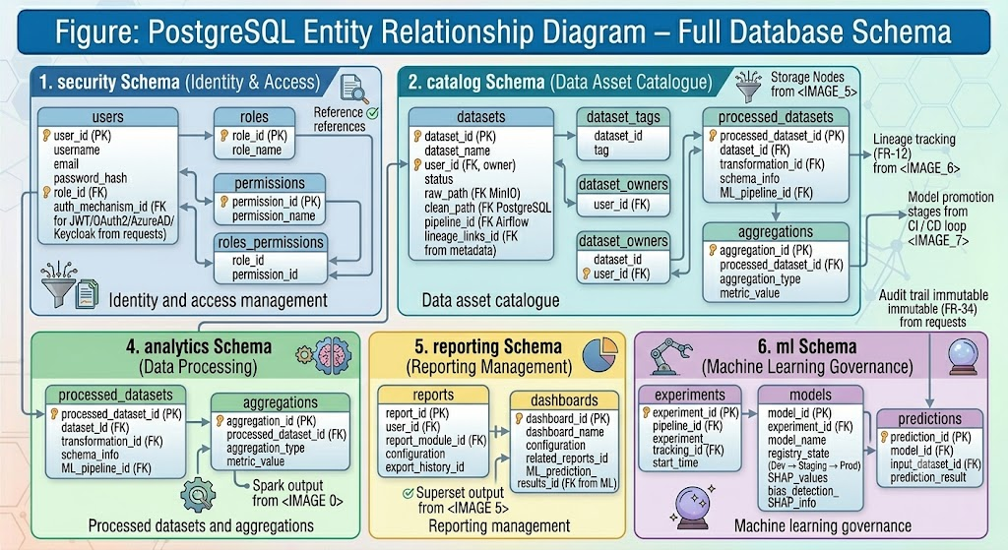
[ Figure / Chart: PostgreSQL Entity Relationship Diagram – Full Database Schema ]
Figure: PostgreSQL Entity Relationship Diagram – Full Database Schema

8. MinIO Object Storage Design
MinIO policies are assigned to each bucket to control access:
Policy | Applies To
Admin (ReadWrite) | Administrators can read and write all buckets
ReadOnly | Viewers can download from approved buckets only
Versioning | All buckets have versioning enabled for audit trail

9. Apache Superset Dashboard Design
Five dashboards are defined with specific KPIs:
Dashboard | KPIs
Learner Dashboard | Completion rate, Dropout rate, Enrolment trend, Regional breakdown
Grants Dashboard | DG utilisation %, MG utilisation %, Sector distribution, Year-on-year comparison
ETQA Dashboard | Accreditation status, APP targets vs actuals, Compliance score
Skills Dashboard | Scarce skills list, Regional demand heat map, Qualification gap analysis
Executive Dashboard | One-page strategic KPI summary for CHIETA leadership

10. MLflow Machine Learning Design
MLflow manages the complete ML lifecycle:
MLflow Component | Purpose
Experiments | Record each model training run with parameters and metrics
Tracking | Log accuracy, precision, recall, F1 score for every experiment
Model Registry | Manage model lifecycle: Development → Staging → Production → Archived
Explainability | SHAP values and bias analysis for every production model

11. Security Architecture
Security Layer | Technology
Authentication | JWT tokens, OAuth2, Azure AD
Authorisation | Role-Based Access Control (RBAC)
Encryption at Rest | AES-256
Encryption in Transit | TLS 1.3
Secrets Management | Azure Key Vault — no secrets in code
Container Security | Trivy and Snyk image scanning
Code Security | SonarQube static analysis, OWASP Dependency Check

12. Repository and Coding Standards

Git Strategy: GitFlow
- main — production-ready code only
- develop — integration branch for completed features
- feature/* — one branch per feature (e.g., feature/login, feature/upload)
- release/* — release candidate branches (e.g., release/v1.0)
- hotfix/* — emergency production fixes

Coding Standards
Language / Layer | Standard
Python | PEP8 — official Python style guide
JavaScript | ESLint + Prettier — automatic code formatting
API | OpenAPI 3.0 — all endpoints documented
Git | GitFlow — structured branching strategy
VOLUME IV
Database and API Engineering Specification (DAES)
The Engineering Handbook for Developers and Data Engineers

Volume IV: Database and API Engineering Specification (DAES)
This volume is the detailed engineering handbook for backend developers, data engineers, ML engineers, DBAs, and DevOps engineers. It specifies every database table, API endpoint, JSON schema, and engineering standard.

1. Database Architecture Overview

PostgreSQL — Structured Data
PostgreSQL stores all structured data: user accounts, dataset metadata, audit logs, reports, ML experiments, models, and configurations.

MinIO — Unstructured Data
MinIO stores all raw and processed files: uploaded CSVs, generated PDF reports, ML model artifacts, images, and operational logs.
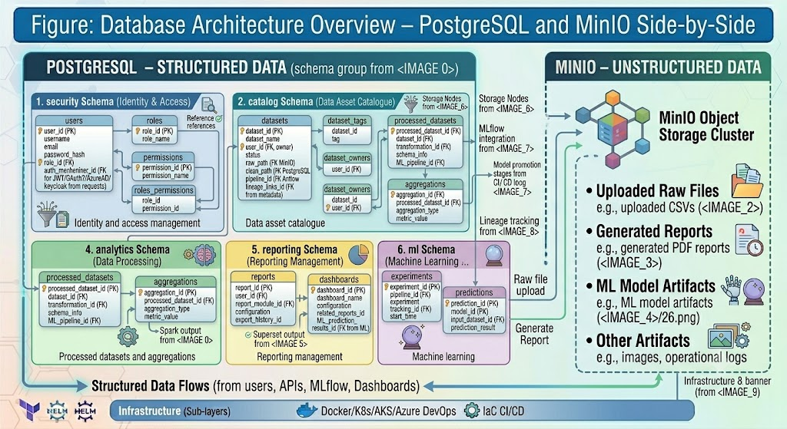
[ Figure / Chart: Database Architecture Overview – PostgreSQL and MinIO Side-by-Side ]
Figure: Database Architecture Overview – PostgreSQL and MinIO Side-by-Side

2. Entity Relationship Model
The master ER model shows how all database entities relate to each other:
- Users have Roles, Roles have Permissions
- Datasets have Metadata and Tags
- Experiments have Models, Models have Predictions
- Reports relate to Dashboards

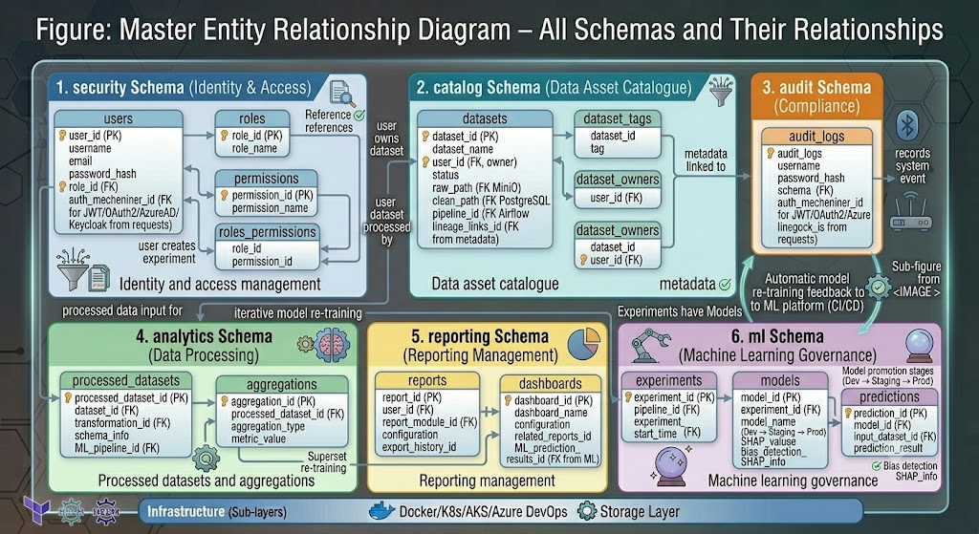
[ Figure / Chart: Master Entity Relationship Diagram – All Schemas and Their Relationships ]
Figure: Master Entity Relationship Diagram – All Schemas and Their Relationships

3. Table Definitions
The following tables are defined in the CHIETA Data Lab database:

security.users
Stores all platform user accounts:
Column | Data Type | Description
user_id | UUID PRIMARY KEY | Unique identifier for each user
username | VARCHAR(100) | Login username
email | VARCHAR(255) | Email address for notifications
password_hash | TEXT | Encrypted password (never stored as plain text)
role_id | UUID | Foreign key linking to the roles table
status | VARCHAR(20) | Active or Disabled
created_at | TIMESTAMP | When the account was created

security.roles
Defines the four user roles: Admin, Analyst, Viewer, Student

catalog.datasets
Column | Data Type | Description
dataset_id | UUID PRIMARY KEY | Unique identifier for each dataset
dataset_name | VARCHAR(255) | Descriptive name of the dataset
owner_id | UUID | Foreign key to the user who uploaded it
classification | VARCHAR(50) | Public, Internal, or Restricted
source_system | VARCHAR(100) | Where the data originated
created_at | TIMESTAMP | Upload timestamp

audit.audit_logs
Column | Data Type | Description
log_id | UUID PRIMARY KEY | Unique audit log entry identifier
user_id | UUID | Who performed the action
event_type | VARCHAR(50) | Type of event (LOGIN, UPLOAD, EXPORT, etc.)
description | TEXT | Human-readable description of the event
timestamp | TIMESTAMP | When the event occurred

ml.experiments and ml.models
Track all ML experiments, their parameters, and the models that result from them. Models progress through stages: Development, Staging, Production, Archived.

ml.predictions
Stores prediction results: which model made the prediction, when it was made, and the predicted value. This supports dashboarding of ML outcomes.

4. Indexing Strategy
Database indexes speed up query performance — they are like the index at the back of a textbook. Instead of reading every page to find a topic, you consult the index and jump directly to the right page.

Table | Index Column | Purpose
security.users | email | Fast user lookup during login
catalog.datasets | dataset_name | Fast dataset search
audit.audit_logs | event_type | Fast filtering of audit events by type
ml.predictions | prediction_date | Fast time-range queries on predictions

5. Data Dictionary
Table | Description
users | All registered platform users and their login credentials
roles | Four user roles defining access levels
permissions | Granular access rights assigned to each role
datasets | Registry of all datasets uploaded to the platform
metadata | Descriptions, tags, and ownership of each dataset
reports | All generated reports and their export history
experiments | All ML experiment runs, parameters, and results
models | Registered ML models and their lifecycle stages
predictions | All prediction results from production models
audit_logs | Complete audit trail of all platform events

6. API Design Principles
Principle | Standard Applied
API Standard | REST (Representational State Transfer)
Data Format | JSON (JavaScript Object Notation)
Documentation | OpenAPI 3.0 (Swagger auto-generated)
Authentication | JWT Bearer Token
Base URL | /api/v1
Versioning | /api/v1, /api/v2 — backward compatible versioning

7. Full API Catalogue

Authentication APIs
Method | Endpoint | Description
POST | /api/v1/login | Authenticate user and return JWT token
POST | /api/v1/logout | Invalidate current session
POST | /api/v1/refresh-token | Issue a new JWT token before expiry

User Management APIs
Method | Endpoint | Description
GET | /api/v1/users | Retrieve list of all users
POST | /api/v1/users | Create a new user account
PUT | /api/v1/users/{id} | Update user details or role
DELETE | /api/v1/users/{id} | Disable or delete a user account
GET | /api/v1/roles | Retrieve available roles

Dataset APIs
Method | Endpoint | Description
POST | /api/v1/datasets/upload | Upload a new dataset file
GET | /api/v1/datasets | List all datasets
GET | /api/v1/datasets/{id} | Retrieve a specific dataset
DELETE | /api/v1/datasets/{id} | Delete a dataset
GET | /api/v1/datasets/search | Search datasets by name, tag, date
GET | /api/v1/datasets/tags | List all available dataset tags

Dashboard APIs
Method | Endpoint | Description
GET | /api/v1/dashboard/learners | Retrieve learner KPI data for dashboard
GET | /api/v1/dashboard/grants | Retrieve grant utilisation data
GET | /api/v1/dashboard/etqa | Retrieve ETQA compliance metrics
GET | /api/v1/dashboard/skills | Retrieve skills demand data

Machine Learning APIs
Method | Endpoint | Description
POST | /api/v1/models/train | Trigger a new model training run
GET | /api/v1/models | List all registered models
POST | /api/v1/predict | Submit data for prediction scoring
GET | /api/v1/experiments | List all ML experiments

8. JSON Schemas

Dataset Upload Request
{ "dataset_name": "learners_2025", "category": "Learners", "tags": ["ETQA", "Skills"] }
Response: { "status": "success", "dataset_id": "UUID" }

Prediction Request
{ "model_name": "dropout_model", "input_data": [...] }
Response: { "prediction": 0.91, "risk": "High" }

9. Error Handling Standard
All error responses follow a consistent JSON structure:
{ "timestamp": "ISO-8601 datetime", "status": 404, "error": "Not Found", "message": "Dataset not found", "path": "/api/v1/datasets/xyz" }

HTTP Status Code | Meaning
200 | Success — request completed successfully
201 | Created — new resource created successfully
400 | Bad Request — client sent invalid data
401 | Unauthorised — authentication required
403 | Forbidden — user lacks permission for this action
404 | Not Found — requested resource does not exist
500 | Internal Server Error — unexpected system error

10. Pagination and Filtering Standards

Pagination
All list endpoints support pagination to avoid returning thousands of records at once:
Request: GET /datasets?page=1&size=20
Response: { "page": 1, "size": 20, "total_records": 1000, "data": [...] }

Filtering
All list endpoints support URL-based filtering:
- GET /datasets?category=ETQA — filter by category
- GET /datasets?tag=skills — filter by tag
- GET /datasets?created_after=2025-01-01 — filter by date

11. Data Lineage Specification
Every dataset follows this lineage path, fully tracked by OpenMetadata:
- CSV file uploaded by user
- File stored in MinIO raw-data bucket
- Apache Airflow triggers the cleaning pipeline
- Apache Spark transforms and validates the data
- Clean data loaded into PostgreSQL
- OpenMetadata registers the asset and records the full lineage
- Apache Superset reads from PostgreSQL for dashboarding
- Dashboard displayed to end user
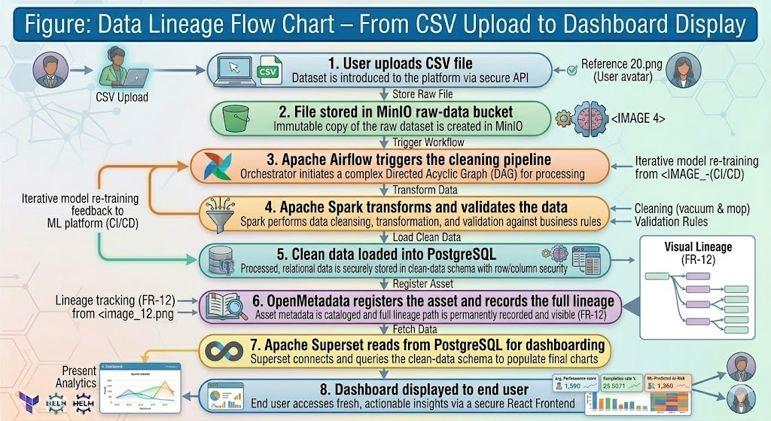
[ Figure / Chart: Data Lineage Flow Chart – From CSV Upload to Dashboard Display ]
Figure: Data Lineage Flow Chart – From CSV Upload to Dashboard Display

12. Audit Specification
All of the following events are captured in the audit log:
- Login events — who logged in, from which IP, at what time
- Logout events — session duration
- Dataset upload events — who uploaded what, when
- Report export events — who exported which report
- Metadata updates — who changed dataset descriptions
- Model execution events — which model was run, on which data

Audit logs are retained for 7 years and protected from deletion by all users except the system administrator.

13. Naming and Versioning Standards
Item | Standard | Example
Database Tables | snake_case | audit_logs, dataset_tags
Database Columns | snake_case | created_at, owner_id
Python Code | PEP8 | def get_dataset_by_id():
React/JavaScript | camelCase | datasetUploadHandler
API Versioning | /api/v1, /api/v2 | Backward compatible increments
Container Versions | Semantic versioning (1.0.0) | 1.0.0, 1.1.0, 2.0.0
VOLUME V
DevSecOps, Infrastructure & Deployment Engineering Handbook
The Operational Blueprint for Cloud, Containers, and CI/CD

Volume V: DevSecOps, Infrastructure & Deployment Handbook
This handbook is the primary reference for the Principal System Engineer, DevOps Engineer, Cloud Engineer, and Operations Team. It covers every aspect of deploying and maintaining the CHIETA Data Lab in production.

1. DevSecOps Architecture
DevSecOps integrates Development, Security, and Operations into a single, automated pipeline. Instead of treating security as a final gate before release, it is embedded at every step.

The DevSecOps pipeline flows as follows:
- Developer writes code and commits to a Git repository
- Azure DevOps automatically detects the commit and triggers the pipeline
- Code quality and security scans run (SonarQube, OWASP, Trivy)
- Automated tests execute (unit, integration, API)
- A Docker container image is built and scanned
- The image is pushed to Azure Container Registry
- The image is deployed to the AKS cluster
- Monitoring confirms deployment health
- Release promoted to production
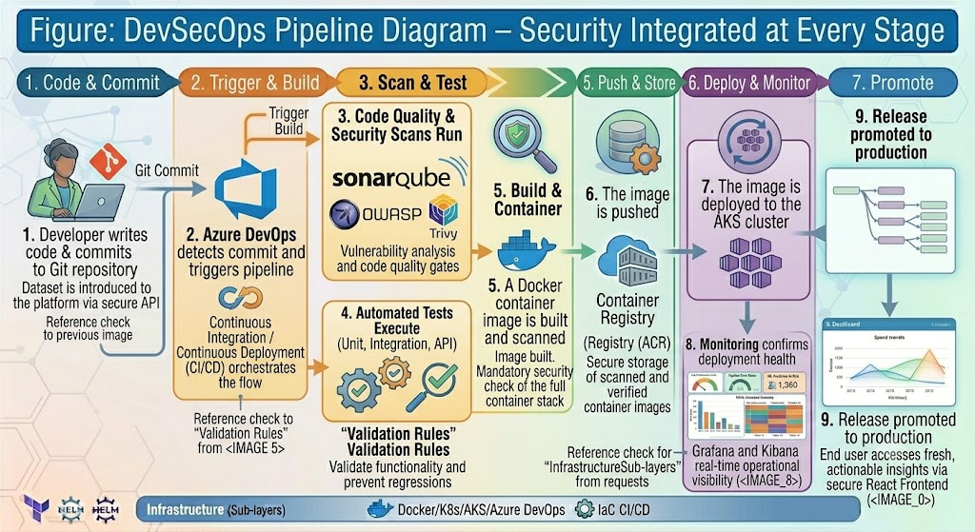
[ Figure / Chart: DevSecOps Pipeline Diagram – Security Integrated at Every Stage ]
Figure: DevSecOps Pipeline Diagram – Security Integrated at Every Stage

2. Docker Architecture
Docker is the containerisation technology used to package each microservice. A Docker container bundles the application code, runtime, libraries, and configuration into a single, portable unit that runs identically on any machine.

Analogy: A Docker container is like a shipping container. The same container can be loaded onto a ship, a truck, or a train and its contents remain identical. Similarly, a Docker container runs identically on a developer's laptop, a test server, or the Azure cloud.

The following containers are deployed in the CHIETA Data Lab:
Container | Technology | Port
frontend | React | 3000
backend | FastAPI | 8000
airflow | Apache Airflow 2.10 | 8080
spark | Apache Spark | 7077
superset | Apache Superset | 8088
mlflow | MLflow | 5000
openmetadata | OpenMetadata | 8585
postgres | PostgreSQL 15 | 5432
minio | MinIO | 9000
prometheus | Prometheus | 9090
grafana | Grafana | 3000
elasticsearch | ElasticSearch | 9200
kibana | Kibana | 5601

3. Dockerfiles

React Frontend Dockerfile
FROM node:22 → sets the base image; WORKDIR /app → sets working directory; COPY . . → copies source code; RUN npm install → installs dependencies; RUN npm run build → compiles production build; EXPOSE 3000 → opens port; CMD npm start → starts the server

FastAPI Backend Dockerfile
FROM python:3.12 → Python 3.12 base; WORKDIR /app; COPY . .; RUN pip install -r requirements.txt → installs Python packages; EXPOSE 8000; CMD uvicorn main:app → starts the FastAPI server

4. Docker Compose — Development Environment
Docker Compose orchestrates all containers together for local development. A single command (`docker-compose up`) starts the entire platform stack on a developer's machine, including frontend, backend, PostgreSQL, MinIO, Airflow, Superset, MLflow, and OpenMetadata.
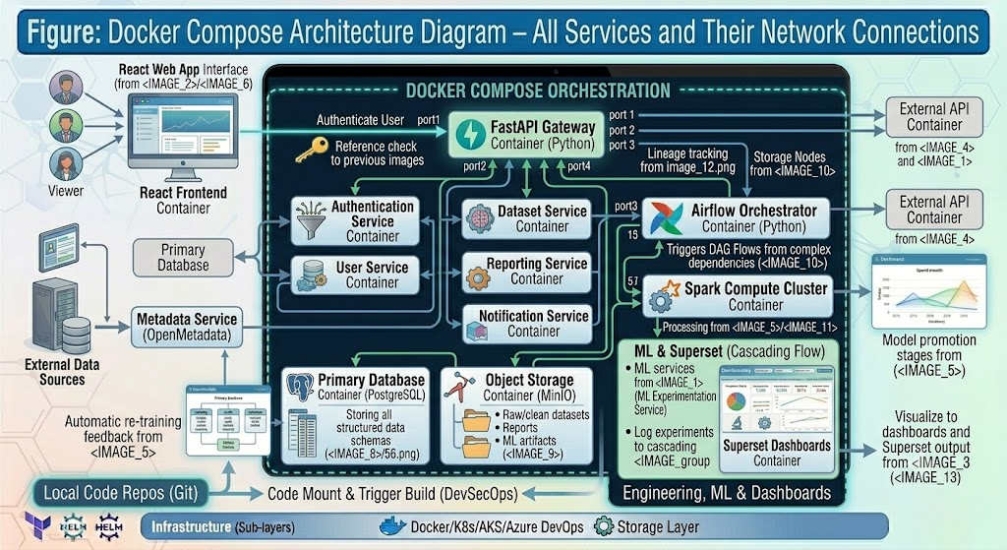
[ Figure / Chart: Docker Compose Architecture Diagram – All Services and Their Network Connections ]
Figure: Docker Compose Architecture Diagram – All Services and Their Network Connections

5. Azure Kubernetes Service (AKS) Design
In production, the platform is deployed on AKS — Microsoft Azure's managed Kubernetes service. Kubernetes is an orchestration platform that manages containers at scale, handling deployment, scaling, and self-healing automatically.

AKS Cluster: AKS-CHIETA-DATALAB
The cluster uses four dedicated node pools for different workloads:
Node Pool | Purpose | Sizing
systempool | Kubernetes system components | Standard, always on
apppool | Frontend and backend services | Auto-scalable
sparkpool | Apache Spark data processing jobs | Large memory nodes
mlpool | ML training workloads | GPU-enabled nodes

Kubernetes Namespaces
Services are isolated into logical namespaces to prevent interference between components:
- frontend — React web application
- backend — FastAPI gateway and services
- airflow — Data pipeline orchestration
- spark — Data processing engine
- mlflow — ML experiment tracking
- superset — Dashboarding platform
- metadata — OpenMetadata catalogue
- monitoring — Prometheus, Grafana, ELK Stack
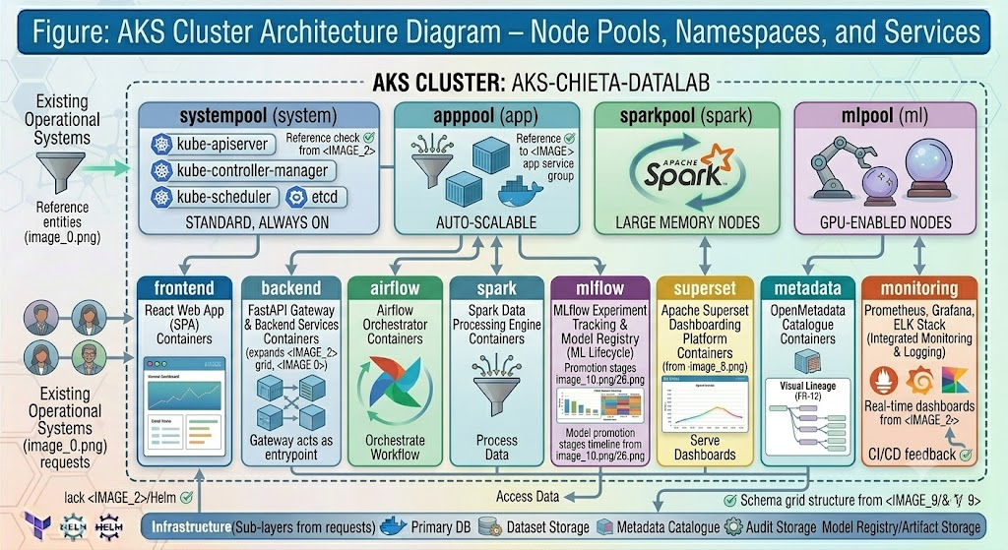
[ Figure / Chart: AKS Cluster Architecture Diagram – Node Pools, Namespaces, and Services ]
Figure: AKS Cluster Architecture Diagram – Node Pools, Namespaces, and Services

6. Kubernetes Manifests
Kubernetes resources are defined in YAML manifest files. The key resource types used are:
Resource Type | Purpose
Deployment | Defines how many replicas of each service to run
Service | Exposes a deployment to other services or external traffic
Ingress | Routes external HTTP/HTTPS traffic to internal services
ConfigMap | Stores non-sensitive configuration (environment variables)
Secret | Stores sensitive configuration (passwords, tokens)
HorizontalPodAutoscaler | Automatically scales replicas based on CPU/memory load

7. Helm Charts
Helm is the package manager for Kubernetes — like npm for Node.js or pip for Python. Each microservice has a Helm chart that packages its Kubernetes manifests into a deployable unit.

Helm charts defined: frontend-chart, backend-chart, airflow-chart, spark-chart, mlflow-chart, superset-chart, metadata-chart, monitoring-chart

8. Terraform Infrastructure as Code
Terraform defines all Azure infrastructure as code — every resource group, virtual network, AKS cluster, PostgreSQL server, Key Vault, and monitoring workspace is described in Terraform files.

This ensures infrastructure is version-controlled, reproducible, and auditable. Destroying and recreating the entire infrastructure from scratch takes minutes, not weeks.

Terraform Modules
- resource_group — Azure Resource Group
- network — Virtual Network, Subnets, Private Endpoints
- aks — AKS Cluster configuration
- postgres — Azure Database for PostgreSQL
- keyvault — Azure Key Vault for secrets
- monitoring — Prometheus, Grafana workspace
- storage — MinIO storage configuration
- acr — Azure Container Registry

Environment Structure
Four environments are managed: dev (development), test (integration testing), uat (user acceptance testing), prod (production). Each environment has its own Terraform state stored in Azure Storage.
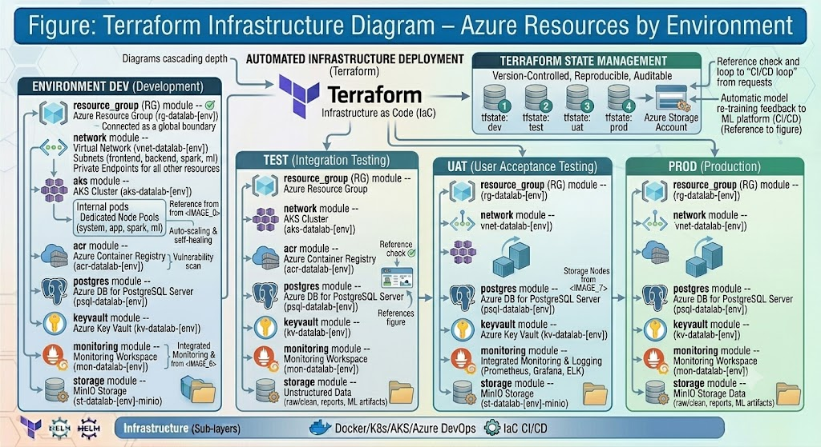
[ Figure / Chart: Terraform Infrastructure Diagram – Azure Resources by Environment ]
Figure: Terraform Infrastructure Diagram – Azure Resources by Environment

9. Azure DevOps Pipelines

Frontend Pipeline
- Build the React application
- Run unit tests (Jest)
- Build Docker image
- Push to Azure Container Registry
- Deploy to AKS frontend namespace

Backend Pipeline
- Run linting (Pylint)
- Run unit tests (Pytest)
- Build Docker image
- Push to Azure Container Registry
- Deploy to AKS backend namespace

Airflow Pipeline
- Validate DAG syntax
- Run DAG tests
- Build container
- Deploy to AKS airflow namespace

ML Pipeline
- Train model on latest data
- Evaluate model metrics (accuracy, F1, AUC)
- Register model if it meets threshold
- Deploy prediction API

10. Git Strategy: GitFlow

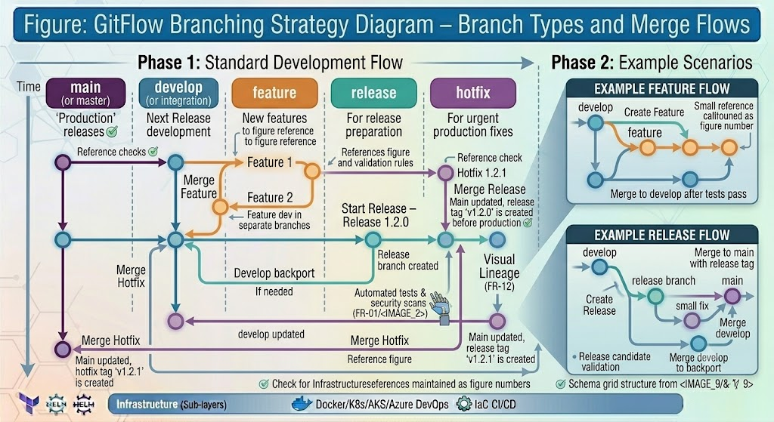

[ Figure / Chart: GitFlow Branching Strategy Diagram – Branch Types and Merge Flows ]
Figure: GitFlow Branching Strategy Diagram – Branch Types and Merge Flows

Branch Type | Naming Convention | Purpose
Main | main | Production-ready code — never commit directly
Develop | develop | Integration branch — merges from all features
Feature | feature/login | Individual features in development
Release | release/v1.0 | Release candidates undergoing final testing
Hotfix | hotfix/security | Emergency fixes applied directly to production

11. Secrets Management with Azure Key Vault
Azure Key Vault is a cloud-hosted secure vault for storing sensitive configuration:
- Database passwords — PostgreSQL connection credentials
- JWT secrets — signing keys for authentication tokens
- OAuth credentials — Azure AD client secrets
- TLS certificates — SSL certificates for HTTPS
- API keys — keys for third-party integrations

Critical Rule: No secrets are ever stored inside source code, Docker images, or Kubernetes manifests. All secrets are retrieved from Azure Key Vault at runtime. This is the industry gold standard for secrets management.

12. Production Deployment Strategy
The platform supports three deployment strategies:
Strategy | How It Works | When Used
Blue-Green | Two identical environments; switch traffic between them instantly | Major releases with risk
Canary | Route a small percentage of traffic to the new version first | Gradual feature rollouts
Rolling | Replace old instances one at a time with zero downtime | Regular deployments

13. Release Management
Releases follow a fortnightly (every 2 weeks) cadence, aligned with sprint completion. Semantic versioning is used:
- 1.0.0 — major initial release
- 1.1.0 — minor feature additions (backward compatible)
- 1.1.1 — patch releases (bug fixes)
- 2.0.0 — major version with breaking changes

14. Performance Engineering
Performance targets are enforced through the following techniques:
Target | Technique
Dashboard response ≤ 3 seconds | Redis caching for frequently accessed data
500,000+ record support | PostgreSQL indexing and Spark distributed processing
API response < 500ms | Async FastAPI endpoints with connection pooling
High throughput | Kubernetes horizontal scaling under load
Large dataset querying | Data partitioning by date and category
VOLUME VI
Testing, Quality Assurance & Validation Handbook
Ensuring Every Component Meets the Highest Standards

Volume VI: Testing, Quality Assurance & Validation Handbook
This handbook defines the complete quality assurance and validation framework for the CHIETA Data Lab, supporting Deliverable D7.

1. Test Strategy
The QA strategy is built on four principles:
- Shift Left Testing — testing starts early in development, not at the end
- Continuous Testing — every code commit triggers automated tests
- Risk-Based Testing — highest effort applied to highest-risk components
- Test Automation — the majority of tests run automatically, without human intervention

The Testing Pyramid
The testing pyramid defines how test effort is distributed across three levels:
- Unit Tests (base — most tests) — test individual functions in isolation; fast and cheap
- Integration Tests (middle) — test multiple components working together; moderate speed
- UI Tests (top — fewest) — test through the browser like a real user; slow but comprehensive

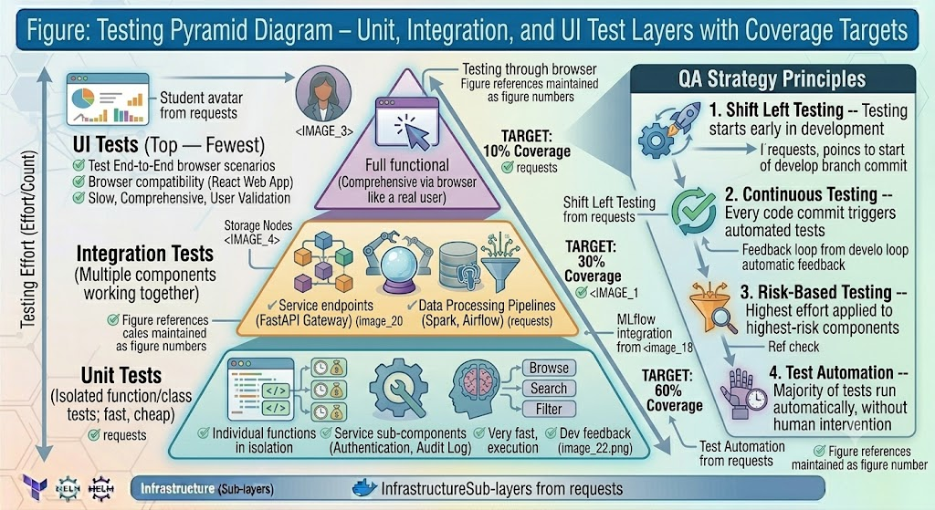
[ Figure / Chart: Testing Pyramid Diagram – Unit, Integration, and UI Test Layers with Coverage Targets ]
Figure: Testing Pyramid Diagram – Unit, Integration, and UI Test Layers with Coverage Targets

2. Quality Framework
Quality Area | Standard Applied
Software Quality | ISO 25010 — international software quality standard
Security | OWASP Top 10 — ten most critical web security vulnerabilities
Accessibility | WCAG 2.1 AA — web accessibility guidelines
API Standards | OpenAPI 3.0 — documented, testable API contracts
Code Quality | PEP8 (Python), ESLint (JavaScript)
DevOps | GitFlow — structured branching and release strategy
Database | PostgreSQL best practices — indexing, normalisation, backups
AI/ML | Responsible AI principles — explainability, fairness, accountability

3. Unit Testing
Layer | Framework | Coverage Target
Frontend (React) | Jest + React Testing Library | ≥ 80%
Backend (FastAPI) | Pytest | ≥ 85%
Data Engineering | Pytest + Great Expectations | ≥ 80%
Machine Learning | Pytest | ≥ 80%

4. Integration Testing
Integration tests verify that components work correctly together. Key integration test pairs:
- React Frontend ↔ FastAPI Gateway — verify all API calls from UI work correctly
- FastAPI ↔ PostgreSQL — verify all database operations succeed
- FastAPI ↔ MinIO — verify file uploads and downloads
- Airflow ↔ Spark — verify pipeline execution end-to-end
- Spark ↔ MLflow — verify experiment logging
- OpenMetadata ↔ PostgreSQL — verify metadata registration
- Superset ↔ PostgreSQL — verify dashboard data retrieval

5. API Testing
Every API endpoint is tested against five categories of tests:
Test Category | Description | Tool
Positive Tests | Verify endpoints work correctly with valid inputs | Postman
Negative Tests | Verify endpoints reject invalid inputs gracefully | Postman
Boundary Tests | Test edge cases (empty strings, maximum lengths) | Postman
Authentication Tests | Verify JWT validation on protected endpoints | Newman
Authorisation Tests | Verify RBAC — lower-privilege roles cannot access restricted APIs | Newman

6. UI Testing with Cypress
Cypress is used for end-to-end browser testing. Test scenarios include:
- Upload a dataset — simulate a real user uploading a CSV file
- Create a user — verify Administrator can add new accounts
- Export a report — verify PDF and Excel export works
- Navigate dashboards — verify all dashboards load within 3 seconds
- Browse metadata catalogue — verify OpenMetadata integration

7. Data Quality Testing with Great Expectations
Great Expectations is a Python library that validates datasets against documented expectations before they are loaded into the production database.

Validation Rule | What It Checks
Missing Values | No column should have more than 5% null values
Duplicate Records | No two rows should be identical across all key columns
Outliers | Numeric values should fall within expected statistical ranges
Data Types | Each column should contain only its expected data type
Referential Integrity | Foreign keys should reference existing parent records

8. Machine Learning Validation

Model Performance Metrics
Metric | Description | Minimum Threshold
Accuracy | Percentage of correct predictions | > 80%
Precision | Correctness of positive predictions | > 75%
Recall | Ability to detect all true positives | > 75%
F1 Score | Harmonic mean of precision and recall | > 77%
ROC-AUC | Overall discriminative ability of the model | ≥ 0.80

Explainability and Fairness
- SHAP values computed for every production model prediction
- Bias testing using Equal Opportunity and Demographic Parity metrics
- Models must pass bias checks before promotion to production

9. Performance Testing with JMeter
Apache JMeter simulates multiple concurrent users to test platform performance under load:
Test Parameter | Target
Concurrent Users | 100 simultaneous users
Dashboard Response | ≤ 3 seconds at full load
API Response | ≤ 500 milliseconds
Dataset Size | 500,000 records processed without degradation
Metrics Captured | Response time, throughput (requests/second), CPU, memory

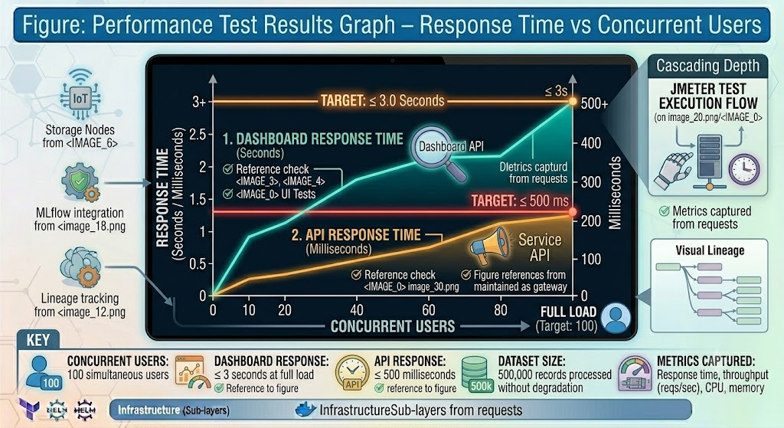
[ Figure / Chart: Performance Test Results Graph – Response Time vs Concurrent Users ]
Figure: Performance Test Results Graph – Response Time vs Concurrent Users

10. Security Testing
Test Area | Tool | Frequency
OWASP Top 10 Vulnerabilities | OWASP ZAP | Every sprint
Container Vulnerabilities | Trivy | Every build
Dependency Vulnerabilities | Snyk | Every build
Static Code Analysis | SonarQube | Every commit
Penetration Testing | External security firm | Quarterly
SQL Injection | OWASP ZAP | Every sprint
XSS (Cross-Site Scripting) | OWASP ZAP | Every sprint

11. Accessibility Testing (WCAG 2.1 AA)
The platform must be accessible to users with disabilities, conforming to Web Content Accessibility Guidelines 2.1 Level AA:
- Keyboard Navigation — all functions accessible without a mouse
- Colour Contrast — all text meets minimum contrast ratios
- Screen Reader Support — all UI elements readable by screen readers
- Alt Text — all images have descriptive alternative text

12. User Acceptance Testing (UAT)
UAT is conducted by CHIETA stakeholders — the real end users of the platform. Their approval is required before production release.

UAT Participant | Scenarios Tested
Administrators | User management, role assignment, system configuration
Analysts | Dataset upload, dashboard creation, ML experiment execution
Management | Executive dashboard, report export, data export
Students | Data cleaning contributions, documentation tasks

Acceptance Criteria: 95% of UAT test cases must pass before production sign-off.

13. Defect Management
Severity | Meaning | Target Resolution
Critical (P1) | System unavailable — no user can log in or use the platform | Same day
High (P2) | Major functionality broken — uploads, dashboards, or ML not working | Within 24 hours
Medium (P3) | Partial failure — a feature works but with limitations | Within 3 days
Low (P4) | Cosmetic issue — visual glitch with no functional impact | Next sprint

14. Requirements Traceability Matrix (RTM)
The RTM links every requirement in the SRS to one or more test cases, ensuring complete test coverage:
Requirement | Description | Test Case
FR-1 | User Login | TC-001: Login with valid credentials
FR-5 | Dataset Upload | TC-010: Upload CSV file successfully
FR-20 | Dashboard Creation | TC-035: Create and view dashboard
FR-24 | Experiment Tracking | TC-050: Log and retrieve ML experiment
FR-32 | Report Export | TC-080: Export report as PDF

15. Test Automation Pipeline
All tests run automatically in the CI/CD pipeline on every code commit:
- Commit pushed to Git repository
- Unit tests run (Pytest, Jest)
- Integration tests run (Pytest, Postman/Newman)
- Security scans run (Trivy, SonarQube)
- Performance tests run (JMeter — on test environment only)
- All results published to Azure DevOps Test Plans
- If any test fails, deployment is blocked automatically

16. Key QA Metrics and KPIs
Metric | Target
Code Coverage | ≥ 80% across all repositories
Defect Leakage Rate | < 5% (defects reaching production)
Platform Availability | 99.9% uptime
Dashboard Response | ≤ 3 seconds
Critical Defects in Production | 0

17. Sign-Off Procedure
Production release requires sign-off from all of the following:
- Solution Architect — confirms architecture compliance
- Principal System Engineer — confirms integration and performance
- QA Lead — confirms all test cases passed
- Project Manager — confirms schedule and scope
- CHIETA Representative — confirms business requirements met

Sign-off triggers: D7 Validation Report → UAT Approval → Production Readiness Review → Final Release
VOLUME VII
Operations, Maintenance, Training & Handover Handbook
Sustaining the CHIETA Data Lab After Go-Live

Volume VII: Operations, Maintenance, Training & Handover Handbook
This handbook provides the complete operational framework for the post-implementation phase. It supports Deliverables D8 (Training and User Guides) and D9 (Source Code and Documentation).

1. Operations Framework (ITIL v4)
The platform operates according to ITIL v4 principles — the global best practice framework for IT service management. ITIL ensures that the platform is managed as a reliable, professional service rather than an ad hoc system.

Operational Domain | Responsible Team
Application Operations (Frontend + Backend) | Platform Support Team
Data Operations (Pipelines) | Data Operations Team
Infrastructure Operations (AKS + Docker) | Infrastructure Team
Database Operations (PostgreSQL + MinIO) | Database Team
Metadata Operations (OpenMetadata) | Metadata Team
ML Operations (MLflow) | ML Team
BI Operations (Superset) | BI Team
Security Operations (IAM + Audits) | Security Team

2. System Administration Guide

User Administration
The CHIETA System Administrator can perform the following actions through the Administration Module:
- Create new user accounts — assign username, email, and initial password
- Assign roles — Admin, Analyst, Viewer, or Student
- Reset passwords — for users who have forgotten their credentials
- Disable accounts — for users who have left the organisation
- View active sessions — see who is currently logged in
- Force logout — disconnect specific users remotely
- Lock accounts — temporarily prevent login after suspicious activity

3. Platform Operations Manual
Each service has a designated owner responsible for its operational health:
Repository / Service | Owner
frontend-react (React) | Frontend Lead
backend-fastapi (FastAPI) | Backend Lead
airflow-etl (Airflow Pipelines) | Data Engineering Lead
spark-processing (Spark Jobs) | Data Engineering Lead
ml-platform (MLflow) | ML Lead
superset-dashboards (Superset) | BI Lead
metadata-platform (OpenMetadata) | Metadata Lead

4. Backup Procedures
Component | Backup Frequency | Retention Period | Recovery Method
PostgreSQL | Daily | 30 days | Point-in-Time Recovery via Azure Database
MinIO | Daily | 30 days | Bucket replication + versioning
Git Repositories | Continuous | Unlimited | Git clone from Azure DevOps
Terraform State | Every change | Unlimited | Azure Storage Account versioning

5. Monitoring Procedures
The operations team uses Prometheus and Grafana for real-time monitoring. Daily checks include:
- Review platform health dashboard in Grafana
- Check for any Prometheus alerts
- Verify Airflow pipelines completed successfully
- Review API response time metrics
- Check disk usage on MinIO and PostgreSQL
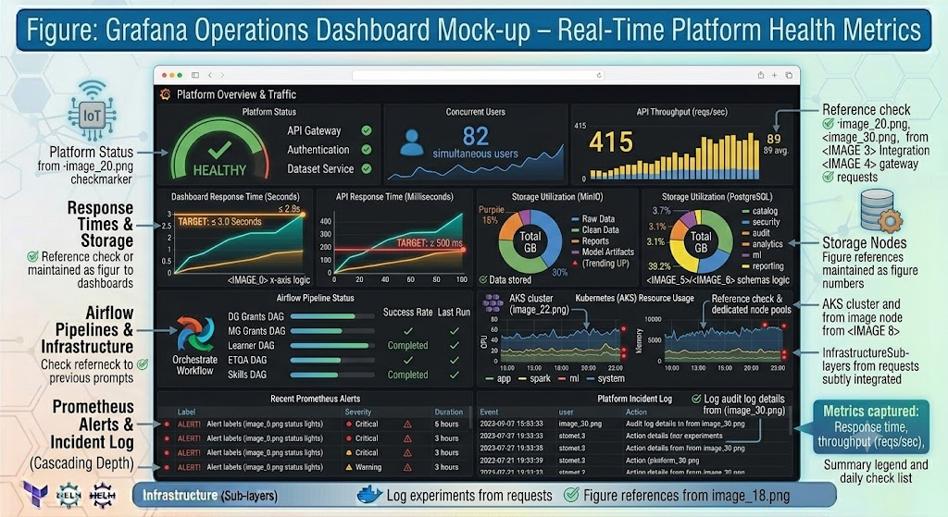
[ Figure / Chart: Grafana Operations Dashboard Mock-up – Real-Time Platform Health Metrics ]
Figure: Grafana Operations Dashboard Mock-up – Real-Time Platform Health Metrics

6. Incident Management
All incidents follow a structured workflow from detection to closure:
- Detection — Prometheus alert fires or user reports an issue
- Logging — incident logged in Azure DevOps with severity level
- Assignment — assigned to appropriate team based on component
- Resolution — team investigates and resolves the issue
- Closure — user confirms resolution, incident closed
- Postmortem — root cause analysed; improvements identified

Severity Levels and Response Times
Severity | Definition | Response Target
P1 Critical | Complete system outage — no users can access the platform | 30 minutes
P2 High | Major feature failure — uploads, dashboards, or ML not working | 2 hours
P3 Medium | Minor service degradation — feature works with limitations | 8 hours
P4 Low | Cosmetic or minor issue with no functional impact | 24 hours

7. Problem Management
Problem Management goes beyond fixing incidents — it investigates the underlying root causes to prevent recurrence. Root cause analysis methods used:
- 5 Whys — repeatedly asking 'why?' to drill down to the fundamental cause
- Fishbone Diagram — a structured visual method for identifying all possible causes

A Problem Register is maintained in Azure DevOps, tracking all known problems and their resolution status.

8. Change Management
All changes to the production platform follow a formal Change Management process:
Change Type | Definition | Approval Required
Standard Change | Pre-approved routine change with known low risk | No additional approval
Normal Change | Planned change requiring impact assessment | Change Advisory Board
Emergency Change | Urgent change to restore service or security | Project Manager + PSE

Change Advisory Board members: Project Manager, Principal System Engineer, DevOps Lead, CHIETA Representative

9. User Manual

Analyst Functions
- Log in with your username and password
- Navigate to Datasets → Upload a CSV or Excel file
- Wait for the system to validate and process your upload
- Open the Dataset Explorer to browse and filter your data
- Navigate to Dashboards to view existing visualisations
- Create a new dashboard using the drag-and-drop builder
- Export your dashboard as PDF or Excel
- Navigate to Experiments to launch or view ML models

Viewer Functions
- Log in and navigate directly to Dashboards
- Select the dashboard relevant to your area (Learner, Grants, ETQA, Skills, Executive)
- Apply filters to customise the view
- Download reports as PDF or Excel

Student Contributor Functions
- Log in to the Student workspace
- View assigned data cleaning tasks
- Apply cleaning rules to datasets
- Document findings in the student contribution log
- Submit completed work for QA review

10. Video Training Framework
A comprehensive video training library is produced to support all user types:
Video Title | Duration | Audience
Introduction to the CHIETA Data Lab | 15 minutes | All users
Dataset Upload and Management | 10 minutes | Analysts
Creating Dashboards in Superset | 20 minutes | Analysts
Airflow Pipeline Operations | 30 minutes | Data Engineers
MLflow Experiment Tracking | 30 minutes | ML Engineers
OpenMetadata Catalogue Management | 20 minutes | Metadata Team
Backup and Recovery Procedures | 15 minutes | Administrators
Disaster Recovery Operations | 20 minutes | Infrastructure Team

11. Train-the-Trainer Programme
A structured six-week programme prepares internal CHIETA staff to train future users independently:
Week | Topic
Week 1 | Platform Overview — architecture, user roles, core features
Week 2 | Data Management — uploading, cleaning, versioning, metadata
Week 3 | Dashboards — building, customising, exporting visualisations
Week 4 | Machine Learning — running experiments, interpreting results
Week 5 | Platform Administration — user management, system configuration
Week 6 | Operations — monitoring, backups, incident response

Successful completion results in an internal CHIETA Data Lab Trainer Certificate.

12. Student Mentorship Framework

Student Roles
- Data Assistant — assists with data cleaning and validation
- QA Assistant — supports testing and defect logging
- Documentation Contributor — writes user guides and technical notes
- UI Reviewer — performs accessibility and usability testing

Mentorship Activities
- Pair Programming — students work alongside experienced developers
- Code Reviews — students participate in reviewing pull requests
- Sprint Demonstrations — students present their contributions to the team
- Weekly Workshops — skill development sessions on data science and engineering

Contributions are tracked in the students/ directory of each repository. Recognition is provided through digital badges, certificates, and capstone project credits.

13. Knowledge Transfer Plan
Phase | Activity
Phase 1 | Developer Training — handover of all technical documentation to CHIETA developers
Phase 2 | Administrator Training — admin guide, user management procedures
Phase 3 | Analyst Training — dashboard creation, data exploration, ML usage
Phase 4 | Operations Training — monitoring, incident response, backup procedures
Phase 5 | Independent Operation — CHIETA team operates the platform without vendor support

14. Support Model
A four-tier support escalation model ensures that issues are resolved at the most efficient level:
- Level 1 — Help Desk: password resets, basic navigation questions
- Level 2 — Application Support: feature questions, data issues, report problems
- Level 3 — Engineering Team: technical bugs, performance issues, integration problems
- Level 4 — Principal System Engineer: architecture-level issues, security incidents

15. SLA Framework
SLA Metric | Target
Platform Availability | 99.9% uptime
Dashboard Response Time | ≤ 3 seconds
Critical Incident (P1) Response | 30 minutes
High Incident (P2) Response | 2 hours
Medium Incident (P3) Response | 8 hours
Low Incident (P4) Response | 24 hours

16. Maintenance Schedule
Frequency | Activities
Daily | Monitor pipelines, check logs, review Prometheus alerts
Weekly | Validate backups, optimise database queries, review security patches
Monthly | Security scanning, capacity analysis, performance review
Quarterly | Disaster recovery drill, penetration testing, architecture review

17. Post-Implementation Support Phases
Phase | Duration | Activities
Phase 1: Hypercare | 30 days | Intensive support — daily check-ins, immediate response to all issues
Phase 2: Stabilisation | 90 days | Reduced support — focus on tuning, optimisation, and knowledge transfer
Phase 3: Operational Handover | 6 months | CHIETA team takes full ownership; vendor on retainer for escalations

18. Handover Deliverables
At programme completion, the following deliverables are formally transferred to CHIETA:
- Source Code — all repositories in Azure DevOps transferred to CHIETA ownership
- Docker Images — all container images in Azure Container Registry
- Helm Charts — all Kubernetes deployment packages
- Terraform Modules — all infrastructure-as-code
- Documentation — this eight-volume handbook
- Video Tutorials — full video training library
- Runbooks — step-by-step operational procedures
- Architecture Documents — all diagrams and design documents
VOLUME VIII
Project Governance, PMBOK & Agile Delivery Handbook
The Master Programme Governance Blueprint

Volume VIII: Project Governance, PMBOK & Agile Delivery Handbook
This document serves as the Master Programme Governance Handbook for the entire 18-month CHIETA Data Lab programme. It combines PMBOK 7, Agile Scrum, SAFe (Scaled Agile Framework), and DevSecOps into a unified governance model.

1. Project Charter
Charter Item | Detail
Project Name | CHIETA Data Lab
Programme Duration | 18 Months
Sponsor | CHIETA (Chemical Industries Education and Training Authority)
Product Owner | CHIETA representative
Delivery Team | Software Provider (Principal System Engineer + development teams)
Strategic Alignment | CHIETA Fusion 2030 Strategic Plan
Main Objective | Establish a secure, browser-based Data Lab for data ingestion, analytics, dashboarding, ML, metadata management, and prototype development

Success Criteria
- All nine deliverables (D1–D9) successfully completed and accepted
- Platform availability ≥ 99% in production
- Dashboard response time ≤ 3 seconds
- At least one fully operational prototype demonstrated to CHIETA
- Complete source code transferred to CHIETA ownership
- Training programme completed with internal certification
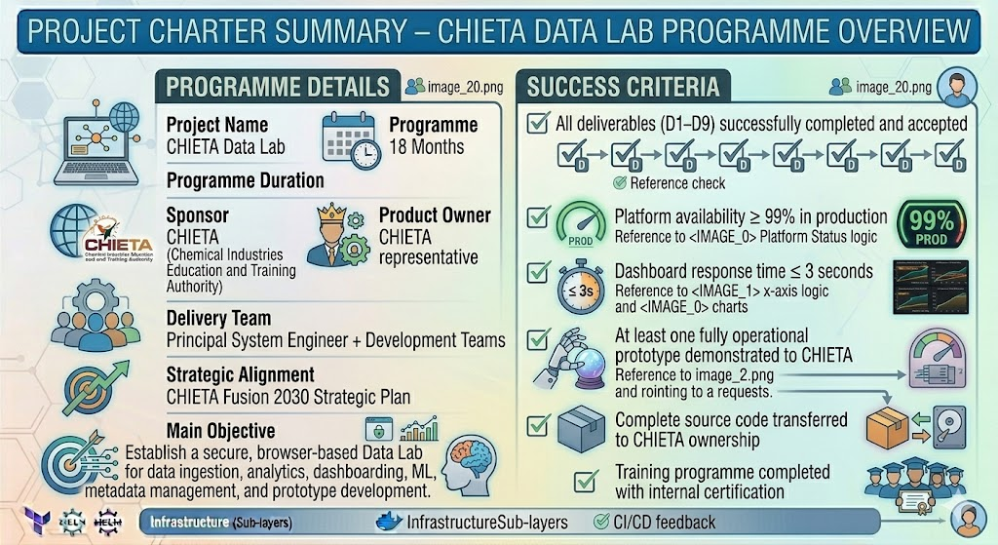
[ Figure / Chart: Project Charter Summary – One-Page Programme Overview ]
Figure: Project Charter Summary – One-Page Programme Overview

2. Governance Structure
The programme governance structure follows a tiered model from strategic oversight to implementation:
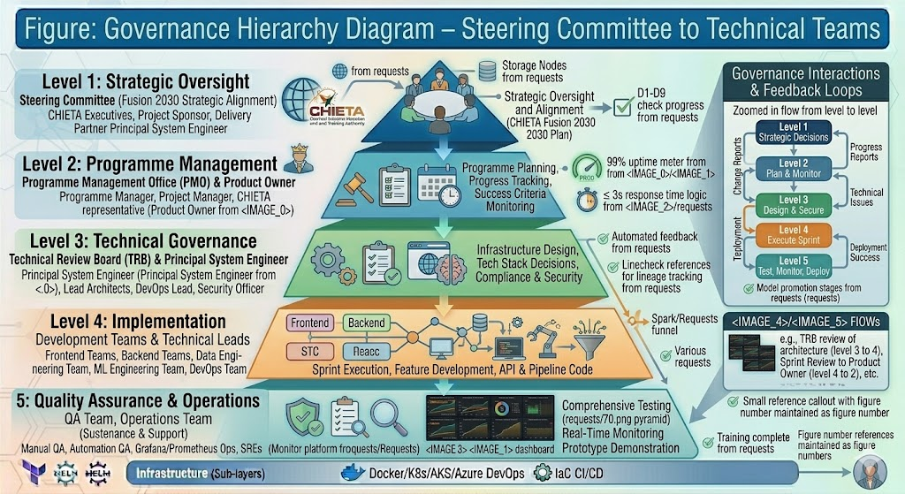
[ Figure / Chart: Governance Hierarchy Diagram – Steering Committee to Technical Teams ]
Figure: Governance Hierarchy Diagram – Steering Committee to Technical Teams

Governance Level | Body / Role | Responsibility
Strategic | Steering Committee | Programme oversight, budget approval, strategic decisions
Programme | Programme Manager | Cross-stream coordination, risk escalation, reporting to Steering Committee
Project | Project Manager | Day-to-day delivery management, sprint planning, stakeholder communication
Product | Product Owner | Requirements prioritisation, backlog management, UAT sign-off
Architecture | Solution Architect | Technical design decisions, architecture governance
Integration | Principal System Engineer | Full-stack integration, CI/CD, production readiness
Delivery | Technical Leads (8 teams) | Sprint execution across Frontend, Backend, Data Eng, ML, BI, Metadata, DevOps, QA

3. Stakeholder Register
Stakeholder | Role | Engagement Level
CHIETA Executives | Sponsors — fund and champion the programme | Steering Committee
Project Manager | Manages delivery schedule, risks, and budget | Daily
Solution Architect | Owns the technical design | Weekly
Principal System Engineer | Integrates all systems and manages production | Daily
Frontend Developers (2) | Build the React user interface | Daily
Backend Developers (2) | Build the FastAPI services and APIs | Daily
Data Engineers (2) | Build Airflow and Spark pipelines | Daily
Data Scientists (2) | Build and train ML models | Daily
BI Developer (1) | Build Superset dashboards | Daily
Metadata Engineer (1) | Configure and manage OpenMetadata | Daily
DevOps Engineer (1) | Manage CI/CD, AKS, and infrastructure | Daily
DBA (1) | Manage PostgreSQL and MinIO | Daily
QA Engineers (2) | Test all platform components | Daily
Technical Writer (1) | Produce user guides and documentation | Weekly
Student Contributors (6–10) | Data cleaning, documentation, QA support | Per sprint

4. Work Breakdown Structure (WBS)
The WBS decomposes the entire programme into manageable work packages. With an estimated 600–700 user stories and 4,000–5,000 tasks, the WBS covers all programme activity from inception to handover.

Major Work Packages (Level 1)
WP No. | Work Package | Description
WP-01 | Project Management | Governance, planning, reporting, change control, stakeholder management
WP-02 | Architecture | Solution design, architecture documents, technical standards
WP-03 | Infrastructure | AKS, Docker, Terraform, Azure resource provisioning
WP-04 | Security | IAM, RBAC, encryption, Key Vault, penetration testing
WP-05 | Backend Development | FastAPI services, APIs, business logic, database integration
WP-06 | Frontend Development | React UI, components, pages, state management
WP-07 | Data Engineering | Airflow DAGs, Spark jobs, ETL pipelines for five CHIETA datasets
WP-08 | Storage Layer | PostgreSQL schema design, MinIO bucket configuration
WP-09 | Metadata Management | OpenMetadata catalogue, data lineage, business glossary
WP-10 | Machine Learning | Feature engineering, model training, MLflow tracking, model serving
WP-11 | Dashboards | Five Superset dashboards, chart configuration, export functions
WP-12 | Testing and QA | Unit, integration, API, UI, performance, security, UAT
WP-13 | Documentation | SRS, SADD, DDD, DAES, DevSecOps, QA, Operations, Governance handbooks
WP-14 | Prototype | At least one fully operational data science prototype
WP-15 | Integration | End-to-end integration of all platform components
WP-16 | Training | Video library, train-the-trainer programme, student mentorship
WP-17 | Handover | Knowledge transfer, source code handover, operational handover

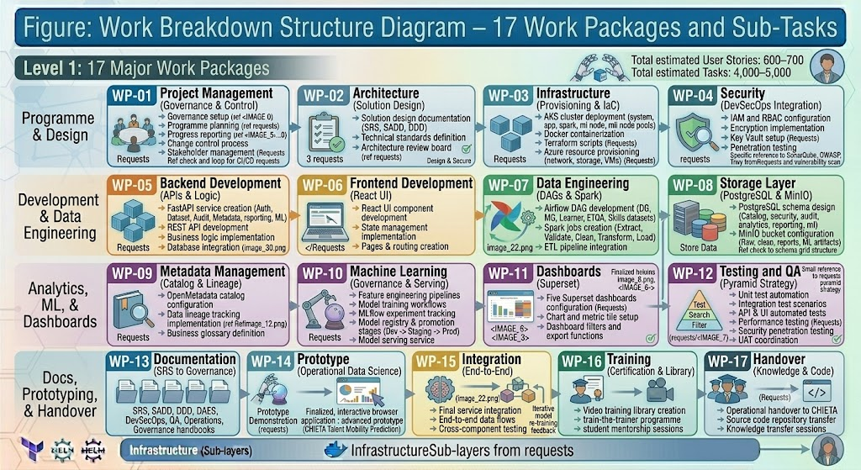
[ Figure / Chart: Work Breakdown Structure Diagram – 17 Work Packages and Sub-Tasks ]
Figure: Work Breakdown Structure Diagram – 17 Work Packages and Sub-Tasks

5. Resource Plan
Role | Headcount | Primary Responsibility
Project Manager | 1 | Programme delivery management
Solution Architect | 1 | Technical design and architecture governance
Principal System Engineer | 1 | Full integration, CI/CD, production operations
Frontend Developers | 2 | React UI development
Backend Developers | 2 | FastAPI development and API engineering
Data Engineers | 2 | Airflow and Spark pipeline development
Data Scientists | 2 | ML model development and explainability
BI Developer | 1 | Superset dashboard development
Metadata Engineer | 1 | OpenMetadata configuration and management
DevOps Engineer | 1 | CI/CD, AKS, Terraform, container management
Database Administrator | 1 | PostgreSQL and MinIO management
QA Engineers | 2 | Testing across all layers
Technical Writer | 1 | Documentation and user guides
Student Contributors | 6–10 | Data cleaning, QA support, documentation

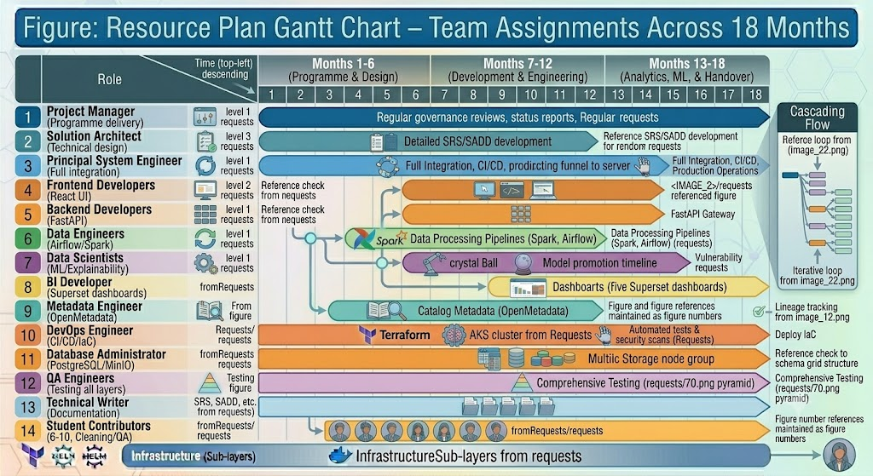
[ Figure / Chart: Resource Plan Gantt Chart – Team Assignments Across 18 Months ]
Figure: Resource Plan Gantt Chart – Team Assignments Across 18 Months

6. RACI Matrix
RACI defines for each deliverable who is Responsible (does the work), Accountable (owns the outcome), Consulted (provides input), and Informed (receives updates).

Deliverable | Project Manager | Solution Architect | Principal System Engineer | Technical Teams
D1 – SRS | A | R | C | I
D2 – Architecture | C | A | R | I
D3 – Functional Platform | C | C | A | R
D4 – Datasets | I | C | C | R
D5 – Dashboards | I | C | C | R
D6 – Prototype | I | C | C | R
D7 – Testing | I | C | C | R
D8 – Training | I | C | C | R
D9 – Technical Handover | C | A | R | I

7. RAID Register

Risks
Risk | Probability | Impact | Mitigation
Poor data quality in source datasets | High | High | Great Expectations validation; data cleaning pipeline
Scope creep — requirements expanding | Medium | High | Formal Change Control Board process
Security breach or data leak | Low | High | DevSecOps, penetration testing, OWASP
Student contributor turnover | Medium | Medium | Cross-training; contribution documentation
Resource shortage — key staff departure | Medium | High | Knowledge transfer; documentation; backup resources

Assumptions, Issues, Dependencies
- Assumption: CHIETA datasets will be available within the first 30 days of the programme
- Assumption: Azure subscription and AKS quota will be provisioned before Sprint 1
- Assumption: Key CHIETA stakeholders will be available for UAT in the final two sprints
- Issue: Late requirements delivery can compress development sprints — mitigated through Agile sprint buffering
- Dependency: Azure subscription must be active before infrastructure work can begin
- Dependency: Source datasets must be received before data pipeline development can start

8. Risk Register

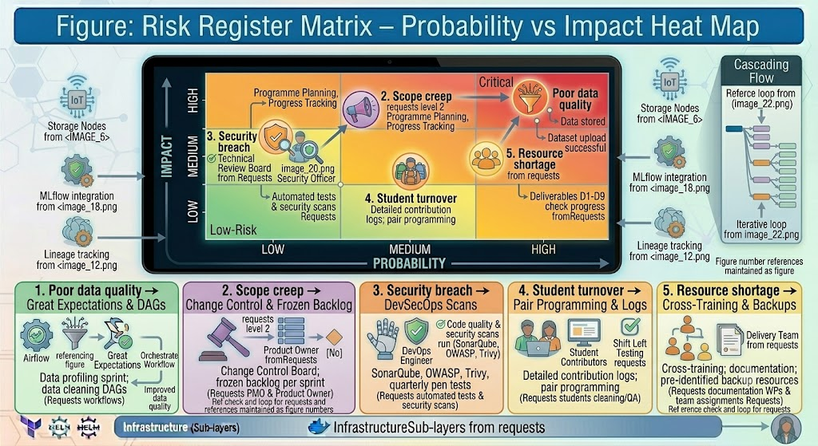
[ Figure / Chart: Risk Register Matrix – Probability vs Impact Heat Map ]
Figure: Risk Register Matrix – Probability vs Impact Heat Map

Risk | Probability | Impact | Risk Score | Mitigation Strategy
Poor data quality | High | High | Critical | Data profiling sprint; Great Expectations; data cleaning DAGs
Scope creep | Medium | High | High | Change Control Board; frozen backlog per sprint
Security breach | Low | High | High | OWASP, Trivy, SonarQube, quarterly pen tests
Student turnover | Medium | Medium | Medium | Detailed contribution logs; pair programming
Resource shortage | Medium | High | High | Cross-training; documentation; pre-identified backup resources

9. Communication Plan
Meeting | Frequency | Participants | Purpose
Daily Scrum Standup | Daily | Development teams, Scrum Masters | Sprint progress, blockers
Sprint Review | Fortnightly | All teams + Product Owner | Demo completed work to stakeholders
Technical Meeting | Weekly | Technical Leads + PSE + Architect | Architecture and integration decisions
Sprint Retrospective | Fortnightly | Development teams | Process improvement
Steering Committee | Monthly | CHIETA executives + Programme Manager + PM | Strategic oversight, budget, risks
Program Increment Planning | Quarterly | All teams + Product Owner + Architect | Plan the next 9 sprints (PI)

10. Quality Management Plan
Quality Area | Standard | Target
Software Quality | ISO 25010 | All quality characteristics met
Security | OWASP Top 10 | 0 critical vulnerabilities in production
Accessibility | WCAG 2.1 AA | Full compliance
API Documentation | OpenAPI 3.0 | 100% of endpoints documented
Code Coverage | Unit + Integration Tests | ≥ 80%
Platform Availability | Uptime monitoring | ≥ 99.9%
Critical Defects | Defect tracking | 0 critical defects in production

11. Procurement Plan
The procurement strategy prioritises open-source technologies to minimise licensing costs and avoid vendor lock-in:
Technology | Licence Type | Procurement Method
React, FastAPI, Airflow, Spark, Superset, MLflow, OpenMetadata | Open-source (Apache / MIT) | Free to use
PostgreSQL | Open-source | Free to use
Docker | Open-source | Free to use
Azure AKS | Pay-per-use (Azure) | Azure subscription
Azure Key Vault | Pay-per-use (Azure) | Azure subscription
Azure DevOps | Microsoft licence | Azure subscription

12. Cost Baseline
The programme cost baseline includes the following major categories:
Cost Category | Description
Personnel | Salaries and contractor fees for all team members over 18 months
Cloud Infrastructure | Azure AKS, PostgreSQL, Key Vault, Container Registry, DevOps
Training | Video production, trainer fees, student stipends
Monitoring and Security | Prometheus, Grafana licences (enterprise), security tools
Documentation | Technical writer fees, handbook production
Travel and Logistics | On-site workshops, stakeholder meetings
Contingency Reserve | 10–15% of total budget for unforeseen risks

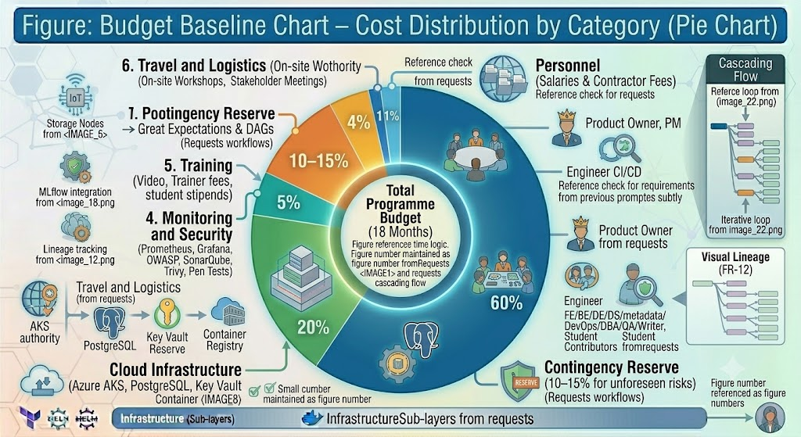
[ Figure / Chart: Budget Baseline Chart – Cost Distribution by Category (Pie Chart) ]
Figure: Budget Baseline Chart – Cost Distribution by Category (Pie Chart)

13. Sprint Plan — 36 Sprints over 18 Months
The programme is structured into 36 two-week sprints, grouped into 9 Programme Increments (PIs) of 4 sprints each.
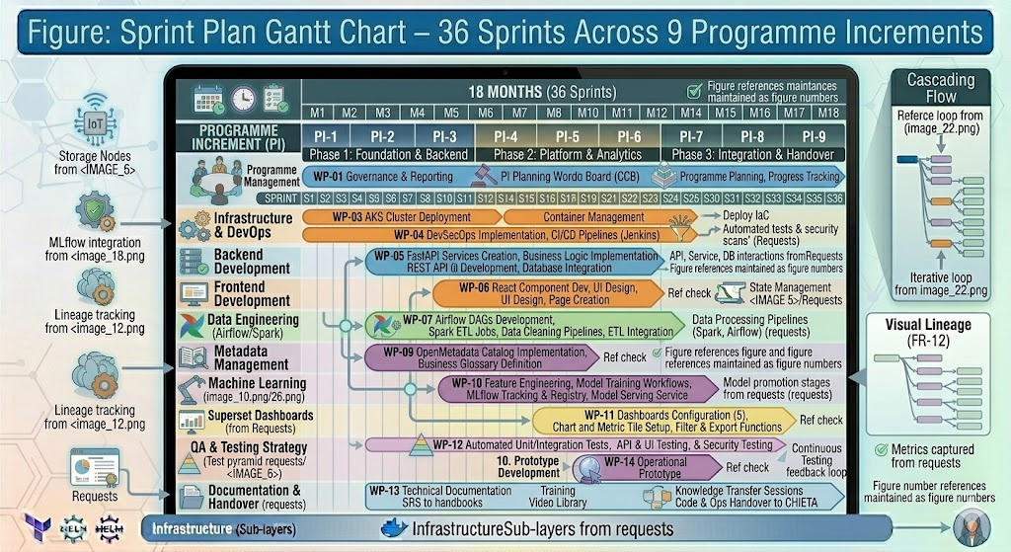
[ Figure / Chart: Sprint Plan Gantt Chart – 36 Sprints Across 9 Programme Increments ]
Figure: Sprint Plan Gantt Chart – 36 Sprints Across 9 Programme Increments

Programme Increment | Sprints | Focus Area
PI 1 – Foundation | Sprints 1–4 | Project setup, architecture, infrastructure provisioning, security baseline
PI 2 – Core Platform | Sprints 5–8 | Backend APIs, database schemas, authentication, user management
PI 3 – Data Engineering | Sprints 9–12 | Airflow DAGs, Spark jobs, ETL for all five CHIETA datasets
PI 4 – Storage & Metadata | Sprints 13–16 | PostgreSQL optimisation, MinIO configuration, OpenMetadata setup
PI 5 – Dashboards | Sprints 17–20 | All five Superset dashboards, chart configuration, export functions
PI 6 – Machine Learning | Sprints 21–24 | Feature engineering, model training, MLflow registry, prediction API
PI 7 – Prototype | Sprints 25–28 | Full operational prototype (Learner Success Prediction or equivalent)
PI 8 – Testing & QA | Sprints 29–32 | Performance testing, security testing, UAT, defect resolution
PI 9 – Handover | Sprints 33–36 | Training programme, knowledge transfer, documentation finalisation, go-live

14. Program Increment Planning
Quarterly PI Planning sessions bring together all teams, the Product Owner, and the Solution Architect for two days of structured planning. Each session produces:
- PI Objectives — 3–5 goals for the next nine sprints
- Team capacity — planned available person-days after leave and training
- Risks and dependencies — cross-team dependencies identified and resolved
- Program Board — visual wall (physical or digital) showing all team deliverables and dependencies
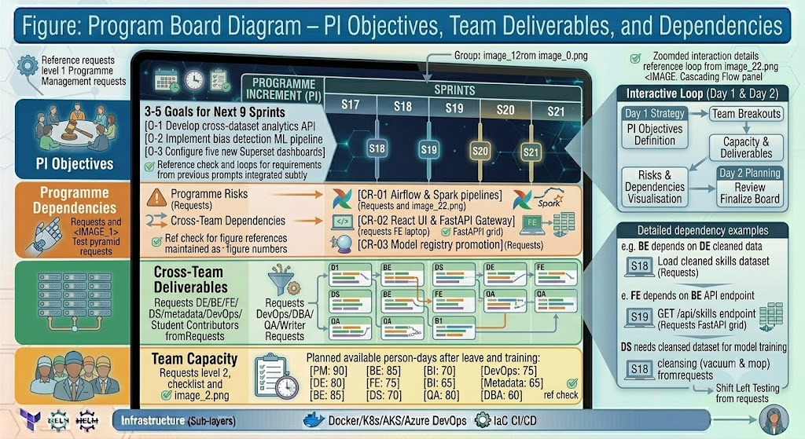

[ Figure / Chart: Program Board Diagram – PI Objectives, Team Deliverables, and Dependencies ]
Figure: Program Board Diagram – PI Objectives, Team Deliverables, and Dependencies

15. Azure DevOps Structure

Boards and Work Items
All work is tracked in Azure DevOps Boards using the standard Agile hierarchy:
- Epics — large bodies of work spanning multiple sprints (e.g., 'Build Dashboarding Layer')
- Features — deliverable capabilities within an Epic (e.g., 'Learner Dashboard with 5 KPIs')
- User Stories — specific user-facing functionality (e.g., 'As an Analyst, I want to filter the dashboard by province')
- Tasks — technical implementation steps within a story (e.g., 'Create API endpoint GET /dashboard/learners?province=GP')

Repositories in Azure DevOps
- frontend-react, backend-fastapi, airflow-etl, spark-processing
- ml-platform, superset-dashboards, metadata-platform, infrastructure

Pipelines and Wiki
- CI/CD pipelines for each repository — automated build, test, and deploy
- Wiki — knowledge base for architecture decisions, runbooks, and onboarding guides

16. Change Management
The Change Control Board (CCB) meets weekly to review and approve change requests:
- Change request submitted by any team member
- Impact analysis completed within 48 hours (schedule, cost, quality, risk)
- CCB reviews and votes to approve, reject, or defer the change
- Approved changes are added to the product backlog and planned into future sprints
- Implementation validated and change closed

CCB Members: Project Manager (chair), Principal System Engineer, Solution Architect, CHIETA Representative

17. Reporting Framework
Report | Frequency | Audience | Content
Sprint Report | Fortnightly | Programme Manager, Product Owner | Stories completed, velocity, burndown, blockers
Monthly Status Report | Monthly | Steering Committee | Schedule, budget, quality, risks, milestone status
Executive Report | Quarterly | CHIETA Executives | Programme health, PI objectives, benefits realisation

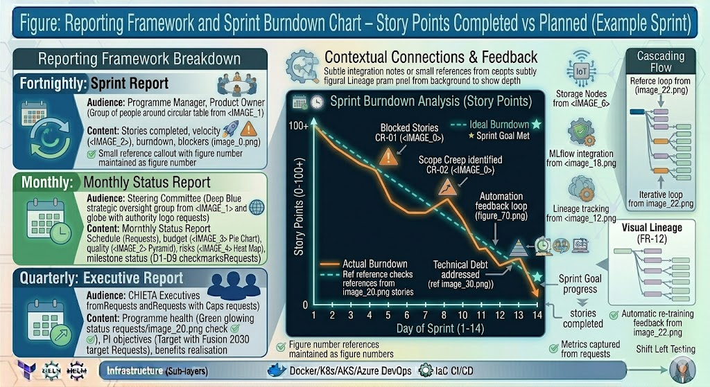
[ Figure / Chart: Sprint Burndown Chart – Story Points Completed vs Planned (Example Sprint) ]
Figure: Sprint Burndown Chart – Story Points Completed vs Planned (Example Sprint)

18. Earned Value Management (EVM)
EVM provides an objective measure of programme performance by comparing planned value, earned value, and actual cost:

EVM Metric | Definition | Formula | Threshold
PV (Planned Value) | Budgeted value of work scheduled | PV | Baseline
EV (Earned Value) | Budgeted value of work actually completed | EV | Baseline
AC (Actual Cost) | Actual cost incurred | AC | Baseline
SPI (Schedule Index) | Are we ahead or behind schedule? | EV / PV | ≥ 0.9 (warning below 0.9)
CPI (Cost Index) | Are we under or over budget? | EV / AC | ≥ 0.9 (warning below 0.9)

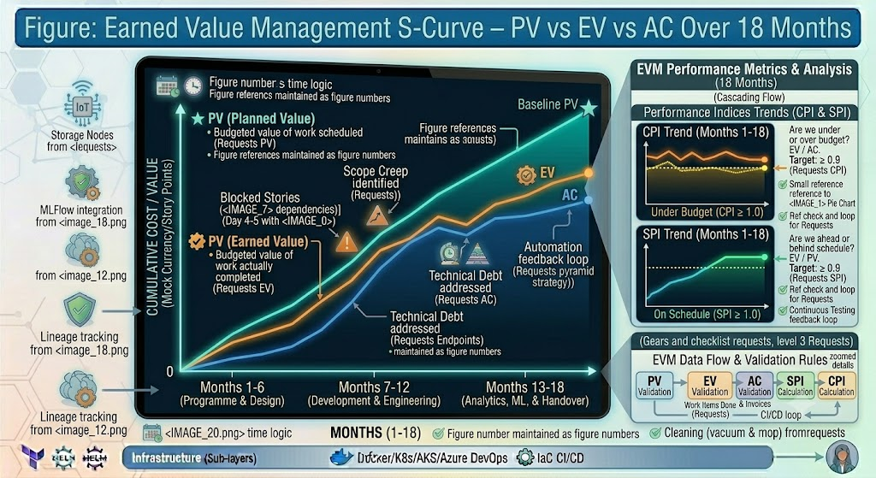

[ Figure / Chart: Earned Value Management S-Curve – PV vs EV vs AC Over 18 Months ]
Figure: Earned Value Management S-Curve – PV vs EV vs AC Over 18 Months

Reading EVM: An SPI of 1.0 means the project is exactly on schedule. An SPI of 0.85 means the team is delivering only 85 cents of value for every rand of work scheduled — a warning signal. A CPI of 1.1 means the team is delivering 10% more value than it is costing — a very positive signal.

19. Escalation Framework
Issues that cannot be resolved at the team level are escalated upward:
- Team Level — Team Lead attempts resolution within 1 sprint
- Scrum Master — facilitates resolution if team cannot solve it
- Project Manager — escalates resource, scope, or timeline issues
- Programme Manager — escalates cross-stream or commercial issues
- Steering Committee — critical issues requiring executive decision

Critical incidents (P1 security breach, data loss, complete system failure) bypass all intermediate levels and go directly to the Steering Committee.

20. Closure and Benefits Realisation

Programme Closure Activities
- Formal sign-off from CHIETA on all nine deliverables (D1–D9)
- Complete knowledge transfer to CHIETA internal team
- Source code and all repositories transferred to CHIETA ownership
- Final training programme completed with certification
- All documentation handed over in electronic and printed format
- Lessons learned workshop conducted with all team members
- Final project report presented to Steering Committee

Benefits Realisation
Benefit | Measurement
Data-driven decision making | Executive dashboards used in monthly CHIETA management meetings
Improved reporting efficiency | Reduction in manual report preparation time (hours per report)
Predictive analytics capability | At least one prototype model deployed and generating predictions
Skills intelligence | Skills demand forecasting informing CHIETA strategic planning
Student development | Number of students who received digital badges and certification
Intellectual property ownership | 100% of source code owned by CHIETA at programme close

Master Blueprint Complete — Summary of All Eight Volumes
The complete CHIETA Data Lab Blueprint is now documented across eight volumes. Together, these volumes form a comprehensive, production-ready programme blueprint comparable to what would be produced for a large-scale Microsoft Fabric, Databricks, or Dataiku enterprise implementation.

Volume | Document Title | Primary Deliverable
Volume I | Software Requirements Specification (SRS) | D1
Volume II | Software Architecture Design Document (SADD) | D2
Volume III | Detailed Design Document (DDD) | D2, D3
Volume IV | Database and API Engineering Specification (DAES) | D3, D4, D9
Volume V | DevSecOps, Infrastructure & Deployment Handbook | D2, D7, D9
Volume VI | Testing, Quality Assurance & Validation Handbook | D7
Volume VII | Operations, Maintenance, Training & Handover Handbook | D8, D9
Volume VIII | Project Governance, PMBOK & Agile Delivery Handbook | All

This handbook is sufficient in depth and detail for architects, developers, QA engineers, DevOps teams, data scientists, project managers, and CHIETA stakeholders to execute and maintain the complete CHIETA Data Lab programme from inception through to post-implementation support.

End of Handbook CHIETA Data Lab — Comprehensive Project Handbook | Version 1.0 | Eight Volumes | Full Programme Blueprint

