

Individual Assessment Coversheet
To be attached to the front of the assessment.
Campus:____Bedfordview_____________________________________________________________________
Faculty: _ Higher Certificate Cyber Security______________________________________________________
Module Code: ____ITXLA0______________________________________________________________________
Group: __________________________________________________________________________
Lecturer’s Name: ________________Mr.Othello_________________________________________________________
Student Full Name: ___________X _________________________________________________
Student Number: __________________X________________________________________________________

Indicate | Yes | No
Plagiarism report attached

Declaration:
I declare that this assessment is my own original work except for source material explicitly acknowledged. I also declare that this assessment or any other of my original work related to it has not been previously, or is not being simultaneously, submitted for this or any other course. I am aware of the AI policy and acknowledge that I have not used any AI technology to generate or manipulate data, other than as permitted by the assessment instructions. I also declare that I am aware of the Institution’s policy and regulations on honesty in academic work as set out in the Conditions of Enrolment, and of the disciplinary guidelines applicable to breaches of such policy and regulations.

Signature M.A | Date 13-05-2024

Lecturer’s Comments:

Marks Awarded: |  | %
Signature | Date

Eduvos (Pty) Ltd. (formerly Pearson Institute of Higher Education) is registered with the Department of Higher Education and Training as a private higher education institution under the Higher Education Act, 101, of 1997. Registration Certificate number: 2001/HE07/008

Contents
Question 1 3
Question 2 15
Question 3 16
Reference 20

Question 1
NOTE: Ensure you take screenshots of all your configurations and put them in one final document.

- Allocate Virtual Machine 1 with 50 GB and named Vision2025.
Install Ubuntu 22.04 on a 25 GB Partition.
Set the Administrator username to your “first_name” and the Administrator password will be L1n@x2000
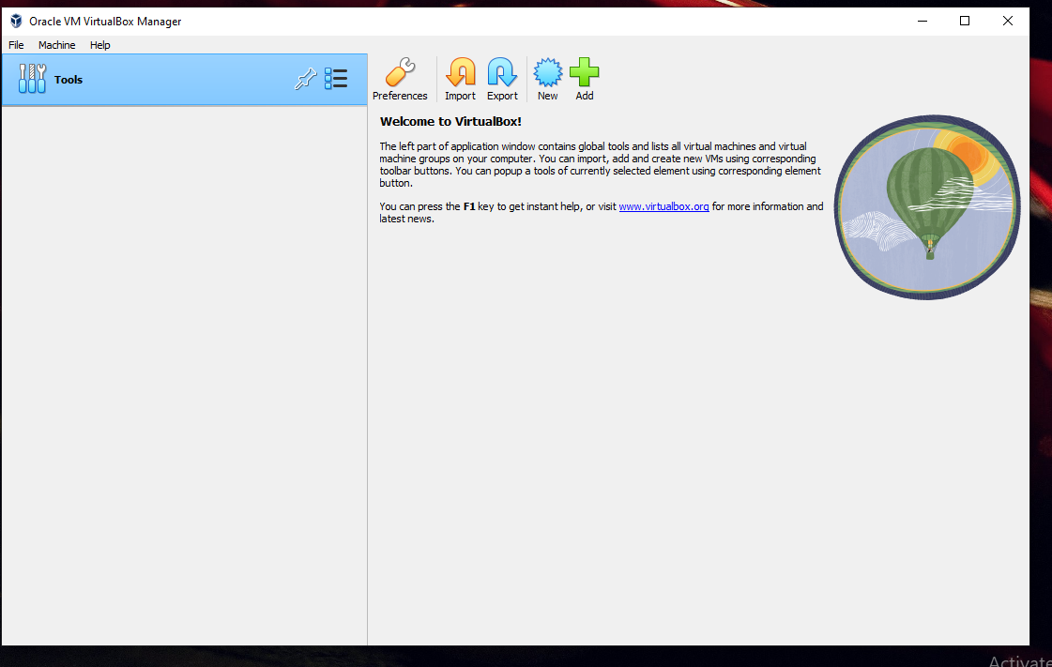
- Step 1: Allocate Virtual Machine 1 with 50 GB and named Vision2025.

Step 1:Naming it Vision2025
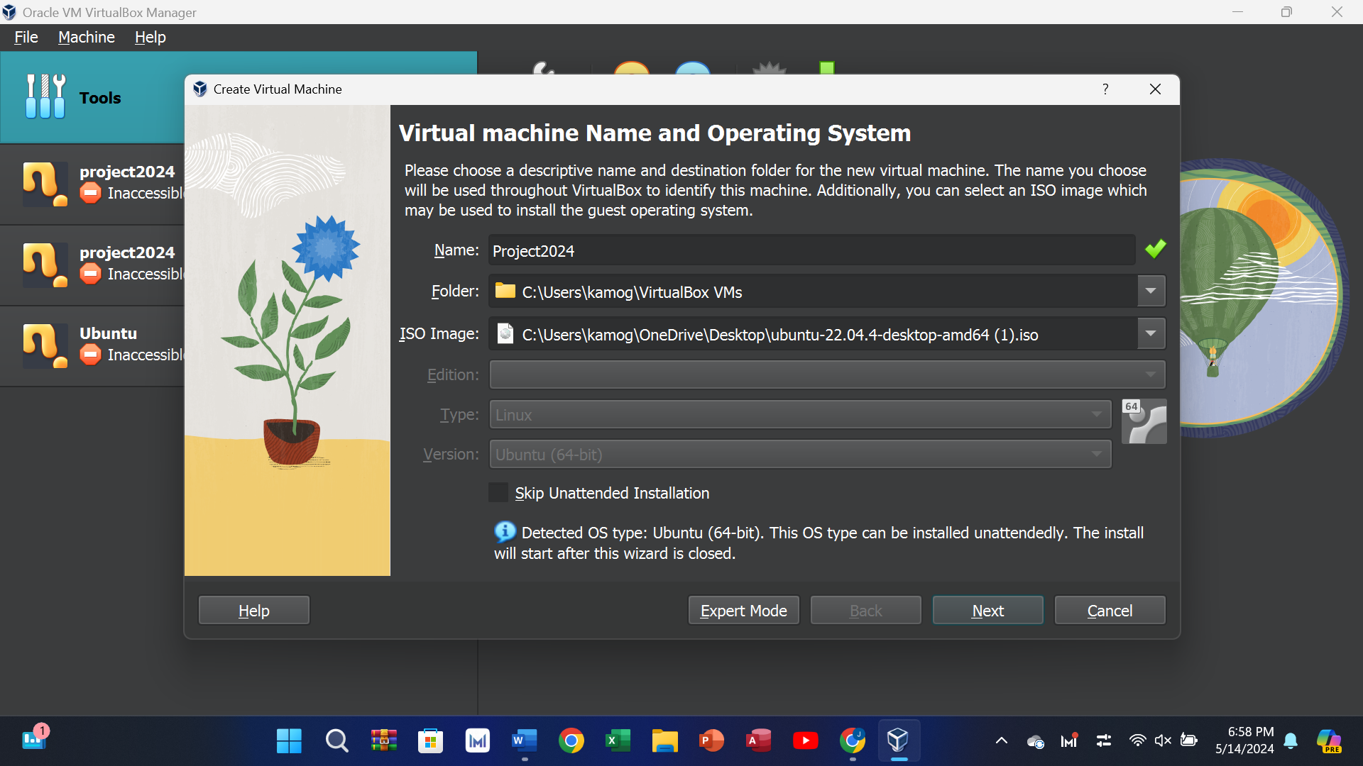

Step1: Allocate Virtual Machine 1 with 50 GB
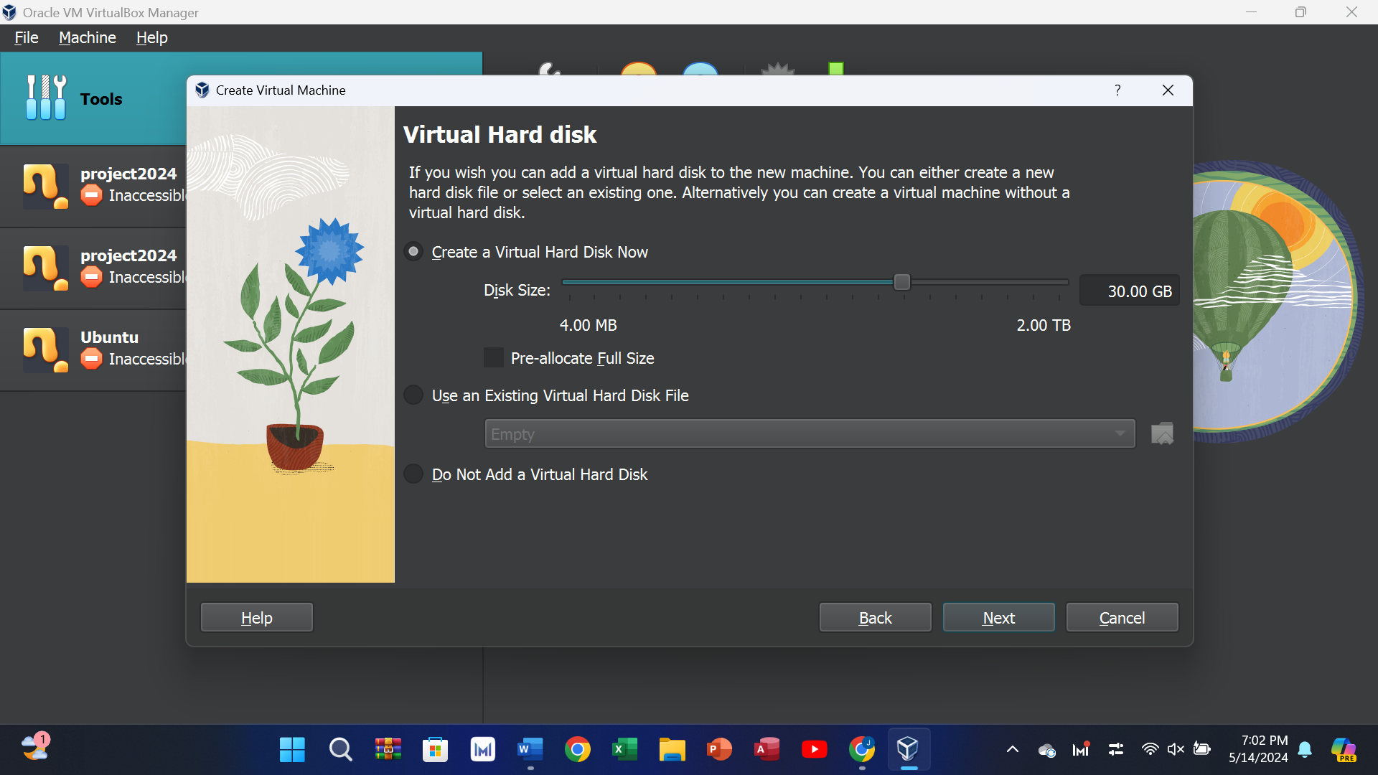

Set the Administrator username to your “first_name” and the Administrator password will be L1n@x2000

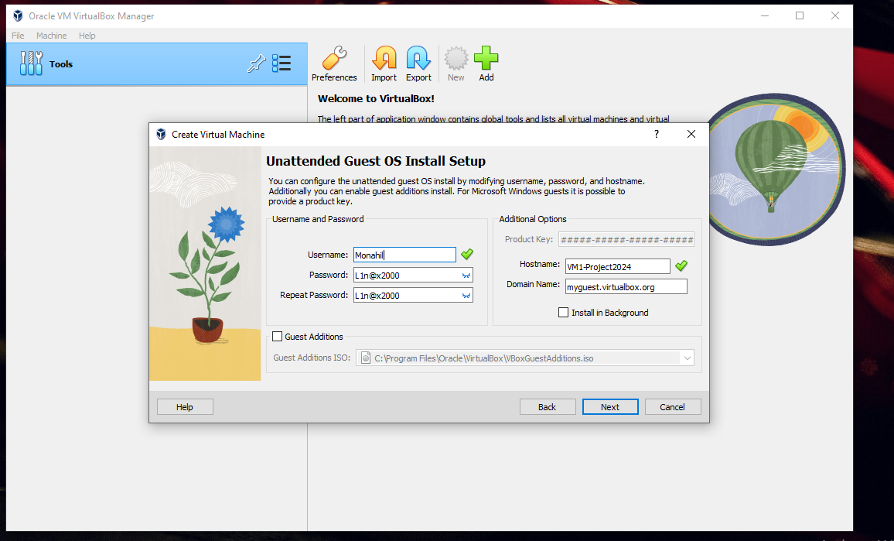

Partition of 25GB:
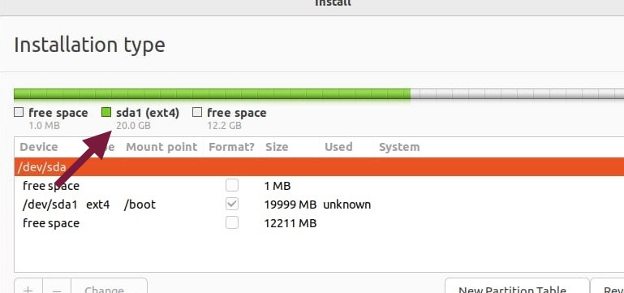

Run virtual machine 1.
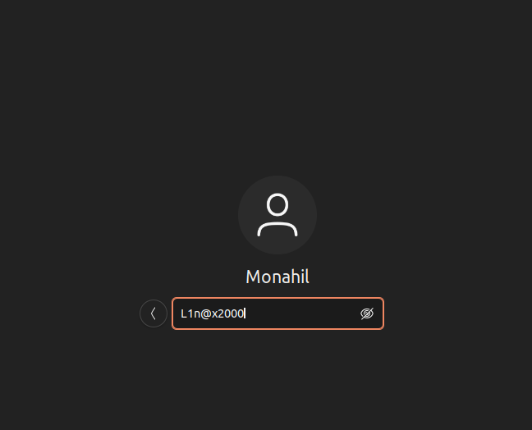

c. Install Ubuntu 22.04 on the second VM using a 25GB partition.
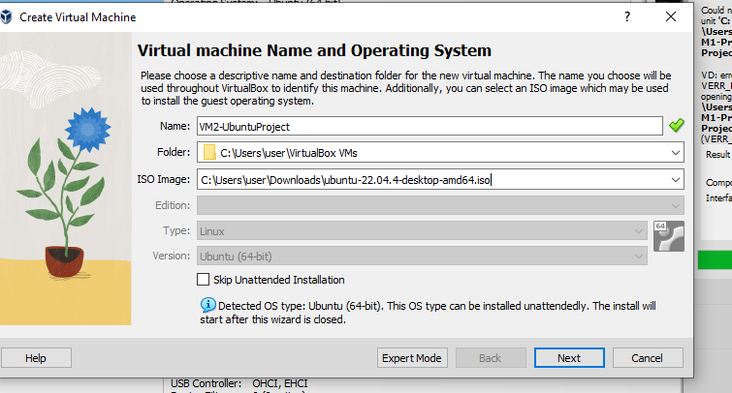
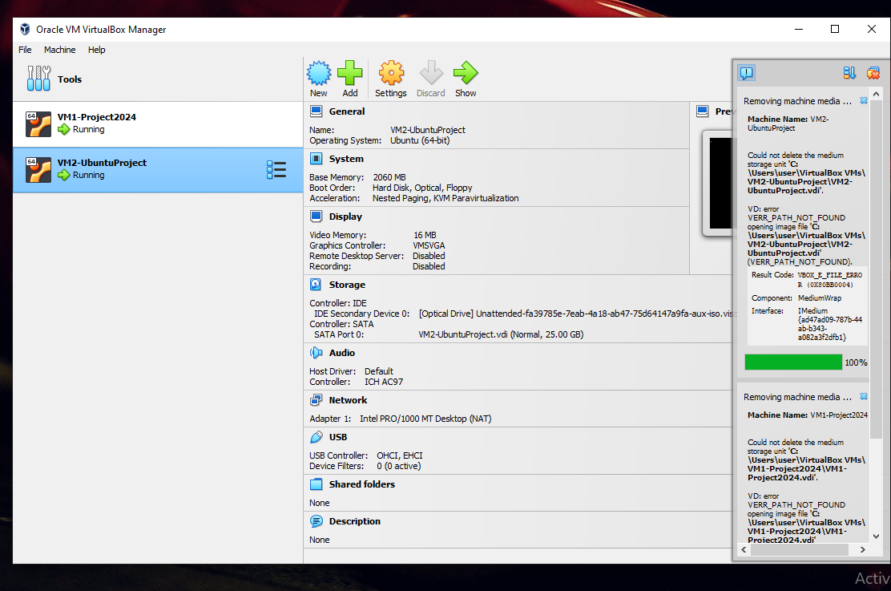

Partition of 25GB:
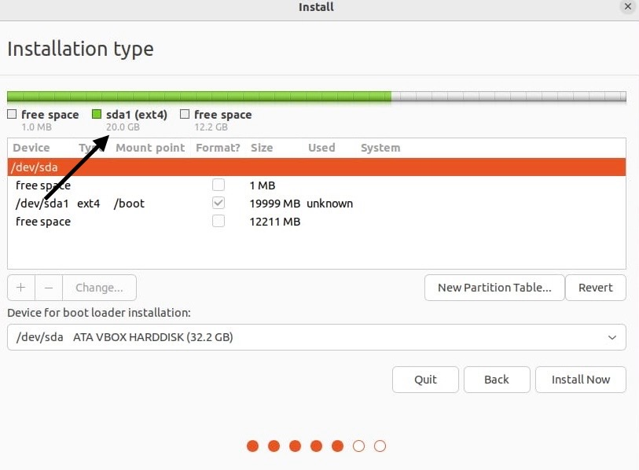

d. Set the Administrator username to “Christiano Ronaldo”.
e. The computer name will be XUbuntu. The Administrator password will be L1n@x2000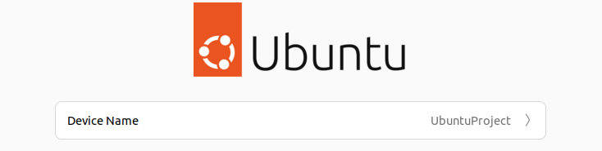
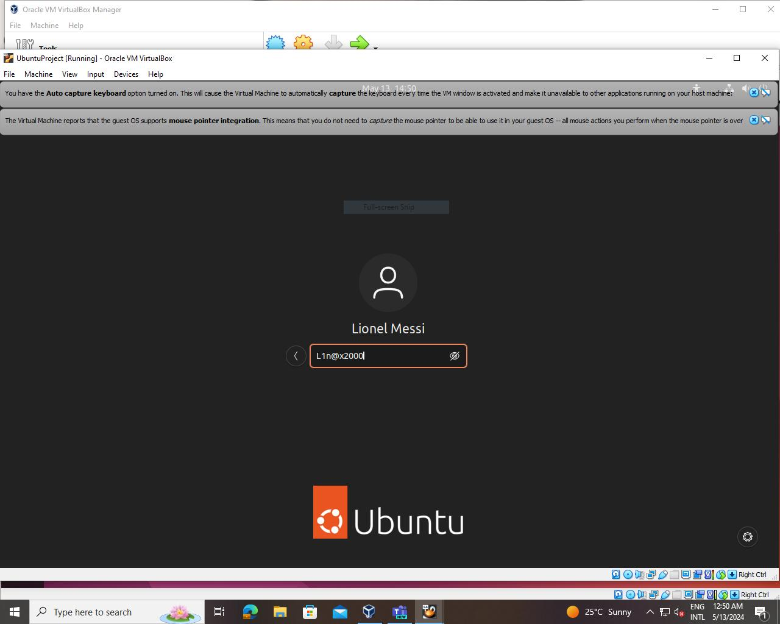

The following tasks must be performed on Virtual Machine 1 using the command-line interface.
1.2 In your home directory, create a new sub-directory called WorldCup2022. Change to this directory
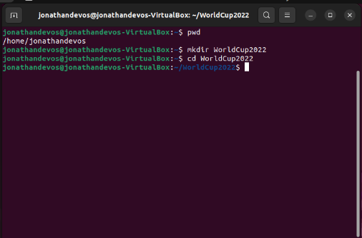
1.3 Using the vi / vim / nano editor, create a text file called GroupAandB. Enter the following names in the file, placing each name on a separate line: Russia, Uruguay, Egypt, Saudi Arabia, Iran, Portugal, Spain, Morocco
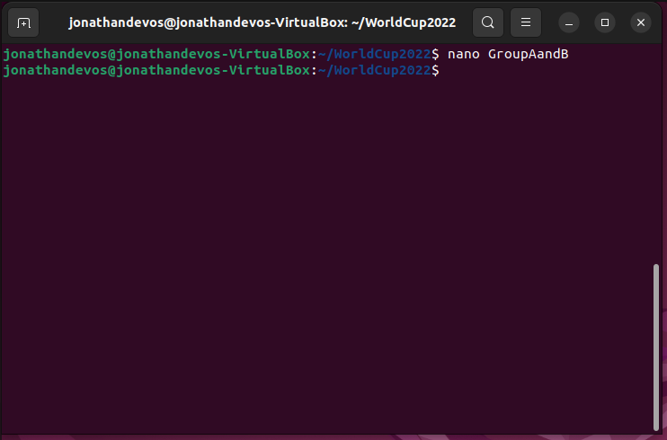
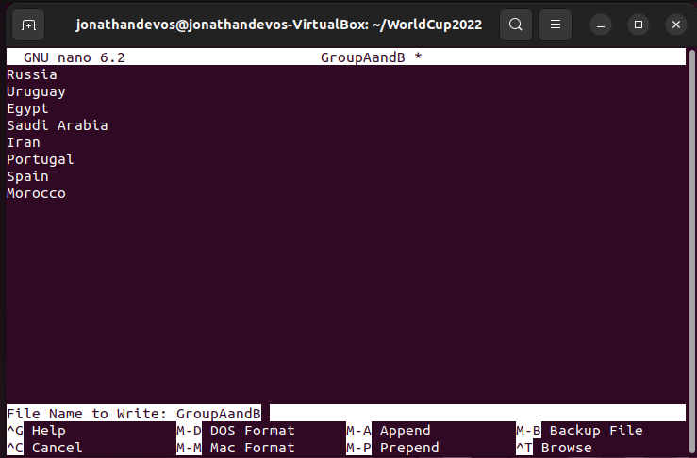

1.4 Using a single command sort the contents of the GroupAandB file into alphabetical order and save it as a new file called GroupAandB2.

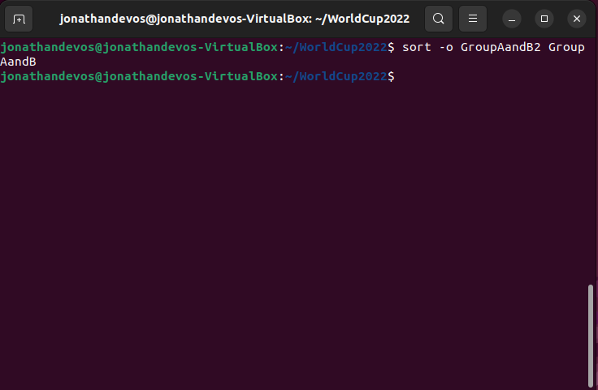

1.5 Copy the GroupAandB2 file to the /tmp directory. Change to the /tmp directory and do a directory listing to confirm that the file is in fact in the /tmp directory.Change back to the WorldCup2022 directory and delete the GroupAandB2 file. Do a directory listing to confirm that the file is no longer in the GroupAandB2 directory.
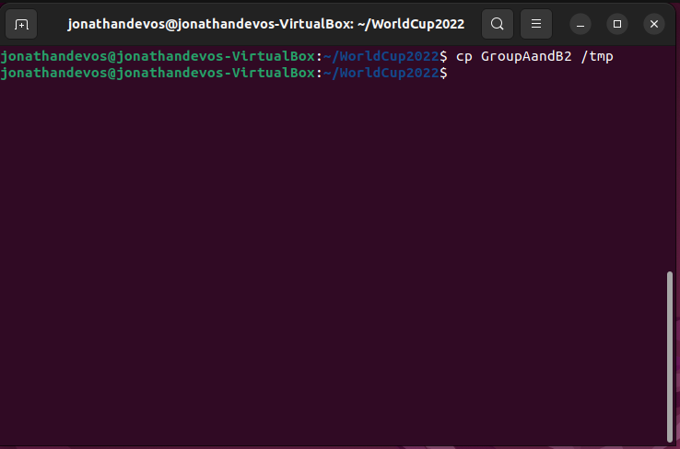
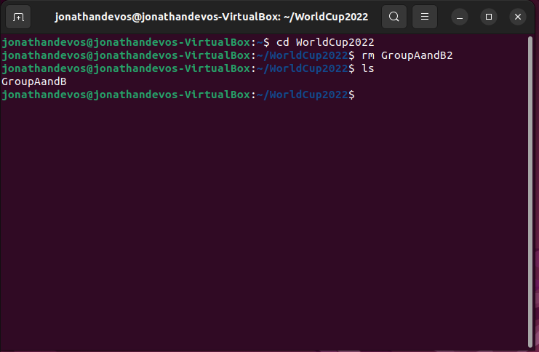
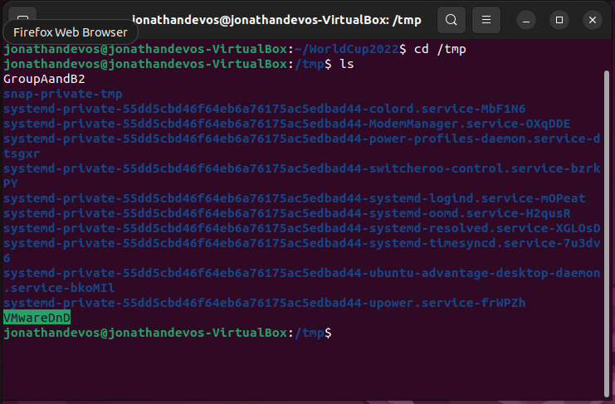

Save and Close Nano:
Save: To save the file, press Ctrl + O. Then, to verify the file name, hit Enter.
Exit: To close the nano editor, press Ctrl + X.
1.4 Change back to your home directory. Using a single command, sort the contents of the Hardware file into alphabetical order, and save it as a new file called Gadgets in the ITDepartment directory.

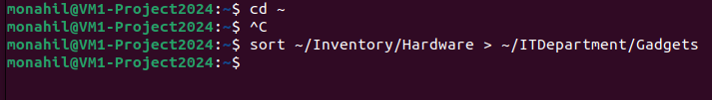
Justification
The command to switch directories is cd.
The icon for the home directory is ~.
Output: If the command is successful, nothing is displayed. It merely brings up the command prompt again.
Justification
Sorting lines in a text file is done with the sort command.
The file that must be sorted is called ~/Inventory/Hardware.> is a redirection operator that moves the output to a different file.
The sorted output is saved in the file ~/ITDepartment/Gadgets.
Output: If the command is successful, nothing is displayed. It merely brings up the command prompt again.

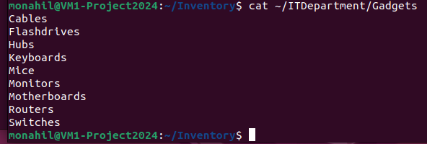

Question 2
Troubleshooting Video 20 Marks
Study the scenario and complete the question(s) that follow(s):
Troubleshooting Issues
As you navigate your Linux desktop, intermittent crashes disrupt your workflow, leaving you frustrated.
Each time you launch the application, uncertainty looms. With deadlines looming, you scramble to troubleshoot, scanning logs and forums for solutions.
Persistence pays off as you uncover the culprit which is a conflicting library. Source: Muzvidziwa, M. 2024 Record a short video addressing the following: 2.1 Provide step-by-step instructions on how would you diagnose the root cause of these crashes? Note: The maximum file upload size is 100MB.
If your video is more than 100MB, you can use Handbrake to reduce its video size. You may download it here: https://handbrake.fr/downloads.php ; You can make use of this video for instructions on how to reduce the size: https://www.youtube.com/watch? v=2rX8mTTOC8s [Sub Total 20 Marks]
#################################Exampler below########################################
Here are the steps I have mentioned in my video on how to troubleshoot slow performance issues on the Linux machine.
First, make sure the system resources are checked.
Let's first check the status of your system resources. Pressing Ctrl + Alt + T will open a terminal window for you. Type "top" into the terminal and press Enter. This command provides you with a list of all the processes that are now operating on your computer as well as details on CPU and memory use. To identify the source of the slowdown, look for any processes that are consuming a lot of CPU or memory.

Check Disk Usage in Step Two.
Let's examine your disk utilization next. Press Enter after typing df -h into the terminal. You can see how much disk space is available and in use on your machine by using this command. Your system may lag if you have any partitions that are almost full. Check for them. Try to free up some space by eliminating or relocating unwanted data to an external disk if you locate a partition that's almost full.

Step 3: Inspect Network Problems
Let's now investigate any network problems that might be the source of the slowdown. Press Enter after typing "ping google.com" into the terminal. This command calculates the round-trip time by sending a packet to Google's servers. High latency or packet loss may be signs of a network problem. To find out the route your network packets travel to get to their destination, you can also use the traceroute command. If any hops are taking longer than normal, there may be a bottleneck in the network. Look for any such hops.
Step 4: Look for Conflicts in Software
Slowdowns in your system might also be caused by software conflicts. First, try disabling any recently installed applications or updates to see if there are any problems. Next, type ps into the terminal and press Enter. This command provides you with a system-wide list of all active processes. Keep an eye out for any processes that seem odd or superfluous, since they might be interfering with other programs and contributing to the slowdown.
Step 5: Upgrade Drivers and Software
Updating your drivers and software can frequently fix performance problems. To update the package list, type sudo apt update in the terminal and press Enter. The installed packages can then be updated to the most recent versions by typing sudo apt upgrade and pressing Enter. Both performance and issue fixes might come from this.
Step6: Give the system a restart.
Restarting your computer can often improve its performance. To restart, click the power icon in the corner of your screen. This will restart your computer and shut off all open apps and services.

Step 7: Keep an eye on the performance of the system.
Lastly, it's a good idea to keep an eye on the performance of your system to identify any problems early. Type "htop" into the terminal and press Enter. This command provides you with up-to-date details on the CPU and memory consumption of your system. Keep a watch out for any odd usage increases, since they may point to an issue that requires attention.
These procedures should help you locate and fix the problems that are slowing down your Ubuntu Linux computer. Please get in touch if you require any additional help. I appreciate you seeing!

Question 3
Question 3
10 Marks Study the scenario and complete the question(s) that follow(s):
Pipes A data analyst in Linux needs to process a large log file. They utilize pipes to extract relevant information using 'grep', then refine it with 'awk' for specific fields.
Next, they sort the data with 'sort' to identify patterns. Finally, they count occurrences with 'uniq', yielding actionable insights. Pipes seamlessly connect these commands, streamlining data analysis and exemplifying Unix's ethos of combining small tools for powerful outcomes.
Source: Muzvidziwa, M. (2024) Using the Ubuntu PC installed in Question 1, answer the following questions and provide screenshots to demonstrate how each answer is conveyed in a more practical sense:

3.1 How does a data analyst in Linux leverage pipes to streamline log file processing?
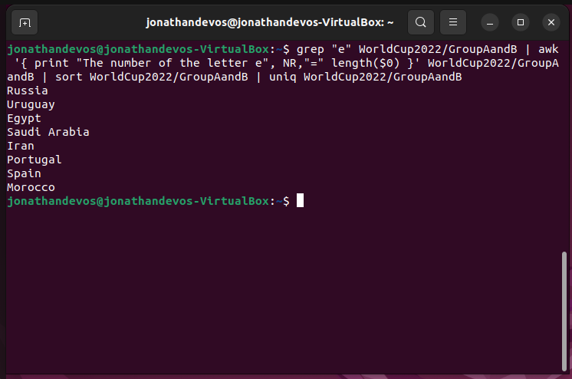
3.2 What programs and tools is Alex going to use to compress the chosen directories into archives?
Alex intends to compress the chosen directories into archives using the tar program. The tar command can produce.tar archives and use gzip or bzip2 to compress them.

3.2 What commands are used to extract relevant information and refine data in the given scenario?
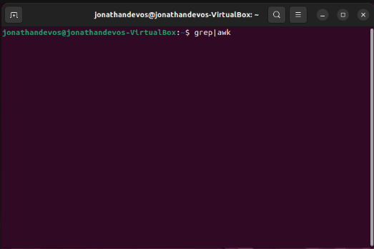

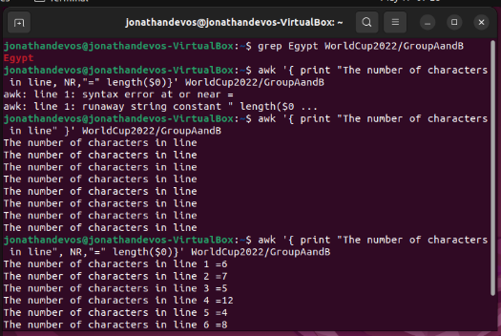

3.3 Explain the role of 'sort' command in the data analysis process described
In this scenario, the sort command is used to identify patterns in a file. The sort command is generally used to sort the contents of a file into alphabetical order or any order that you define.
3.4 What is the significance of using 'uniq' command in the final stage of data analysis?
The uniq command is used to count occurrences of certain things in a file or to look for repeated lines or words and delete the duplicated lines or filter them out. This increases the efficiency of the process and the accuracy of the end product.

3.5 How does the described scenario exemplify the Unix philosophy of combining small tools for powerful outcomes?
The Unix philosophy of combining small tools for powerful outcomes is exemplified in this scenario by making use of pipelines to seamlessly connect different commands like grep, awk, sort and uniq to streamline the process of data analysis.

FIND REFERENCES TO SUPPORT YOUR ANSWERS ONLINE

Reference

King, B. (2022) Introduction to ubuntu 20.04: A beginner’s guide, DigitalOcean. Available at: https://www.digitalocean.com/community/conceptual-articles/ubuntu-20-04-beginners-guide#examples-of-ubuntu-server-setups (Accessed: 10 May 2024).
Perkins, J. (2021) Linux running too slow? here’s how to find the cause, Make Tech Easier. Available at: https://www.maketecheasier.com/linux-running-too-slow-heres-how-to-find-the-cause/ (Accessed: 13 May 2024).
Troubleshooting performance issues in linux (no date) RimuHosting. Available at: https://rimuhosting.com/knowledgebase/linux/misc/troubleshooting-performance-issues#:~:text=Troubleshooting%20performance%20issues%20in%20Linux%201%20Common%20performance,usage%20with%20iostat%20...%206%20Memory%20usage%20 (Accessed: 13 May 2024).
What is linux operating system (2024) GeeksforGeeks. Available at: https://www.geeksforgeeks.org/introduction-to-linux-operating-system/ (Accessed: 13 May 2024).
Strickland, J. (2011b) What’s ubuntu, and how is it different from linux?, HowStuffWorks. Available at: https://computer.howstuffworks.com/ubuntu.htm (Accessed: 13 May 2024).
(2023) The Linux Command Line for beginners | ubuntu. Available at: https://ubuntu.com/tutorials/command-line-for-beginners (Accessed: 14 May 2024).

