**ACKNOWLEDGEMENT**

I WISH TO EXPRESS MY SINCERE GRATITUDE TO PROJECT **MR. K.S. BRAMHAWALE** PRINCIPAL OF MODEL COLLEGE OF SCIENCE & COMMERCE FOR PROVIDING ME THE OPPURTUNITY TO DO MY WEB PROJECT WORK ON E-LEARNING MANAGEMENT SYSTEM. I WANT TO SINCERELY THANK MY PROJECT GUIDES **MRS MINAKSHI DHANDE** AND **MRS SHEETAL VEKHANDE** FOR GUIDANCE AND ENCOURAGEMENT IN CARRYING OUT THIS PROJECT WORK.

SPECIAL THANKS TO ALL THE LAB SYSTEMS FOR SEEMINGLY SMALL BUT VALUABLE HELP IN TERMS OF TIMELY INTERNET AND LAB ACCESS.

**DECLARATION**

I ASHISH HARISH SHETTY, STUDENT OF MODEL COLLEGE OF SCIENCE & COMMERCE, RAJBHAR NAGAR, CHINCHPADA ROAD, KATEMANIVALI NAKA, KALYAN (EAST) 421306. STUDYING IN 3RD YEAR B.SC IN INFORMATION TECHNOLOGY HEREBY DECLARE THAT I HAVE COMPLETED THIS PROJECT ON E-LEARNING MANAGEMENT SYSTEM DURING THE ACADEMIC YEAR 2020-21.

THE INFORMATION SUBMITTED IS TRUE AND ORIGINAL TO THE BEST OF MY KNOWLEDGE.

DATE:

PLACE:

**Ashish Harish Shetty**

**TABLE OF CONTENTS**

|  |  |  |  |
| --- | --- | --- | --- |
| **Sr. No.** | **INDEX** | **Pg.**  **No.** | **Sign** |
| **CHAPTER 1:** | **INTRODUCTION** |  |  |
| 1.1 | Background |  |  |
| 1.2 | Objectives |  |  |
| 1.3 | Purpose, Scope & Applicability |  |  |
| 1.3.1 | Purpose |  |  |
| 1.3.2 | Scope |  |  |
| 1.3.3 | Applicability |  |  |
| 1.4 | Organization of Report |  |  |
| **CHAPTER 2:** | **SURVEY OF TECHNOLOGIES** |  |  |
| **CHAPTER 3:** | **REQUIREMENTS AND ANALYSIS** |  |  |
| 3.1 | Problem Definition |  |  |
| 3.2 | Requirements Specification |  |  |
| 3.3 | Planning and Scheduling |  |  |
| 3.4 | Software and Hardware Requirements |  |  |
| 3.5 | Conceptual Models |  |  |
| **CHAPTER 4:** | **SYSTEM DESIGN** |  |  |
| 4.1 | Basic Modules |  |  |
| 4.2 | Data Design |  |  |
| 4.2.1 | Schema Design |  |  |
| 4.2.2 | Data Integrity and Constraints |  |  |
| 4.3 | Procedural Design |  |  |
| 4.3.1 | Logic Diagrams |  |  |
| 4.3.2 | Algorithm Design |  |  |
| 4.4 | User Interface Design |  |  |
| 4.5 | Security Issues |  |  |
| 4.6 | Test Case Design |  |  |

**ABSTRACT**

The SYB e-Learning Management System is developed as a solution to the modern e-LMS problems. The LMSs currently available in the market has certain shortcomings which need to be addressed as it hinders the path of the knowledge for the students. This system is developed for country like India but can be scaled up easily to handle other regions as well. In these testing times of covid, all colleges/schools/universities are shutdown and lectures are conducted online. This is developed as a SAAS platform so colleges can buy any package suitable for their needs out of the three available packs. There are four main users of this system: SYB admin (our admin who will manage the platform itself), college admin (add classes/departments/teachers, manage subscription), teacher and student both of whom are core to the system.

Teachers can post documents, videos, images, text, links, etc for students which will appear in the students’ main activity feed. Detailed descriptions of the system and its core functionalities are mentioned in the forthcoming chapters.

**CHAPTER 1: INTRODUCTION**

An e-Learning Management System (e-LMS) is a software application for the administration, tracking, reporting, automation and delivery of educational courses. The LMS concept emerged directly from the e-Learning. Although the first LMS appeared in the higher education sector, the majority of the LMSs today focus on the corporate market. Learning Management Systems make up the largest segment of the learning system market. The first introduction of the LMS was in the late 1990s.

Learning management systems were designed to identify training and learning gaps, utilizing analytical data and reporting. LMSs are focused on online learning delivery but support a range of uses, acting as a platform for online content, including courses, both asynchronous based and synchronous based. An LMS may offer classroom management for instructor-led training or a flipped classroom, used in higher education, but not in corporate space. Modern LMSs include intelligent algorithms to make automated recommendations for courses based on a user’s skill profile as well as extract meta-data from learning materials in order to make such recommendations even more accurate.

* 1. **BACKGROUND**

There are several historical phases of distance education that preceded the development of LMS:

**Correspondence teaching:** The first document of correspondence teaching dates back to 1723, through the advertisement of Boston Gazette of Caleb Phillips, professor of Shorthand, offering teaching materials and tutorials.

**Multimedia teaching:** The concept of e-Learning began developing in the early 20th century, marketed by the appearance of audio-video communication systems used for remote teaching. In 1909, E.M. Forster published his story ‘The Machine Stops’ and explained the benefits of using audio communication to deliver lectures to remote audiences. The earliest networked learning system was the Plato Learning Management system developed in the 1970s by Control Data Corporation.

The history of application of computers to education is filled with broadly descriptive terms such as computer-managed instruction (CMI) and integrated learning systems (ILS), computer-based instruction (CBI), computer-assisted instruction (CAI), and computer-assisted learning (CAL). These terms describe drill-and-practice programs, more sophisticated tutorials, and more individualized instruction, respectively.

The first fully-featured Learning Management System (LMS) was called EKKO, developed and released by Norway’s NKI Distance Education Network in 1991. Three years later, New Brunswick’s NB Learning Network presented a similar system designed for DOS-based teaching, and devoted exclusive to business learners.

Most modern LMSs are web-based applications like Google’s Classroom. In these systems learners can see real-time progress of their learning and get learning materials and content directly to their device’s feed and email inbox.

**1.2 OBJECTIVES**

The objectives of this system are as follows:-

* To provide education opportunity for every student even if they are not able to physically attend the educational institution.
* To streamline the learning process and make productive use of both learner’s and instructor’s time.
* To make the learning process more engaging and less robotic. Learners can share their feedback about any specific topic posted by instructors.
* To reduce infrastructure costs for the institutions providing the educational courses.
* To increase efficiency of both instructors and students.
* To leverage technology and make learning future ready.
* To provide a centralized learning platform for multiple users.
* To provide anywhere, anytime learning. Centralized nature of e-LMS makes this possible.

**1.3.1 PURPOSE**

This is a web-based e-Learning Management System built with the purpose of delivering and managing all types of content, including video, documents, articles, etc. In the education and higher education markets, an LMS will include a variety of functions that is similar to corporate but will have features such as rubrics (scoring system), teacher and instructor facilitated learning, a discussion board, and often use of a syllabus.

SYB e-LMS has the following purposes:-

1. To provide an easy to use mobile learning experience
2. To make learning inclusive and engaging
3. To provide a centralized platform for sharing learning resources
4. To reduce infrastructure cost

After learning about most of the popular existing systems and understanding the need for developing a system different people involved in related activities have been consulted. The data required for this study has been collected from company records and reputed internet sources.

**1.3.2 SCOPE**

A learning management system (LMS) is a software application for the administration, documentation, tracking, reporting and delivery of educational courses or training programs.

LMS tools were created for making knowledge-sharing easier. The whole system was created to work across different web-based platforms. The technology has found its way in both education and the business world.

With LMS tools, businesses receive a lot of benefits, as their employees can acquire knowledge without burning a hole in the pocket.

On the education side of things, educational institutes are now in a position to work with students who are thousands of miles away. Plus, the functionality of these platforms makes the learning process easier than ever before.

**1.3.3 APPLICABILITY**

SYB e-learning management platform make learning efficient and easier for people who are not able to physically attend the institutions providing the educational/training courses. The mobile first approach of design focuses on the broad user base especially in a country like India where majority of the Internet users are mobile users.

Year 2020 has been a very difficult time for everyone due to the global covid-19 pandemic, but it has been especially true for the education system. As colleges and schools remain shut many students are facing difficulty in their education. And with the low availability of a local e-LMS many colleges depend on big alternatives like Google Classroom. While Google’s Classroom is a good option there are certain serious privacy concerns from student’s data privacy point of view.

The SYB e-LMS provides a safe platform with zero privacy concerns as we do not use our customer data outside of the scope of this product, nor do we share any private information (not even email).

**1.4 ORGANISATION OF REPORT**

* SURVEY OF TECHNOLOGIES: In this chapter we will discuss the student’s awareness and understanding of available technologies related to the topic.
* REQUIREMENTS AND ANALYSIS: In this chapter we will discuss the requirements specification of the system i.e. hardware and software, problem definition, planning and scheduling.
* SYSTEM DESIGN: In this chapter we will discuss the features and operation of this system in detail, including screen layout, business rule, process diagram, pseudo code and other documentation.
* The chapter 5 to 7 include the IMPLEMENTATION AND TESTING, RESULTS AND DISCUSSION ,CONCLUSIONS, REFERENCES and will be submitted in the next semester i.e. semester VI
* IMPLEMENTATION AND TESTING: Inside this chapter we will discuss coding details and code efficiency, types of testing, testing approaches, modifications and improvements of this project.
* RESULTS AND DISCUSSION: We will discuss the test reports and user documentation in this chapter.
* CONCLUSIONS: The conclusions will be summarized in a fairly short chapter (2 or 3 pages). This chapter brings together many of the points that would have made in other chapters.
* REFERENCES: In this chapter we will discuss the bibliography and website used to create the project.

**CHAPTER 2: SURVEY OF TECHNOLOGIES**

**Front End: HTML, CSS, Bootstrap, JavaScript, jQuery**

As SYB e-LMS is a web application, we will use HTML for frontend markup and CSS along with Bootstrap (CSS framework) for styling. We will use JavaScript and jQuery in the front end for handling events and sending AJAX requests. These entire front end technologies are very popular and robust and are being used by several organizations as their front end choices thus proving their ability.

**HTML** is the standard markup language for web pages.

**CSS** is the language we use to style an HTML document. They can be inline code, internal code (using <style> tags) or external files. CSS along with HTML go hand in hand to specify the layout of web pages.

**Bootstrap** is a free CSS framework i.e. it provides a set of pre-written styles for us to directly use in our project. Bootstrap was created by twitter and is an open-source project. We are going to use Bootstrap 4 in this project.

**JavaScript** is the programming language of the web. It is an easy to learn scripting language.

Just like how Bootstrap is a CSS library (framework), **jQuery** is a JavaScript language library (more of a framework). jQuery greatly simplifies JavaScript programming especially some of the event handling part.

**Back End: Django (python) and MySQL (or MariaDB) database server**

**Django** is a high-level Python web framework that encourages rapid development and clean, pragmatic design. Built by experienced developers, it takes care of much of the hassle of Web development, so you can focus on writing your app without needing to reinvent the wheel. It’s free and open source. Django will be the backend for our e-LMS web application. The code will be written in python language.

**MySQL** is the world’s most popular open-source relational database management system. This will be our data storage solution. We will use either MySQL server or MariaDB server, either one will work fine the only difference is MySQL server is commercially distributed and MariaDB is community-developed and commercially supported fork of MySQL server.

**CHAPTER 3: REQUIREMENTS AND ANALYSIS**

**3.1 PROBLEM DEFINITION**

There are several problems that are indentified in the current learning systems. The proposed enhancement system can prevent and overcome the existing problems. First of all, current distance learning systems are a mess when it comes to efficiency and productivity. There are a very few good systems existing today which focus exclusively on college and universities. Current system has structural problems such as ungrouped listing of content, no subject categories to separate study materials, weak multimedia support especially when it comes to video. The most popular system used today is Google’s classroom for which they force you to use Google’s own email system i.e. Gmail for signing up or logging in. This forces users to open and use Gmail account even if they already have another email provider. Moreover this existing system promotes other products of Google alongside classroom, so it becomes sort of a promotional platform rather than an educational platform.

Another major issue in existing systems is privacy. Most current systems use the personal data of its users for promotional activities and also share these details with the SAAS provider’s partners. Recently in 2020 itself the attorney general of New Mexico state in the US has revealed that Google and other major LMS providers track children across the internet, across devices, in their homes, and well outside the educational sphere, all without obtaining parental consent. These tracking activities are performed using cookies and other such technologies. Our system will not share any personal data of its users with anyone nor will it track the user’s internet activity outside the sphere of our application’s usage (by the user).

Account management and the overall administration of the current existing system are complicated. There are several other issues with the current system all of which are listed below:

1. Difficult account management
2. Complex administration
3. No automated feed updates
4. Difficult learner sharing
5. Content management problems
6. Unstable file handling
7. Privacy concerns
8. Shady marketing gimmicks

This is why the current system is proposed as a replacement for the existing system.

**3.2 REQUIREMENTS SPECIFICATION**

The project has been planned to have a distributed architecture, with centralized storage of the database. The database application to be used for storage has been planned to be MySQL server or MariaDB server. Both are same with MariaDB being more popular and stable. Django web framework will be used as the main backend which will handle the database server connectivity as well as the business logic and URL view management. It is an open-source framework written in Python and is regularly updated with security patches and new and improved features. Django uses the MVC pattern/architecture for development of the applications. It is a very high performance framework and is used by big corporations such as Facebook (for Instagram), Disqus, Spotify, YouTube, etc. Django uses ORM for database management and CRUD operations i.e. the developer does not have to manually write the SQL statements, the framework will generate these statements instead. We just have to provide the data Models as classes and also define the relationships between these models. This helps in developing a robust and stable application under less time.

**3.3 PLANNING AND SCHEDULING**

* **PLANNING**

Project planning defines the project activities that will be performed and describes how the activities will be accomplished. The purpose of project planning is to define each major task, estimate the time and resources required, and provide a framework for management review and control. The project planning activities and goals include defining:

* + The specific work to be performed and goals that define and bind the project.
  + Estimates to be documented for planning, tracking, and controlling the project.
  + Commitments that are planned, documented, and agreed to by affected groups.
  + Project alternatives, assumptions, and constraints.
* **SCHEDULING**

The project schedule provides a graphical representation of predicted tasks, milestones, dependencies, resource requirements, task duration, and deadlines. The project’s master schedule inter-relates all tasks on a common time scale. The project schedule should be detailed enough to show each WB Stack to be performed, the name of the person responsible for completing the task, the start and end date of each task, and the expected duration of the task.

* Define the type of schedule
* Define precise and measurable milestones
* Estimate task duration
* Define priorities
* Define the critical path
* Document assumptions
* Identify risks
* **GANTT CHART**

A Gantt chart is a horizontal bar chart used in project management as a tool for graphically representing the schedule of a set of specific activities or tasks. The horizontal bars indicate the length of time allocated to each activity, so the x-axis of a Gantt chart is subdivided into equal units of time, e.g., days, weeks, months. The y-axis of a Gantt chart, on the other hand, simply lists all the activities or tasks being monitored by the Gantt chart. A simple look at a Gantt chart should enable its user to determine which tasks take the longest time to complete, which tasks are overlapping with each other, etc.

|  |  |  |  |  |  |  |  |  |  |  |  |  |
| --- | --- | --- | --- | --- | --- | --- | --- | --- | --- | --- | --- | --- |
| **Month** | **July** | | | | **August** | | | | **September** | | | |
| **Weeks** | | | | **Weeks** | | | | **Weeks** | | | |
| **1** | **2** | **3** | **4** | **1** | **2** | **3** | **4** | **1** | **2** | **3** | **4** |
| **Planning** |  |  |  |  |  |  |  |  |  |  |  |  |
| **Requirement**  **gathering** |  |  |  |  |  |  |  |  |  |  |  |  |
| **Analysis** |  |  |  |  |  |  |  |  |  |  |  |  |
| **Design** |  |  |  |  |  |  |  |  |  |  |  |  |

**3.4 HARDWARE AND SOFTWARE REQUIREMENTS**

**HARDWARE**:

Processor : Intel dual core and above

RAM : 2GB and above

Hard Disk : 120 GB

Monitor : LCD/LED

Keyboard : Normal or Multimedia

Mouse : Compatible Mouse

**SOFTWARE**

Front end : HTML, CSS, Bootstrap, JavaScript (AJAX) and jQuery

Back end : Django (Python), MySQL server (or MariaDB server)

Operating system : Windows 7/8/10 (Linux distro or Mac OS will also work fine)

**3.5 CONCEPTUAL MODELS**

**E-R DIAGRAMS:** A graphical model of the data needed by a system, including things about which information is stored & the relationships among them, produced in structured analysis & information engineering. ER Diagram represents entities or tables and their relationships with one another.

**Symbols:**

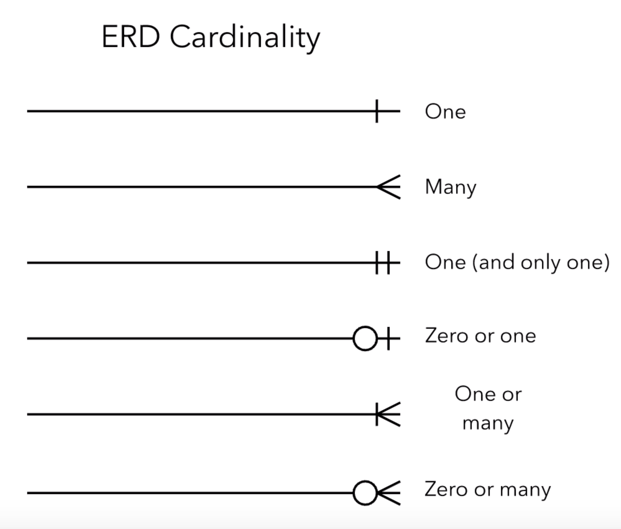

Fig 3.1 E-R cardinality symbols

**E-R DIAGRAM**

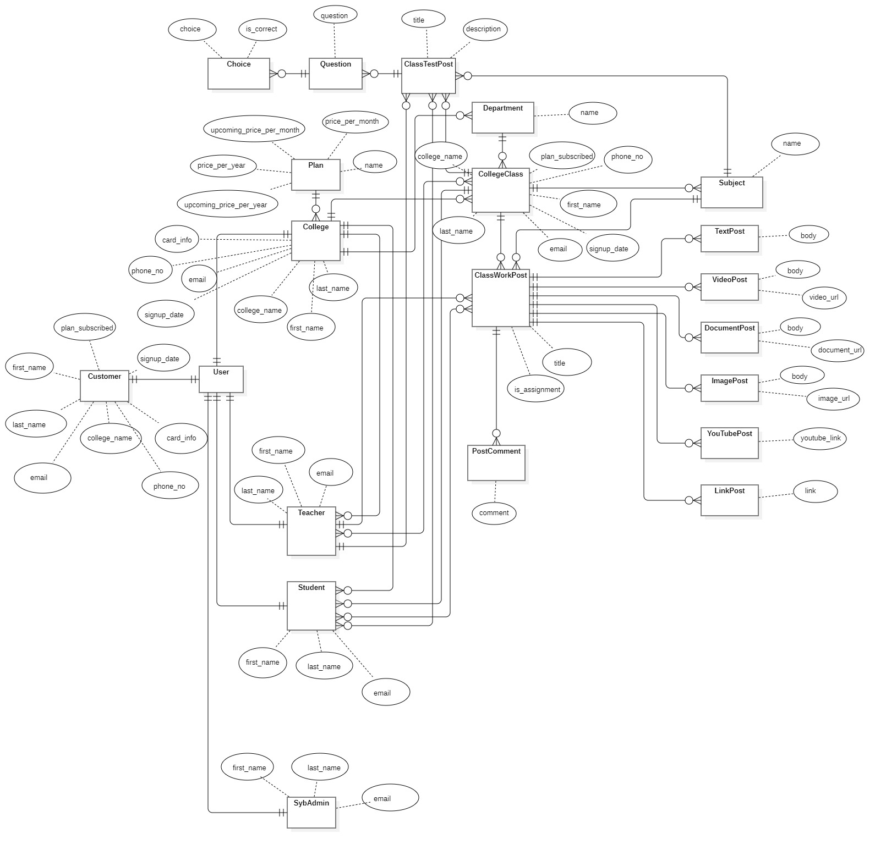

Fig 3.2 E-R diagram

**DATA FLOW DIAGRAM**

* A **Data Flow Diagram (DFD)** is a graphical representation of the “flow” of data through an information system.
* DFDs can also be used for the visualization of data processing (structured design).
* It views a system as a function that transforms the input into desired output.

**SYMBOLS:**

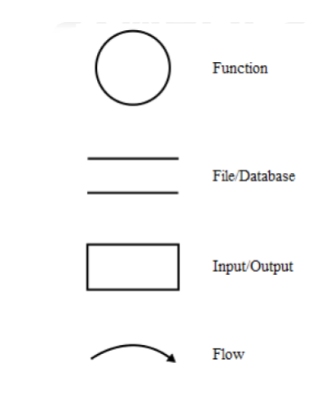

Fig 3.3 DFD symbols

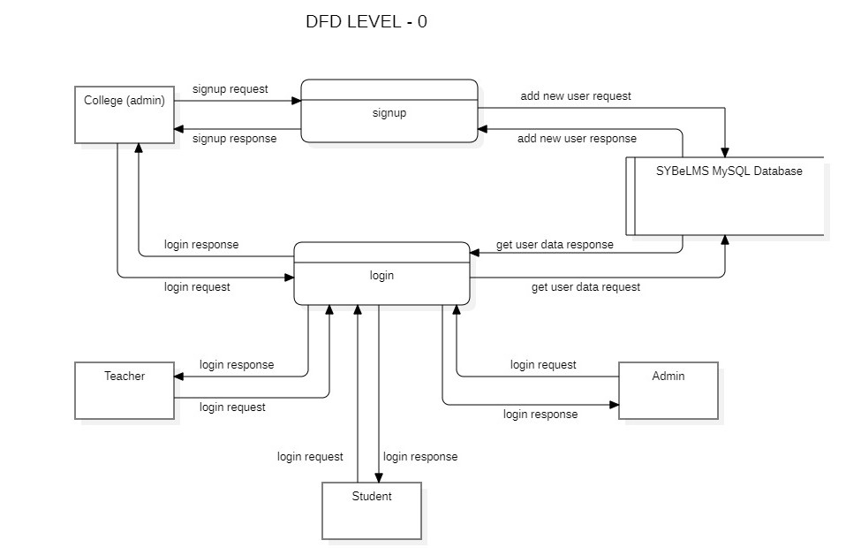

Fig 3.4 DFD Level 0

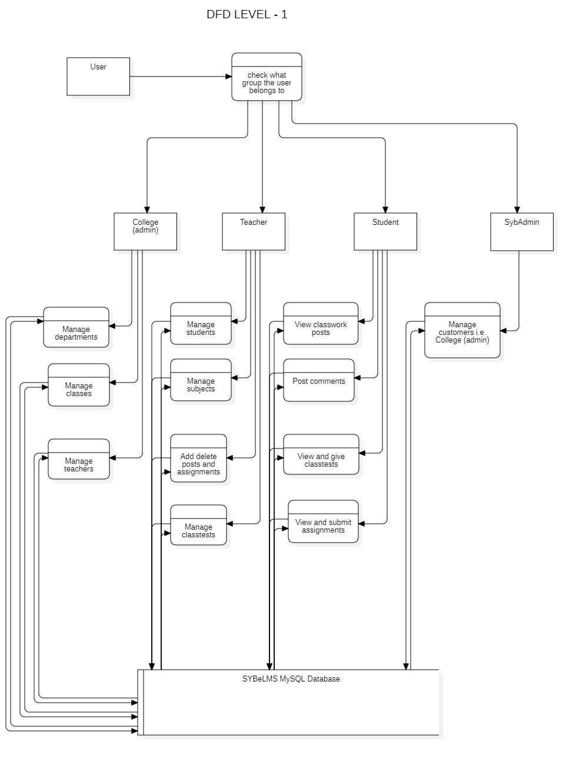

Fig 3.5 DFD Level 1

**OBJECT ORIENTED DIAGRAM**

**CLASS DIAGRAM**

A class diagram is an illustration of the relationships and source code dependencies among classes in the Unified Modelling Language (UML). In this context, a class defines the methods and variables in an object which is a specific entity in a program or the unit of code representing the entity. Class diagrams are useful in all forms of object-oriented programming.

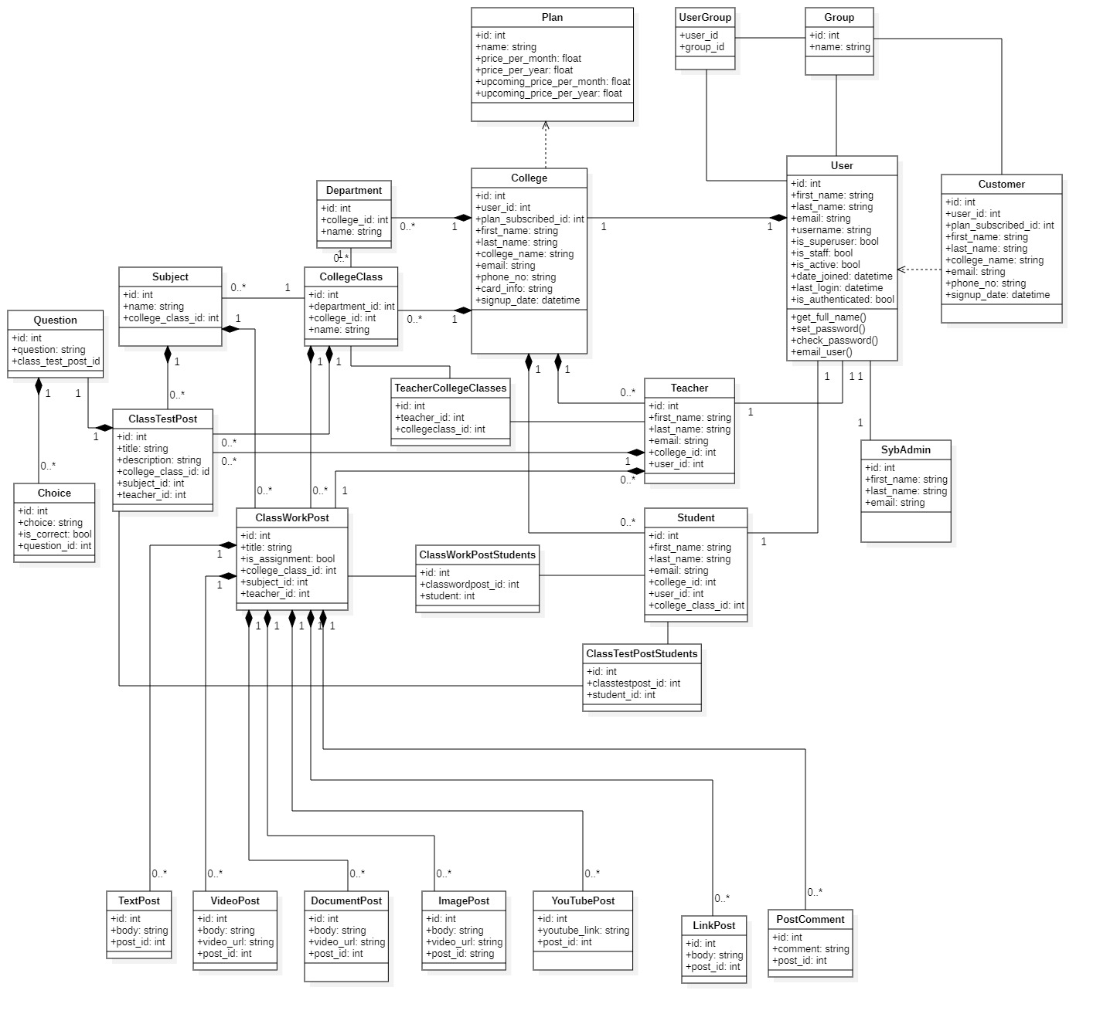

Fig 3.6 Class Diagram

**COMPONENT DIAGRAM**

A component diagram, also known as a UML component diagram, describes the organization and wiring of the physical components in a system. Component diagrams are often drawn to help model implementation details and double-check that every aspect of the system's required functions is covered by planned development.

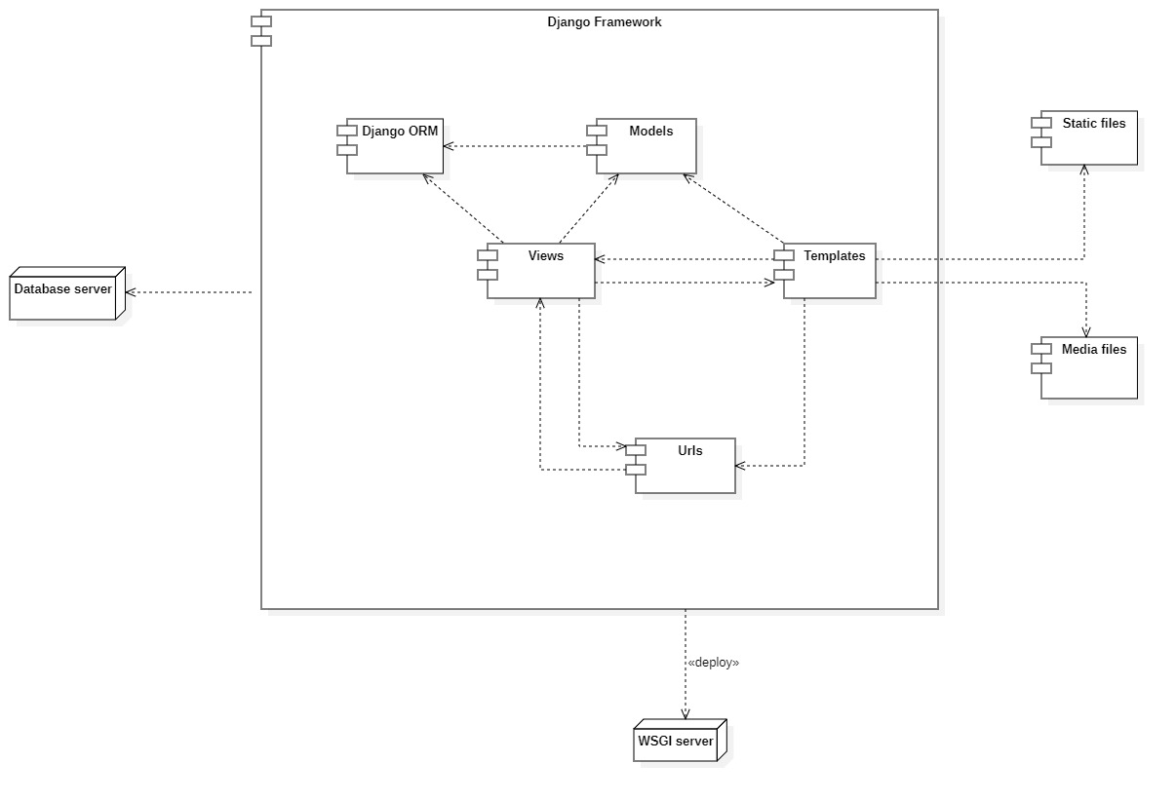

Fig 3.7 Component Diagram

**COLLABORATION DIAGRAM**

A collaboration diagram, also known as a communication diagram, is an illustration of the relationships and interactions among software objects in the Unified Modeling Language (UML). These diagrams can be used to portray the dynamic behavior of a particular use case and define the role of each object.

Collaboration diagrams are created by first identifying the structural elements required to carry out the functionality of an interaction. A model is then built using the relationships between those elements. Several vendors offer software for creating and editing collaboration diagrams.

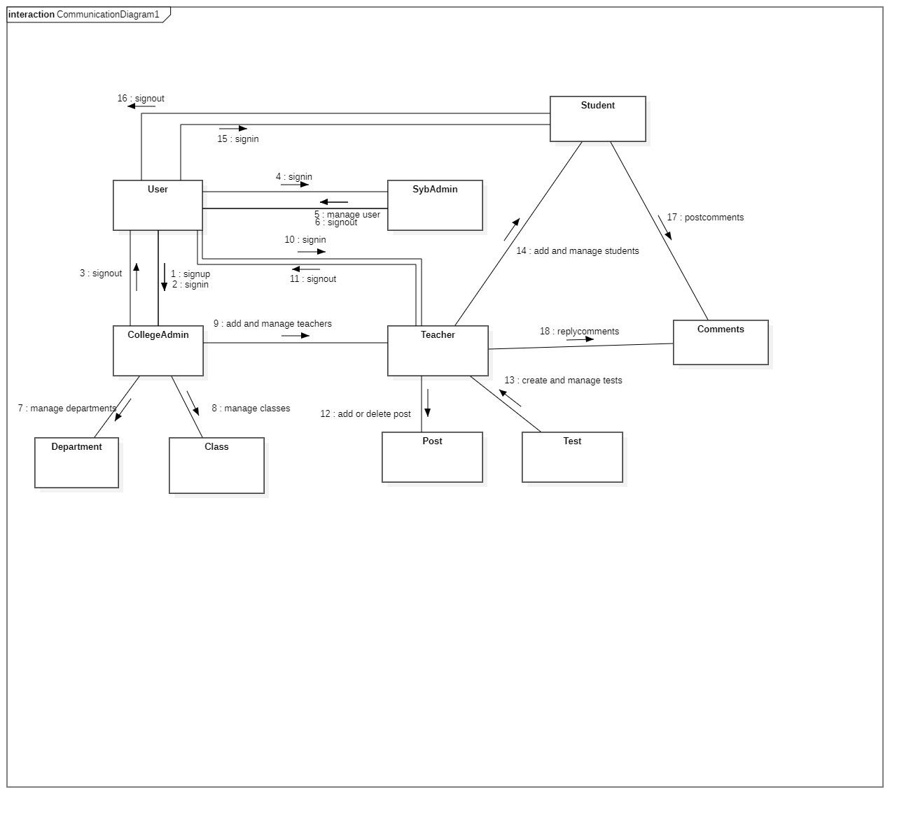

Fig 3.8 Collaboration (Communication) Diagram

**PACKAGE DIAGRAM**

Package diagram is UML structure diagram which shows packages and dependencies between the packages. Model diagrams allow to show different views of a system, for example, as multi-layered (aka multi-tiered) application - multi-layered application model. The following nodes and edges are typically drawn in a package diagram: package, packageable element, dependency, element import, package import, package merge.

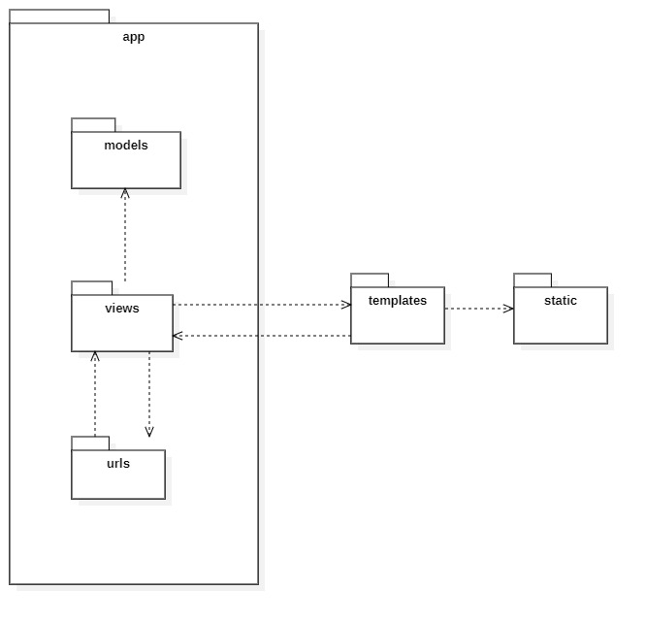

Fig 3.9 Package Diagram

**CHAPTER 4: SYSTEM DESIGN**

**4.1 BASIC MODULES**

BASIC MODULES: -

* SybAdmin module
* College module
* Teacher module
* Student module

**SybAdmin module:** This module oversees all the College users (customers) who have subscribed and are currently using the e-LMS service. This module is integrated to the whole e-LMS system and the ‘sybadmin’ user has control over each and every component of each and every College (customer) user.

**College module:** This module takes the responsibility of management of its staff and courses. This module can manage (add, modify or delete) Teachers, Departments, Classes. This module also has its own dashboard so that a ‘collegeuser’ can see and manage their respective college resources. This module is only for College (collegeadmin) users.

**Teacher module:** This module is only visible to Teacher user and has the responsibility of managing Student users and Subjects as well as creating, updating or deleting posts which are viewable to the Student users on their post feed. This module also has a dashboard from where Teachers can manage their responsibilities.

**Student module:** This module is visible only to the Student user and has a post feed where students can check and interact with the content posted by their respective Teachers. It also has a separate section for class tests and assignments.

**4.2 DATA DESIGN**

**EVENT TABLE**

|  |  |  |  |  |  |
| --- | --- | --- | --- | --- | --- |
| **Event** | **Trigger** | **Source** | **Use case** | **Response** | **Destination** |
| User signup | Signup request sent | College user | Validate payment and user-data and create user | Signup successful or failed | College user |
| User login | Login request sent | User | Validate username and password | Login successful or failed | User |
| Add teacher | Add teacher request | College user | Validate form data and add user | Creation successful or failed | College user |
| Update teacher | Update teacher request | College user | Validate from data and update teacher | Update successful or failed | College user |
| Delete teacher | Delete teacher request | College user | Delete a particular teacher | Deletion successful or failed | College user |
| Add department | Add department request | College user | Validate form data and add department | Creation successful or failed | College user |
| Update department | Update department request | College user | Validate from data and update department | Update successful or failed | College user |
| Delete department | Delete department request | College user | Delete a particular department | Deletion successful or failed | College user |
| Add collegeclass | Add collegeclass request | College user | Validate form data and add collegeclass | Creation successful or failed | College user |
| Update collegeclass | Update collegeclass request | College user | Validate from data and update collegeclass | Update successful or failed | College user |
| Delete collegeclass | Delete collegeclass request | College user | Delete a particular collegeclass | Deletion successful or failed | College user |
| Add student | Add student request | Teacher user | Validate form data and add student | Creation successful or failed | Teacher user |
| Update student | Update student request | Teacher user | Validate from data and update student | Update successful or failed | Teacher user |
| Delete student | Delete student request | Teacher user | Delete a particular student | Deletion successful or failed | Teacher user |
| Add subject | Add subject request | Teacher user | Validate form data and add subject | Creation successful or failed | Teacher user |
| Update subject | Update subject request | Teacher user | Validate from data and update subject | Update successful or failed | Teacher user |
| Delete subject | Delete subject request | Teacher user | Delete a particular subject | Deletion successful or failed | Teacher user |
| Add post | Add post request | Teacher user | Validate form data and add post | Creation successful or failed | Teacher user |
| Update post | Update post request | Teacher user | Validate from data and update post | Update successful or failed | Teacher user |
| Delete post | Delete post request | Teacher user | Delete a particular post | Deletion successful or failed | Teacher user |
| Add classtest | Add classtest request | Teacher user | Validate form data and add classtest | Creation successful or failed | Teacher user |
| Delete classtest | Delete classtest request | Teacher user | Delete a particular classtest | Deletion successful or failed | Teacher user |
| Get classtest | Get classtest data request | Student user | Get classtest data for this particular student | Retrieval successful or failed | Student user |
| Submit classtest | Submit classtest request | Student user | Submit this student’s finished classtest | Submission successful or failed | Student user |
| Add comment | Add comment request | Student user | Validate form data and add comment | Creation successful or failed | Student user |
| Edit comment | Edit comment request | Student user | Validate form data and update comment | Update successful or failed | Student user |
| Delete comment | Delete comment request | Student user | Delete a particular comment | Deletion successful or failed | Student user |
| Update customer (College user) data | Update college data request | SybAdmin user | Validate form data and update college data | Update successful or failed | SybAdmin user |
| Delete customer (College user) data | Delete college data request | SybAdmin user | Delete a particular college data | Deletion successful or failed | SybAdmin user |

**4.2.1 SCHEMA DESIGN**

A **database** is an organized collection of data, generally stored and accessed electronically from a computer system. Where databases are more complex they are often developed using formal design and modeling techniques.

The **database schema** of a database is its structure described in a formal language supported by the database management system (DBMS). The term "schema" refers to the organization of data as a blueprint of how the database is constructed (divided into database tables in the case of relational databases). The formal definition of a database schema is a set of formulas (sentences) called integrity constraints imposed on a database. These integrity constraints ensure compatibility between parts of the schema. All constraints are expressible in the same language. A database can be considered a structure in realization of the database language. The states of a created conceptual schema are transformed into an explicit mapping, the database schema. This describes how real-world entities are modeled in the database.

**Normalization**

Database Normalization is a technique of organizing the data in the database. Normalization is a systematic approach of decomposing tables to eliminate data redundancy (repetition) and undesirable characteristics like Insertion, Update and Deletion Anomalies. It is a multi-step process that puts data into tabular form, removing duplicated data from the relation tables.

Normalization is used for mainly two purposes,

* Eliminating redundant (useless) data.
* Ensuring data dependencies make sense i.e. data is logically stored.

There are different forms of normal forms:

* First normal form (1NF)
* Second normal form (2NF)
* Third normal form (3NF)
* Boyce code normal form (BCNF)
* Fourth normal form (4NF)
* Fifth normal Form (5NF)

**group table**

|  |  |  |  |
| --- | --- | --- | --- |
| **Field Name** | **Data Type** | **Nullable** | **Key** |
| id | int | Not Null | Primary Key |
| name | varchar(150) | Not Null |  |

**user table**

|  |  |  |  |
| --- | --- | --- | --- |
| **Field Name** | **Data Type** | **Nullable** | **Key** |
| id | int | Not Null | Primary Key |
| password | varchar(128) | Not Null |  |
| last_login | datetime(6) | Null |  |
| is_superuser | tinyint(1) | Not Null |  |
| username | varchar(150) | Not Null |  |
| first_name | varchar(150) | Not Null |  |
| last_name | varchar(150) | Not Null |  |
| email | varchar(254) | Not Null |  |
| is_staff | tinyint(1) | Not Null |  |
| is_active | tinyint(1) | Not Null |  |
| date_joined | datetime(6) | Not Null |  |

**user_groups table**

|  |  |  |  |
| --- | --- | --- | --- |
| **Field Name** | **Data Type** | **Nullable** | **Key** |
| id | int | Not Null | Primary Key |
| user_id | int | Not Null | Foreign Key |
| group_id | int | Not Null | Foreign Key |

**elearn_choice table**

|  |  |  |  |
| --- | --- | --- | --- |
| **Field Name** | **Data Type** | **Nullable** | **Key** |
| id | int | Not Null | Primary Key |
| choice | varchar(256) | Null |  |
| is_correct | tinyint(1) | Not Null |  |
| question_id | int | Not Null | Foreign Key |

**elearn_classtestpost table**

|  |  |  |  |
| --- | --- | --- | --- |
| **Field Name** | **Data Type** | **Nullable** | **Key** |
| id | int | Not Null | Primary Key |
| title | varchar(256) | Not Null |  |
| description | varchar(500) | Null |  |
| college_class_id | int | Not Null | Foreign Key |
| subject_id | int | Not Null | Foreign Key |
| teacher_id | int | Not Null | Foreign Key |

**elearn_classtestpost_students table**

|  |  |  |  |
| --- | --- | --- | --- |
| **Field Name** | **Data Type** | **Nullable** | **Key** |
| id | int | Not Null | Primary Key |
| classtestpost_id | int | Not Null | Foreign Key |
| student_id | int | Not Null | Foreign Key |

**elearn_classworkpost table**

|  |  |  |  |
| --- | --- | --- | --- |
| **Field Name** | **Data Type** | **Nullable** | **Key** |
| id | int | Not Null | Primary Key |
| title | varchar(256) | Not Null |  |
| is_assignment | tinyint(1) | Not Null |  |
| college_class_id | int | Not Null | Foreign Key |
| subject_id | int | Not Null | Foreign Key |
| teacher_id | int | Not Null | Foreign Key |

**elearn_classworkpost_students table**

|  |  |  |  |
| --- | --- | --- | --- |
| **Field Name** | **Data Type** | **Nullable** | **Key** |
| id | int | Not Null |  |
| classworkpost_id | int | Not Null | Foreign Key |
| student_id | int | Not Null | Foreign Key |

**elearn_college table**

|  |  |  |  |
| --- | --- | --- | --- |
| **Field Name** | **Data Type** | **Nullable** | **Key** |
|  |  |  |  |
|  |  |  |  |
|  |  |  |  |
|  |  |  |  |
|  |  |  |  |
|  |  |  |  |
|  |  |  |  |
|  |  |  |  |
|  |  |  |  |
|  |  |  |  |