**Documentation for end users**

At the heart of this application is the User. Users can belong to any one of the four groups mentioned below. The signin page is common for all the users. Every user can update their personal info like name, email, password, etc. by going to their profile page by clicking on the navbar button pictured below.



**Types of users/groups:**

1. sybadmin
2. collegeadmin
3. teacher
4. student

**Sybadmin** – This User is responsible for administering the entire application. They can be superusers or regular users. Only a ‘superuser sybadmin’ can create other ‘superuser sybadmin’. Some example of the tasks these users can perform are: create other sybadmin users. Manage (edit/update) collegeadmin users (the Colleges), manage invoices, etc.

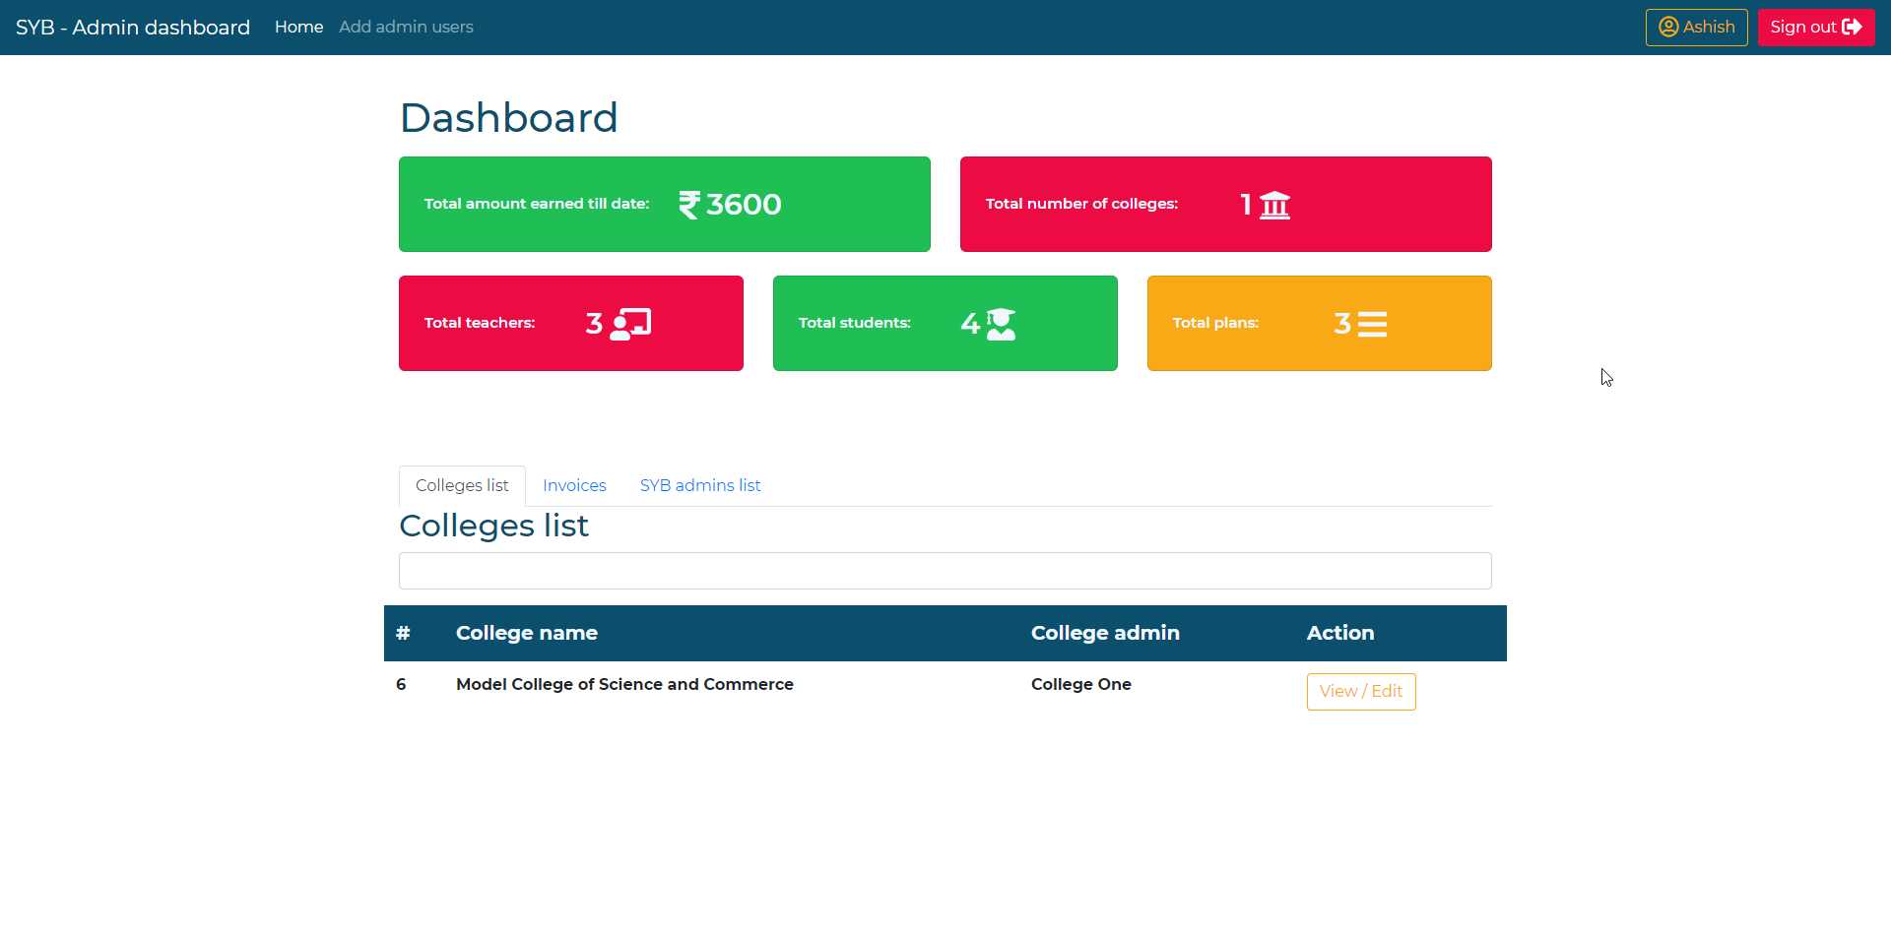

**Sybadmin’s dashboard page**

**Collegeadmin** – This is the customer of the service, the one who will be purchasing the service and who is attached to the invoice. This user can create and manage departments, classes and then create and attach teachers (users belonging to teacher group) to these classes. The can also manage (renew/cancel) their subscription plan.

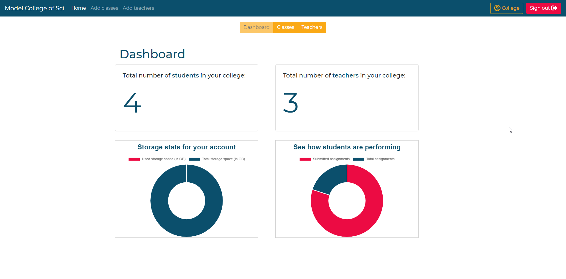

**Collegeadmin’s dashboard page**

**Teacher** – Teachers can create posts which will appear on their own and students’ posts feed. These posts can belong to either of the 3 categories: regular post, assignment post and classtest post. There are 6 types of posts: Text, Video, Document, Image, YouTube and Articles. Teachers can add and assign subjects and students to classes. Teachers themselves can belong to multiple classes. Teachers can also add comments and reply to comments on a post.

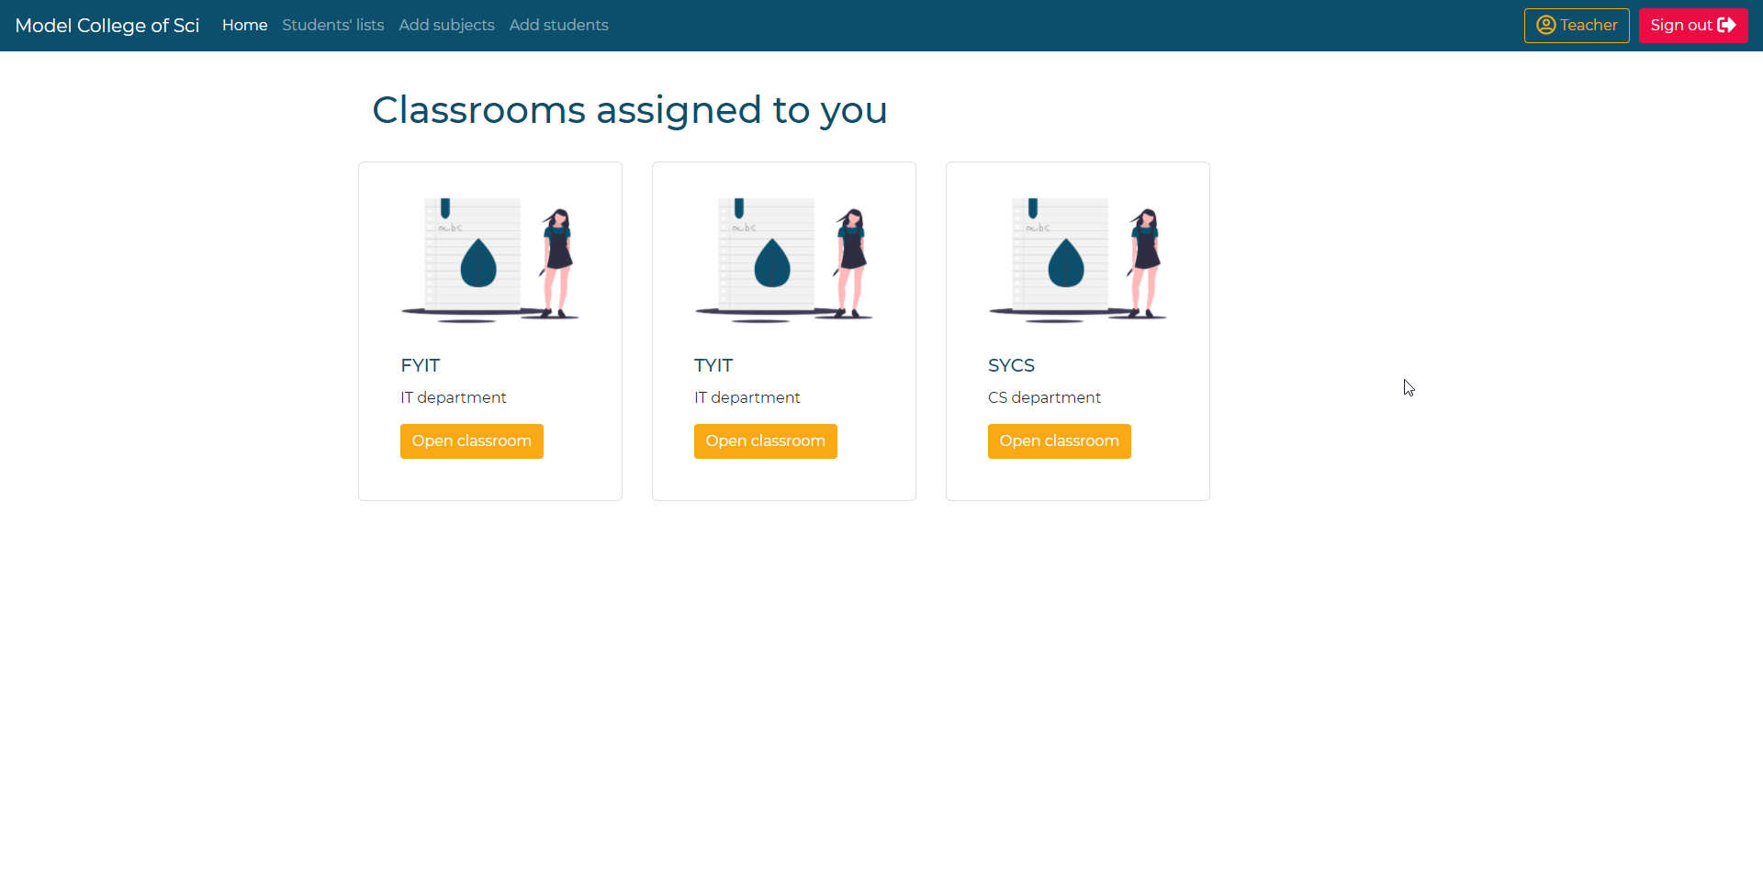

**Teacher’s homepage**

**Student** – Students can access all the posts created by their teachers for them on their home feed. They can also add comments to post and reply to other comments just like teachers. They can solve and submit classtests and assignments.