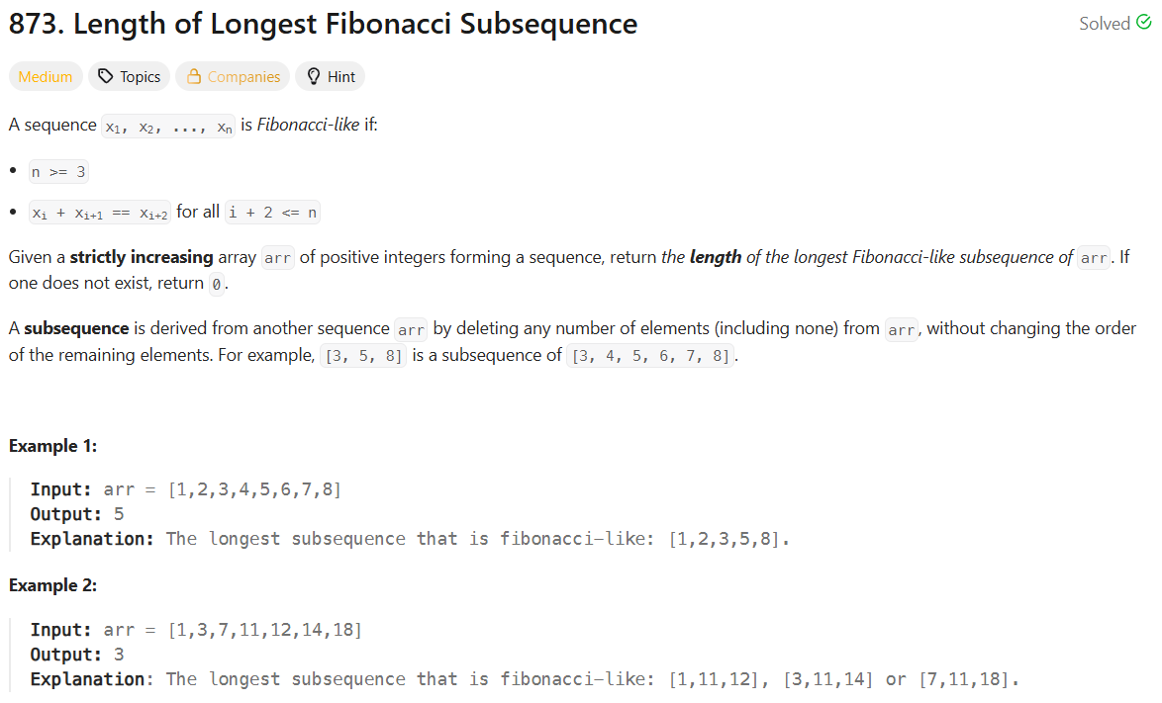

Let $v_{ij}$ denote the length of the longest sequence starting with $f_{0}=a_{i}$ and $f_{1}=a_{j}$. Then, we have the recursion

$$v_{ij}=\left\{\begin{matrix}1+v_{jk} & a_{k}=a_{i}+a_{j} \\ 2 & ∄k\end{matrix}\right.$$