UNIVERSIDADE FEDERAL DE SANTA CATARINA
CAMPUS ARARANGUÁ
COMPUTER ENGINEERING PROGRAM

TECHNICAL DOCUMENTATION
PULSEIRA INTELIGENTE PARA MONITORAMENTO E SEGURANÇA DE IDOSOS COM ESP32 E HOME ASSISTANT

Valentina Ragnini Scherer Col Debella Leiria
Leticia Damasio Veran

Course: Integrative Project I — 2026.1
Araranguá, 2026

1 Introduction and Motivation
Falls are the leading cause of serious injury and accidental death among the elderly, with roughly 646,000 fatal falls per year worldwide (WHO, 2021). Beyond the impact itself, a prolonged time on the floor without help — the so-called “long-lie” — significantly worsens the clinical outcome and can be fatal even when the fall caused no direct injury.
This project, developed in the course Integrative Project I (2026.1) at UFSC Araranguá, proposes a low-cost solution: a wearable ESP32-based bracelet that detects falls automatically through an inertial sensor (MPU6050), triggers an immediate local sound alarm, and sends a persistent notification to the caregiver's phone via the MQTT protocol and the Home Assistant platform. The elderly person can also trigger a manual emergency button.

2 System Overview
Elderly people living alone are at risk of falling without immediate assistance. The system addresses this risk with two complementary mechanisms: automatic detection by the sensor and manual activation by the emergency button. The diagram below illustrates the complete flow, from the battery and the wrist sensor to the notification on the caregiver's phone.
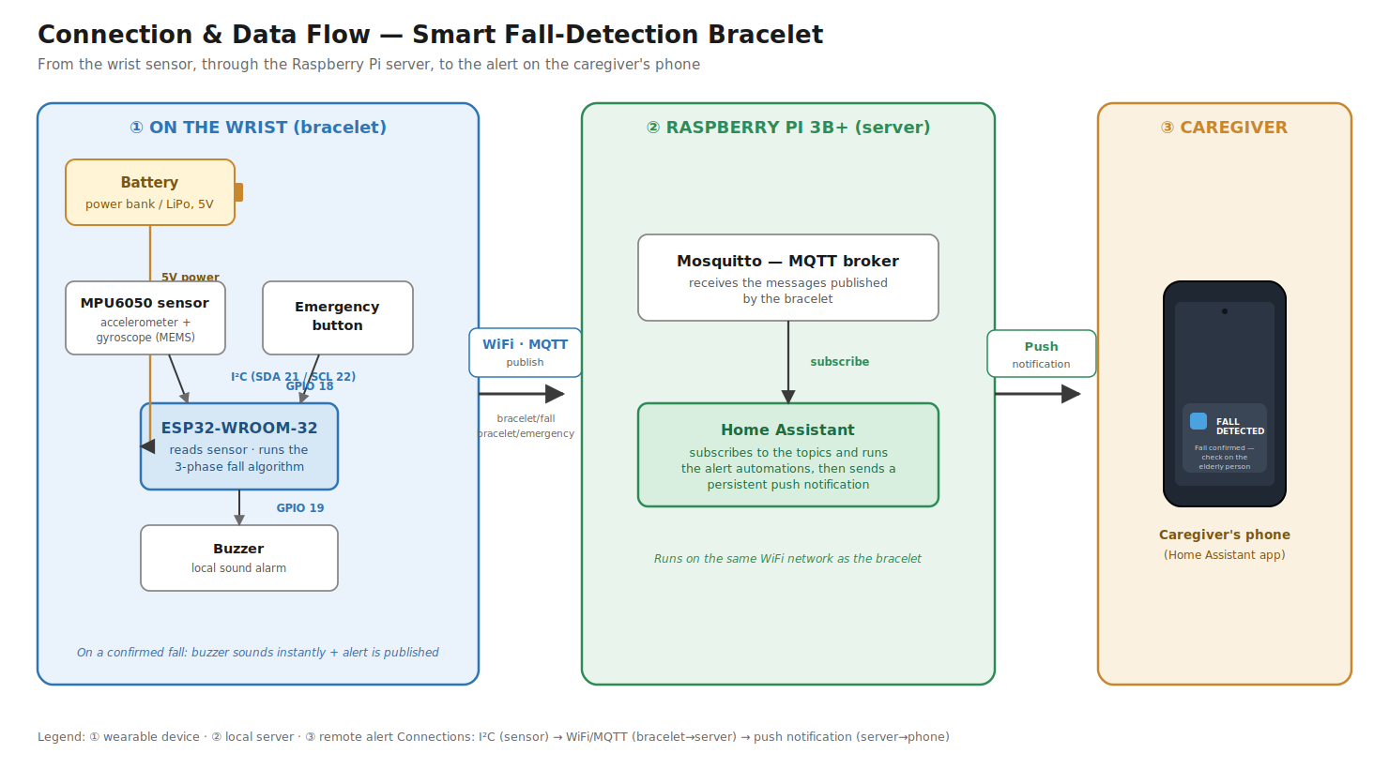
Figure 1 — Connection and data flow: from the wrist sensor to the alert on the phone.

3 Hardware

3.1 Components
Component | Function | Note
ESP32-WROOM-32 | Reads the sensor, runs the algorithm, communicates via WiFi/MQTT | Any ESP32 DevKit
MPU6050 (GY-521) | Accelerometer + gyroscope on the wrist | I2C communication
Active 5V buzzer | Local sound alarm | Sounds when powered (no PWM)
Push button | Manual emergency trigger | 4 pins, only 2 used
Raspberry Pi 3B+ | Home Assistant server + MQTT broker | 32GB SD card

3.2 MPU6050 sensor and scale choice
The MPU6050 integrates a tri-axial accelerometer and gyroscope (MEMS) in a single chip, with 16-bit conversion and I2C communication (InvenSense, 2013). The accelerometer scale was set to ±4g (sensitivity of 8,192 LSB/g). Real falls produce impact peaks between 2.5g and 3.8g; a ±2g scale would saturate exactly at the impact, distorting the reading. The internal digital filter (DLPF) was set to ~94 Hz, preserving the impact peak (a 50–100 ms event) without excessive noise.

3.3 Wiring (pinout)
From | To (ESP32) | Note
MPU6050 VCC / GND | 3.3V / GND | Power
MPU6050 SCL / SDA | GPIO 22 / GPIO 21 | I2C bus
Buzzer + / − | VIN (5V) / GPIO 19 | LOW = on (inverted)
Button pin 1 / pin 2 | GPIO 18 / GND | Internal pull-up

3.4 Final assembly
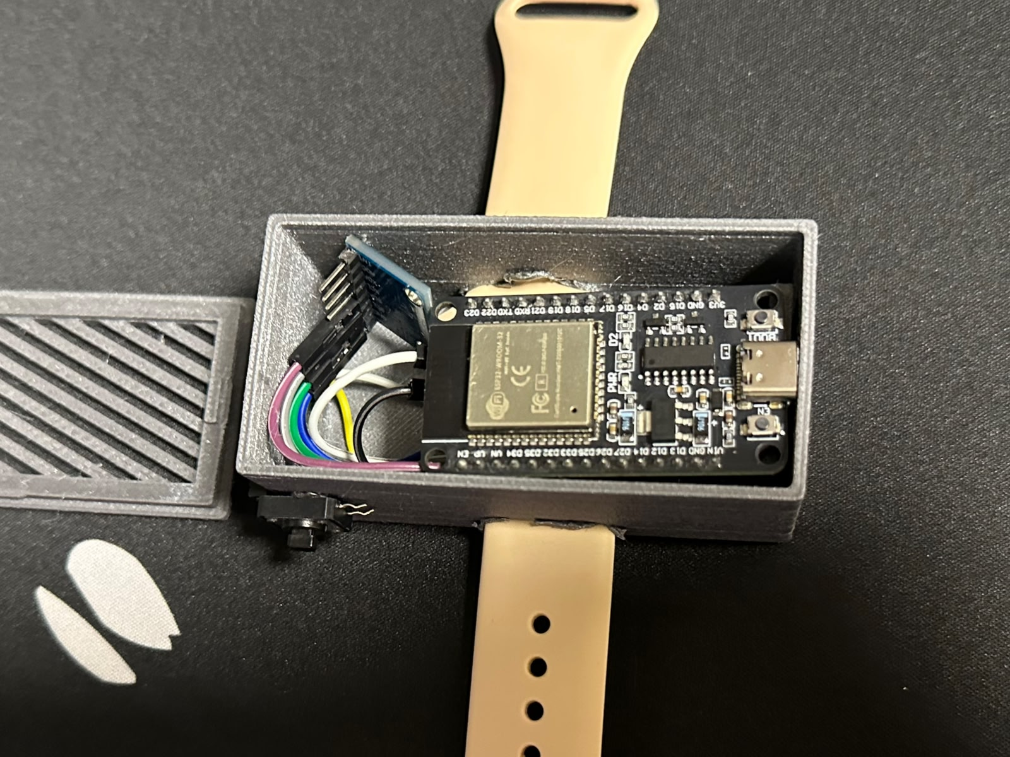 | 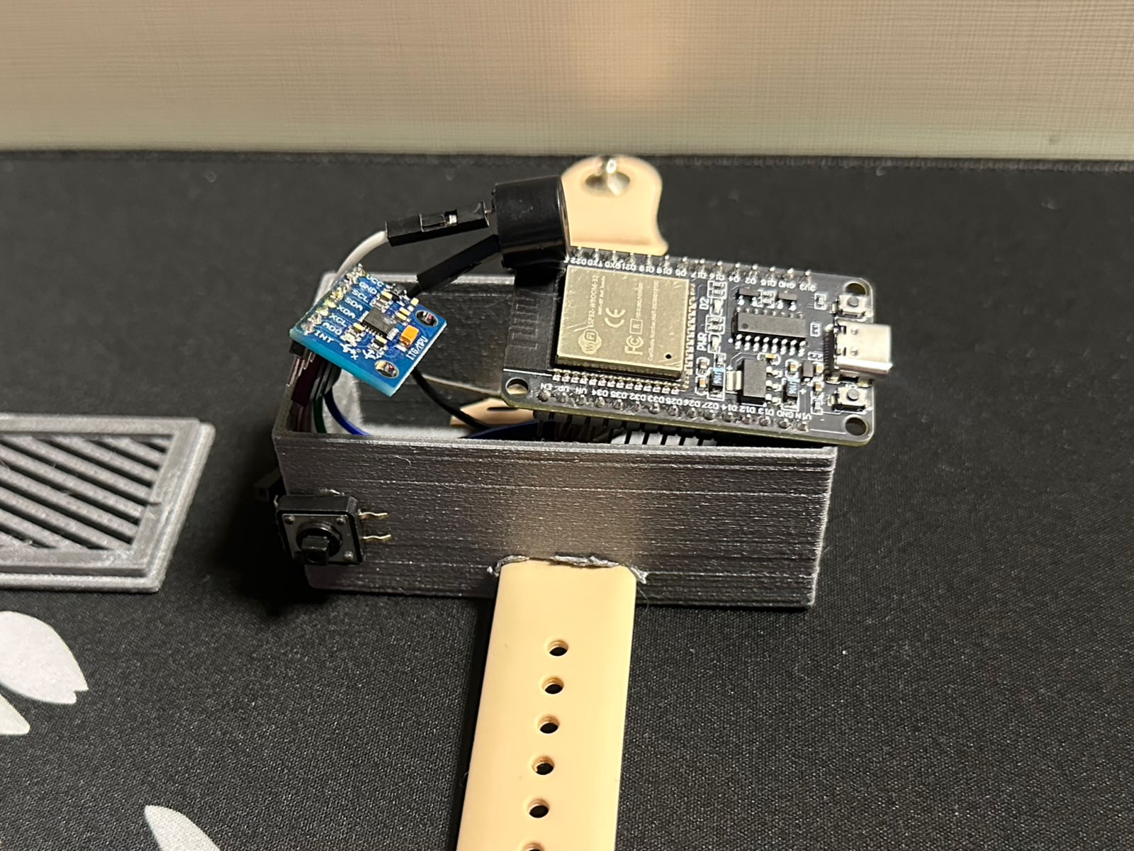
Figure 2 — Assembly: ESP32, MPU6050, jumpers and buzzer inside the 3D-printed case.
The case is a simple 3D-printed prototype (vented lid + base), sized to hold the ESP32 DevKit with the sensor and buzzer on jumper wires. Because it is only a prototype, it came out bulky for a wrist device and no 3D model (STL) is published; a more compact case is future work.

4 Firmware

4.1 Structure
The firmware was written in C++ in the Arduino IDE 2, using the Wire (I2C), WiFi and PubSubClient (MQTT) libraries. Network credentials live in a separate config.h file, kept out of version control for security.

4.2 Fall-detection algorithm (3 phases)
The algorithm is threshold-based, the approach validated by Bourke and Lyons (2008) and Al-Dahan et al. (2016). Since a real fall is not a single threshold crossing, the algorithm chains three sequential phases:
- Phase 1 — Free fall: the acceleration magnitude drops below ~0.30g together with a high jerk (sharp change), indicating the abrupt onset of a fall.
- Phase 2 — Impact: within 1 s, the magnitude exceeds ~1.16g as the body hits the ground.
- Phase 3 — Rest: after the impact, the system waits ~3 s and confirms the body is still, distinguishing a real fall from a sharp gesture.
The gyroscope provides a confidence bonus: rotation detected during free fall raises the confidence. The system reports high confidence (3 phases + rotation) or medium confidence (3 phases without rotation).

4.3 Calibrated parameters (±4g scale)
Parameter | Value | Justification
Free-fall threshold | 2,500 LSB | Real data: 1,691–2,833 LSB
Impact threshold | 9,500 LSB | Real data: 10,047–15,994 LSB
Rest threshold | 9,500 LSB | Must be > 8,192 (1g at rest)
Gyroscope threshold | 10,000 LSB | ~152°/s on the ±500°/s scale
Jerk threshold | 35,000 LSB/s | Sharp onset of the fall
Time window | 1,000 ms | Free fall to impact
Rest duration | 3,000 ms | Final confirmation

5 Server — Home Assistant and MQTT
The server is a Raspberry Pi 3B+ running Home Assistant OS with the Mosquitto MQTT broker. The ESP32 publishes to the topics below; automations in Home Assistant react and send a persistent notification to the caregiver's phone (which does not disappear until acknowledged).
Topic | Payload | When
bracelet/fall | high_confidence | Fall with detected rotation
bracelet/fall | medium_confidence | Fall without detected rotation
bracelet/emergency | manual_button | Emergency button pressed
bracelet/status | online | ESP32 connected to the broker

6 Results and Testing

6.1 Calibration
Thresholds were calibrated from real readings captured on the device (±4g scale, ~8,192 LSB/g, rest ≈ 8,192 LSB):
Event | Measured range (LSB) | Threshold chosen
Free fall | 1,691 – 2,833 | 2,500
Impact | 10,047 – 15,994 | 9,500
Rest (body still) | ≈ 8,192 (1g) | 9,500 (upper bound)

6.2 Algorithm evolution
Version | Approach | Outcome
1 | Single threshold | Too many false positives
2 | Reading count | Still confused gestures with falls
3 | Two phases (free fall + impact) | Better, but sharp gestures slipped through
4 (final) | Three phases + gyroscope | Reliable separation of falls and gestures

6.3 Functional validation
- The single startup beep confirms the buzzer and power are working.
- Simulated falls produced the MQTT messages high_confidence / medium_confidence and the matching beep patterns.
- The emergency button produced manual_button and 10 beeps.
- The MPU6050 auto-recovery re-initialized the sensor after induced I2C failures.
- Everyday gestures did not trigger Phase 1, having no free-fall signature.
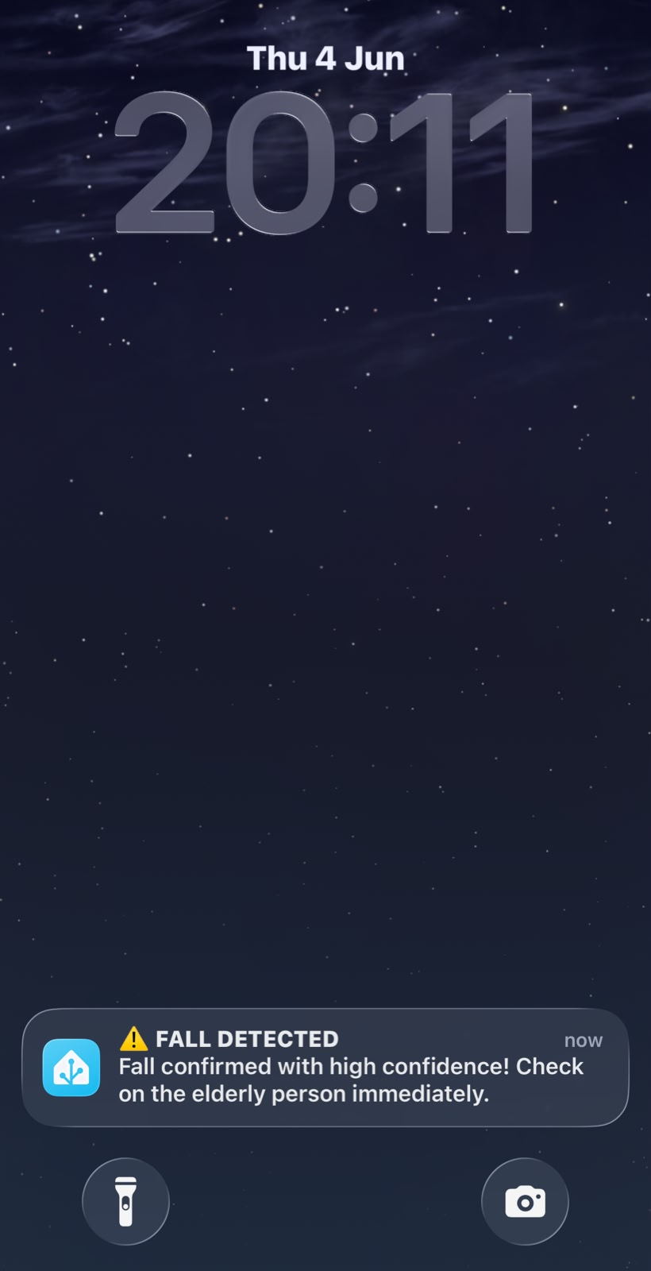 | 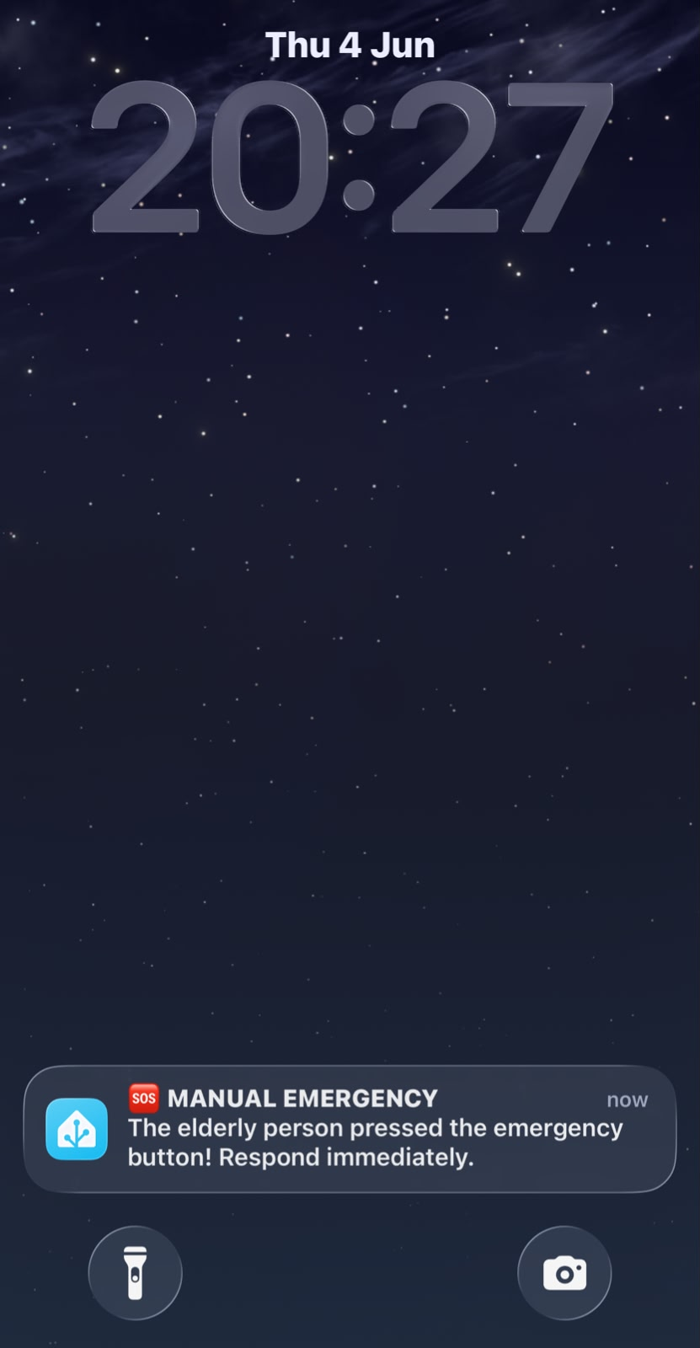
Figure 3 — App screens: fall (high confidence) and manual emergency notifications.

7 Conclusion and Future Work
The system reliably detects falls and notifies the caregiver, meeting the functional requirements of automatic detection, emergency button, sound alarm and communication with Home Assistant. Future work includes: a more compact 3D-printed case, power management for longer autonomy, the optional vital-signs sensors (RF01), a status LED, and a periodic heartbeat to detect disconnections.

References
AL-DAHAN, Z. T.; BACHACHE, N. K.; BACHACHE, L. N. Design and Implementation of Fall Detection System Using MPU6050 Arduino. In: Inclusive Smart Cities and Digital Health (ICOST 2016). Lecture Notes in Computer Science, v. 9677. Springer, Cham, 2016.
BANKS, A.; GUPTA, R. MQTT Version 3.1.1. OASIS Standard, 2014.
BOURKE, A. K.; LYONS, G. M. A threshold-based fall-detection algorithm using a bi-axial gyroscope sensor. Medical Engineering & Physics, v. 30, n. 1, p. 84–90, 2008.
ESPRESSIF SYSTEMS. ESP32 Technical Reference Manual. Espressif Systems, 2023.
HOME ASSISTANT. Home Assistant Documentation. Nabu Casa, 2023.
INVENSENSE. MPU-6000/MPU-6050 Product Specification, Revision 3.4. InvenSense, 2013.
WORLD HEALTH ORGANIZATION. Falls. WHO, 2021.

