**Udacity GPT**

Welcome to Udacity GPT, a friendly and helpful AI-powered chatbot designed to assist students in their learning journey. Udacity GPT is available to provide support and answer questions related to your track.

Using Udacity GPT is straightforward. Students can simply type their questions or topics of interest, and the chatbot will provide informative and helpful responses. Whether students need clarification on content , or assistance with any aspect of their learning experience, Udacity GPT is here to help.

Main Features

**Informative Responses:** Udacity GPT provides informative and detailed responses to student queries, offering explanations, examples, and step-by-step guidance.

**Concept Clarification:** Students can ask Udacity GPT to clarify complex concepts from your track or any other topic, helping them deepen their understanding.

**Learning Resources:** The chatbot can recommend additional learning resources, such as articles, videos, or tutorials, to supplement students' understanding and enhance their knowledge.

**24/7 Availability:** Udacity GPT is available round the clock, allowing students to seek support and guidance whenever they need it, regardless of their time zone.

**Non-Technical Assistance:** Students can rely on Udacity GPT for non-technical questions or concerns, including help with navigating the Udacity Support Community or managing support tickets.

**Personalized Support:** Udacity GPT aims to provide personalized support tailored to each student's needs, ensuring a more effective and efficient learning experience.

**Friendly and Approachable:** The chatbot is designed to be friendly and approachable, creating a comfortable environment for students to ask questions and seek assistance.

Here is a graphic for reference when you are considering the different types of AI. Much like a square is a rectangle but a rectangle is not a square; many of these categories are refinements of the others.

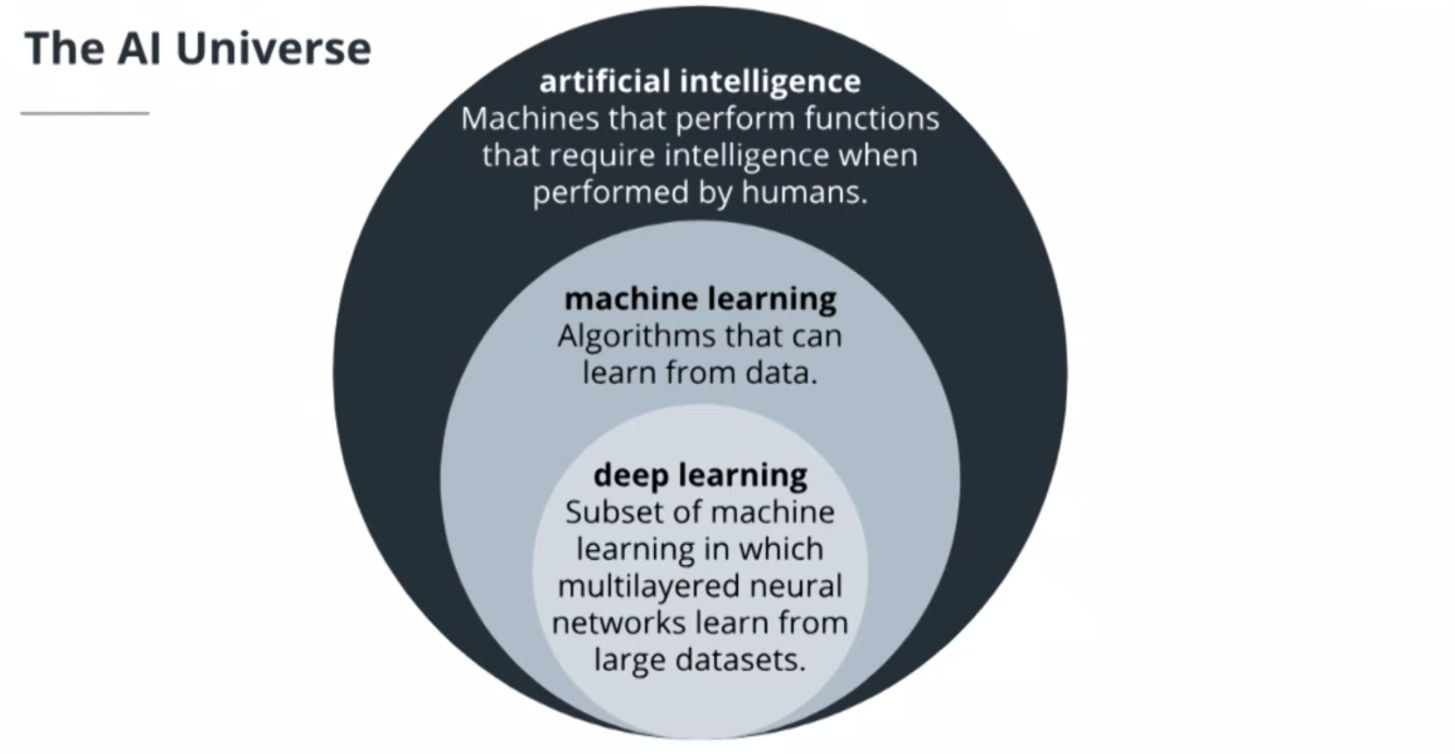

* **FlOps -** floating point operations, which computers use to do any calculation (from storing text to doing multiplication!)

**Supervised vs. Unsupervised Learning**

When you are thinking about using machine learning to solve a task, the type of algorithm you’ll use will generally depend on the data you are given. Before approaching a task, you should ask two questions: Does the data contain labels, such as true classes? Is the data continuous?

For example, if you are given images with true class labels, these labels indicate that you’ll likely use a supervised learning method that learns to associate patterns in the data with the given labels. This data is also discrete since there are a limited number of image classes. These two qualities: supervised learning and discrete data mean that you should use a classification algorithm to solve this task.

It may be helpful to consult the matrix below that addresses all kinds of data analysis cases.

* **Discrete** data is data that you can count and it has a finite amount, say the number of image classes or clothing item types.
* **Continuous** data is often numerical data that takes a large range of values.

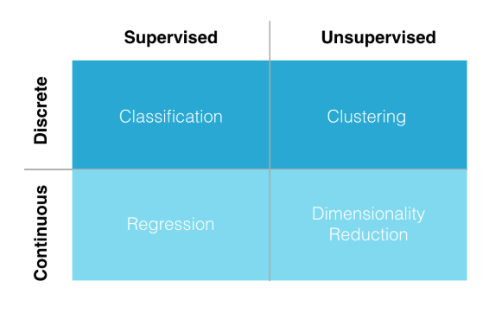

* **Human in the Loop** (HITL) refers to having a human-moderator or data annotator that can help with quality control of a product.

**Neural Networks**

Welcome to Introduction to ChatGPT!

This learning journey is designed to give you hands-on experience with a Large Language Model (LLM) developed by [**OpenAI(opens in a new tab)**](https://openai.com/) called ChatGPT that can generate human-like text.

We are experiencing a transformative period in technology, riding a wave of advancements in Artificial Intelligence. At the forefront of this wave lies a subset of artificial intelligence called **Generative AI**. These AI models can create something new from the patterns they've learned - producing human-like text, composing music, writing code, or generating images. ChatGPT is a Generative AI application.

Beyond its ability to generate text, ChatGPT represents a significant leap in how we interact with machines and how they can aid us in tasks that were traditionally believed to be human-centric.

Whether you're aiming to automate certain aspects of your work, improve your productivity, or have a curious mind intrigued by the potential of AI, you'll learn to use ChatGPT as a tool to accomplish many different tasks.

Throughout our journey, we'll investigate ChatGPT's capabilities:

* We'll explore its underlying technology, learn how to craft effective prompts, and understand how to interpret its outputs.
* We'll discuss its practical applications and how it can be an incredibly powerful tool for tasks ranging from drafting emails and articles to generating creative content.

By the end, you will have a comprehensive understanding of ChatGPT and a new skill set that enables you to harness the power of this AI model. You'll be equipped to navigate the potential applications and limitations of ChatGPT, with an added awareness of the ethical considerations when using AI.

Let's explore a world where machines can mimic human language, generate creative outputs, and transform our work. How can we leverage this potential to elevate our work and productivity? Let's find out!

**Terms**

**Generative AI**: AI models that can create something new from the patterns they've learned - producing human-like text, composing music, writing code, or generating images.

ChatGPT is a variant of the GPT (Generative Pretrained Transformer) language model developed by OpenAI. It's designed to generate human-like text based on the input it's given. The goal of ChatGPT is to generate responses that are indistinguishable from those a human might produce in a similar context.

What is ChatGPT?

Developed by OpenAI, ChatGPT is a sophisticated AI model that can understand and generate text. You can interact with it using:

* The ChatGPT web app
* The ChatGPT mobile app
* Programmatically through OpenAI APIs

ChatGPT operates using AI technology called Transformer neural networks, particularly a variant called GPT or **Generative Pre-trained Transformer**.

You interact with ChatGPT through **prompts**, which are instructions given in natural language. The AI *doesn't replicate information verbatim from its training data* - it generates unique combinations based on patterns and structures it has learned.

ChatGPT generates unique responses by learning patterns and structures from a vast amount of human-written text. It predicts the next word in a given text based on probabilities. For every potential next word, it creates a ranked list, continuously evaluating the context to determine the most appropriate next word.

The model operates with a degree of randomness while generating responses. This randomness, controlled by a parameter referred to as '**temperature**,' influences the selection of words in responses.

* At lower temperatures, more likely words are chosen
* at higher temperatures, less probable but grammatically correct words might be chosen. This can lead to creative and unique responses.

ChatGPT operates using a type of AI called a Transformer neural network, specifically a variant called GPT or generative pre-trained Transformer.

**Terms**

**Prompts**: instructions given to ChatGPT in natural language.

**Temperature**: In the context of AI language models like ChatGPT, "temperature" is a parameter that regulates the randomness of the model's output. A lower temperature leads to more likely, or predictable word choices, while a higher temperature allows for more creative word choices.

What can you use ChatGPT for?

ChatGPT is effective for drafting emails or other pieces of writing, creating written content, translating languages, and more. Other uses for ChatGPT include:

* **Content Generation:** Digital marketers, bloggers, and copywriters can use ChatGPT to generate ideas for blog posts, social media content, ad copy, and more. By providing a topic or a rough outline, users can get a draft they can then refine, saving them time in the content creation process.
* **Customer Service:** Companies can integrate ChatGPT into their customer service operations to handle frequently asked questions. This reduces the workload on customer service representatives and provides customers with immediate responses, improving customer satisfaction.
* **Productivity Tools:** Developers and software engineers can use ChatGPT as a coding assistant to suggest code snippets or troubleshoot code issues. It can help make their programming workflow more efficient.
* **Business Intelligence and Data Analysis:** Data analysts can use ChatGPT to write queries or generate reports. By asking ChatGPT to write a SQL query to extract specific information or to describe the insights from a data visualization, analysts can save time and focus on more complex tasks.

What's the difference between GPT-3.5 and GPT-4 in ChatGPT?

GPT-3.5 is the free, fastest version of the ChatGPT Generative pretrainted transformer AI model in ChatGPT.

GPT-4 is a slower version of the Generative Pretrained Transformer model in ChatGPT that has more capabilities and has undergone additional training. In order to use this model, you'll need to pay a monthly subscription fee.

**Generative AI** is a subset of machine learning, which in turn is a subset of AI. It represents a significant step forward in AI technology, moving beyond simply predicting outcomes to creating original outputs.

Show TranscriptSummarize Video

learned during its extensive machine learning training.

AI is about creating machines that can mimic human intelligence. A significant field of AI is **machine learning (ML)**, which focuses on creating systems that learn from data rather than explicit programming. Classic machine learning predicts specific outputs. Generative AI takes a step further to generate new, novel content similar to the data it has learned from.

Just as a child learns a language by immersion in conversations, exposure to words, idioms, facts, and contextual cues, and gradually understanding grammar and the world, a generative AI like Chat GPT learns by exposure to vast amounts of text data and *generates* responses based on patterns it learned during its extensive machine learning training.

**Large Language Models (LLMs)** are a subset of generative AI that understand complex language patterns and generate text closely mirroring human language. OpenAI's GPT models (GPT-3.5 and GPT-4) are f**oundational models**. These models serve as the base for more specialized models and applications. For example, you can add data about a business or product to the GPT-3 model (called fine-tuning) to create specific business applications like customer service chatbots, automated report writing, or personalized marketing messages.

Generative AI generates new content: Unlike traditional ML models that predict specific outputs, generative AI can produce new, novel content that is similar to the data it was trained on.

**Terms**

**Machine learning (ML)**: systems that learn from data rather than explicit programming.

**Generative AI**: A subset of machine learning capable of generating new, novel content similar to the data it has learned from.

**Large Language Models (LLMs**): A subset of generative AI that learn complex language patterns and generate text closely mirroring human language.

**Foundation Models**: Generative AI models which serve as the base for more specialized models and applications

**ChatGPT Datasets and Training Process**

Training Chat GPT involves a multi-stage process using text data collected from various Internet sources and a method called **Reinforcement Learning from Human Feedback (RLHF).**

* A machine learning model was designed to *generate the next word in a sentence or paragraph* in a coherent way. This led to the creation of the GPT model and its successors, including GPT-3, which improved over time through enlarging data sets and model size. GPT-3 wasn't trained for a specific task, its training on a vast data set enabled it to perform diverse tasks when prompted appropriately.
* Then, the GPT models were trained to follow instructions through a curated data set of human-generated responses using RLHF. This process involves humans rating multiple outputs from the model from least to most desirable and providing the model with scores based on the quality of its content. This led to the creation of Instruct GPT, a model that could perform tasks and generate responses based on detailed instructions provided in the input.
* The next phase was to train the model to converse, enabling the creation of ChatGPT. The training data included dialogues. Further fine-tuning with reinforcement learning enabled the model to handle conversations in a human-like way.

As impressive as Chat GPT is, it still has limitations like generating false content and reflecting societal biases. Ensuring the safe and beneficial use of AI is a major concern. The fine-tuning process involves important safety measures and implementing safety protocols to ensure the model's responsible use. You'll see this safety layer in the model's responses to various prompts, like asking for medical advice.

Remember, Chat GPT is a tool and doesn't have beliefs or intentions. It generates responses based on patterns it learned during its training.

**Conversational AI**

Conversational AI is a name given to AI systems that understand and respond to user instructions and questions in a coherent, engaging - or conversational - way!

**Conversational AI** systems allow computers to understand, process, and respond to human language naturally and meaningfully. Thanks to its language understanding and generation capabilities, ChatGPT serves as a powerful tool for building conversational AI systems.

* ChatGPT's training was fine-tuned using a dataset of conversations. It learned to respond in dialogue and manage a conversation over multiple turns. A **conversation turn** is one back-and-forth dialogue between the AI assistant and the user.
* Within a single conversation, GPT models are designed to consider all of the text in the history of the conversation - the conversation context- when generating a response. This additional training allows the model to answer follow-up questions, correct mistakes, and challenge incorrect premises, all of which contribute to its ability to converse in a more human-like way.
* This makes ChatGPT a specialized tool for conversational tasks.

You might use ChatGPT to build a virtual assistant or a customer service bot because it responds in a human-like way.

ChatGPT can manage a conversation over multiple turns, taking into account the history of the conversation when generating a response. This makes it feel like you're speaking to a human who's paying attention and remembering what you said.

**Terms**

**Conversational AI**: A name given to AI systems that understand and respond to user instructions and questions in a conversational way.

**Context-awareness**: In Conversational AI, context-awareness means taking into account all the text in the history of the conversation when generating a response.

**Conversation Turn:** One back-and-forth dialogue between the AI assistant and the user in a Conversational AI system.

**ChatGPT Large Language Model Components**

Conversations in Chat GPT have some key components. You can leverage these components to get higher quality and more effective responses from the model.

**System Messages**

* These are messages used to set the behavior of Chat GPT. For example, a system message might say, 'You are a helpful financial assistant.' This message guides Chat GPT to respond using this role or behavior throughout the conversation.

**Roles**

* In a conversation with Chat GPT, there are typically two roles: the user and the assistant. The user refers to you or the one asking questions or making requests. The assistant is Chat GPT, which responds based on the user's prompts.

**Prompts**

* These are the instructions or inputs we give to Chat GPT. The model uses the prompt to generate a relevant response.

**Tokens**

* These are the chunks of text that the model reads at a time. A token can be as short as one character or as long as one word.

**Context Window**

* This is an important component. It consists of tokens that are in the recent history of the conversation that the model considers when generating a response. In Chat GPT, the model can remember thousands of tokens in its context window. Anything beyond this limit gets cut off and won't be considered by the model.

**Responses**

* These are the outputs generated by Chat GPT in reply to a user's prompt.

When interacting with Chat GPT, you'll deal with prompts, roles, system messages, the context window, tokens, and responses. Understanding these components helps you get the most out of your conversations.

Utilize system messages, roles, prompts, and the context window to have suddessful conversations with ChatGPT. These components guide the assistant's behavior, impact it's responses, and manage the model's memory and response generation process.

**Prompt Designs:**

**Few-Shot Prompts**

Example:

* Give ChatGPT examples of Python functions and their reviews
* Then assign it the task of reviewing a specific function. From this, we learn that providing multiple examples can help shape the response from the AI model.

**One-Shot Prompts**

Example

* ChatGPT is given one example of how to calculate sales for a certain quarter (Q1).
* Then ask it to perform the same task for a different quarter (Q2). This shows that even a single example can guide the model's output.

**Zero-Shot Prompts**

* A zero-shot prompt is giving ChatGPT a task without any specific examples related to the task. Create a catchy slogan for a new eco-friendly, solar-powered car.
* This prompt strategy is helpful to see how the model relies on prior training to generate responses.

Prompt Design Strategy Tips

* **Few-Shot Prompts**: For complex tasks that require a specific format or domain knowledge, providing multiple examples can help guide the model's response.
* **One-Shot Prompts**: If you have a relatively straightforward task that doesn't require many examples, a one-shot prompt with one example can be enough.
* **Zero-Shot Prompts**: A zero-shot prompt without examples can be used for more general tasks where you trust the model to use its pre-training knowledge.

The quality of the task completion depends on the clarity of your instructions and the relevant examples you provide. Experiment with these three prompt strategies to determine which works best for your task.

**Practice: Prompt Design**

Now you'll put your prompt design skills to the test! Make sure you can access ChatGPT and practice designing prompts to solve these problems. Focus your learning on structuring your prompts to get the most useful responses from the AI model.

Customer Support Query

In this scenario, you have a customer support representative who needs to respond to common customer inquiries. The ChatGPT can assist in drafting responses.

Try this one-shot prompt:

Example:

Customer: "I've been charged twice this month for my subscription. Can you help?"

Agent: "I'm sorry to hear that. Let me check your account and I'll get back to you as soon as possible."

Question:

Customer: "I can't log into my account. Can you assist me?"

Market Research Analysis

In this scenario, an analyst wants to use ChatGPT to generate insights about different companies based on specific data points.

Try this few-shot prompt:

Example 1:

Input:

{

"company": "Company A",

"revenue": 1000000,

"employeeCount": 500,

"industry": "Technology"

}

Output:

{

"insight": "Company A, a technology firm, has a high revenue per employee ratio, indicating high productivity or high-value products."

}

Example 2:

Input:

{

"company": "Company B",

"revenue": 200000,

"employeeCount": 100,

"industry": "Manufacturing"

}

Output:

{

"insight": "Company B, a manufacturing business, has a lower revenue per employee, which is common in labor-intensive industries."

}

Input:

{

"company": "Company C",

"revenue": 500000,

"employeeCount": 200,

"industry": "Services"

}

Scheduling Meetings

A busy executive wants to use the AI to schedule meetings based on a set of criteria.

Try this zero-shot prompt to solve this problem:

Input:

{

"task": "Schedule a meeting",

"with": "John Doe",

"preferred_date": "next Wednesday",

"duration": "30 minutes",

"topic": "Project X update"

}

Experiment and Refine

Remember, designing prompts is an iterative process. You may not always get the results you want on the first try. You should experiment with different prompt structures, levels of specificity, and the number of examples you provide. With practice and refinement, you can design prompts that effectively communicate your task to the AI model and yield the most useful responses.

**Limitations**

* One significant limitation is that ChatGPT doesn't truly understand text in the way humans do. It can generate relevant responses based on patterns it learned during training but it doesn't possess actual comprehension or context beyond the given conversation.
* Another limitation is ChatGPT may sometimes produce outputs that are nonsensical or factually incorrect, and it doesn't have a built-in fact-checking mechanism.
* ChatGPT doesn't know real-time information, and 's training ends at a specific moment in time. It's knowledge of the world ends on that date. If you try to ask ChatGPT about recent world events, It will respond with:

**Ethical Use**

* AI should be used responsibly. ChatGPT can be misused to generate harmful or misleading content, which is why OpenAI has usage policies in place to prevent such applications. You'll see safety messages from the model if you try to generate unethical responses.
* Adhere to OpenAI's use-case policy to ensure the model is not used for generating harmful or misleading content.

**Biases**

* AI models like ChatGPT learn from data; if that data contains biased language, the model can perpetuate those biases.
* If the training data includes biased language or perspectives, the model may generate biased outputs. For instance, if the training data includes stereotypes or biased viewpoints, the model might generate text that reflects those biases.
* Given a prompt, the model might generate an output that confirms the assumptions or assertions made in the prompt, even if they are incorrect or biased.
* The model may be biased toward generating more commonly seen phrases or ideas, even if they are not the most accurate or unbiased response.
* To navigate bias, you should develop an understanding of potential bias and craft your prompts to avoid triggering such biases

Be mindful of these issues when using ChatGPT:  
Recognize its lack of true comprehension, ensure responsible use to prevent harmful output, and be mindful of potential biases in the data that could lead to biased outputs.

**Customer Support Services**

* ChatGPT can automate Customer Support Services, freeing human agents to handle more complex issues.
* It can also be used to create detailed and personalized responses to frequently asked questions
* A powerful tool for support chatbots and assistants.

**Media and Publishing**

* ChatGPT can be used to draft articles, blogs, social media posts, and more.
* Assist in editing by suggesting improvements in grammar, generating style, and helping with content structure.
* Generate creative copy for advertisements, social media posts, email marketing campaigns, and product descriptions.
* Analyze customer feedback, sentiment, and trends.

**Financial Sector**

* ChatGPT can help draft reports and summarize financial news
* Generate insights from financial data
* Answer customer queries about financial products.

**Legal Professionals**

* Use ChatGPT to help draft legal documents
* Summarize complex legal texts
* Answer legal queries.

**Software Development and IT**

* ChatGPT can generate code
* Assist in code documentation
* Summarize technical documents
* Provide first-level tech support

ChatGPT can be a powerful productivity tool, but it's important to consider its limitations. The AI doesn't understand context like humans do, and it doesn't know any specific documents or proprietary databases unless the information is in the data it was trained on.

ChatGPT doesn't know specifics about a company's services, clients, internal processes, or confidential data.

ChatGPT can be a powerful productivity tool across various industries such as customer support, media and publishing, advertising, finance, law, and IT

**What Is Ethical AI?**

Fundamentally, all AI models operate by the same principle:

* The AI model takes in input data from the world
* The data is processed by the AI model
* The AI model outputs a prediction/inference to take action.

**How do we apply ethics to AI?**

Ethical AI is a space that minimizes the risks that AI systems have and maximizes its potential to do good for our societies.

**How does ethical AI work?**

Ethical AI requires a multi-disciplinary approach involving the definition and implementation of (1) principles, (2) practices, and (3) processes to ensure AI is used for good and not malicious purposes.

**Is there a difference between responsible and ethical AI?**

Responsible AI and ethical AI are often used interchangeably to represent principles, practices, and processes toward the ethical definition, construction, and implementation of AI systems.

**Apply Ethical AI to the AI Lifecycle**

How do we identify the ethical AI implications of a use case?

In this section, we covered the steps of an AI lifecycle, from pre-design to development and deployment, and how ethical AI ties into each stage to do this.

1. **Pre-design:** We defined our problem statement, defining the level of control we give our AI model to respond to customer calls.
2. **Development:** We designed an AI technology stack to solve this objective, looking at why informed consent and avoiding harmful AI-generated remarks are critical
3. **Deployment:** Finally, after deploying our model into the world, we looked at end-user concerns, asking if our AI stack can recognize users with different dialects and privacy concerns.

We define **human-centered AI** as an AI system prioritizing the needs of human participants and working in a complementary way with us.

Other Top Digital Skills

As we've mentioned, Ethical AI has been identified as one of the most disruptive skills. If you're looking to broaden your knowledge, here are some of the other top digital skills that you may want to explore:

* **Discovering Data Science**
* **Discovering Artificial Intelligence and Machine Learning**
* **Discovering Cybersecurity**
* **Discovering Cloud Computing**