AEGISDRIVE AI
What the product actually looks like
Web control room and driver app · 4 August 2026
Two clients share one design language: a control-room console for operators, and a driver app built to be used one-handed in a moving vehicle. Dark-first, one accent hue, alarm colours reserved for alarms.
CAPTURED  The web screenshots are real — the running client at localhost:5173 in its simulation mode, at 1728×1080. | RECONSTRUCTED  The phone screens are drawn from the Expo source — the same tokens, copy and layout rules. The app needs native modules, so it cannot render in a browser to be screenshotted.

1 · The control room
Web · React 19 · Vite · Tailwind v4
One reconfigurable board of fifteen widgets, ordered the way a control room is actually scanned on arrival: numbers, then geography, then decisions, then working surfaces, then who you can send, then what you preserve. The layout is data rather than markup — reordering the board or giving a role a different default is an edit to one array, with no component changes.
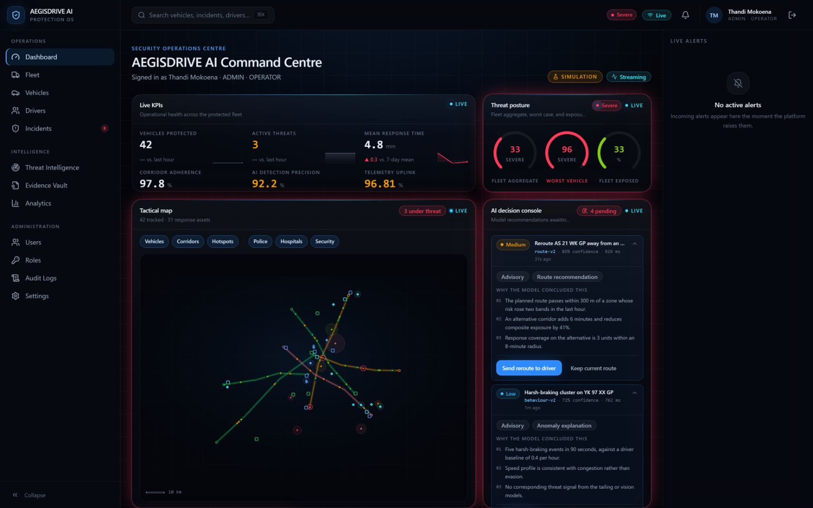
Command centre — the glance layer. KPIs and posture answer “is anything wrong right now”; the map answers “where”; the decision console answers “what does the platform want me to do”. Every model recommendation shows its modelId, confidence and inference time, and states its reasoning above the buttons — an operator cannot accept an immobilisation without seeing what it was based on. The SIMULATION badge is deliberately loud: the production build refuses to boot with mock data at all.
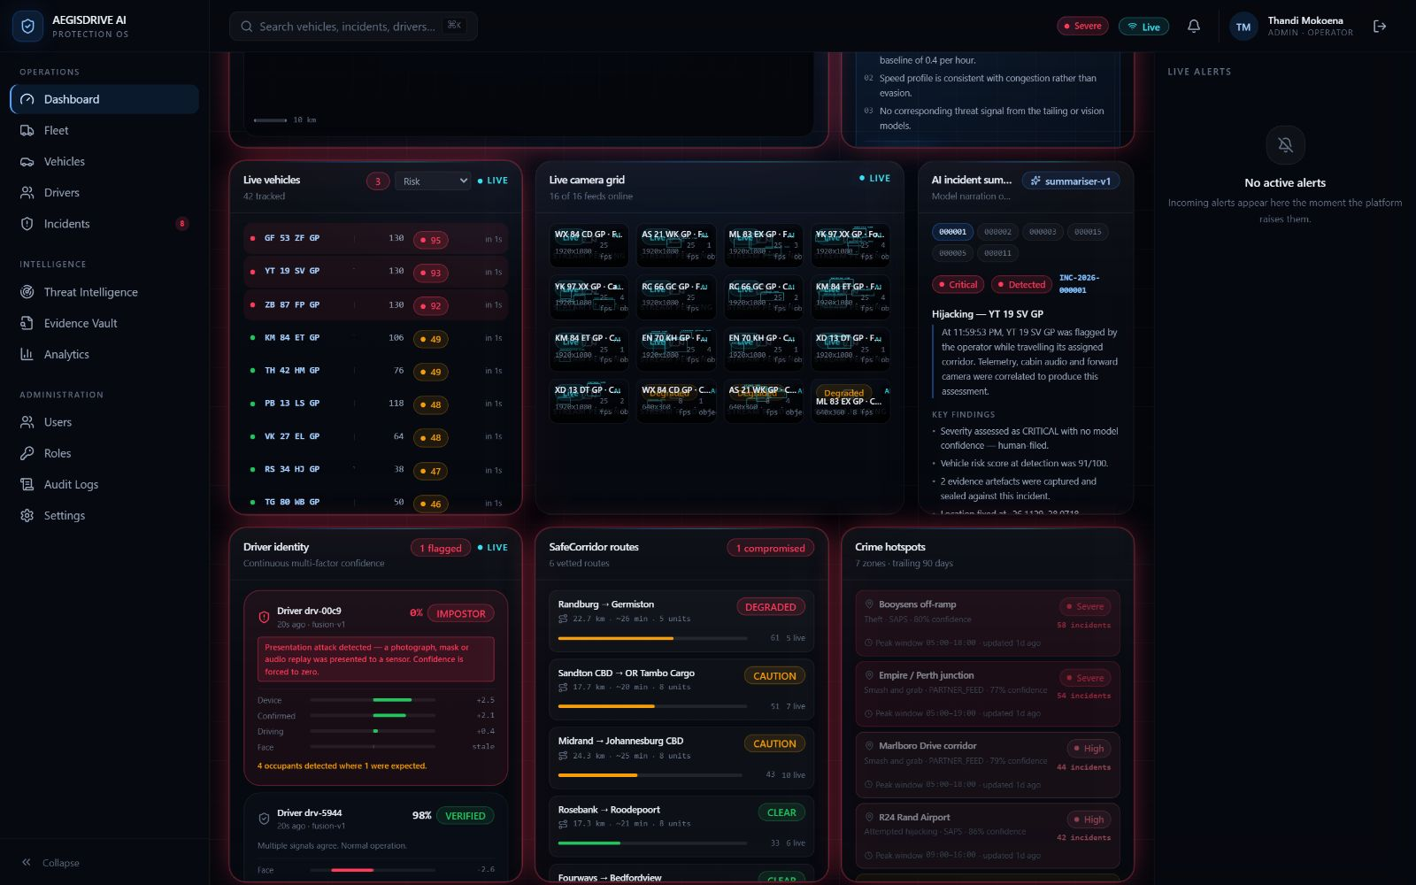
Working surfaces — vehicles, cabin, identity, routes. Driver identity is the panel worth pausing on. It shows a fused multi-factor confidence with each signal’s contribution — device +2.5, face stale — and drops to 0% IMPOSTOR when a presentation attack is detected, because a spoof that matches well is exactly what makes it dangerous. Corridors and hotspots carry their risk in bar length as well as colour, so the reading survives sunlight and colour-vision deficiency.
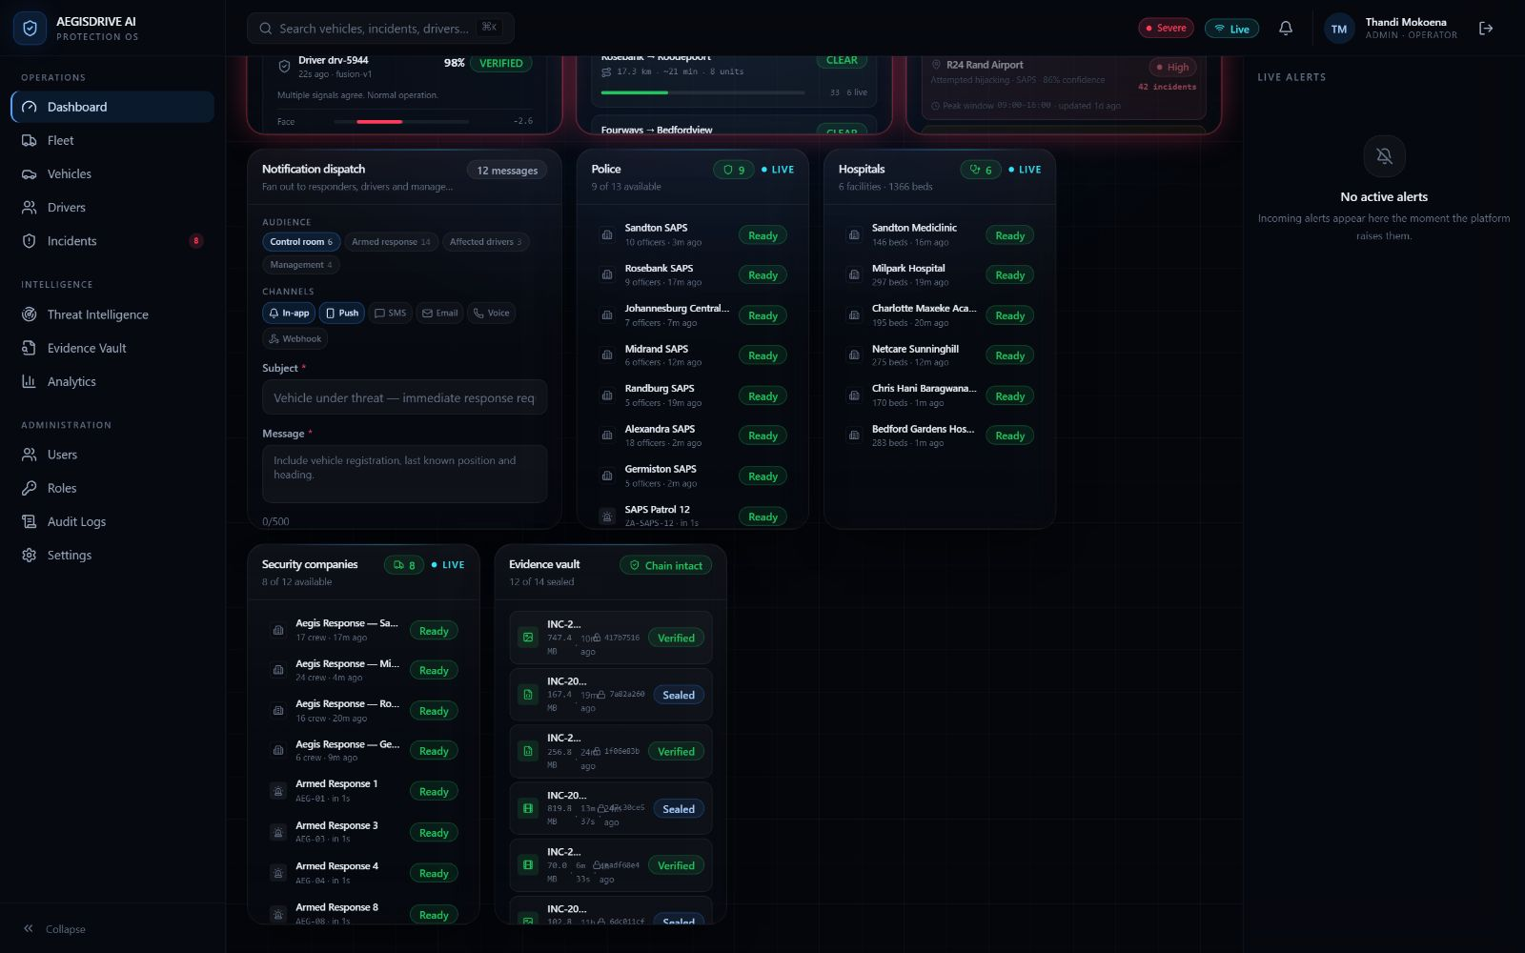
Response and aftermath — who you send, what you preserve. Dispatch fans out to control room, armed response, affected drivers and management across five channels. Below it, real SAPS stations and Johannesburg hospitals with live availability, and the evidence vault showing each artefact’s checksum and seal state — “Chain intact” is a claim the platform has to be able to make in court.
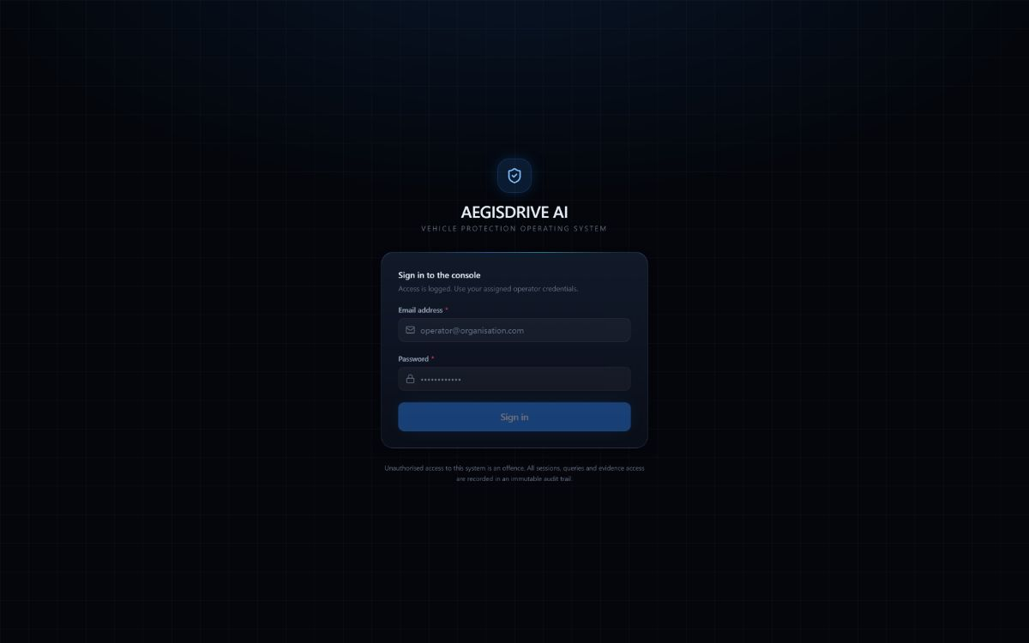
Sign in. One error message for every credential failure, so the screen cannot be used to enumerate accounts. The notice underneath is not boilerplate — sessions, queries and evidence access all land in an append-only audit trail.
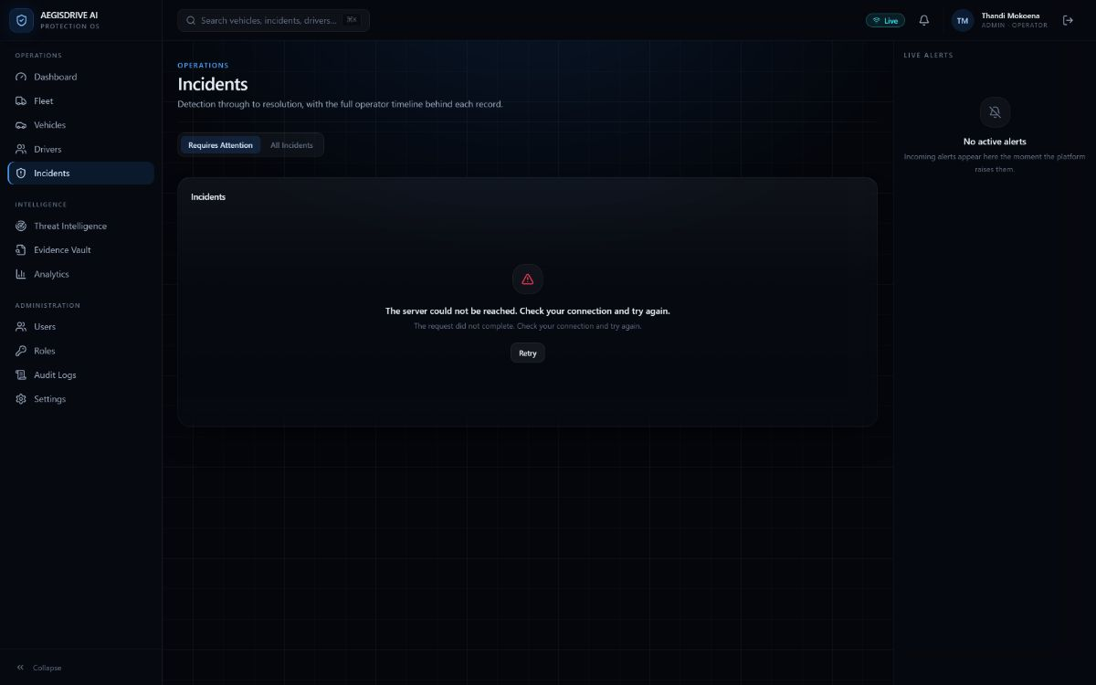
When the API is down. Captured with the backend deliberately stopped. The shell, navigation and alert rail stay usable and the failure is scoped to the panel that owns the data, with the top bar still stating the connection’s true state. Silence about a dropped feed is the dangerous failure mode, so a connected socket that has gone quiet reports “No data 20s” rather than showing as healthy.

2 · The driver app
Mobile · Expo SDK 53 · React Native · expo-router
Five tabs, because a driver glancing at a phone in a cradle can hit five targets and not seven. Minimum 48pt touch targets. The panic button sits above the fold on every device size — that is the hardest layout constraint on the home screen and it wins over everything else.
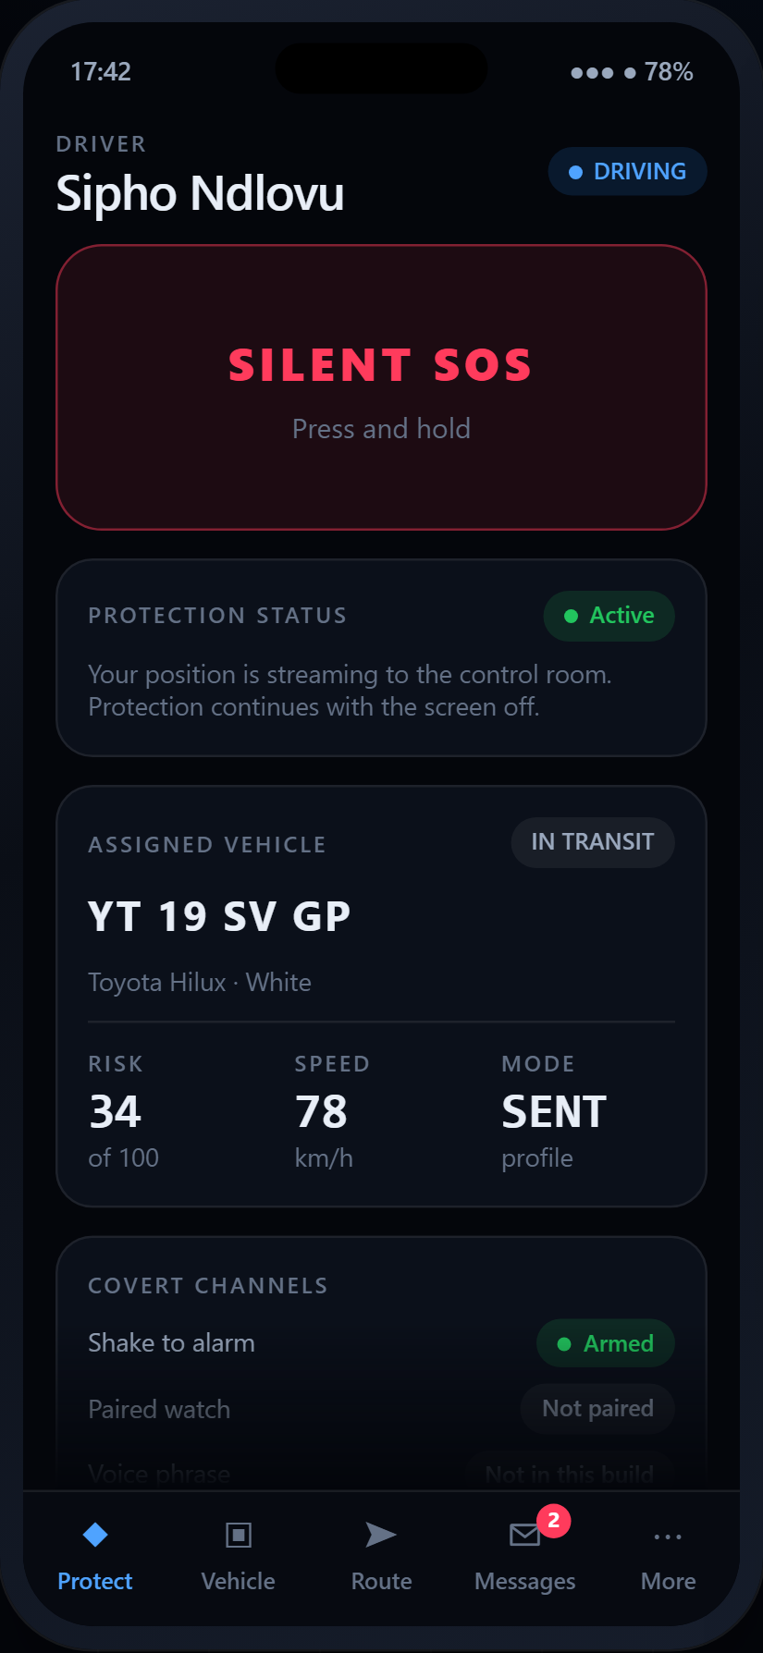 | Protect — the home tab  Long-press to arm, not tap: a pocket tap must not dispatch armed responders. The screen is ordered by what matters when the phone is picked up in a hurry — anything undelivered, then the panic button, then whether tracking is genuinely on, then everything else.
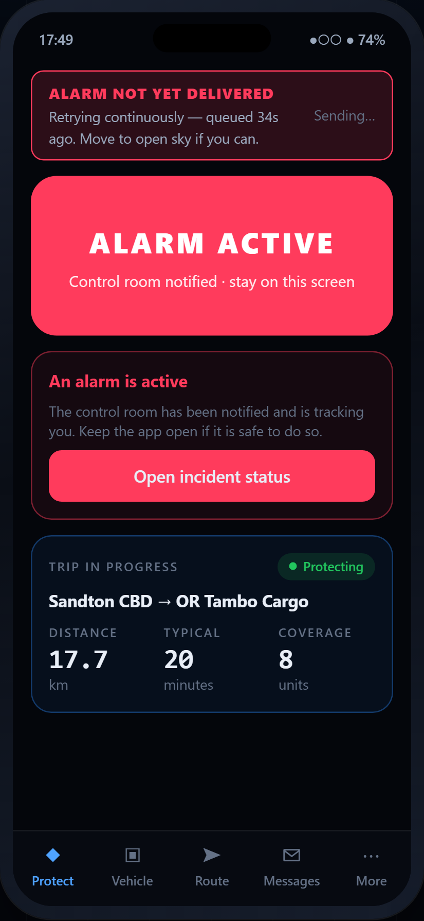 | Protect — alarm raised, not yet delivered  The state the connectivity banner exists for. A driver in a dead zone must know help has not been reached, because their next decision depends on it; a generic offline icon would let them assume help is on the way. Once active there is no one-tap cancel — standing down is a separate, deliberate act on the incident screen.
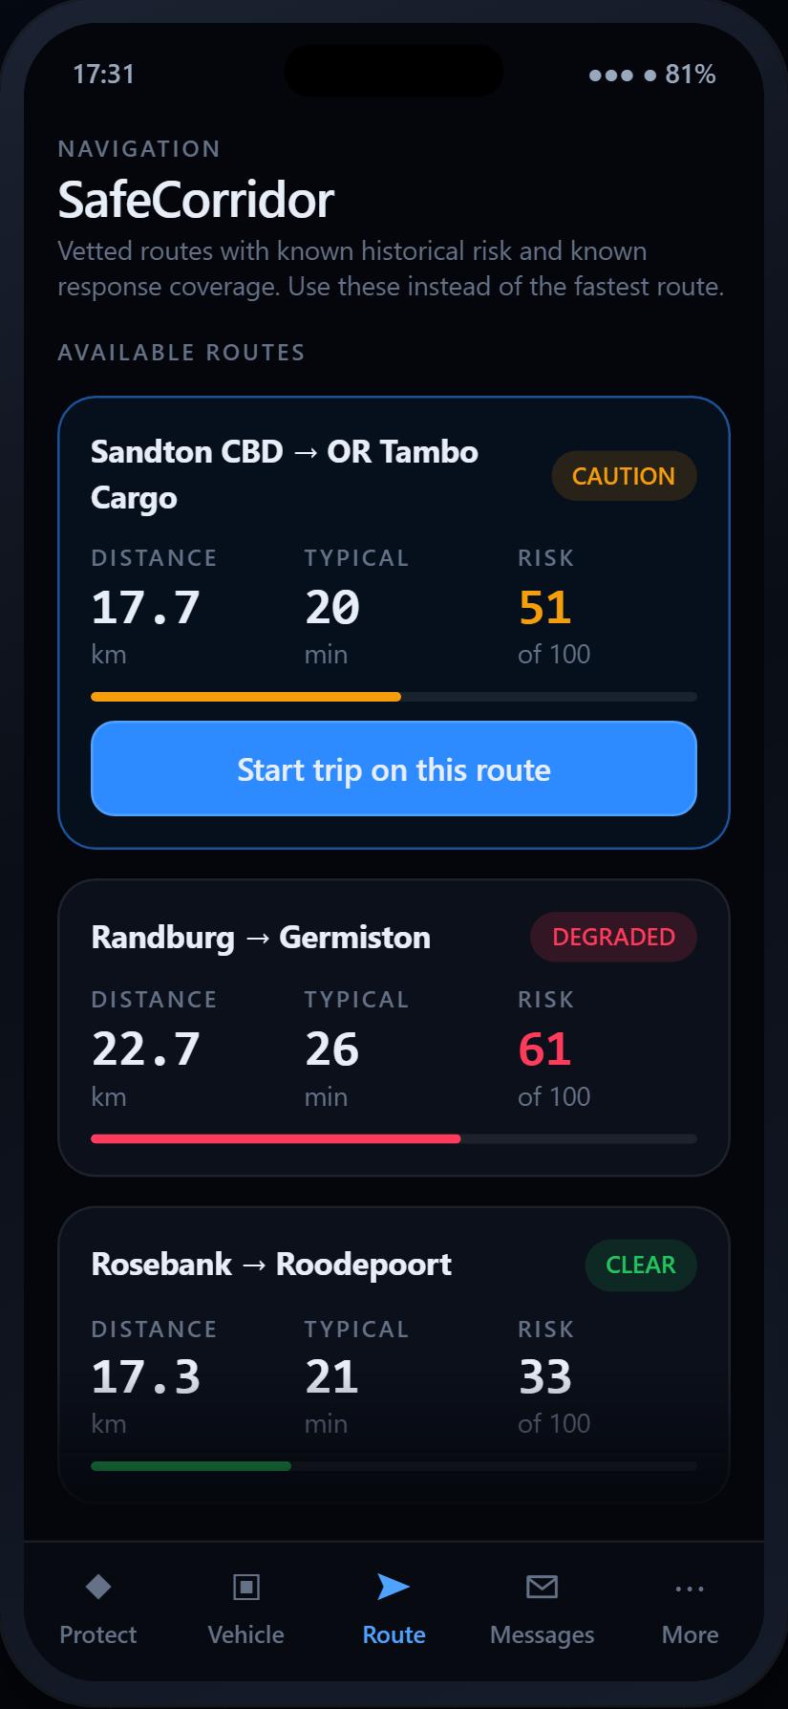 | Route — SafeCorridor  Not a turn-by-turn navigator; the driver already has one. This is the protection layer: which vetted route, what historical risk it carries, how much response coverage sits along it, and a warning if the vehicle leaves it.
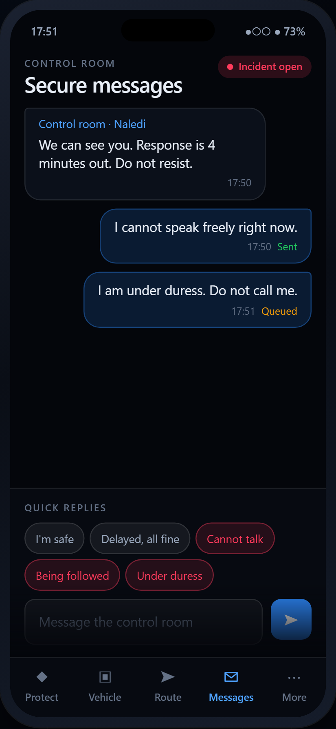 | Messages — quick replies first  A driver under duress cannot type. The three covert replies send with no confirmation dialog and no visible change beyond the message appearing, so a glance over the shoulder reveals nothing. A queued message says so — a driver must never believe the control room has read something it has not received.
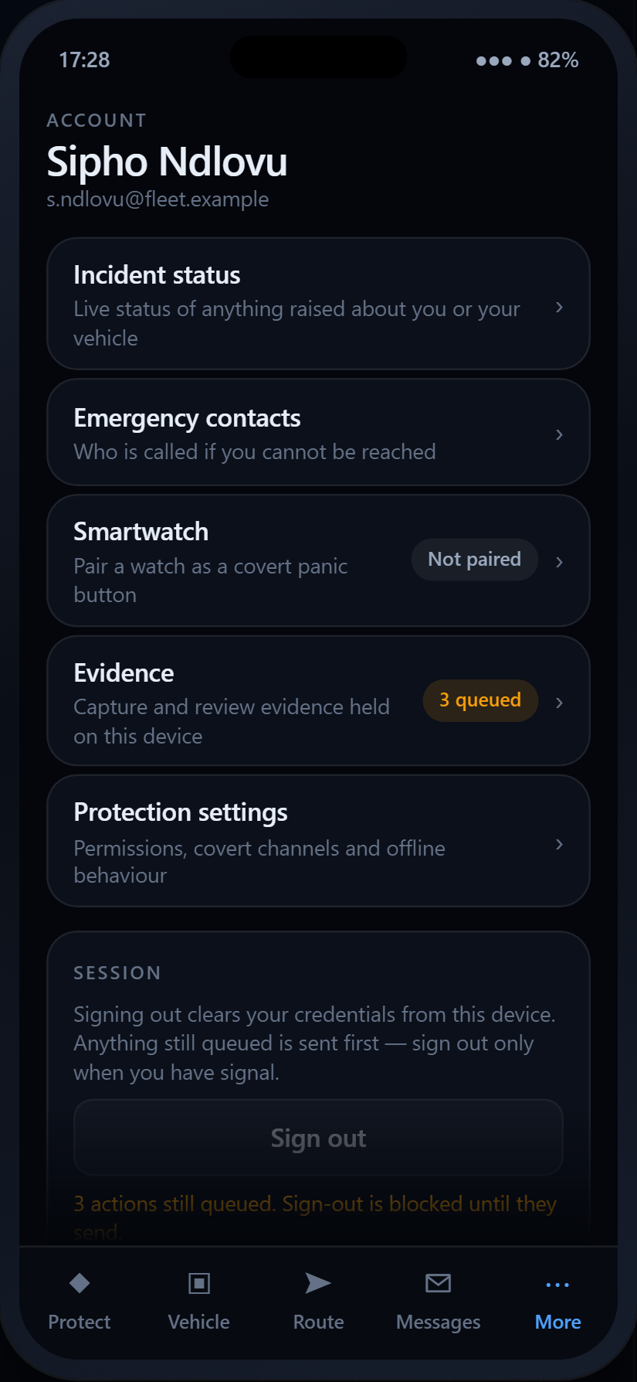 | More — account and covert channels  Sign-out is disabled, with the reason stated, while anything is still queued. Nothing here claims to work when it does not: the watch pairing and voice trigger report their real state rather than being stubbed.

The panic control, in all three of its states
Every constraint on it comes from the same fact: it is pressed by someone whose vehicle is being taken from them.

- Idle. Hold for 600 ms rather than tap. Deliberate, but still fast — and large enough to be found without looking.
- Arming. Ten seconds to undo a mistake, with the remaining time stated in words as well as by the ring, and cancellable by tapping anywhere.
- Active. No one-tap cancel. An attacker who grabs the phone must not be able to silence it with one press.

3 · Shared design language
React Native cannot read Tailwind’s custom properties, so the palette exists twice — in packages/ui/src/styles/theme.css and apps/mobile/src/theme/tokens.ts — with a comment on both saying change them together. The neutrals are blue-tinted rather than pure grey, because pure black reads as a dead panel.
 | Token | Hex | Where it is used
 | void | #04060B | Page ground. The darkest surface; nothing sits behind it.
 | surface | #0B101A | Cards and panels, one step up from the ground.
 | aegis-500 | #2E8BFF | The single accent hue. Primary actions, active navigation, selection.
 | hologram | #37E1F5 | Reserved for live and streaming affordances only.
 | success | #22C55E | Semantic. Clear, ready, verified, protecting.
 | warning | #F59E0B | Semantic. Caution, degraded, queued, simulation.
 | critical | #FF3B5C | Semantic. Alarms and nothing else.
 | ink-primary | #E8EEF7 | Body text and metrics on dark ground.

The hologram cyan is reserved for live and streaming affordances only, and the three semantic colours are reserved for alarms — which is why a board carrying forty moving vehicles still reads calm until something is actually wrong.

Web screenshots captured 4 August 2026 from the running client with VITE_DATA_SOURCE=mock. Every vehicle, threat, corridor and camera feed on those screens is generated by the in-browser simulation and marked as such by the SIMULATION badge — the production build throws on boot rather than render fabricated data. Phone screens are reconstructions from the Expo source, with illustrative content.

