ReasonTouch Piano Roll UI / UX Review
Summary of design discussion beginning from: 'Lets dial back a little and deal with just the Piano Roll layout/display.'

Core Design Direction
- Retain a single unified piano roll rather than introducing separate track editors.
- The currently selected track remains fully editable while other tracks display as ghost notes.
- Track selection should be large and touch-friendly.
- Mute functionality should remain available globally within the piano roll.
- Volume sliders already provide mix control, reducing reliance on dedicated mute buttons.
- Velocity editing should become optional/on-demand instead of permanently visible.
- Dual-axis zoom (horizontal + vertical) is essential for mobile usability.
- A proper zoom system removes the need for complex per-track edit screens.
- The piano roll should function as a refinement environment rather than a full DAW-style workstation.

Track Header Problems Identified
- BASS / LEAD / CHORD / PAD / DRUM buttons are too small on phones.
- The integrated mute (M) buttons frequently intercept intended track-selection taps.
- Current touch targets are too dense for reliable mobile interaction.
- Persistent velocity lane consumes excessive vertical screen estate.

Recommended Track Header Layout
Each track should become a larger touch-friendly card:
[ TRACK NAME ] [Mute]
[ Volume Slider ]
Behavior:
- Tap card = select/edit track
- Tap mute icon = mute track
- Drag slider = adjust volume

Unified Piano Roll Concept
- Active track notes are bright and editable.
- Inactive tracks display as dim ghost notes.
- Users remain inside one continuous piano roll.
- No separate editor windows required.
- Editing remains contextual and visually coherent.

Velocity Lane Proposal
- Remove permanently visible velocity bars.
- Open velocity editor only on demand.
- Possible approaches: slide-up drawer, toggle button, or note-selection panel.
- Recovered vertical space significantly improves note editing on phones.

Dual-Axis Zoom: Critical Architectural Insight
The existing system only zooms horizontally via pixelsPerBeat. Vertical note scaling is effectively hardcoded.
Current implementation:
var pixelsPerBeat by mutableStateOf(80f)
val noteHeight = 22f
Required change:
var noteHeight by mutableStateOf(22f)
- Horizontal zoom alone is insufficient for dense arrangements.
- Vertical zoom is necessary for chord editing, drum programming, and octave navigation.
- Dual-axis zoom eliminates the need for separate track editors.
- Pinch gestures should ideally infer orientation (horizontal / vertical / diagonal).
- Double-tap reset zoom is strongly recommended.

Suggested Zoom Limits
minNoteHeight = 10f
maxNoteHeight = 80f
minPixelsPerBeat = 24f
maxPixelsPerBeat = 320f

Implementation Steps for Dual-Axis Zoom
- Convert noteHeight from immutable val to mutableStateOf.
- Add vertical zoom constraints.
- Update pinch gesture logic to scale noteHeight.
- Maintain scroll centering during zoom operations.
- Implement optional directional pinch behavior.
- Add double-tap reset zoom.
- Test portrait phone, landscape phone, and tablet behaviors separately.

Architectural Outcome
- One piano roll
- One editing model
- One gesture system
- One track selection paradigm
- Adaptive scaling instead of fragmented UI modes

Reference Images Created During Discussion
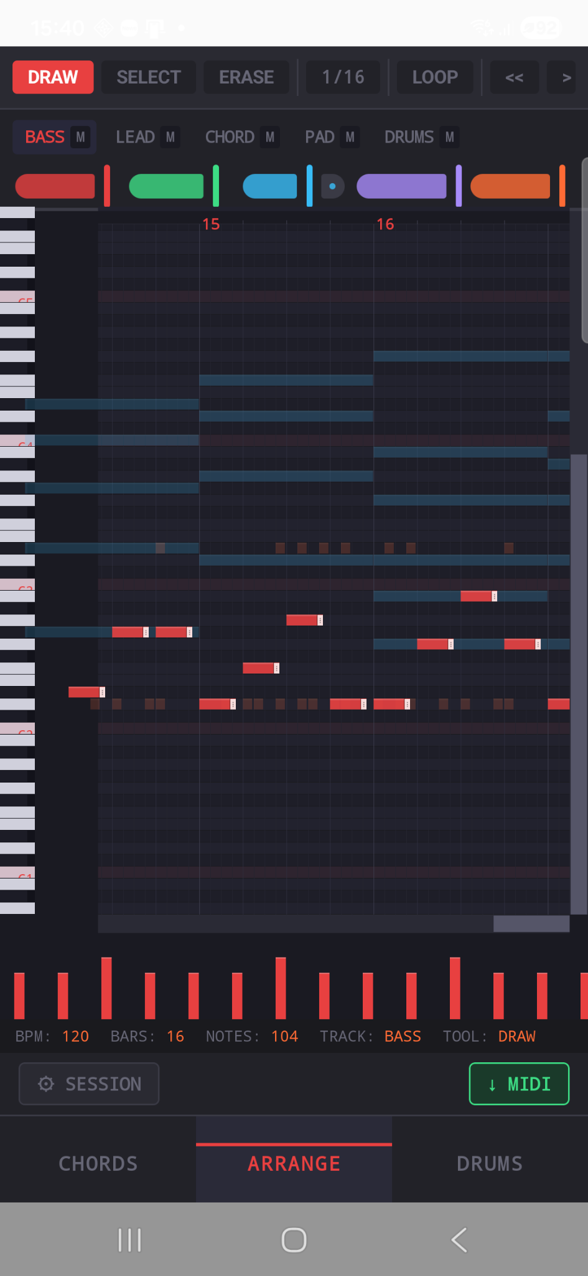
Reference image: 25117431-2f74-407b-8c78-e977ff29af0c.png
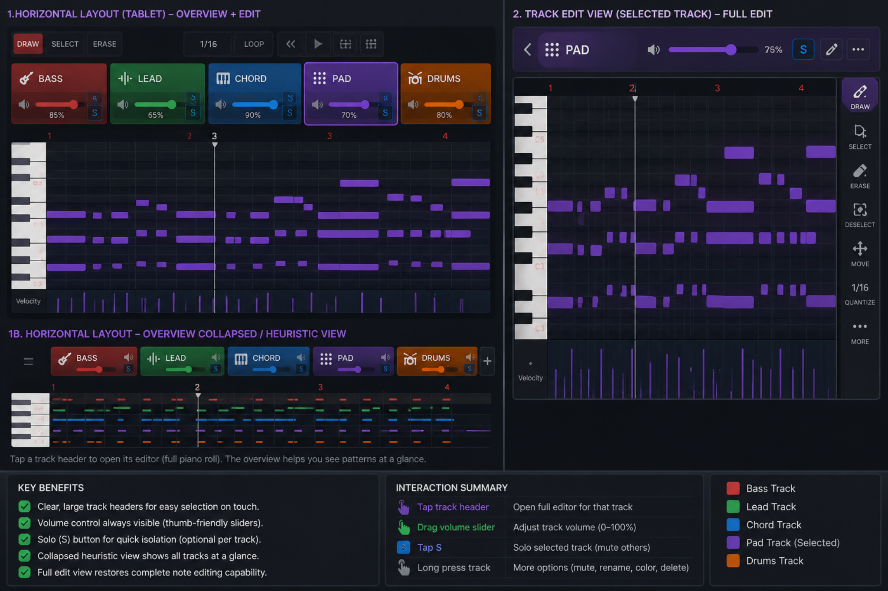
Reference image: 25829137-e99f-46a1-85b8-77c9a044c284.png

Final Key Insight
The discussion ultimately converged on the idea that the piano roll itself should become adaptive and scalable rather than fragmented into multiple editing modes. Dual-axis zoom is the enabling feature that unlocks this architecture.

