Company Management System

Analysis and Design

Version 1.2

Revision History

|  |  |  |  |
| --- | --- | --- | --- |
| **Date** | **Version** | **Description** | **Author** |
| 29/OCT/10 | 1.0 | Initial Analysis and Design | Ryan Rabe |
| 29/NOV/10 | 1.1 | Minor modifications and fixes | Ryan Rabe |
| 19/NOV/11 | 1.2 | Fix UML | Michael Laws |

1. Sequence Diagrams

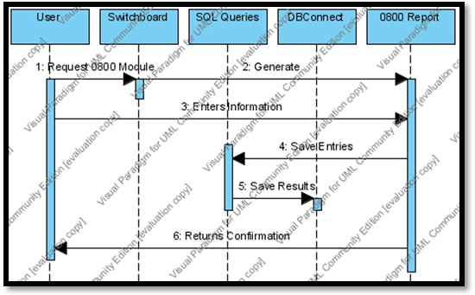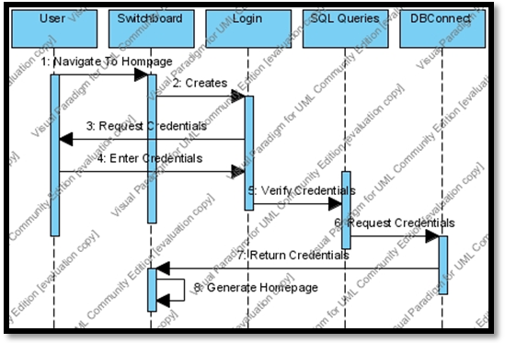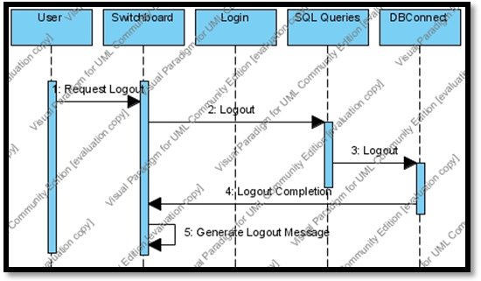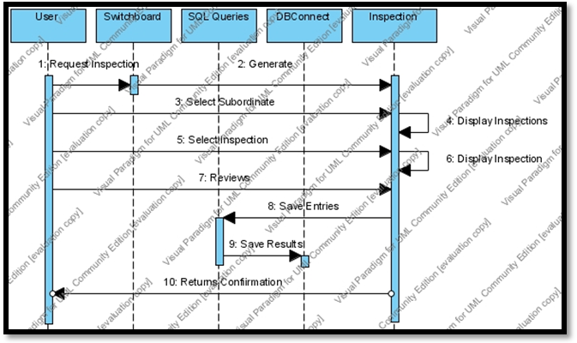



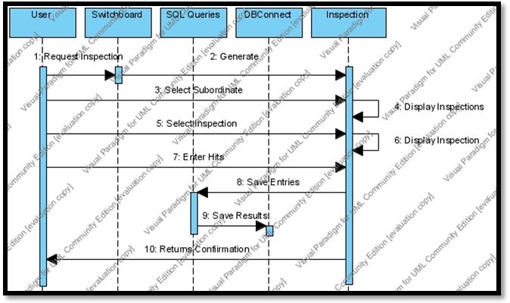

1. Functional Trace Table



1. **Authentication**

The system must allow an individual to log into an account.

1. **Credentials**

The system must manage an individual’s credentials and access based on the user role.

1. **Enter Information**

The system must allow users to enter information, depending on the credentials provided.

1. **Retrieve Information**

The system must allow users to retrieve information, depending on the credentials provided.

1. **Update Information**

The system must allow users to update information, depending on the credentials provided.

1. **Send Information**

The system must allow users to send information, depending on the credentials provided.

1. Analysis Model

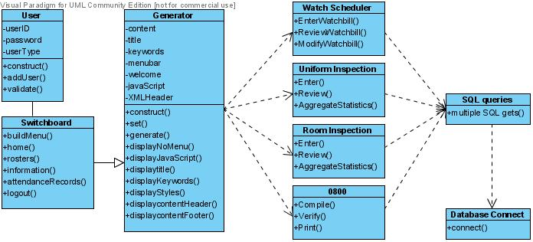

4. UML Diagram

