Contents
Common
CoreService
DataItem
DataList
ErrorList
ServiceListReader
ServiceManager
Database
DBConnections
MySQL
MySQLConn
MySQLDelete
MySQLInsert
MySQLSelect
MySQLUpdate
Catalog
CatalogManager
CatalogItemEditor
CatalogListReader
ContentItemEditor
ContentItemReader
ContentListEditor
ContentListReader
Page
PageManager
ListGenerator
PannelGenerator
TemplateItemEditor
TemplateListReader
ThemeItemEditor
ThemeListReader
Resource
ResourceManager
FileItemEditor
FileItemReader
FileListReader
FileUploader
Setting
SettingManager
SettingItemEditor
SettingListReader
User
UserManager
GradeListReader
GroupItemEditor
GroupListReader
UserItemEditor
UserItemReader
UserListReader
UserPassport

Common

CoreService
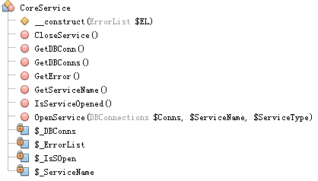

DataList

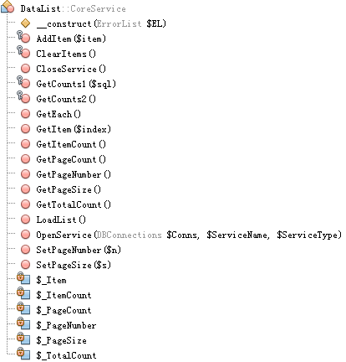

DataItem

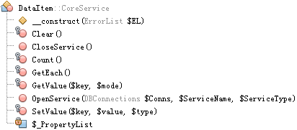

ErrorList

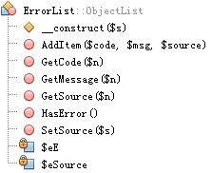

ObjectList

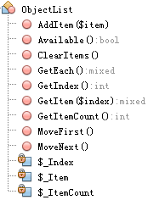

PropertyList

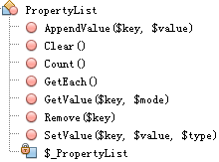

WordList

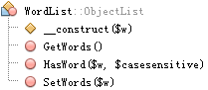

Service

ServiceListReader

ServiceManager

Database

DBConnections

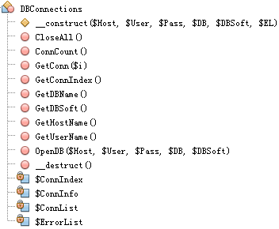

DBConn

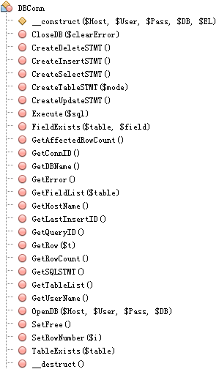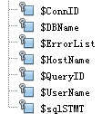

1 Class View database
Class DBConnections

Class ConditionInterface

Class DBConn

Class DBSQLSTMT

Class FieldDefListInterface

Class FieldExpListInterface

Class FieldValListInterface

Class SQLCondition

Class SQLDelete

Class SQLFieldDefList

Class SQLFieldExpList

Class SQLFieldValList

Class SQLInsert

Class SQLSelect

Class SQLTable

Class SQLUpdate
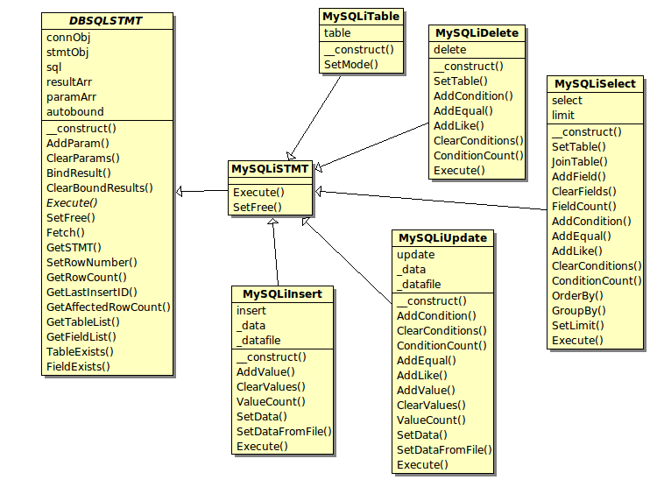
Diagram_STMT

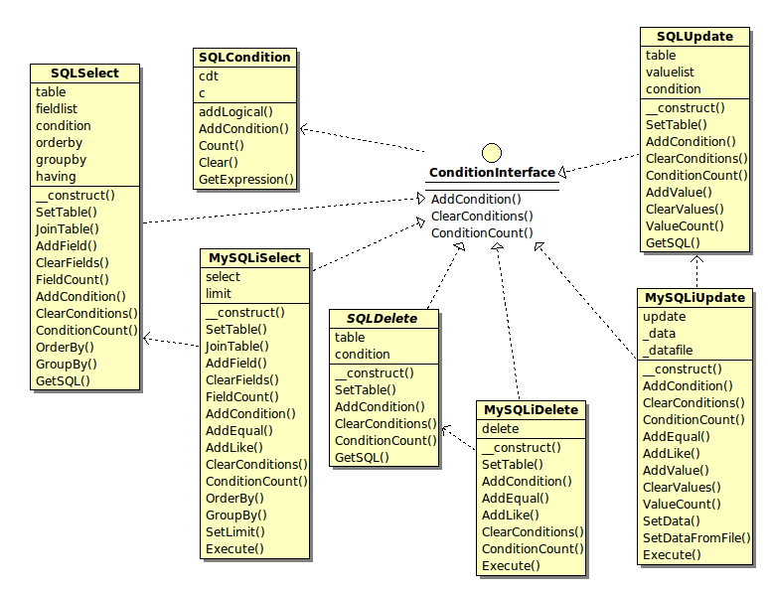
Diagram_Condition

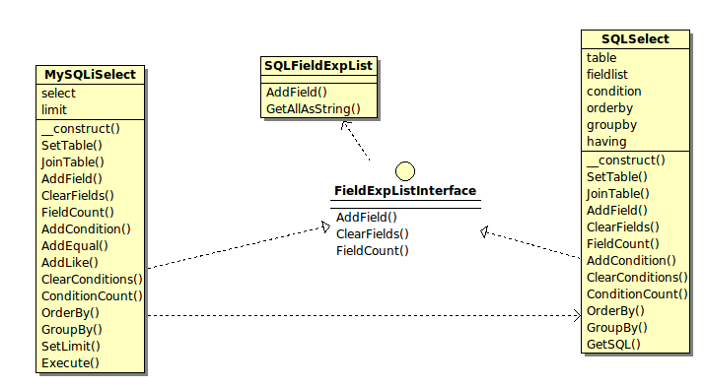
Diagram_Exp

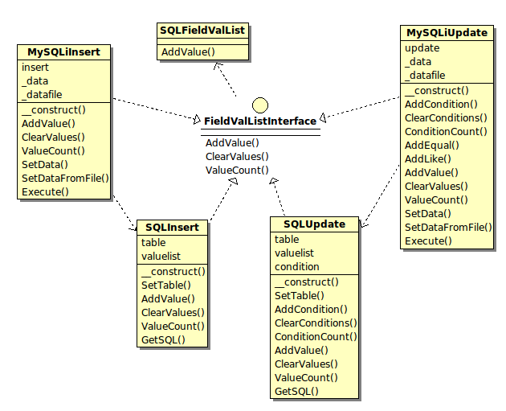
Diagram_Val

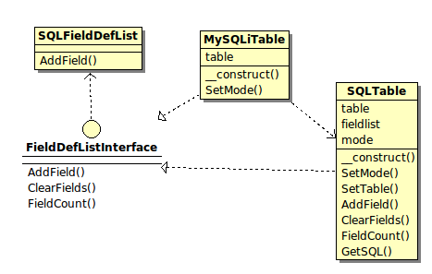
Diagram_Def

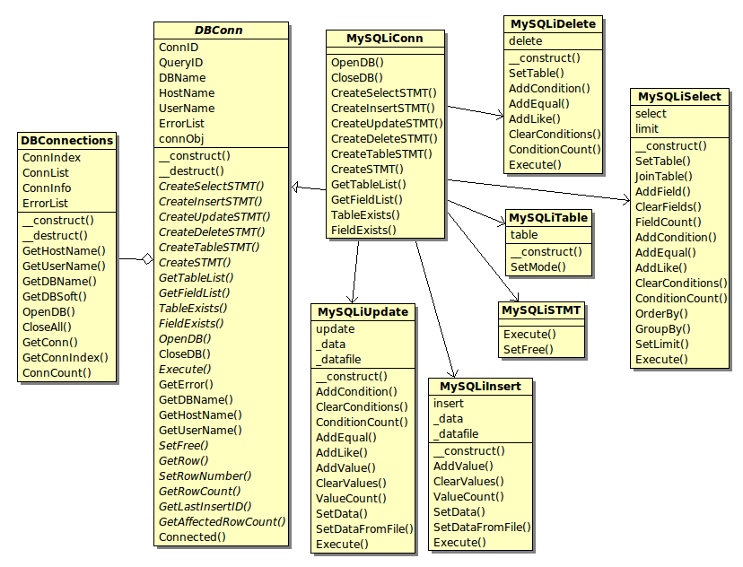
Diagram_Connection

2 Deployment View database

3.2 Class View mysql
Class MySQLCondition

Class MySQLConn

Class MySQLDelete

Class MySQLInsert

Class MySQLSelect

Class MySQLTable

Class MySQLUpdate

4 Package mysql_pdo

4.2 Class View mysql_pdo
Class MySQLConn

Class MySQLDelete

Class MySQLInsert

Class MySQLSelect

Class MySQLTable

Class MySQLUpdate

5 Package mysqli

5.2 Class View mysqli
Class MySQLiConn

Class MySQLiDelete

Class MySQLiSTMT

Class MySQLiInsert

Class MySQLiSelect

Class MySQLiTable

Class MySQLiUpdate

Catalog

CatalogListReader

CatalogManager

CatalogItemEditor

ContentListReader

ContentItemReader

ContentListEditor

ContentItemEditor

CreateContent()
OpenContent($ID)
SaveContent($CatalogID)
SetName($name,$update=false) | 允许批量修改
SetAuthor($author,$update=false) | 允许批量修改
SetKeywords($keywords,$update=false) | 允许批量修改
SetPointValue($n,$update=false) | 允许批量修改
SetAdminUID($uid)
SetVisitGrade($g,$update=false)
SetAdminGrade($g,$update=false)
IsCatalogExists($CatalogID)
MoveTo($CatalogID,$update=false)
AddVisitCount($update=false)
ClearVisitCount($update=false)
SetAutoLink($location)
RemoveAutoLink()

未登录 即“游客” Grade=0
普通 对规定范围内所有人可见，只有发布者才能改 VisitGrade>=0,AdminGrade=-1
隐私 只有发布者才可见可改 VisitGrade=AdminGrade=-1

Setting

SettingListReader

SettingItemEditor

User

UserListReader

AddItem($UID)
OpenGroup($GID)
OpenUserAdminList()
OpenOnlineList()

GroupListReader

GroupListEditor

UserItemReader

UserItemEditor

Log

RecordListReader

Vote

VoteListReader

Add($uid)
OpenGroup($gid)
OpenOnlineList()
OpenUserAdminList()

VoteItemReader
GetCaption
GetStartTime
GetEndTime
GetMinNumber
GetMaxNumber
GetContentID
GetEntryList
OpenVote($id)

VoteItemEditor

OpenVote($id)
SetCaption($caption)
SetTime($startTime,$endTime)
SetNumber($min,$max)
SetContentID($id)
GetEntryList()
SaveVote()
DeleteVote($id)

EntryListReader

OpenVote($id)

EntryListEditor

AddEntry($text,$value)
SetEntry($id,$text,$value)
OpenVote($id)
SaveAsVote($caption,$startTime,$endTime)
SaveChanges(SaveChanges())

Page

PanelGenerator

OpenTemplate($name)
FieldList
GetValue($fieldName)
SetValue($fieldName,$value)
HTML
Content

ListGenerator

ThemeListReader

OpenTemplate($name)
FieldList
GetValue($fieldName)
SetValue($fieldName,$value)
HTML
Content

ThemeItemEditor

OpenTemplate($name)
FieldList
GetValue($fieldName)
SetValue($fieldName,$value)
HTML
Content

TemplateListReader

OpenTemplate($name)
FieldList
GetValue($fieldName)
SetValue($fieldName,$value)
HTML
Content

TemplateItemEditor

OpenTemplate($name)
FieldList
GetValue($fieldName)
SetValue($fieldName,$value)
HTML
Content

Resource

