
Food Social Network

Requirements Specification Document

Document Control

DOCUMENT REVIEW

Date | Version | Reviewer | Role | Status

Key Contacts for the Private Cloud Factory
Role | Name
Team Member | Berkay Göktan <berkay.goktan@boun.edu.tr>
Team Member | Caner Türkmen <turkmen.ac@gmail.com>
Team Member | Canay Özel <canayozel@gmail.com>
Team Member | Esin Karaman <esinkaraman@gmail.com>
Team Member | Merve Battal <merve.battal@accenture.com>

Table of Contents

1. Purpose of this Document 5
2. Project Description 5
3. Functional Requirements 5
4. Non-Functional Requirements 23
5. Analysis Object Model 24
6. Mock-up Scenarios 25

Revision History

Date | Version | Description | Author
1/3/2014 | 0.1 | Initial version | Turkmen
2/3/2014 | 0.2 | List of functions, UC3, UC4 UML scenarios added | Karaman
3/3/2014 | 0.3 | UC1, UC2, UC9, UC10 added | Göktan, Türkmen
3/3/2014 | 0.4 | UC5, UC6 added, introductions were added | Özel, Türkmen
10/3/2014 | 0.5 | UC11 added, UC3 updated (ingredient blacklist added) | Karaman
10/3/2014 | 0.6 | UC7 and UC8 are added. | Battal
10/3/2014 | 0.7 | UC10 updated, web mockups added | Göktan
10/3/2014 | 1.0 | Functional requirements numbered, fixed typos, edited non-functional requirements as agreed on class meeting 3/3/2014. Version updated to 1.0 | Türkmen
17/3/2014 | 2.0 | Analysis object model revised, functional requirements broken down to details, mock-up scenarios added | Karaman, Türkmen

Purpose of this Document

The purpose of this document is to present analysts, reviewers and developers of the Food Social Network system an accurate depiction of the requirements elicited for the software to be developed.

The document first presents an outline of the functional requirements, then breaks the functional requirements down with a Use-Case Analysis with each use case detailed down in later sections. The document then concludes with a set of non-functional requirements for the system.

Project Description
The requirements elicited broadly describe an internet application that exhibits elementary functions of a social network, however is centered around the sharing of food recipes instead of messages, photos or videos.

Food recipes should be presented in a relatively complex data structure, with ingredients and food items and the effect of these items on calories, ailments, etc. This will form the basis of “design for extensibility” of the system, which in future versions may take the form of an intelligent personal assistant.

However, in the first version of the system, the system is designed as a social network centered around recipes, but will also provide the service of querying recipes as an elementary personal assistant function.

Functional Requirements

The functional requirements in this section will first be presented as a list of requirements, after which a Use-Case analysis of the software will be presented and each use case will be detailed down.

Functional requirements

- The system shall exhibit basic social network features. i.e.: the user will be able to register and login to the system. The system services shall only be provided to logged in users.
- User shall be able to display profile information on their profile, and will be able to edit the same.
- Users will be able to search for other users in the system
- The users shall be able to follow one another in Twitter-like asymmetric follow links
- When logged into the system, the user will be able to see a news feed of what other users he/she is following have been up to
- Users will be able to enter/share recipes of their own
- Users will be able to search the overall recipe database by querying with ingredient, and access a set of recipes that are specifically suited to themselves (by looking at recipe history, recipe ratings given, etc.)
- Users will be able to rate recipes
- Users will be able to edit a new recipe (thus forming a new recipe) by substituting or modifying ingredients; or modifying directions

Use Case Representation

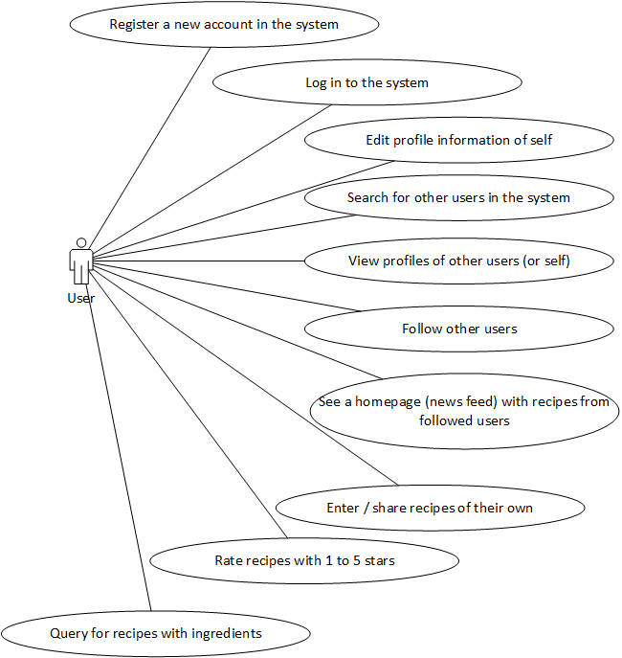

List Of Functions And Associated Use Cases

UC1 - Register a new account in the system
UC2 - Log in to the system
UC3 - Edit profile information of self
UC4 - Search for other users in the system
UC5 - View profiles of other users (or self)
UC6 - Follow other users
UC7 - See a homepage (news feed) with recipes from followed users
UC8 - Enter / share recipes of their own
UC9 - Rate recipes with 1 to 5 stars
UC10 - Query for recipes with ingredients
UC11 – Edit Recipe

UC Identifier | UC1
UC Name | Register a New Account In The System
UC Definition | A user shall be able to register a new account in the Food Social Network system, by providing a set of initial information such as username and contacts, in order to be able to log in and benefit from the services of the system.  On seeing the “registration” view/screen of the system, the user shall be asked for:  - an e-mail address (which will be validated through regular expressions)  - first name  - last name  - a password (not less than 6 characters in length)  - a confirmation of the same password  upon the successful submission of which, the user shall be registered to the system.
Pain-points Addressed | - The need for creating an account in order to be logged in
Objectives | - Provide a reliable interface both over web and mobile for users to register themselves with the system
Expected Results | - A user registration is persisted in the database  - The user is able to successfully log in to the system using provided credentials
Actors | Actor | Role
Actors | User | Enter registration information and submit
Actors | System | Persist user registration in the database
Triggers | - User Request/User demand
Fulfillment Type | Automated – on mobile and web

Use Case Steps

Step # | Service Provisioning | Ref UC # (If Applicable) | Actor
1 | The user enters name, surname, e-mail address, password and password confirmation. |  | User
2 | The system validates the password and e-mail address |  | System
3 | If the above fields are validated, the system persists the user registration record in the database |  | System

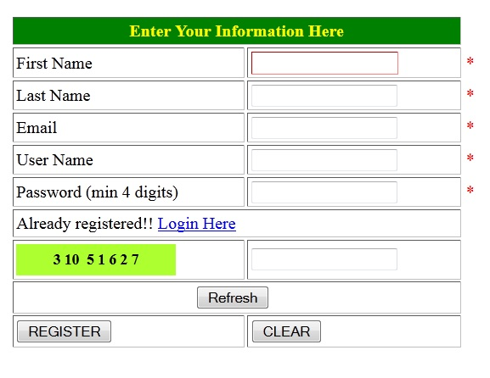

UC Identifier | UC2
UC Name | Log In To The System
UC Definition | The user shall be able to authenticate him/herself to the system in order to gain access to the services of the Food Social network.
Pain-points Addressed | - The need for authenticating users with the system in order to provision services
Objectives | - Provide a reliable, secure and robust way to authenticate users with the system  - Provide a software interface over which both mobile and web clients may perform authentication tasks
Expected Results | - User is successfully logged in to the system
Actors | Actor | Role
Actors | User | Enter and submit login credentials
Actors | System | Authenticate user
Triggers | - User Request/User demand
Fulfillment Type | Automated

Use Case Steps

Step # | Service Provisioning | Ref UC # (If Applicable) | Actor
1 | User enters login credentials: e-mail address and password |  | User
2 | System authenticates and sends the token of authentication to requesting client / denies access if credentials do not match against the database |  | System

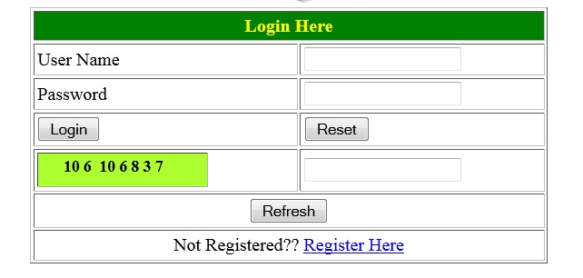
UC Identifier | UC3
UC Name | Edit Profile Information of Self
UC Definition | This use case comprises detailed steps of editing profile information of a system user by self. The profile information is independent of the user registration object, however is linked to the same item. The profile information includes:  - Location  - Date of Birth  - Profile message  all of which are free text fields. And an  - Ingredient black list, with an option for specifying the foods the user does not eat.
Pain-points Addressed | - The need of editing initial profile information of a system user by self
Objectives | 1. Provide reliable, user-friendly and easy-to-use profile update interface to the system users
Expected Results | - Successful editing of profile information
Actors | Actor | Role
Actors | User | Editing profile information
Triggers | - User Request/User demand
Fulfillment Type | Automated

Use Case Steps

Step # | Service Provisioning | Ref UC # (If Applicable) | Actor
1 | End user needs to edit profile information of self. |  | User
2 | End user reaches profile update user interface |  | User
3 | End user edits current name, surname or e-mail address, location, date of birth and profile message. |  | User

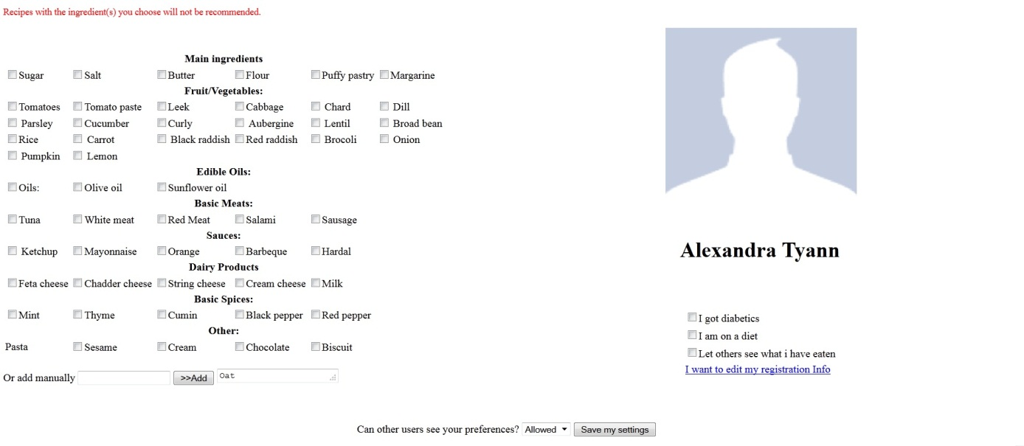
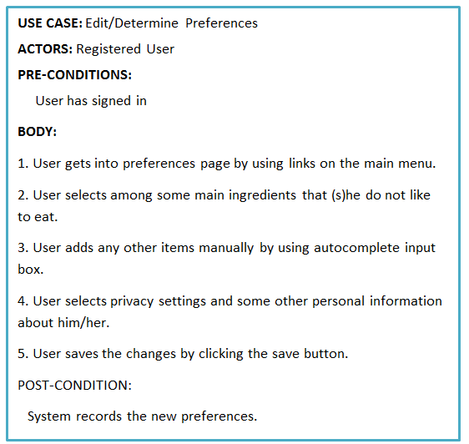

UC Identifier | UC4
UC Name | Search For Other Users In The System
UC Definition | This use case comprises detailed steps of searching for other users in the system
Pain-points Addressed | - The need of searching and exploring other users registered to the system
Objectives | 1. Provide reliable, user-friendly and easy-to-use searching interface to the system users
Expected Results | - User is provided an accurate list of users compatible with the searching criteria
Actors | Actor | Role
Actors | User | Searching for other users in the system
Triggers | - User Request/User demand
Fulfillment Type | Automated

Use Case Steps

Step # | Search For Other Users In The System | Ref UC # (If Applicable) | Actor
1 | End user reaches user search interface |  | User
2 | End user types a name or surname in search user dialog box and submits the form |  | User

UC Identifier | UC5
UC Name | View a User Profile
UC Definition | This use case comprises detailed steps of viewing a user’s profile.
Pain-points Addressed | - The need of viewing other user’s profile information.  - The need of following other users; a user might decide to follow another user by viewing his/her profile.
Objectives | 1. Provide reliable, user-friendly and easy-to-use interface to users to view other users’ profile.
Expected Results | - Successful display of a user’s profile.
Actors | Actor | Role
Actors | User | Viewing a users’ profile.
Triggers | - User Request/User demand
Fulfillment Type | Automated

Use Case Steps

Step # | Service Provisioning | Ref UC # (If Applicable) | Actor
1 | User searches for other users by entering a keyword on home page (screen). | UC4 | User
2 | User views the profile of another user by following the profile link on the search page. | UC6 | User

UC Identifier | UC6
UC Name | Follow other users.
UC Definition | This use case comprises detailed steps of following another user.
Pain-points Addressed | - The need of following other users, in order to view their data on the news feed.
Objectives | 1. Provide reliable, user-friendly and easy-to-use following interface to the system users
Expected Results | - User follows other users in order to view their data on the news feed.
Actors | Actor | Role
Actors | User | Following other users in the system
Triggers | - User Request/User demand
Fulfillment Type | Automated

Use Case Steps

Step # | Search For Other Users In The System | Ref UC # (If Applicable) | Actor
1 | User views other user’s profile. | UC5 | User
2 | User clicks the follow link in order to follow the other user. |  | User

UC Identifier | UC7
UC Name | See a homepage (news feed) with recipes from followed users
UC Definition | This use case comprises detailed steps of displaying homepage with recipes from followed users to a system user.
Pain-points Addressed | - The need of displaying news feed
Objectives | - Provide reliable, user-friendly and easy-to-use homepage interface to the system users
Expected Results | - Displaying successfully homepage with recipes from followed users
Actors | Actor | Role
Actors | User | Displaying homepage with recipes from followed users
Triggers | - User login
Fulfillment Type | Automated

Use Case Steps

Step # | Service Provisioning | Ref UC # (If Applicable) | Actor
1 | End user logins to system |  | User
2 | End user displays homepage with recipes from followed users |  | User
3 | End user navigates to the related news feed items by clicking on the related item. |  | User

UC Identifier | UC8
UC Name | Enter / share recipes of their own
UC Definition | This use case comprises detailed steps of entering / sharing of system user’s own recipes.
Pain-points Addressed | - The need of entering / sharing of system user’s own recipes
Objectives | - Provide reliable, user-friendly and easy-to-use recipe entry/ display interface to the system users
Expected Results | - Entering / sharing successfully system user’s own recipes
Actors | Actor | Role
Actors | User | Entering / sharing own recipes
Triggers | - User Request/User demand
Fulfillment Type | Manual / Automated

Use Case Steps

Step # | Search For Other Users In The System | Ref UC # (If Applicable) | Actor
1 | End user navigates to recipe entry/display interface |  | User
2 | End user enters his/her own recipes to the system |  | User
3 | End user displays the previously entered recipes if needed |  | User

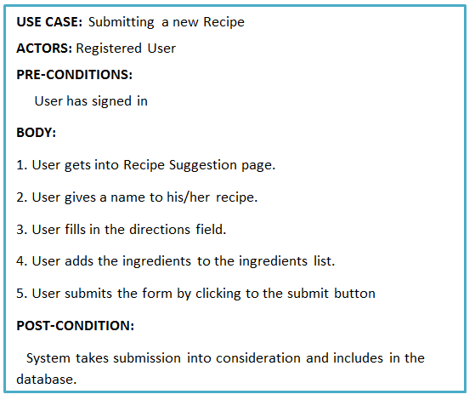
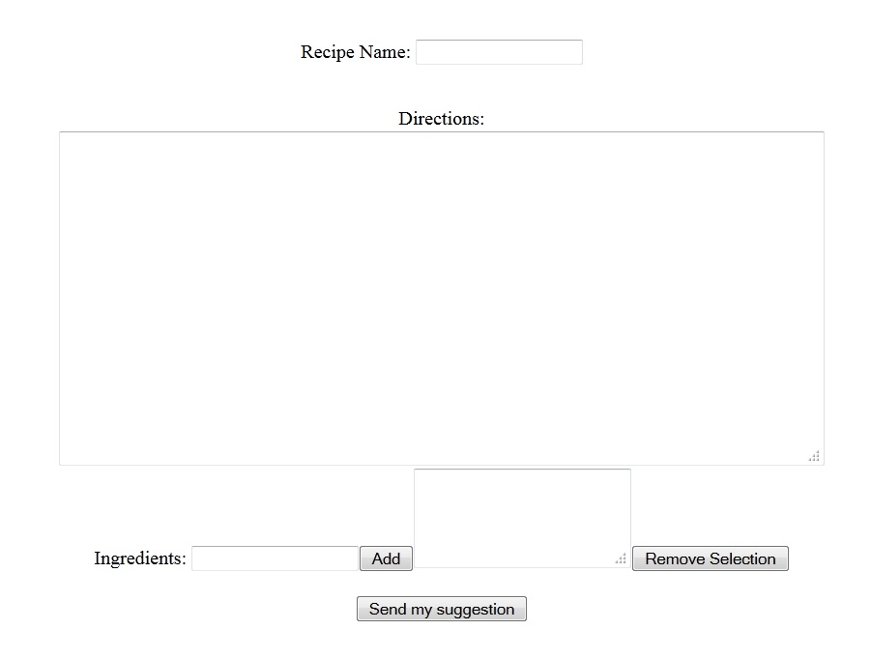

UC Identifier | UC9
UC Name | Rate recipes with 1 to 5 stars
UC Definition | This use case comprises details of rating scheme and results displaying of the receipes.
Pain-points Addressed | - The need for displaying the degree of appreciation of the receipes.
Objectives | 1. Provide degree of appreciation about receipes and let user to contribute to the determination of average rates.
Expected Results | - Clicking a Star over the rating scheme.
Actors | Actor | Role
Actors | User | Giving a rate over 5 stars(points).
Triggers | - User Request/User demand
Fulfillment Type | Automated

Use Case Steps

Step # | Search For Other Users In The System | Ref UC # (If Applicable) | Actor
1 | End user hovers the cursor over rates and clicks to a star that is equievelent to the desired point. |  | User

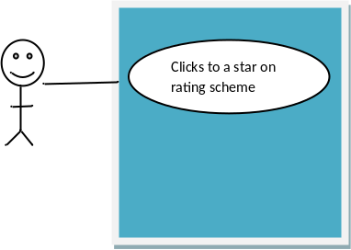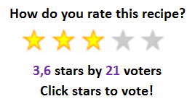

UC Identifier | UC10
UC Name | Query for recipes with ingredients
UC Definition | This use case comprises detailed steps of preparing ingredients list to search among appropriate receipes.
Pain-points Addressed | - The need of searching recipes that can be prepared with materials available (the ingredients provided in search list).
Objectives | 1. Provide an user-friendly and easy-to-use; ingredients adding/removing and receipe searching interface to the system users.
Expected Results | - User types/selects the name of the ingredients and adds them into the searching (ingredients) list.  - User clicks to search button in order to let system make a query.  - Additionaly, the search results will be customized accoding to the user’s specific choices and history
Actors | Actor | Role
Actors | User | Adding items to ingredients list by either writing the ingredient name or selecting from autocomplete list.
Actors | User | Searching through all or user choice-restricted recipes. (With or without specifying available ingredients.)
Triggers | - User Request/User demand
Fulfillment Type | Automated

Use Case Steps

Step # | Query for recipes with ingredients | Ref UC # (If Applicable) | Actor
1 | End user reaches receipe search page. |  | User
2 | End user types the name of ingredient he/she has available into the text area, or selects from autocomplete list. |  | User
3 | End user adds the selected item into the ingredients list. |  | User
4 | End user removes an item from the ingredients list, if required. |  | User
5 | End user starts the query by submitting the list. |  | User

Type/Select ingredients
Add/Remove items from ingredients list.
Submit the list for receipe search
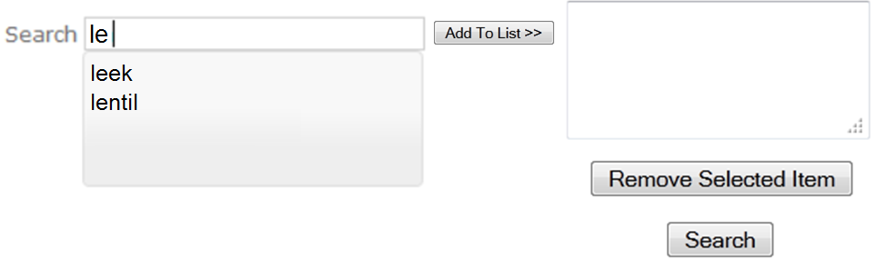
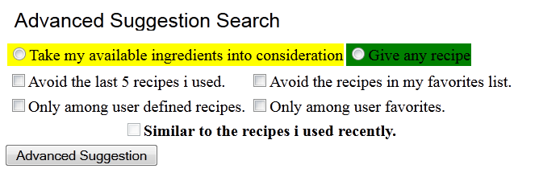

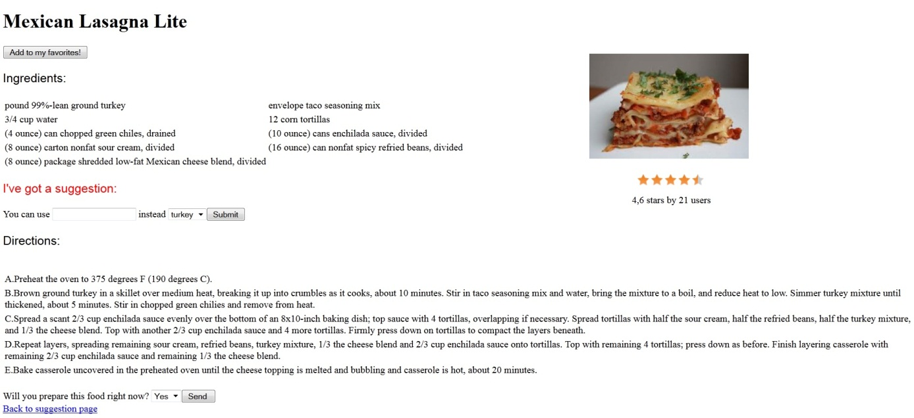

UC Identifier | UC11
UC Name | Edit Recipe
UC Definition | A user shall be able to edit any items of a recipe such as an ingredient, a quantity or directions. The actions a user shall be able to take are:  - A user shall be able to add a new ingredient  - A user shall be able to add delete an ingredient  - A user shall be able to modify an ingredient quantity  - A user shall be able to modify directions  System shall implement a versioning mechanism in order to preserve modification history of a recipe. Each modification shall lead to a version increment.  All versions shall be accessible through the web and mobile interfaces.
Pain-points Addressed | - The need for making suggestions about recipies and sharing individual experience with other system users
Objectives | - Provide a reliable interface both over web and mobile for users to enable them to modify recipies
Expected Results | - A new version of the is persisted in the database  - The new version of the recipe become apparent to the system users
Actors | Actor | Role
Actors | User | Edit recipe
Actors | System | Persist new version of the recipe in the database.
Triggers | - User Request/User demand
Fulfillment Type | Automated – on mobile and web

Use Case Steps

Step # | Edit recipe | Ref UC # (If Applicable) | Actor
1 | The user views a recipe and make modification on recipe items and submits the form. |  | User
2 | The system system increments the current version and persists the new version of the recipe in the database. |  | System

4. Non-Functional Requirements

The system shall fulfill a set of non-functional requirements in addition to the functions outlined above.

- The system database will be initialized with some data, preferably one that is available from open sources as a semantic data schema (RDF format) on the world wide web.
- The system will have both a web interface and a mobile client, over both of which the user shall be able to carry out all of the functions outlined above.
- The mobile client shall run on Android operating system versions 4.1 and above (JellyBean and KitKat)
- The web interface shall be tested and is expected to run on Google Chrome browser version 33.
- The web interface is expecte to perform as per the following performance requirements
  - The web server shall be able to handle (no gateway timeouts) for up to 100 simultaneous users
  - The web server shall be able to recover from errors (i.e., in the event of an exception, the server will keep responding to other web server requests)
  - The response time for requesting the home page, even under load, shall not exceed 10 seconds

5. Analysis Object Model

The analysis object model specifies the principal object classes in the software as a preliminary step for design and better clarifying the functional requirements expected. It describes, at a high level, which constructs make up the system, and the relationships between those constructs.

The below diagram is a specification of the principal object classes within the system. Following the diagram, each object class will be introduced with a brief description of the content it encapsulates and relationships to other objects.

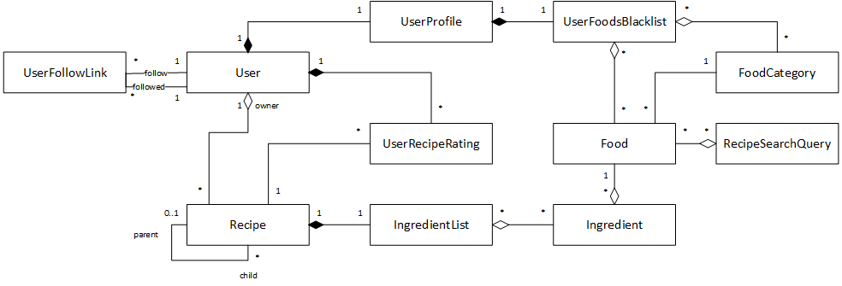

- User: a user object encapsulates the login information of a single end user of the system. Users are allowed to follow other users in an asymmetric link (UserFollowLink)
- UserProfile: user profile objects belong to a specific user and encapsulate profile information as defined in UC3
- UserFoodsBlacklist: a UserFoodsBlacklist object is a part of the UserProfile and has references to a number of foods the user specifies as blacklisted (i.e. the user will not eat those foods)
- UserFollowLink: a UserFollowLink encapsulates a social link between two users, it specifies the following user and the followed user.
- Recipe: a recipe is the most central object for the system. It encapsulates a list of ingredients required to prepare a meal (IngredientList) as well as the directions followed to prepare it. A Recipe object consistently refers to a meal (e.g. apple pie) whereas the Food object refers to a raw food item purchaseable at the grocery store (e.g. apple)
- IngredientList: the ingredient list object is a collection class for all the ingredients required to prepare a meal
- Ingredient: an ingredient is a food item that has an amount specified beside it
- RecipeSearchQuery: is an object representation of the search query a user will submit to look up recipes in the system. It contains a list of foods specified for the query
- UserRecipeRating: a user’s rating of a certain recipe, from 1 to 5 is captured in this object class.
- Food: another central object class in the system, a Food item refers to a raw item that may be purchased from the grocery store and will be used to create an ingredient, therefore a recipe. e.g. sugar, apple, bananas, pasta
- FoodCategory: is a type or category of foods which may contain multiple Food items. FoodCategory objects do not have multiple levels of hierarchy. One food item may belong to multiple categories. The user may choose to blacklist an entire category. e.g. dairy, fruits, vegetables

6. Mock-up Scenarios

Two scenario storyboards were annexed to this document describing two use cases:

- Search & Recommendation, in file Recommendation_scenario_web_mockups_v0.1.pptx
- Recipe substitution, in file Recipe_substitution_scenario_web_mockups_v0.2.pptx

