SoftServe University
43. UML. Behavioral Diagrams

Version 1.0

For internal use

<April 20, 2005>
Revision History
Date | Version | Description | Author
April 20, 2005 | 1.0 | Initial version | A.Pereymybida

Table of contents
1 Interactions 4
1.1 Messages 4
1.2 Sequencing 5
1.3 Example 5
2 Use Cases 6
2.1 Use Case Diagrams 7
3 Interaction Diagrams 8
4 Activity Diagrams 10
4.1 Swimlanes 12
4.2 Object Flow 13
4.3 Example 14
5 Events and Signals 14
5.1 Signals 15
5.2 Call Events 15
5.3 Time and Change Events 15
5.4 Example 16
6 State Machines 16
7 Processes and Threads 18
8 Statechart Diagrams 20

Interactions
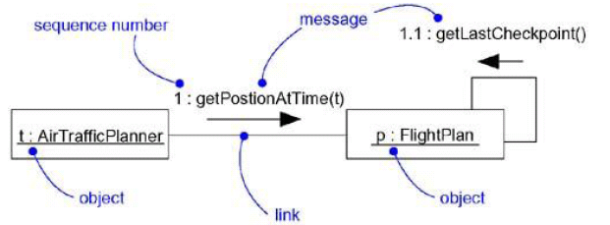
An interaction is a behavior that comprises a set of messages exchanged among a set of objects within a context to accomplish a purpose.
A message is a specification of a communication between objects that conveys information with the expectation that activity will ensue.

Messages
Call | Invokes an operation on an object; an object may send a message to itself, resulting in the local invocation of an operation
Return | Returns a value to the caller
Send | Sends a signal to an object
Create | Creates an object
Destroy | Destroys an object; an object may commit suicide by destroying itself
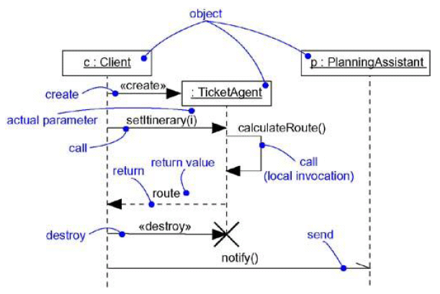

Sequencing on Collaboration diagram
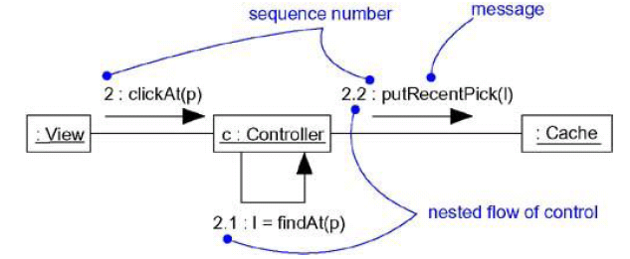

Example
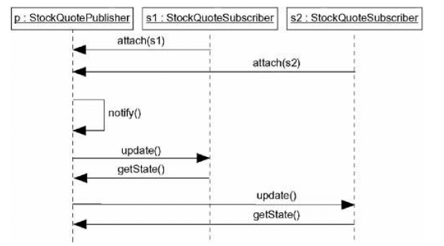
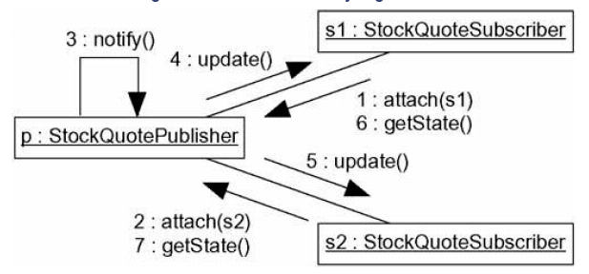

Use Cases
A use case is a description of a set of sequences of actions, including variants, that a system
performs to yield an observable result of value to an actor. Graphically, a use case is rendered as
an ellipse.
An actor represents a coherent set of roles that users of use cases play when interacting with
these use cases. Typically, an actor represents a role that a human, a hardware device, or even
another system plays with a system.
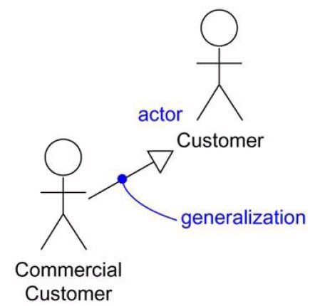
You have to implement your use cases, and you do so by creating a society of classes and other elements that work together to implement the behavior of this use case. This society of elements, including both its static and dynamic structure, is modeled in the UML as a collaboration.
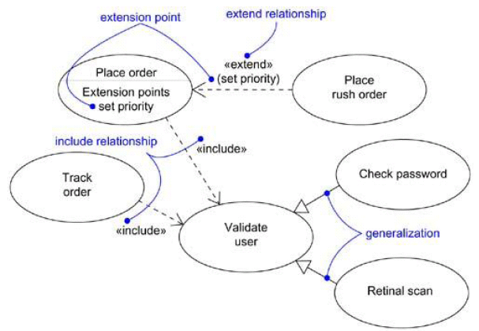

Use Case Diagrams
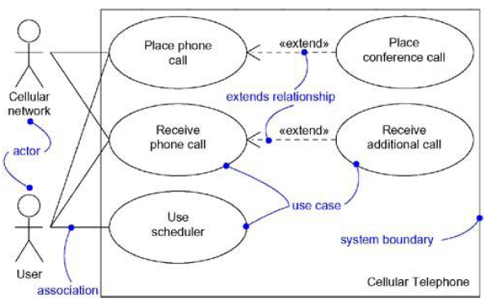
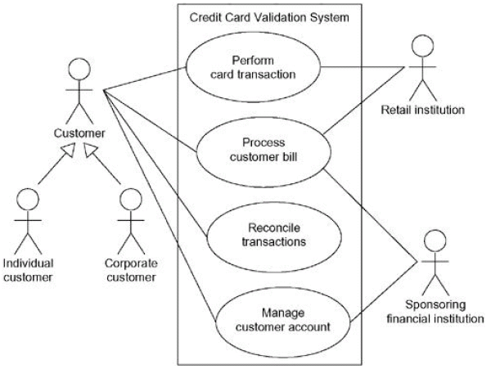

Interaction Diagrams
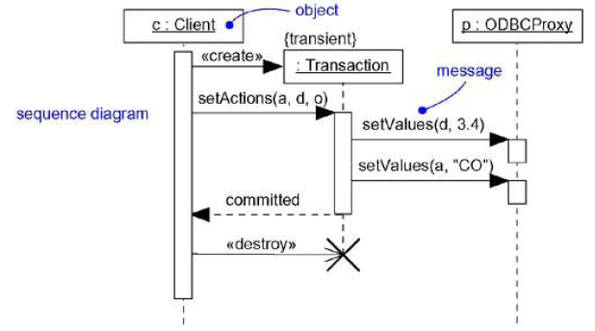
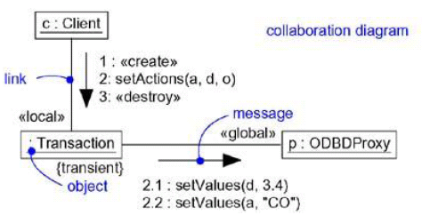
An interaction diagram shows an interaction, consisting of a set of objects and their relationships,
including the messages that may be dispatched among them.
A sequence diagram is an interaction diagram that emphasizes the time ordering of messages. Graphically, a sequence diagram is a table that shows objects arranged along the X axis and messages, ordered in increasing time, along the Y axis.
A collaboration diagram is an interaction diagram that emphasizes the structural organization of the objects that send and receive messages. Graphically, a collaboration diagram is a collection of vertices and arcs.
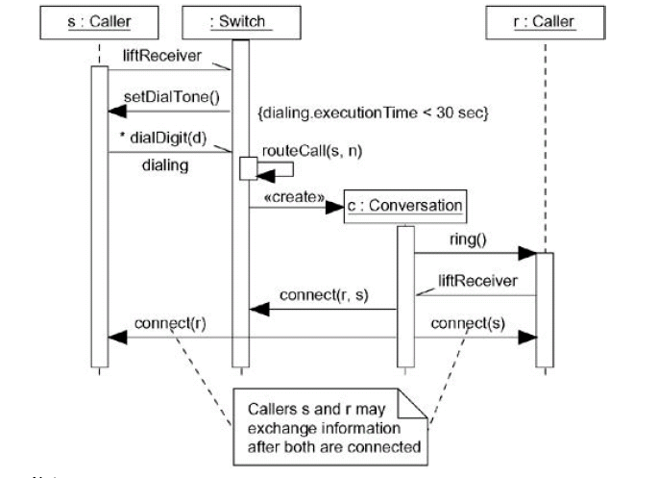
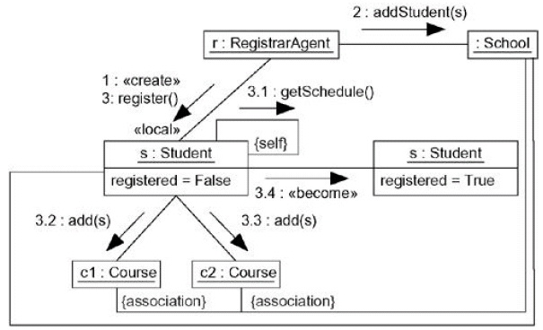

Activity Diagrams
An activity diagram shows the flow from activity to activity. An is an ongoing nonatomic execution within a state machine.
Activities ultimately result in some action, which is made up of executable atomic computations that result in a change in state of the system or the return of a value. Actions encompass calling another operation, sending a signal, creating or destroying an object, or some pure computation, such as evaluating an expression. Graphically, an activity diagram is a
collection of vertices and arcs.
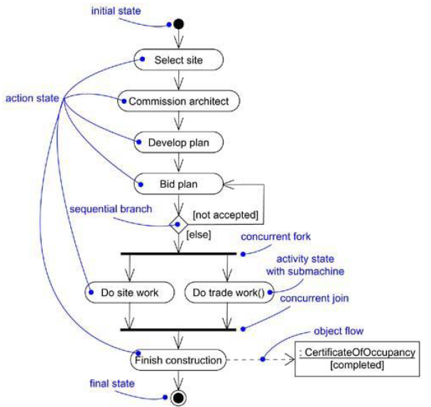

Swimlanes
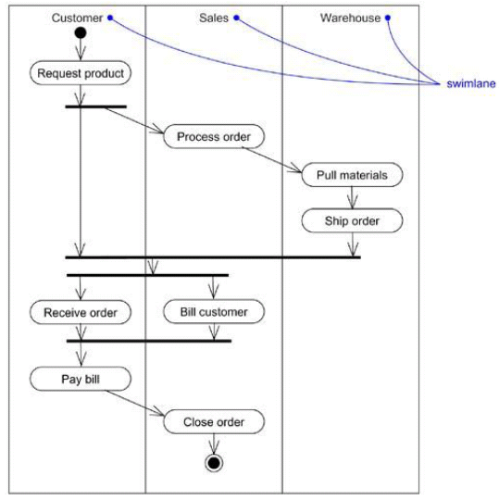

Object Flow
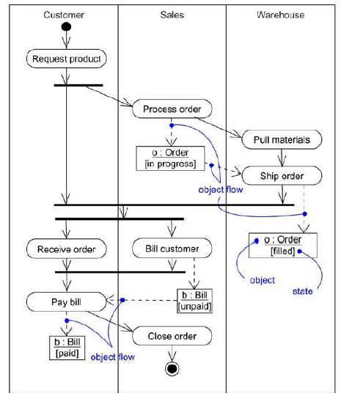

Example
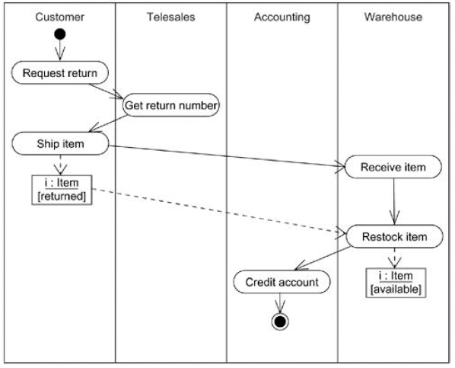

Events and Signals
An event is the specification of a significant occurrence that has a location in time and space. In the context of state machines, an event is an occurrence of a stimulus that can trigger a state transition.
A signal is a kind of event that represents the specification of an asynchronous stimulus communicated between instances.
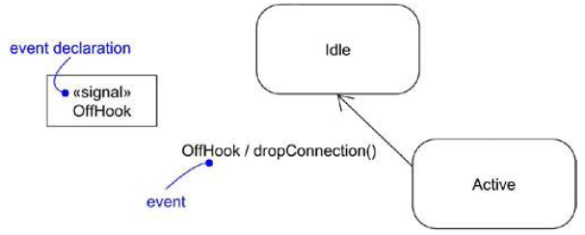

Signals
A signal represents a named object that is dispatched (thrown) asynchronously by one object and
then received (caught) by another. Exceptions are supported by most contemporary programming
languages and are the most common kind of internal signal that you will need to model.
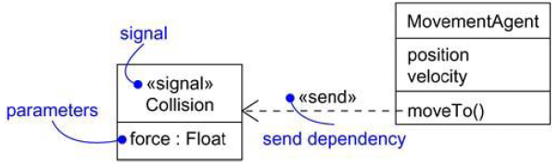

Call Events
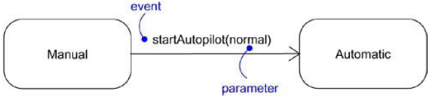

Time and Change Events
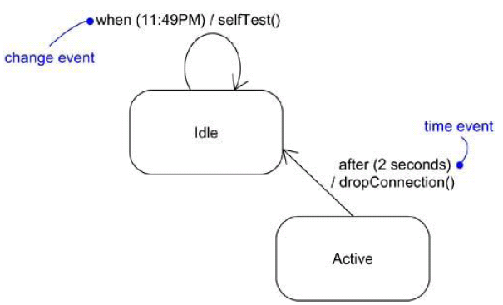

Example
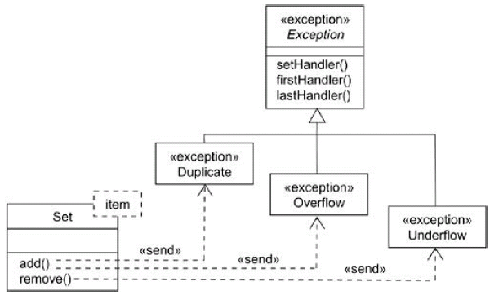

State Machines
A state machine is a behavior that specifies the sequences of states an object goes through
during its lifetime in response to events, together with its responses to those events.
A state is a condition or situation during the life of an object during which it satisfies some condition, performs some activity, or waits for some event.
An event is the specification of a significant occurrence that has a location in time and space. In the context of state machines, an event is an occurrence of a stimulus that can trigger a state transition.
A transition is a relationship between two states indicating that an object in the first state will perform certain actions and enter the second state when a specified event occurs and specified conditions are satisfied.
An activity is ongoing nonatomic execution within a state machine.
An action is an executable atomic computation that results in a change in state of the model or the return of a value. Graphically, a state is rendered as a rectangle with rounded corners. A transition is rendered as a solid directed line.
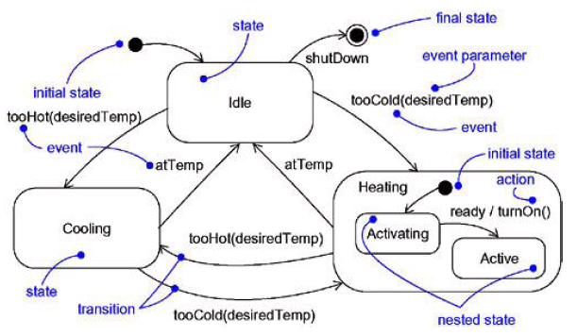
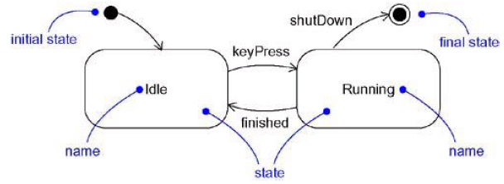
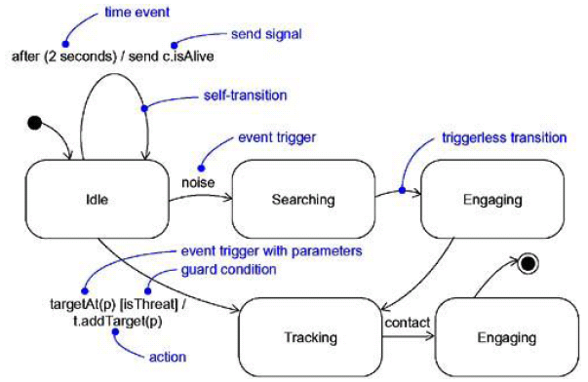
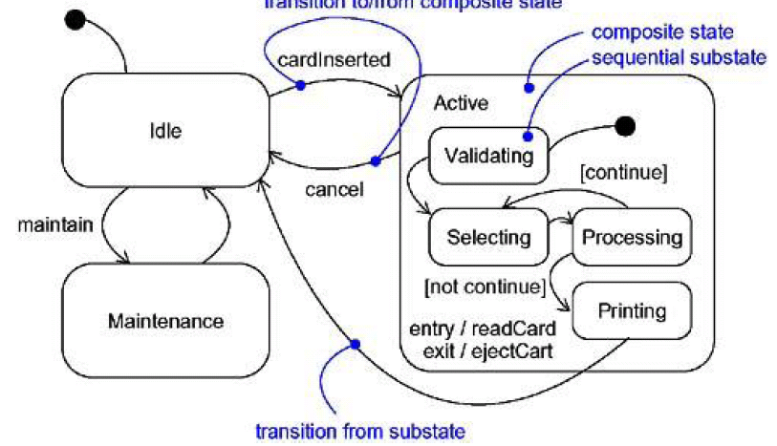

Processes and Threads
An active object is an object that owns a process or thread and can initiate control activity.
An active class is a class whose instances are active objects.
A process is a heavyweight flow that can execute concurrently with other processes.
A thread is a lightweight flow that can execute concurrently with other threads within the same process.
Graphically, an active class is rendered as a rectangle with thick lines. Processes and threads are rendered as stereotyped active classes (and also appear as sequences in interaction diagrams).
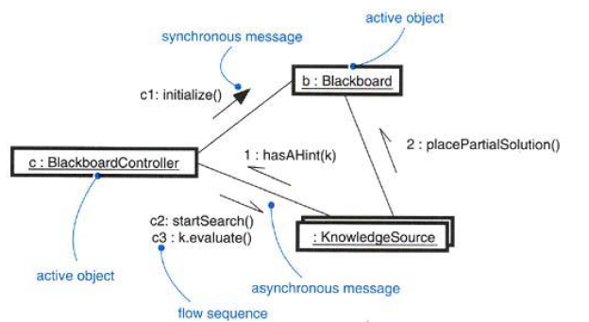
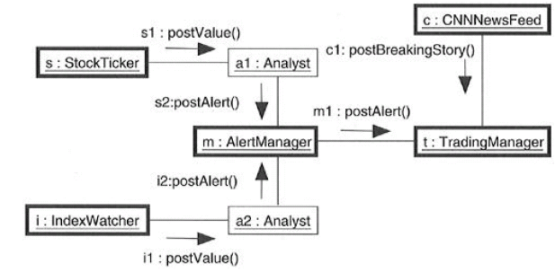
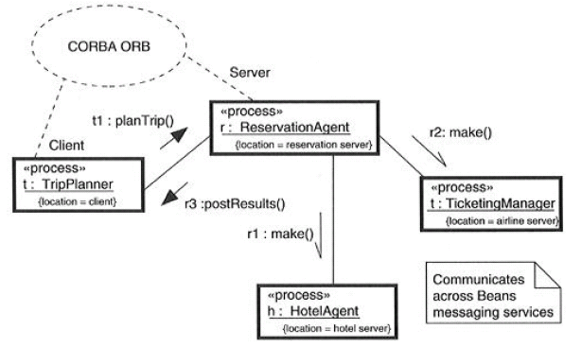

Statechart Diagrams
A statechart diagram shows a state machine, emphasizing the flow of control from state to state.
A state machine is a behavior that specifies the sequences of states an object goes through
during its lifetime in response to events, together with its responses to those events.
A state is a condition or situation in the life of an object during which it satisfies some condition, performs some activity, or waits for some event.
An event is the specification of a significant occurrence that has a location in time and space. In the context of state machines, an event is an occurrence of a stimulus that can trigger a state transition.
A transition is a relationship between two states indicating that an object in the first state will perform certain actions and enter the second state when a specified event occurs and specified conditions are satisfied.
An activity is ongoing nonatomic execution within a state machine.
An action is an executable atomic computation that results in a change in state of the model or the return of a value.
Graphically, a statechart diagram is a collection of vertices and arcs.

