服务器性能测试及优化计划

1. 简介

1.1目的

该测试及优化计划主要实现以下目标：

·确定现有项目的信息以及软件架构

·列出测试需求

·对测试工作进行评估

·分析测试结果

·制定优化计划

1.2背景

本项目为天天浏览器代理服务器端，现由开发人员组织性能测试，为此撰写性能测试报告，并通过对性能测试结果分析，进行优化。

1.3范围

以单元测试为基础，进行性能测试；

主要关注Jetty的性能测试、Memcache的性能测试、Filter单元测试、综合集成测试。

1. 测试需求

包括同事处理多个请求的能力（并发时间曲线、单项相应时间趋势、并发响应时间趋势）、服务器内存资源消耗情况、CPU利用情况；

在负载超出正常时，服务器的工作情况；在比较恶劣的情况下，系统是否崩溃。

1. 测试策略

以单元测试为基础，进行性能测试；测试结束生成动态监测报告、响应时间/吞吐量报告、CPU利用率报告、比较报告等。

1. 测试资源
   1. 角色：由开发人员组成（姜俊、苏伟、赵家智）
   2. 系统：天天浏览器代理服务器
2. 测试成果
   1. Jetty性能测试
      1. 单任务
         1. 事务响应时间如下图：



* + 1. 20并发
       1. 事务响应时间如下图：



* + 1. 200并发
       1. 事务响应时间如下图：



* + 1. 1000并发
       1. 事务响应时间如下图：



* + 1. 2000并发



* 1. 综合性能测试
     1. 单任务
        1. 有缓存

|  |  |  |  |  |  |  |  |  |  |
| --- | --- | --- | --- | --- | --- | --- | --- | --- | --- |
| **事务名称** | **SLA Status** | **最小值** | **平均值** | **最大值** | **标准偏差** | **90 Percent** | **通过** | **失败** | **停止** |
| load163_Transaction | [显示 SLA 结果](slarules:transaction_response_time_load163_Transaction) | 0.025 | 0.11 | 2.69 | 0.436 | 0.05 | 36 | 0 | 1 |

Cpu：

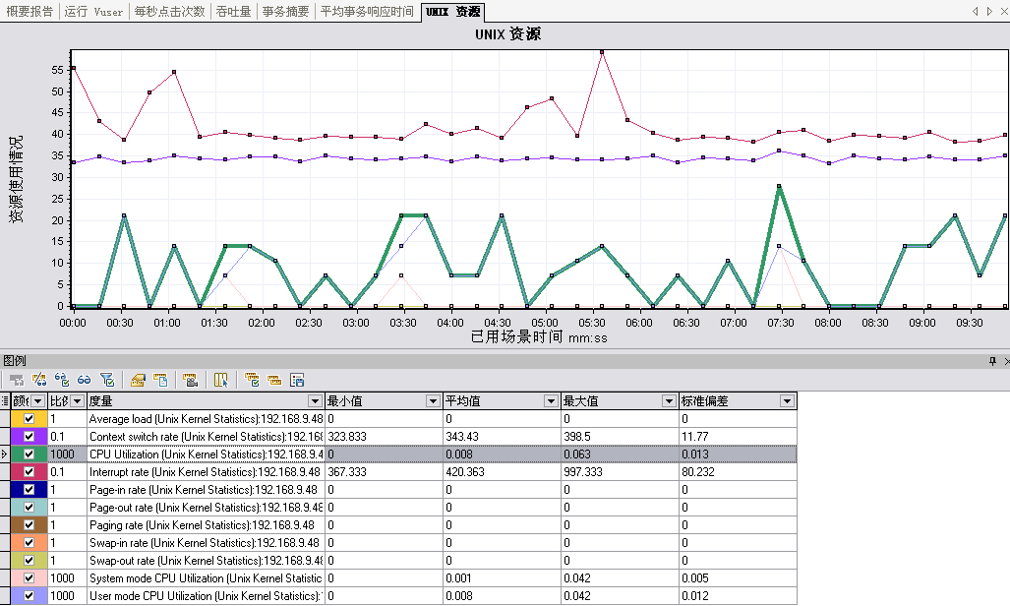

* + - 1. 无缓存

|  |  |  |  |  |  |  |  |  |  |
| --- | --- | --- | --- | --- | --- | --- | --- | --- | --- |
| **事务名称** |  | **最小值** | **平均值** | **最大值** | **标准偏差** | **90 Percent** | **通过** | **失败** | **停止** |
| load163_Transaction |  | 0.376 | 0.459 | 0.924 | 0.107 | 0.581 | 34 | 0 | 1 |

运行时cpu在8%左右，低值为0

* + 1. 20并发
       1. 有缓存

|  |  |  |  |  |  |  |  |  |  |
| --- | --- | --- | --- | --- | --- | --- | --- | --- | --- |
| **事务名称** | **SLA Status** | **最小值** | **平均值** | **最大值** | **标准偏差** | **90 Percent** | **通过** | **失败** | **停止** |
| load163_Transaction | [显示 SLA 结果](slarules:transaction_response_time_load163_Transaction) | 0.032 | 0.257 | 4.719 | 0.68 | 0.182 | 1,500 | 0 | 5 |
|  |  |  |  |  |  |  |  |  |  |

Cpu

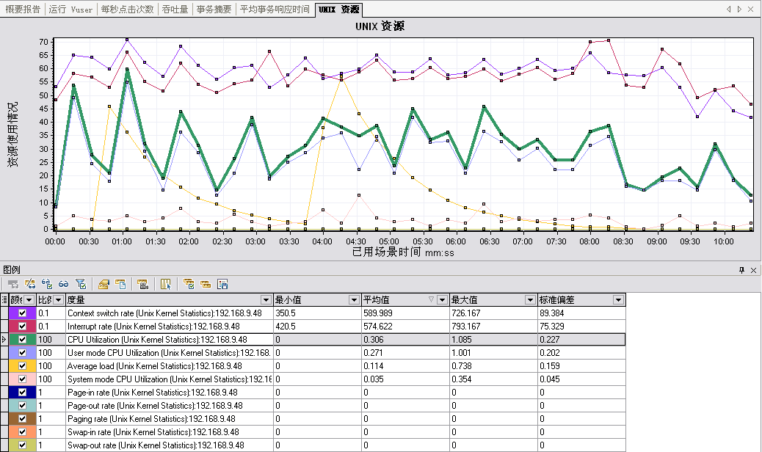

* + - 1. 无缓存

|  |  |  |  |  |  |  |  |  |  |
| --- | --- | --- | --- | --- | --- | --- | --- | --- | --- |
| **事务名称** |  | **最小值** | **平均值** | **最大值** | **标准偏差** | **90 Percent** | **通过** | **失败** | **停止** |
| load163_Transaction |  | 0.497 | 2.693 | 7.581 | 1.053 | 3.735 | 650 | 0 | 5 |

运行时cpu在100%-330%左右，低值为0

* + 1. 200并发
       1. 有缓存

|  |  |  |  |  |  |  |  |  |  |
| --- | --- | --- | --- | --- | --- | --- | --- | --- | --- |
| **事务名称** | **SLA Status** | **最小值** | **平均值** | **最大值** | **标准偏差** | **90 Percent** | **通过** | **失败** | **停止** |
| load163_Transaction | [显示 SLA 结果](slarules:transaction_response_time_load163_Transaction) | 0.046 | 2.273 | 17.485 | 1.877 | 4.714 | 13,208 | 0 | 12 |

Cpu：

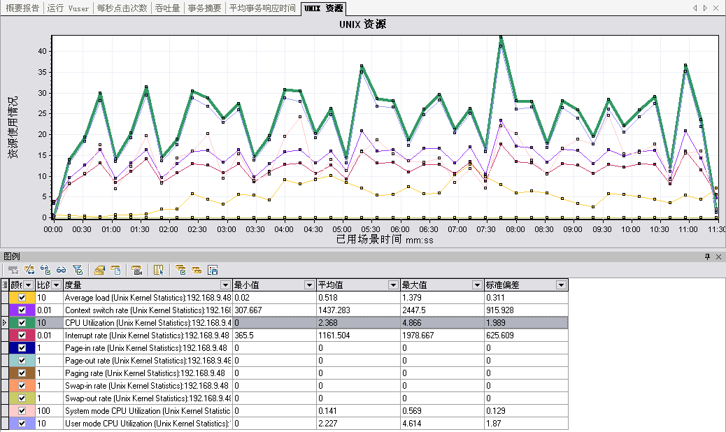

* + - 1. 无缓存

|  |  |  |  |  |  |  |  |  |  |
| --- | --- | --- | --- | --- | --- | --- | --- | --- | --- |
| **事务名称** |  | **最小值** | **平均值** | **最大值** | **标准偏差** | **90 Percent** | **通过** | **失败** | **停止** |
| load163_Transaction |  | 9.785 | 16.249 | 22.79 | 3.117 | 20.133 | 25 | 469 | 187 |

运行时cpu在100-330%左右，运行完毕还保持在100%，程序停止响应。

* + 1. 1000并发
       1. 有缓存

|  |  |  |  |  |  |  |  |  |  |
| --- | --- | --- | --- | --- | --- | --- | --- | --- | --- |
| **事务名称** | **SLA Status** | **最小值** | **平均值** | **最大值** | **标准偏差** | **90 Percent** | **通过** | **失败** | **停止** |
| load163_Transaction | [显示 SLA 结果](slarules:transaction_response_time_load163_Transaction) | 0.127 | 18.65 | 62.768 | 9.63 | 30.963 | 24,588 | 847 | 223 |

Cpu：

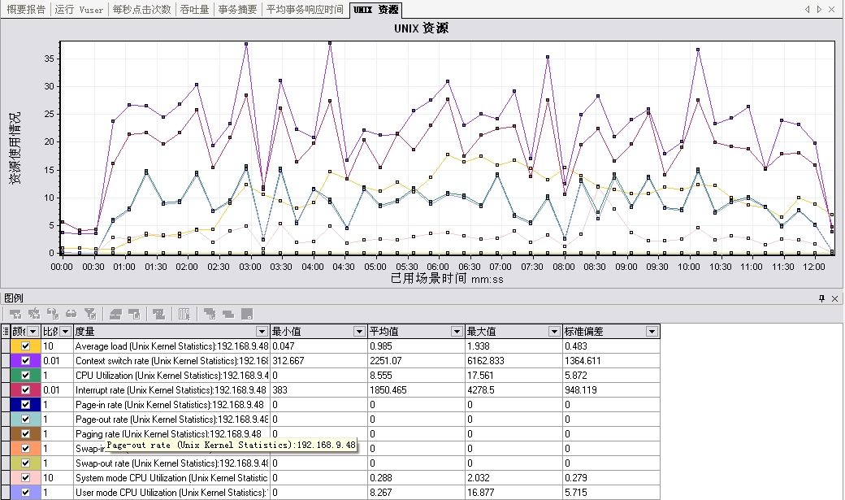

* + - 1. 无缓存

cpu100%，程序停止响应。

* + 1. 2000并发
       1. 有缓存

|  |  |  |  |  |  |  |  |  |  |
| --- | --- | --- | --- | --- | --- | --- | --- | --- | --- |
| **事务名称** | **SLA Status** | **最小值** | **平均值** | **最大值** | **标准偏差** | **90 Percent** | **通过** | **失败** | **停止** |
| load163_Transaction | [显示 SLA 结果](slarules:transaction_response_time_load163_Transaction) | 14.779 | 36.077 | 81.641 | 27.941 | 81.641 | 7 | 7,573 | 1,639 |

Cpu 100% ，程序无响应。

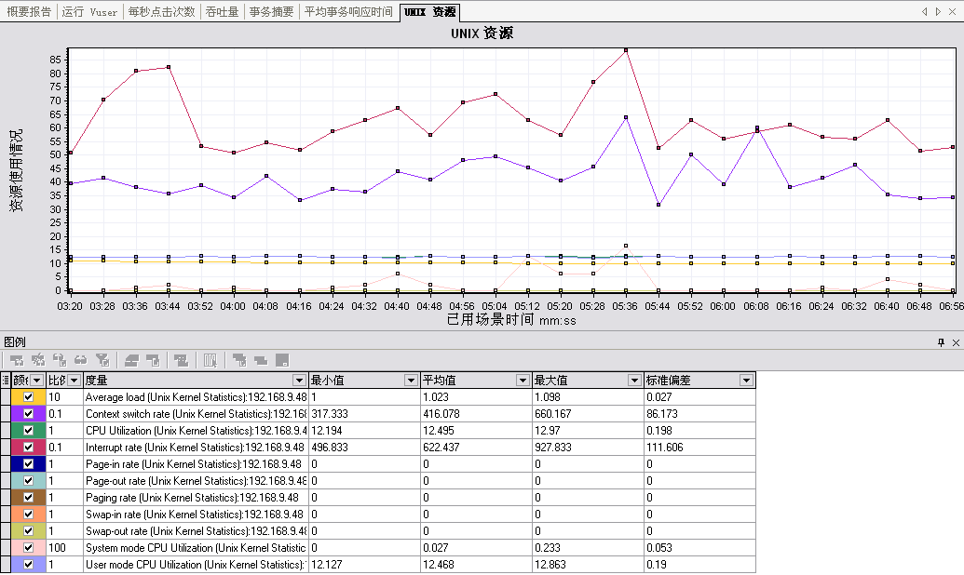

* + - 1. 无缓存  
         cpu100%，程序停止响应。
  1. 模块单元测试，以163主页为例，测试各个模块的处理时间

|  |  |  |  |  |
| --- | --- | --- | --- | --- |
| 模块(网易163首页) | 时间1 | 时间2 | 时间3 | 平均时间 |
| JsonMessgaeParseFilter | 2ms | 1ms | 3ms | 2 |
| PrecacheFilter | 3ms | 1ms | 4ms | 2.6 |
| HttpClientJsonFilter | 381ms | 87ms | 237ms | 235 |
| HtmlDocumentFilter | 676ms | 147ms | 693ms | 505 |
| DetectForumFilter | 81ms | 10ms | 82ms | 57 |
| LoadStyleTemplateFilter | 2ms | 2ms | 2ms | 2 |
| DetectXpathFilter | 0ms | 0ms | 1ms | 0.3 |
| BlockFilter | 395ms | 128ms | 386ms | 303 |
| SequenceFilter | 283ms | 58ms | 283ms | 208 |
| XpathSaveFilter | 1ms | 0ms | 1ms | 0.6 |
| WrapFilter | 55ms | 5ms | 60ms | 40 |
| HyperLinkFilter | 61ms | 8ms | 65ms | 44 |
| InsertCssJsFilter | 1ms | 1ms | 2ms | 1.3 |
| HtmlElementFilter | 177ms | 90ms | 179ms | 125 |
| EndCacheFilter | 154ms | 4ms | 153ms | 311 |
| 总的时间 | 2272ms | 542ms | 2151ms | 1655 |

|  |  |  |  |  |
| --- | --- | --- | --- | --- |
| 模块(新浪Sina首页) | 时间1 | 时间2 | 时间3 | 平均时间 |
| JsonMessgaeParseFilter | 1 | 1 | 1 | 1 |
| PrecacheFilter | 1 | 1 | 1 | 1 |
| HttpClientJsonFilter | 114 | 91 | 93 | 99.3 |
| HtmlDocumentFilter | 147 | 122 | 136 | 135 |
| DetectForumFilter | 10 | 9 | 10 | 29 |
| LoadStyleTemplateFilter | 1 | 1 | 1 | 1 |
| DetectXpathFilter | 1 | 0 | 0 | 0.3 |
| BlockFilter | 82 | 70 | 62 | 71.3 |
| SequenceFilter | 64 | 60 | 63 | 62.3 |
| XpathSaveFilter | 0 | 0 | 1 | 0.3 |
| WrapFilter | 4 | 4 | 3 | 3.6 |
| HyperLinkFilter | 5 | 5 | 5 | 5 |
| InsertCssJsFilter | 2 | 1 | 1 | 1.3 |
| HtmlElementFilter | 39 | 27 | 27 | 31 |
| EndCacheFilter | 2 | 2 | 2 | 2 |
| 总的时间 | 473 | 394 | 406 | 424 |

1. 优化需求

从测试结果分析，服务器在处理高并发的请求时能力不理想，并且CPU利用率上不去，出现这样的情况主要是服务器对单个请求事务的处理时间有限，为了提高服务器的性能，我们需要做以下优化工作：

* 1. 提高单个事务的处理时间
     1. 提高服务器每个模块的处理时间
  2. 减少单个网页的流量
  3. 提高网页压缩的比例

1. 优化计划
   1. 从代码层面来优化
      1. 尽可能的使用Java语言本身提供的函数，从而减少生成的对象或实例，例如StringBuffer等等
      2. 避免生成不太使用或生命周期短的对象或变量
      3. 只在对象作用范围内初始化
      4. 避免对逻辑处理的代码使用try/catch，使用if.while代替
      5. 异常对象尽可能重用
      6. 对于临界资源的同步加锁，尽量对方法或函数同步不要同步整个代码段
      7. 尽量使用输入输出缓冲
      8. 尽量使用局部变量
      9. 避免在同一个类中调用函数或放（Get或Set）来设置或调用变量
      10. 避免在循环中生成同一个变量或调用同一个函数
   2. 从工具层面来优化
      1. Jetty调优
      2. 线程池调优
2. 优化过程
   1. Jetty线程池优化

使用jetty提供的continuation线程池机制，服务器端接收请求的线程不需要等待请求处理完毕就可以返回，而继续处理其他客户端请求，避免了大量用户并发时，部分用户请求无法处理的情况。服务器线程接收到一个请求之后，可以将请求挂起，然后返回继续接收其他客户请求。请求挂起之后，通过一个新线程继续处理，此操作可能很耗时，处理完毕之后将之前挂起的请求恢复，并将最终结果返回客户端。

* 1. 责任链优化

去除SequenceFilter 中根据权重计算和按权重排序，通用版阅读模式也是按照权重计算 ，降低责任链执行时间，提高服务器访问效率

根据权重增加阅读模式二次取最大节点，进一步对阅读模式去噪处理。

* 1. 日志系统优化

##### 对现有com.huawei.nwa.networkagent.log.Logger进行改造，之前使用的jdk的common-log，现在使用log4j进行日志记录。Log4j多线程写日志有个bug容易死锁，经过测试也是这样的，所以将日志级别设置为error，可以极大提高性能。内存2G，1000线程，在loadrunner 2000 users测试时，，依然能保证响应。

|  |  |  |  |  |  |  |  |  |  |
| --- | --- | --- | --- | --- | --- | --- | --- | --- | --- |
| **事务名称** |  | **最小值** | **平均值** | **最大值** | **标准偏差** | **90 Percent** | **通过** | **失败** | **停止** |
| load163_Transaction |  | 0.138 | 12.916 | 101.871 | 13.773 | 22.091 | 18,585 | 0 | 497 |

1. 优化成果

优化成果可以从以下几个方面验证：

1. 服务器并发量是否有提高

并发量有明显提高，8G内存，并发3000个请求在5分钟内的通过率为82%，并发量的限制主要和内存有关，并发太多会导致频繁GC所有请求都变慢，最终很多就失败。

200并发

|  |  |  |  |  |  |  |  |  |  |
| --- | --- | --- | --- | --- | --- | --- | --- | --- | --- |
| **事务名称** |  | **最小值** | **平均值** | **最大值** | **标准偏差** | **90 Percent** | **通过** | **失败** | **停止** |
| load163_Transaction |  | 0.048 | 1.867 | 8.725 | 1.602 | 3.398 | 6,242 | 0 | 106 |
| vuser_end_Transaction |  | 0 | 0 | 0.003 | 0 | 0 | 200 | 0 | 0 |
| vuser_init_Transaction |  | 0 | 0 | 0 | 0 | 0 | 200 | 0 | 0 |

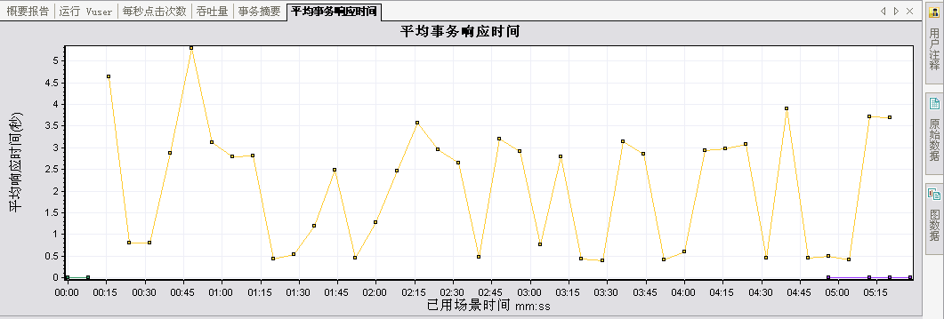

500并发：

|  |  |  |  |  |  |  |  |  |  |
| --- | --- | --- | --- | --- | --- | --- | --- | --- | --- |
| **事务名称** |  | **最小值** | **平均值** | **最大值** | **标准偏差** | **90 Percent** | **通过** | **失败** | **停止** |
| load163_Transaction |  | 0.152 | 6.575 | 22.48 | 3.702 | 11.751 | 10,689 | 0 | 161 |
| vuser_end_Transaction |  | 0 | 0 | 0.001 | 0 | 0 | 500 | 0 | 0 |
| vuser_init_Transaction |  | 0 | 0 | 0.014 | 0.001 | 0 | 500 | 0 | 0 |

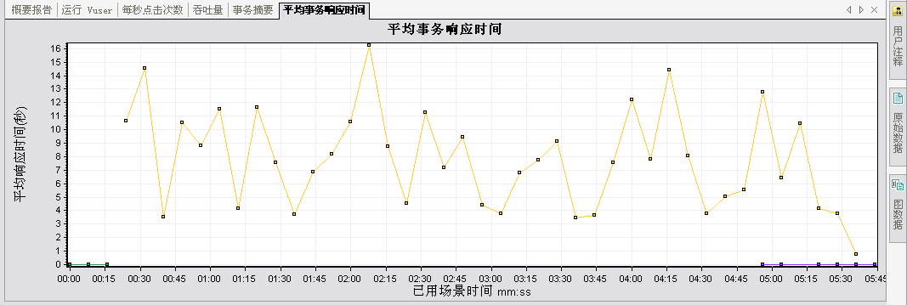

1000并发：

|  |  |  |  |  |  |  |  |  |  |
| --- | --- | --- | --- | --- | --- | --- | --- | --- | --- |
| **事务名称** |  | **最小值** | **平均值** | **最大值** | **标准偏差** | **90 Percent** | **通过** | **失败** | **停止** |
| load163_Transaction |  | 0.076 | 9.485 | 50.673 | 6.386 | 16.8 | 18,415 | 435 | 233 |
| vuser_end_Transaction |  | 0 | 0 | 0.028 | 0.001 | 0 | 1,000 | 0 | 0 |
| vuser_init_Transaction |  | 0 | 0 | 0.001 | 0 | 0 | 1,000 | 0 | 0 |

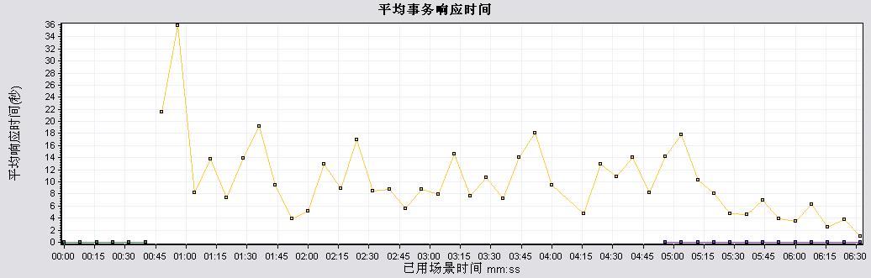

2000并发：

|  |  |  |  |  |  |  |  |  |  |
| --- | --- | --- | --- | --- | --- | --- | --- | --- | --- |
| **事务名称** |  | **最小值** | **平均值** | **最大值** | **标准偏差** | **90 Percent** | **通过** | **失败** | **停止** |
| load163_Transaction |  | 0.079 | 16.577 | 114.009 | 17.777 | 24.189 | 21,923 | 3,049 | 902 |
| vuser_end_Transaction |  | 0 | 0 | 0.007 | 0 | 0 | 2,000 | 0 | 0 |
| vuser_init_Transaction |  | 0 | 0 | 0.004 | 0 | 0 | 2,000 | 0 | 0 |

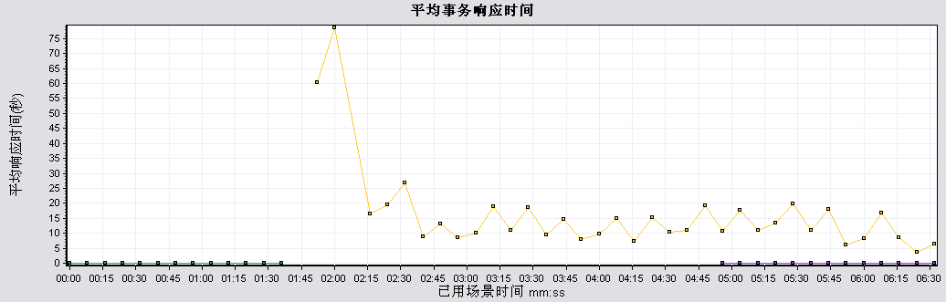

3000并发

|  |  |  |  |  |  |  |  |  |  |
| --- | --- | --- | --- | --- | --- | --- | --- | --- | --- |
| **事务名称** | **SLA Status** | **最小值** | **平均值** | **最大值** | **标准偏差** | **90 Percent** | **通过** | **失败** | **停止** |
| load163_Transaction | [显示 SLA 结果](slarules:transaction_response_time_load163_Transaction) | 0.134 | 24.891 | 149.237 | 20.755 | 50.087 | 45,893 | 7,796 | 2,050 |
| vuser_end_Transaction | [显示 SLA 结果](slarules:transaction_response_time_vuser_end_Transaction) | 0 | 0 | 0.017 | 0 | 0 | 3,000 | 0 | 0 |
| vuser_init_Transaction | [显示 SLA 结果](slarules:transaction_response_time_vuser_init_Transaction) | 0 | 0 | 0.02 | 0.001 | 0 | 3,000 | 0 | 0 |

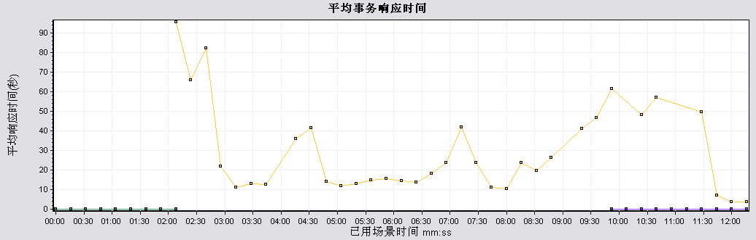

4000并发：

由于 pc性能问题，模拟4000用户并发有困难。

1. 单个事务的处理时间是否有缩短

|  |  |  |  |  |  |
| --- | --- | --- | --- | --- | --- |
| 模块(网易163首页) | 时间1 | 时间2 | 时间3 | 平均时间 | 对比 |
| JsonMessgaeParseFilter | 0 | 15 | 0 | 5 | 2 |
| PrecacheFilter | 0 | 16 | 0 | 5.3 | 2.6 |
| HttpClientJsonFilter | 188 | 62 | 93 | 114 | 235 |
| HtmlDocumentFilter | 140 | 157 | 141 | 146 | 505 |
| DetectForumFilter | 16 | 15 | 16 | 15.6 | 57 |
| LoadStyleTemplateFilter | 0 | 0 | 0 | 0 | 2 |
| DetectXpathFilter | 0 | 0 | 15 | 5 | 0.3 |
| BlockFilter | 125 | 125 | 110 | 120 | 303 |
| SequenceFilter | 94 | 110 | 109 | 104 | 208 |
| XpathSaveFilter | 16 | 0 | 0 | 5.3 | 0.6 |
| WrapFilter | 0 | 15 | 16 | 10.3 | 40 |
| HyperLinkFilter | 14 | 16 | 15 | 15 | 44 |
| InsertCssJsFilter | 0 | 0 | 0 | 0 | 1.3 |
| HtmlElementFilter | 63 | 203 | 188 | 151 | 125 |
| EndCacheFilter | 16 | 0 | 15 | 10.3 | 311 |
| 总的时间 | 672 | 734 | 718 | 708 | 1655 |

|  |  |  |  |  |  |
| --- | --- | --- | --- | --- | --- |
| 模块(新浪Sina首页) | 时间1 | 时间2 | 时间3 | 平均时间 | 对比 |
| JsonMessgaeParseFilter | 0 | 0 | 0 | 0 | 1 |
| PrecacheFilter | 0 | 0 | 0 | 0 | 1 |
| HttpClientJsonFilter | 67 | 75 | 82 | 74 | 99.3 |
| HtmlDocumentFilter | 110 | 106 | 112 | 109 | 135 |
| DetectForumFilter | 31 | 31 | 16 | 26 | 29 |
| LoadStyleTemplateFilter | 0 | 0 | 0 | 0 | 1 |
| DetectXpathFilter | 0 | 0 | 0 | 0 | 0.3 |
| BlockFilter | 102 | 98 | 105 | 101 | 71.3 |
| SequenceFilter | 54 | 42 | 41 | 45 | 62.3 |
| XpathSaveFilter | 0 | 0 | 0 | 0 | 0.3 |
| WrapFilter | 16 | 16 | 15 | 15 | 3.6 |
| HyperLinkFilter | 0 | 15 | 0 | 5 | 5 |
| InsertCssJsFilter | 0 | 0 | 0 | 0 | 1.3 |
| HtmlElementFilter | 27 | 19 | 35 | 27 | 31 |
| EndCacheFilter | 0 | 0 | 0 | 0 | 2 |
| 总的时间 | 407 | 402 | 406 | 405 | 424 |

以网易与新浪首页为例，运行三次，计算三次平均时间，通过比较可以看出整体平均时间以及某些模块时间得到缩减，但不排除网络与服务器实时CPU与内存状态的影响，仅供参考。

1. 流量是否减少

以页面<http://novel.hongxiu.com/a/286613/3518203.shtml>为例，测试优化前后流量对比，无法保证所有页面，仅供参考；

优化前：

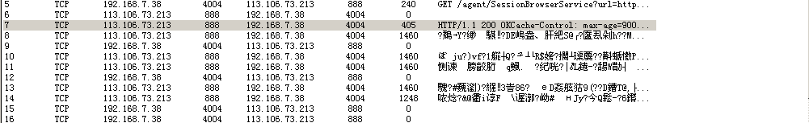

优化后：

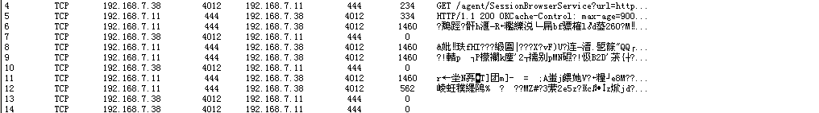

通过对比发现优化前服务器返回数据总量为7493字节，优化之后的服务器返回的数据总量为6729字节，对比优化前有所减少，此例子仅供参考。