Assignment 2

# Restaurant “Yntymak” (web application)

## Actors

* **Visitors:** someone who just look to the information about restaurant, gallery, contacts and etc.
* **Client:**  someone who making reservation and/or order the menu.
* **Administrator:** someone who admit reservations from clients and controls content of web application.

Main page:

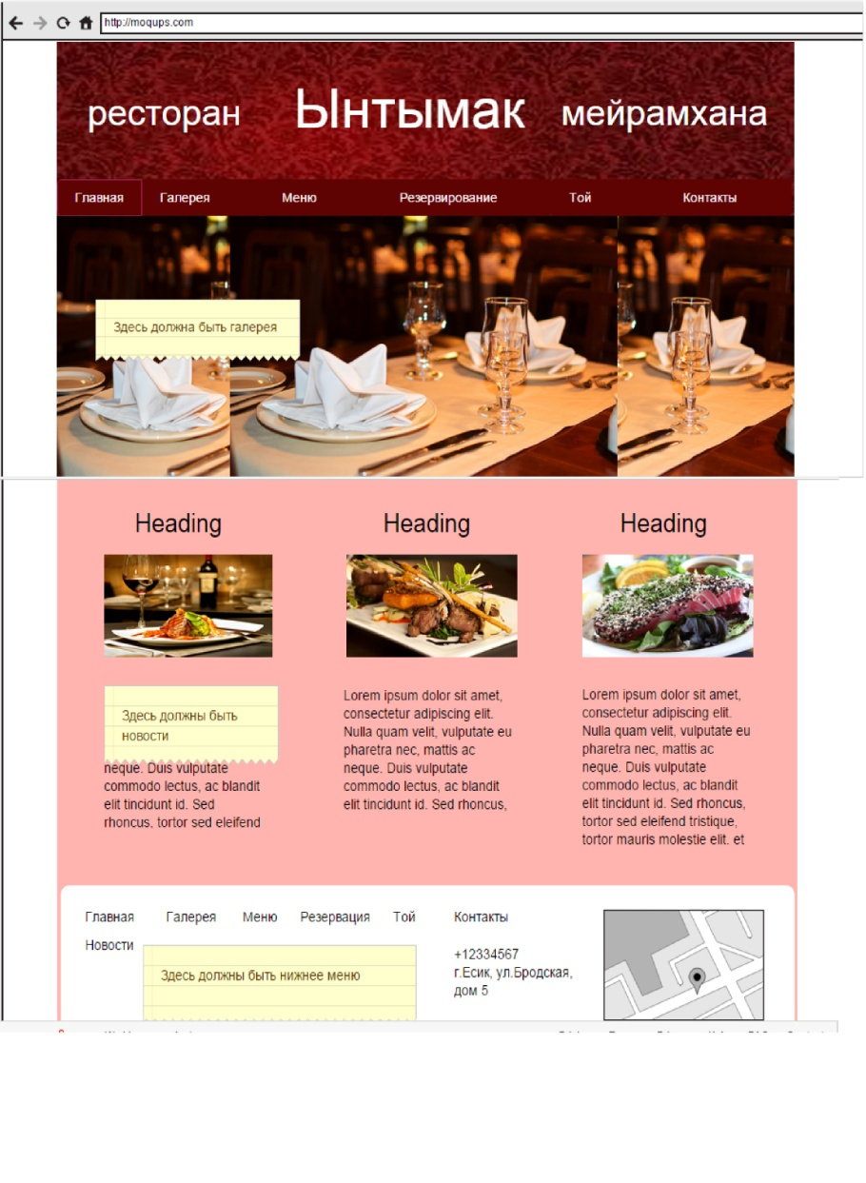

This is the main page of web application.

Developer: Ainur ALmurzina

This is the bottom menu with contact field

Here must be news about restaurant

This is the gallery with pictures of restaurant

This is the main menu.

Gallery page:

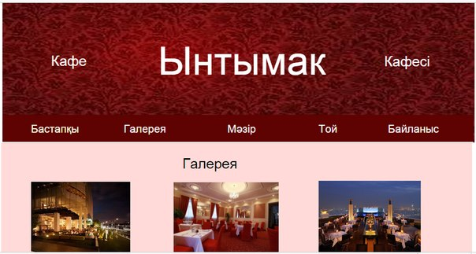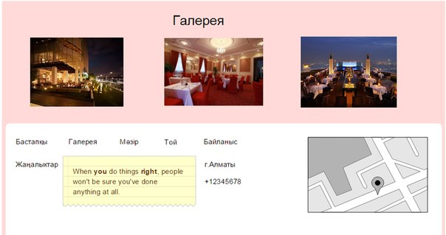

This is a gallery of restaurant

This is a gallery page. The aim of this page is to show how restaurant looks like.

Developer: Gaukhar Mrassylova

## Menu page:

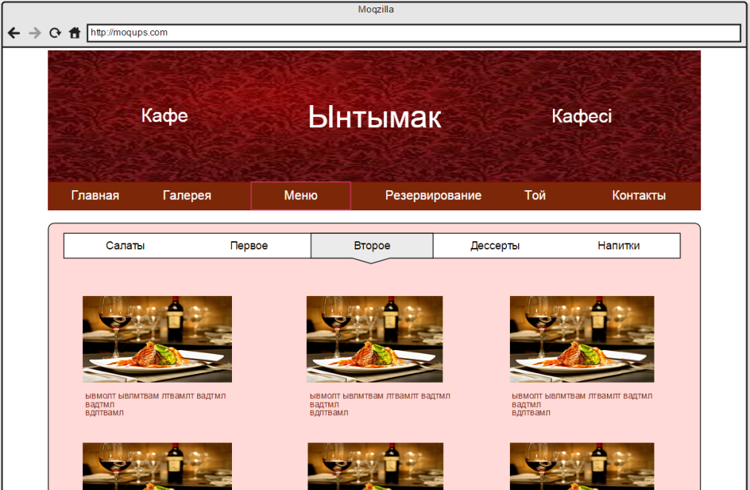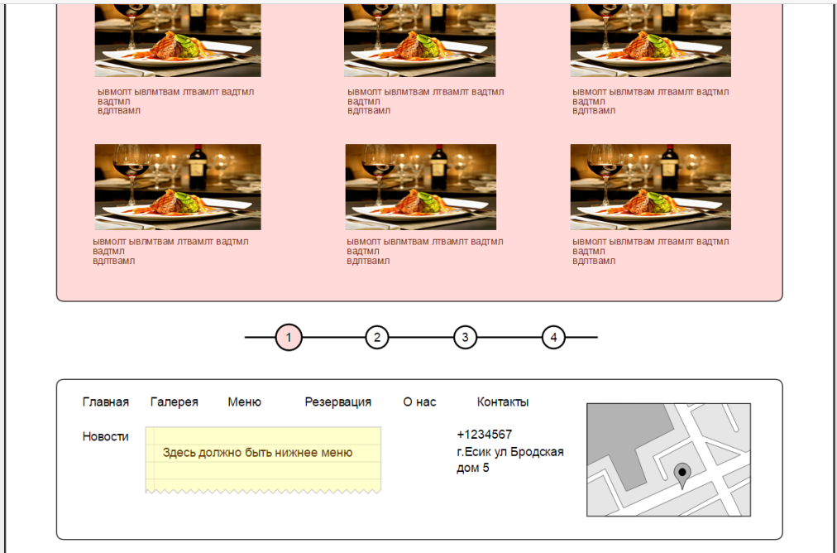

The aim of menu page is to show to visitor the assortment of restaurant’s menu.

Developer: Mariyam Sabyrova

This is scroll bar if there will be more meals

Here is pictures of meals with description and consists.

This is menu with submenus of meal’s type.

## Reservation page:

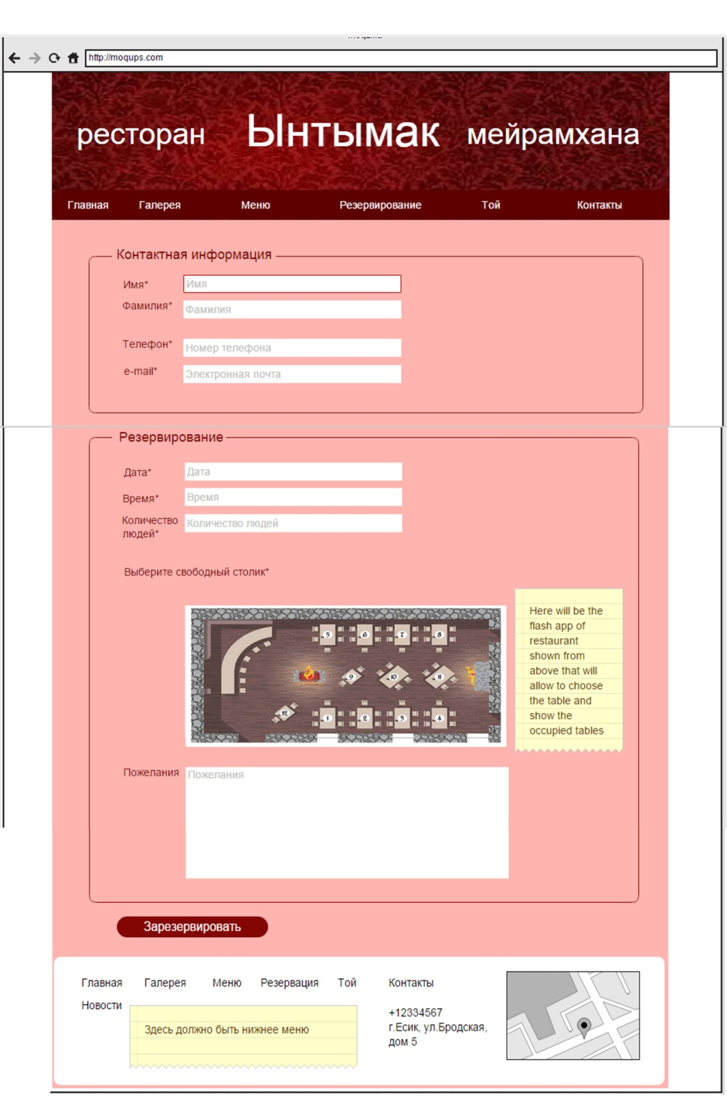

Each field which is selected has such icon for more information about how to fill this blank

C:\Program Files (x86)\Microsoft Office\MEDIA\CAGCAT10\j0293236.wmf

In reservation information there is an application that allow to see the location of each table in restaurant and choose the free one. (there will be shown occupied and free ones)

Button to complete the reservation

Extra info or wishes about reservation clients may write here

Reservation information: date, time, number of people.

Basic contact information about client for rezervation a table

Reservation page allows to clients make an online reservation of table. It consist of main two parts: contact information and reservation information. By contact information the workers of restaurant can confirm the reservation and send the notifications to their e-mails or telephones about reservation. And reservation information includes all needed information for making reservation of table.(Error detection and notification are also included)

Developer: Ainur ALmurzina

## Transition page of reservation:

## C:\Users\Ainur\Desktop\University 4th course\reserv4.PNGC:\Users\Ainur\Desktop\University 4th course\reserv5.PNG

For questions or more information about reservation here is the contacts of restaurant

Also client able to order the menu by clicking this button

Here is the notification about successful reservation

The aim of transition page is to notify the client about successful reservation and request additional feature: ordering the menu. Also there is contact information of restaurant if a client has some question or additional information about reservation.

Developer: Ainur ALmurzina

## Ordering menu page:



The ordering menu page is the same like menu page, the difference is that this page is not static. Here the client may choose the meals and add them to ordering menu list( only after reservation of table). This additional feature allows to client come to restaurant and don’t wait for their order.

Developer: Ainur ALmurzina and Mariyam Sabyrova

Here is the button to complete the ordering menu

Each meal contains in the bottom the check-bottom and stepper input to add this meal into the list of menu order.

## Transition page 1 and 2 of ordering menu:

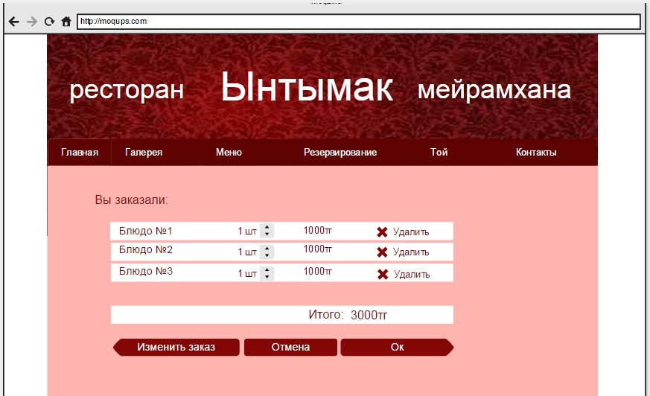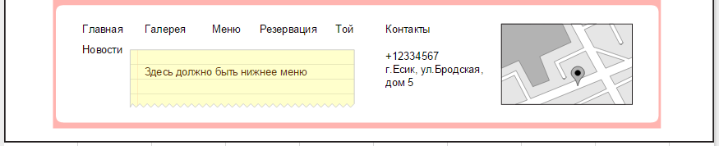

Buttons for returning to previous page to change the order, cancel the order and confirm the order.

The final price

Here is the list of ordered meals with number of meals, price and delete button.

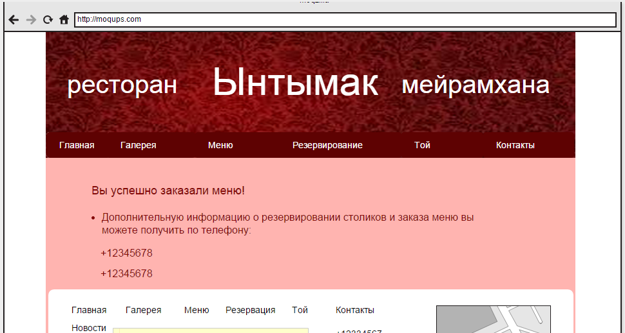

Notification about successful order and contacts of restaurant for additional information and questions

The first transition page is needed to confirm the order of menu and allow to client to change or cancel it if they had mistake. The aim of second transition page is just a notification about successful end or ordering menu.

Developer: Ainur ALmurzina

## About us page:

## C:\Users\Ainur\Desktop\University 4th course\2oSsJdUFA80.jpg

Information about restaurant

This page gives to visitors or clients general information neede for celebrations. For example number of places, number of people that can fit there and etc.

Developer: Mariyam Sabyr

## Contacts page:

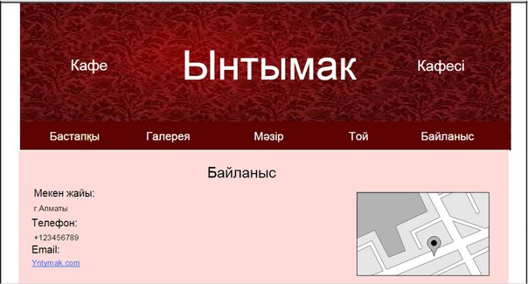

This page gives information about contacts, address, e-mail. There is also a map.

Developer: Gaukhar Mrassylova

Admin page:

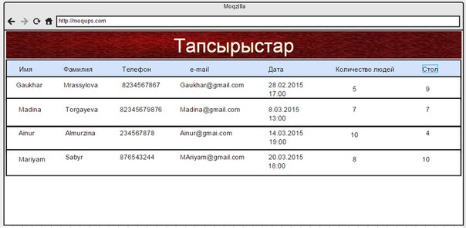

Admin page contains the list of all reservations

Developer: Mariyam Sabyr

# Screenflow:

Order menu

Change Reservation

Make Reservation

Contacts

About us

Reservation

Menu

Gallery

Main Page