Student’s code:……………….
Student’s name:………………
- Online test (30’ – 4 marks)
- Exercise: (60’ - 6 marks)

Ex1: (1.5 marks)
Assume that there are two projects A and B can be invested and estimated the data on the costs and benefits obtained annually according to the following table:
 | year 1 | year 2 | year 3 | year 4 | year 5 | Total
Project A
Cost
Benefit
Project B
Cost
Benefit

Interest rate: 10%.

Question

Write formulate and calculate NPV of two project: ………….

If a project is selected based on the net present value (NPV) then what project is selected: ………..

Ex2 :(4.5 marks)
Currently, TOM Group is planning a project to building an IoT framework and the project management department has set up tasks for implementation as follow:
Task | Predecessors | Duration  (day) | Reduce time  (day) | Cost for reduce/day
A |  | 3 | 0 | -
B |  | 4 | 2 | 10
C |  | 5 | 1 | 50
D |  | 11 | 4 | 20
E |  | 10 | 4 | 60
F |  | 8 | 2 | 40
G |  | 9 | 4 | 150
H |  | 7 | 3 | 30
I

Perform the following requirements:
- Draw PERT diagrams by task and fill in the values (Duration time, ES: Earliest Start date, EF: Earliest Finish date, LS: Latest Start date, LF: Latest Finish date) of each activity.

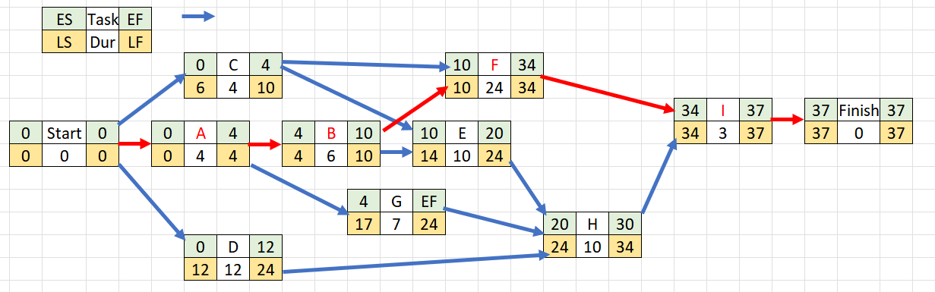
(Example Ans.)

- Calculate duration to complete the project: 37 months

- List tasks on critical path of the project: A, B, F, I

- Shorten the execution time of the project in 7 days with cheapest cost. Determine the order of tasks to be shortened, the time is shortened on each task and then filling the following table:

No. | Task | R. Time | Cost
1 | I | 1 | 3
2 | A | 2 | 10
3 | F | 4 | 52
4 | E+F | 1 | 18
5 | B | 1 | 19
Tổng |  |  | 102

- Draw GANTT diagram of project after shortening

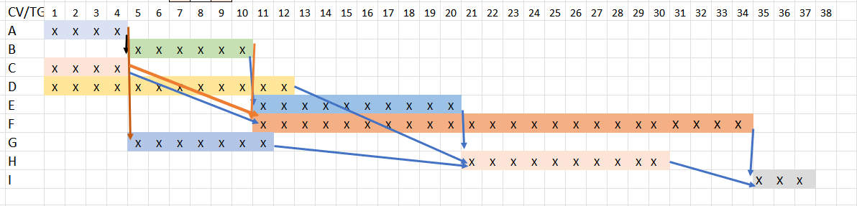

(Example Ans.)

