Let's Code Blacksburg! Arduino Sensors “Sibling Detector” Workshop v2022-06-07a_tweeks
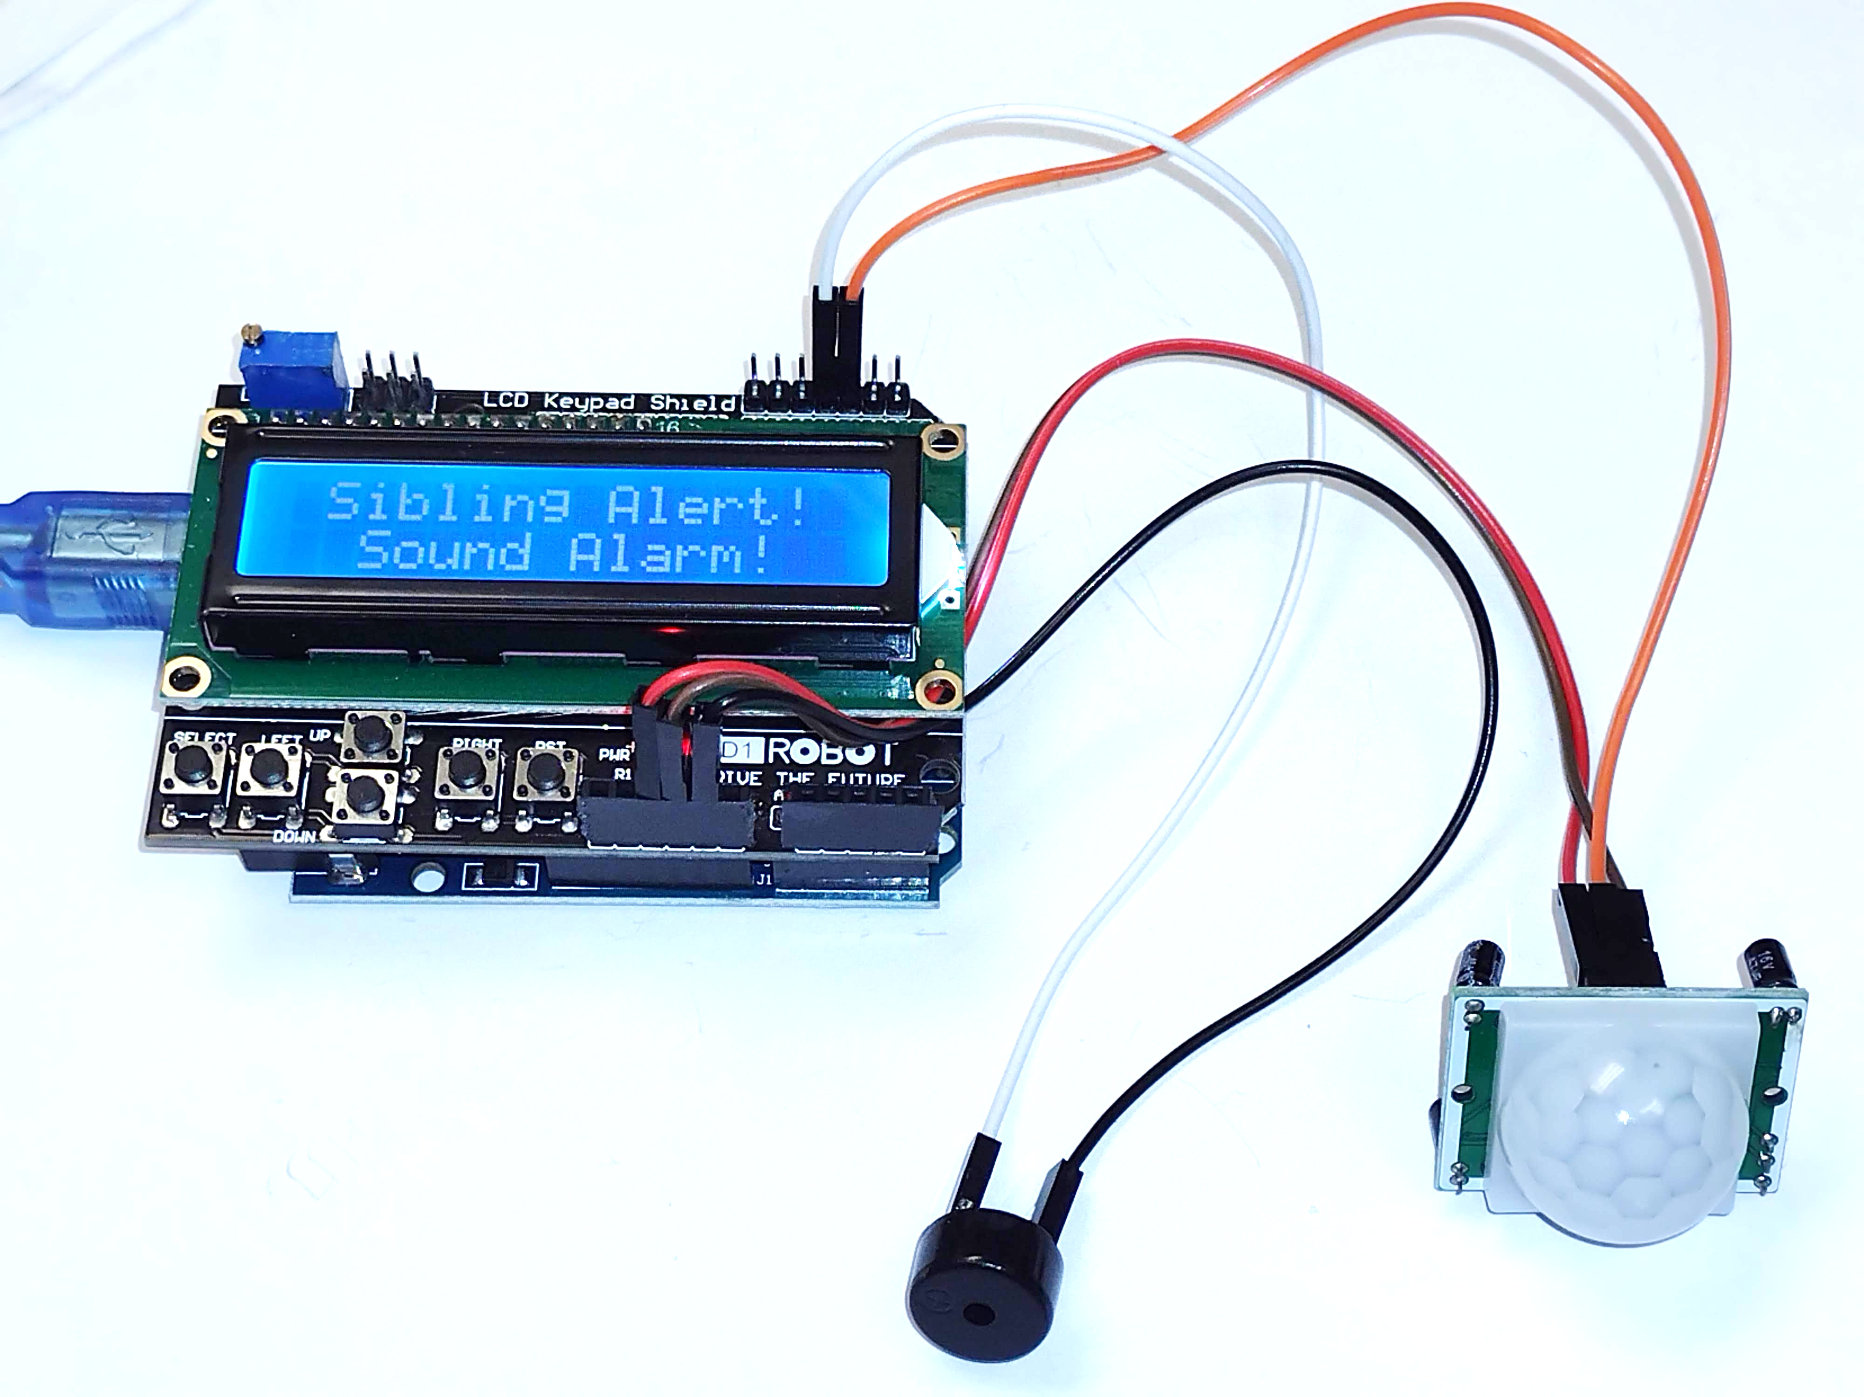
This hands on workshop steps you through building and programming a Sibling Detector room alarm using:
— an arduino microcontroller
— a speaker or 5v buzzer
— a PIR (infra red) motion sensor
— a 1602 LCD shield w/button input

1) Use First Cookbook Recipe - Blink
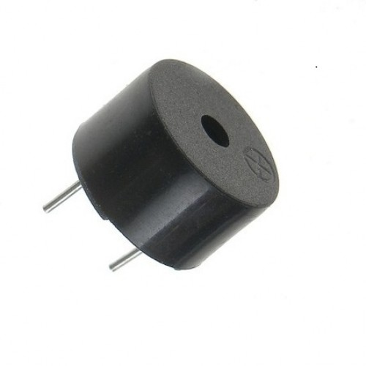
Before you build anything or do any real programming, you need to first open your “LCBB Arduino Cookbook” to the “Blink” recipe and change the blink speed of the LED on pin 13 of the arduino. This will verify that your computer and the installed arduino IDE software (from www.arduino.cc) is properly configured to talk to your arduino. Do not continue past this step until you get TA sign-off:
TA SIGN-OFF:
2) Connect Buzzer and Write An Alarm Sound Program!
A really great first program to learn is making a sounds! In our project, we need to eventually sound an alarm so let's hook up and program this little 5v buzzer. All you need to do is:
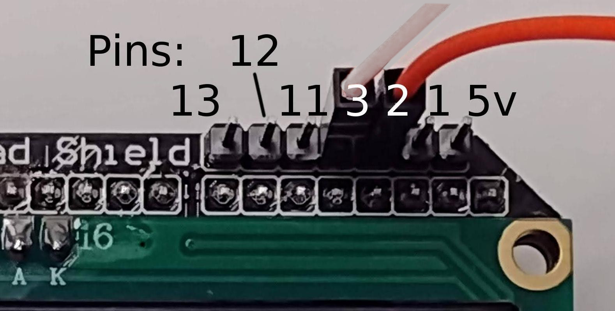
- Unplug power to the arduinos (always before hooking anything up)
- Connect the “+” of the buzzer to the arduino or LCD's pin 3 (use a white or gray wire, see below)
- Connect the other side to the arduino or LCDs GND (ground, black, blue or green, see bottom photo)
- Ask the TA to look over your connections, and hook USB power back up
- Write this NEW little program to make an alarm sound:

// VARIABLES
int buzzerPin = 3; // the alarm buzzer pin
int x = 0;

// variable used for counting
///////////////SETUP This just runs once //////////////
void setup(){
pinMode(buzzerPin, OUTPUT);
}

/////////// soundAlarm() This is the alarm function ////////////
void soundAlarm(int cnt){
for (x=0 ; x<cnt ; x++){
tone(buzzerPin, 1000, 1000); // High tone (arduino pin, the tone, how long)
delay(1000); // do nothing for 1,000ms (1second)
tone(buzzerPin, 800, 1000); // Low tone (arduino pin, the tone, how long)
delay(1000); // do nothing for 1,000ms (1second)
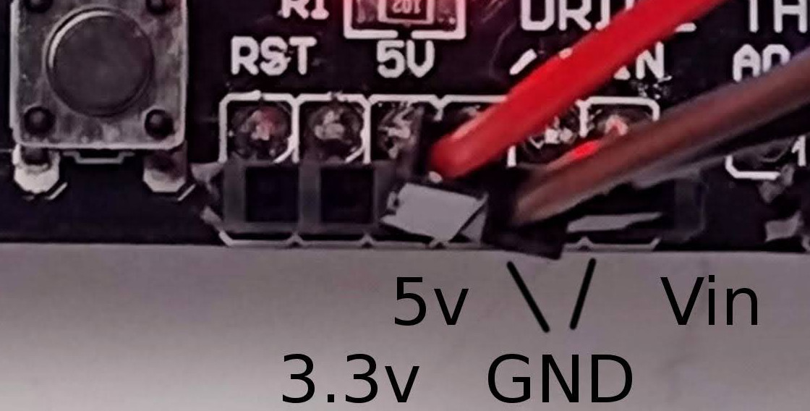
}
}

//////////// loop() This loops over and over //////////////
void loop(){
// This is the main program loop
soundAlarm(3); // Sound alarm (n) times
delay(10000); // wait for 10 seconds
}

Save your program called soundAlarm and get TA sign-off TA SIGN-OFF:
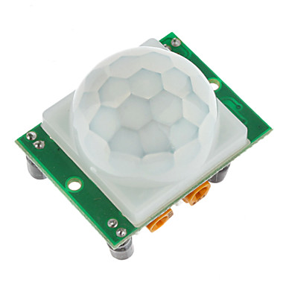
3) Use Cookbook Recipe for Motion Sensor
Next, you need to successfully sense motion with the PIR motion sensor by doing the "INPUT: People Motion Sensor" recipe from the cookbook.
Once you follow the directions for connecting the PIR motion sensor, program, and get it working, you need to save your code. Call it something meaningful like PIR-motion, for example. Then show your TA-Helper and get signed off. You will need this code later, so be sure to save it with a meaningful name and know where it's located on your system!
TA SIGN-OFF:

4) Make Basic Alarm By Combining Your Alarm & PIR Sensor Code!
You now have everything you need to make a basic alarm. You need to now load up both your alarm code as well as your PIR motion code in separate windows, along withe a new program and copy/paste content from each of the variable, setup and loop sections into one new program you should call “Simple_Sibling_Alarm”. Can you get your simple alarm working?
TA SIGN-OFF:

Tips: The motion sensor calibration time gives you enough time to exit the room before the alarm arms itself and tiggers on you. Once uploaded and running, you can hit the small “reset” switch on the arduino board to start the program over, giving you that calibration time delay to get out of the room without setting off the alarm yourself!

NOTE: If you have at least an hour remaining, try the more complicated LCD display with keypad buttons! It can really make your sibling detector something to be proud of! But save your working program first!
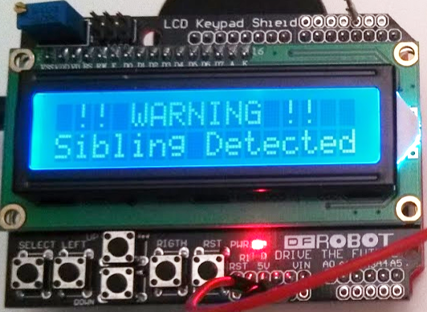

5) Use Cookbook Recipe for LCD Keypad Shield
Want to make your sibling detector alarm really cool? If you have enough time remaining (at least 1hr), then locate the recipe called "INPUT/OUTPUT LCD Keypad shield" (right after the PIR motion sensor recipe in the cookbook).

You will want to start a new program for the LCD shield. If you don't have enough time to type in all the code, then check out the sample code LCD_keypad.ino code under the
“arduino-recipes/shields/lcd_keypad/LCD_keypad/”
repository of the LCBB github project: https://github.com/LetsCodeBlacksburg

Tips: When writing a large program that has sections of code for things like arming buttons, arming countdown timers, and active-scanning loops, it's important to write down what your program needs to do step by step in plain english. This is called pseudo code or a flowchart, and it's very important before starting to write code. It's a way of clarifying your thoughts before writing a single line of code. Doing this will really help you keep a clear head and not get lost in your own code.

Were you able to get your LCD and key buttons and motion sensor and alarm all working together? Show your TA! Show the instructor! Show your friends! WARN your siblings!
TA SIGN-OFF:
NOTE: If you have problems merging your previous code and the LCD_keypad code, then you can download the final step5 completed code from the github repository here: https://github.com/LetsCodeBlacksburg/LCBB_sibling_alarm/blob/master/step-5_complete_PIR_LCD-keypad_buzzer_sibling_alarm.ino

