Architecture
Chosen style: four-tier layered architecture
Presentation (console UI) calls application services which use Domain model which is persistent through Data-access layer over SQLite. Dependencies point downwards only. Repository hasher interfaces are owned by the upper layers, so the domain never depends on SQLite.

Design rationale
Concern | How the layered style meets it
Testability | Business rules live in the Application and Domain layers, which can be unit tested with in-memory fake repositories.
Maintainability | Changes affect isolated repositories not the entire layers.
Security | Only the data-access layer builds SQL.

Rejected alternative: Model-View-Controller
This interface is a console menu and the main complexity is workflow rules not view synchronization (Where MVC focuses).
Explanation for chosen pattern

Design patterns applied
Pattern | Place | Reason
Strategy | LatePenaltyStrategy with StandardLatePenalty and NoLatePenalty | The late rule is the most contested requirement (by HoD & Student rep) and most likely to change. Modifying the policy needs no change to submissionService.
Repository/DAO | Repository and Sqlite implementations | Satisfies rule that SQLite is accessed only through a data-access layer.
Factory | UserFactory | Creating a user means choosing the right subclass from a role value read from the database or entered by the admin.
Observer | EventPublisher notifies NotificationService | Release of marks, extensions and late submissions trigger in-app notices

SOLID
- S: each service has one job (authentication, submission, marking, moderation); the hasher only hashes; repositories only persist.
- O: new penalty rules or notification channels are added by new classes (Strategy, Observer) without editing existing ones.
- L: every User subclass honours the abstract contract; code written against User works for all four roles.
- I: small interfaces: IPasswordHasher, IObserver, and specific repositories rather than one large data interface.
- D: services depend on IRepository, IPasswordHasher and ILatePenaltyStrategy abstractions; concrete classes are injected in main () (constructor injection).

Database Design
Data dictionary

Table | Column | Type | Constraints and meaning
department | id, name | INTEGER, TEXT | PK, name unique
app_user | id, username, role, password_hash, department_id, active | id, username, role, password_hash, department_id, active | PK; username unique; role in STUDENT, LECTURER, HOD, ADMIN; department_id required for HOD and lecturer
course | id, code, title, department_id | INTEGER, TEXT | PK; code unique; FK department
enrolment | course_id, student_id, enrolled_on | INTEGER, TEXT | composite PK; FKs
course_lecturer | course_id, lecturer_id | INTEGER | composite PK; FKs
assignment | id, course_id, title, deadline, max_mark, created_by | INTEGER, TEXT, REAL | max_mark > 0; deadline ISO 8601 UTC
extension | id, assignment_id, student_id, new_deadline, reason, granted_by | INTEGER, TEXT | unique per (assignment, student); new_deadline later than the assignment deadline
submission | id, assignment_id, student_id, state, raw_mark, penalty_percent, final_mark, feedback, first_submitted_at | INTEGER, TEXT, REAL | unique (assignment, student); state restricted to the lifecycle values; marks between 0 and max
submission_version | submission_id, version_no, content, submitted_at | INTEGER, TEXT | composite PK
mark_audit | id, submission_id, changed_by, changed_at, old_value, new_value, reason | INTEGER, REAL, TEXT | append-only; reason NOT NULL
notification | id, user_id, message, created_at, is_read | INTEGER, TEXT | FK user

SQLite Schema
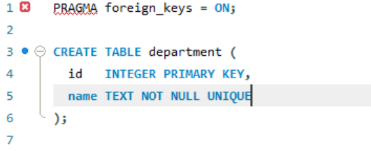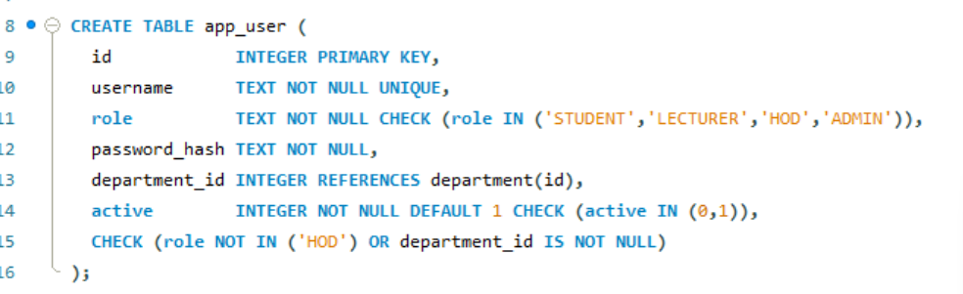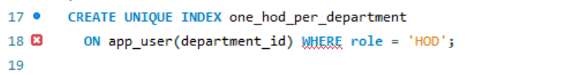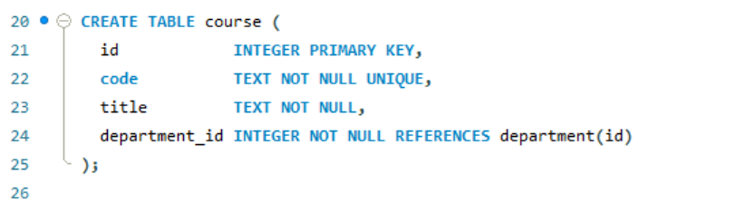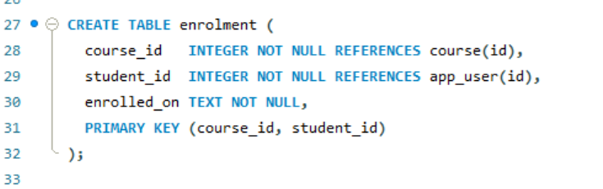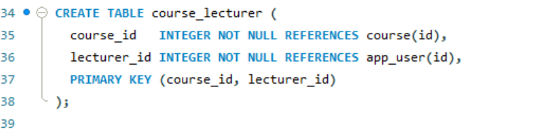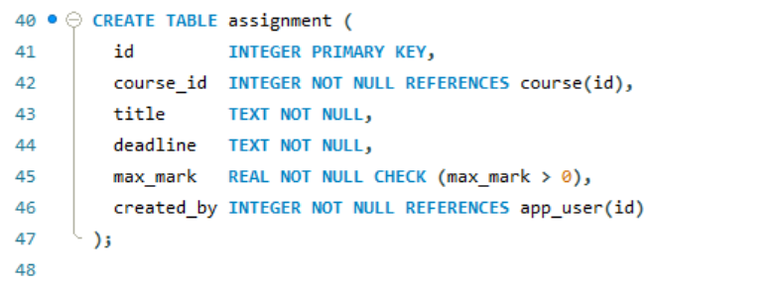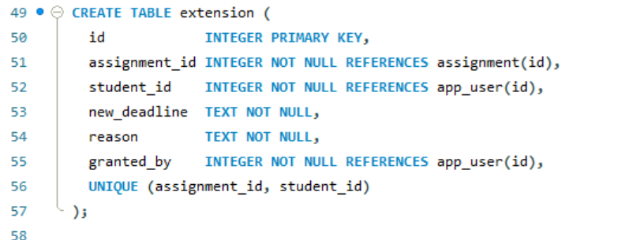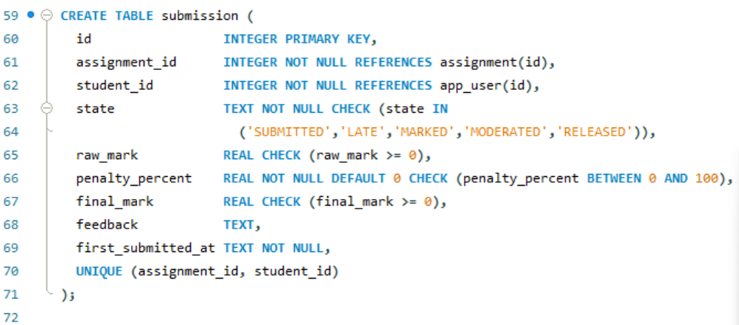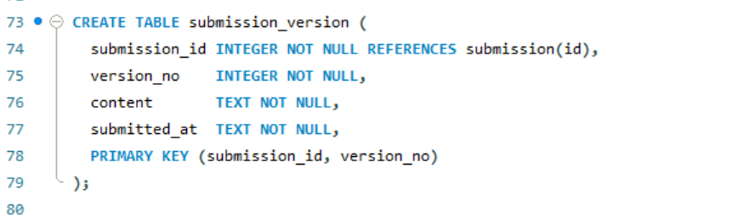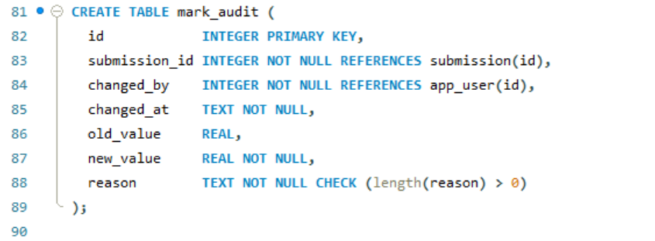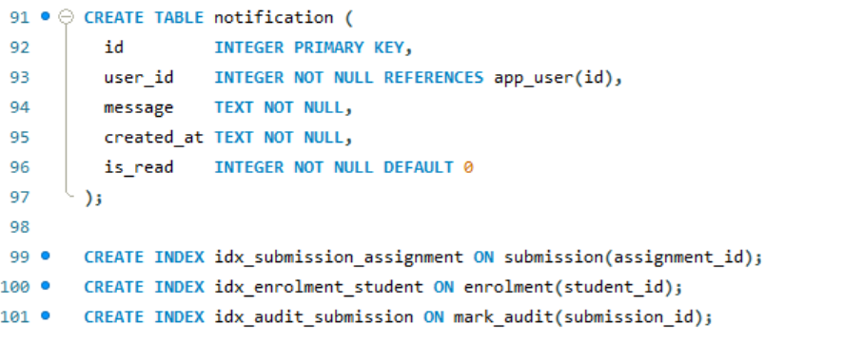

Mapping tables to classes
Table | Class | Difference and justification
app_user | User and its four subclasses | Single-table inheritance: one table with a role discriminator, because the roles share all attributes and differ only in behaviour. UserFactory selects the subclass.
department, course, assignment, extension | Department, Course, Assignment, Extension | Direct mapping; foreign keys become object ids resolved by repositories.
enrolment, course_lecturer | Association between Course and Student or Lecturer | Link tables implement the many-to-many multiplicities.
submission and submission_version | Submission and SubmissionVersion | Composition: versions are loaded and saved with the parent.
mark_audit | MarkAuditEntry | Append-only; the class has no setters and no update or delete in its repository interface.
notification | Event handled by NotificationService | Events are transient objects; only the resulting message is stored.
None | ILatePenaltyStrategy, services, hasher | Behavioural classes with no stored state, so no tables.

