Schematic of the LM386 Audio Amplifier: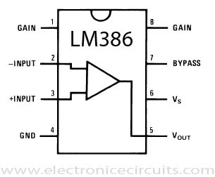

Schematic of the amplifier circuit:

(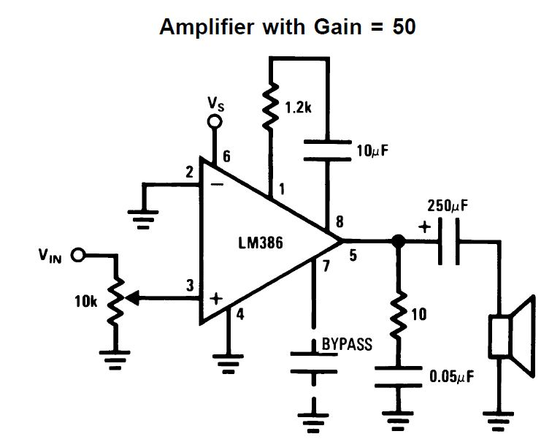<http://circuits.sci-toys.com/LM386_audio_amplifier>)