Name: Zak Nizam
Course: CSD310 – Database Development & Use
Assignment: Module 4.2
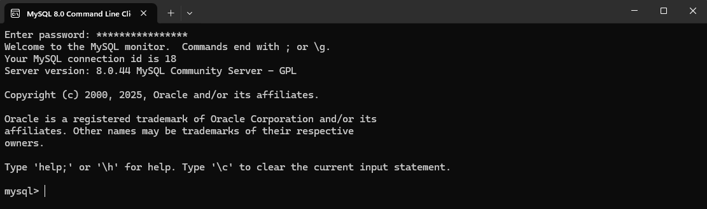
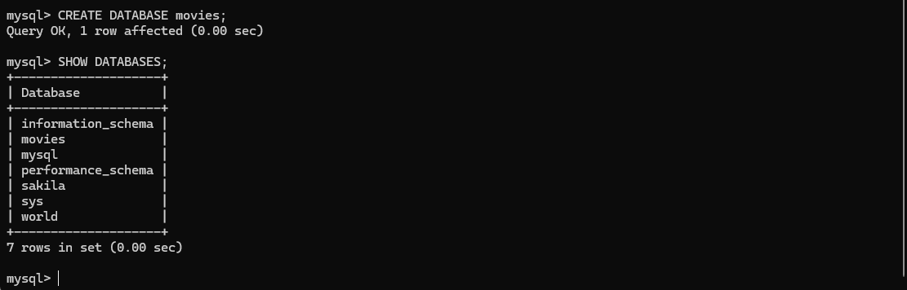
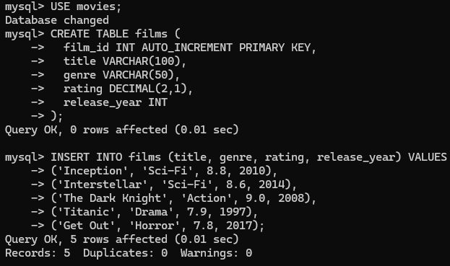

Function 1 (COUNT)
Function: COUNT()
When it might be used: To count how many rows exist (or match a condition). Example: “How many movies are in the table?”
Alias used: total_films
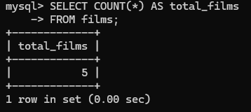
Function 2 (AVG)
Function: AVG()
When it might be used: To calculate an average for a numeric field. Example: “What is the average movie rating?”
Alias used: average_rating
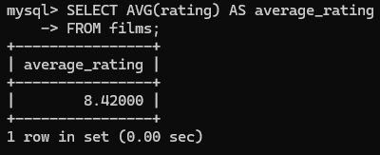
Function 3 (MAX)
Function: MAX()
When it might be used: To return the highest value in a column. Example: “What is the newest release year?”
Alias used: newest_release_year
