Name: Zak Nizam
Course: CSD310 – Database Development and Use
Module 2.3 Assignment: Visual Paradigm
ERD Visual Paradigm
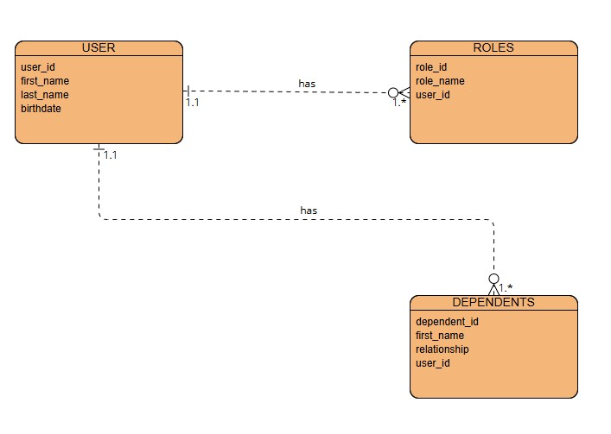
NoSQL Data Structure
