Name: Zak Nizam
Assignment: CSD325 Module 10.2
Screenshot 1: tutorial program running (original to-do program)
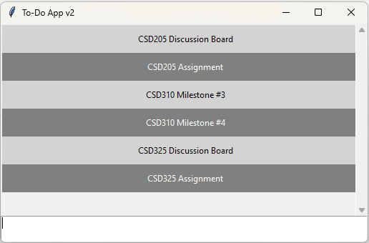
Screenshot 2: updated program running (modified to-do program)
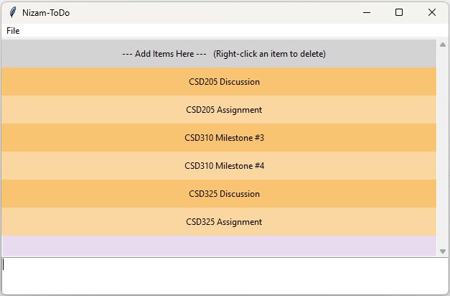
Screenshot 3: shows file → exit menu working
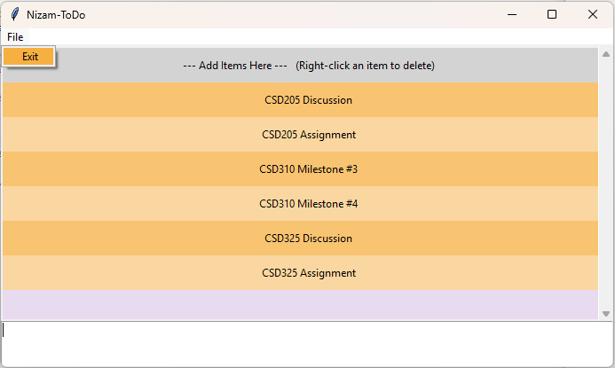
Screenshot 4: shows delete a task using RIGHT-click
