Zak Nizam
CSD325 – Module 2: Documented Debugging

Figure 1 – Breakpoint hit at user input in main().
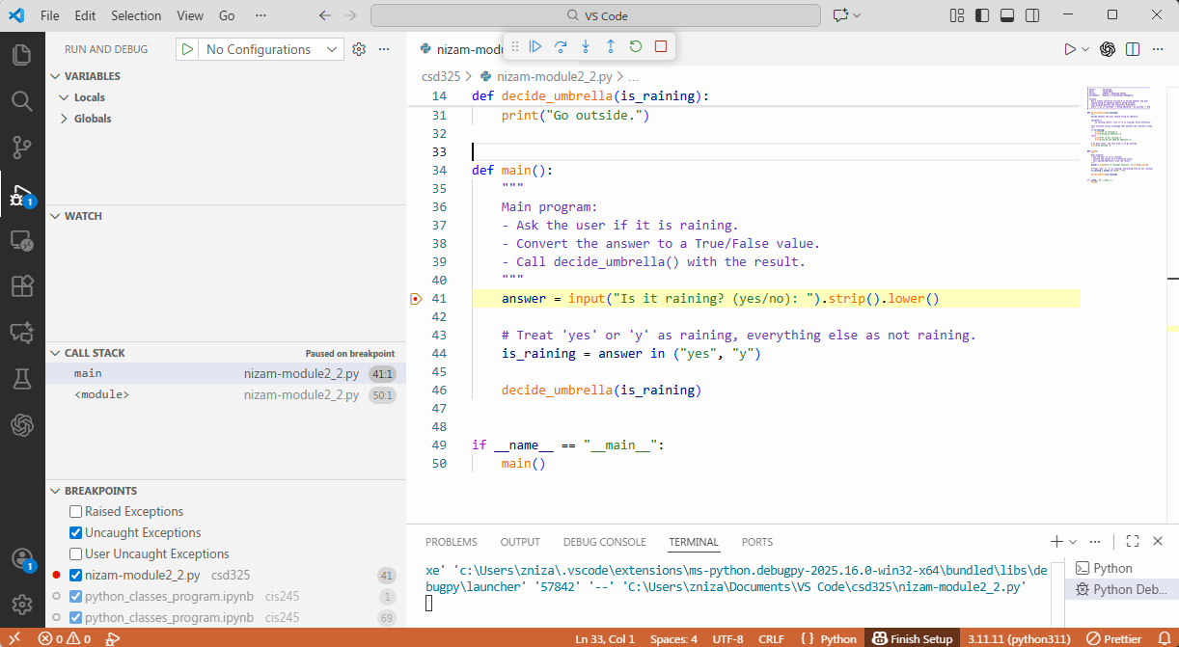
Figure 2 – Stepped into decide_umbrella() during debugging.
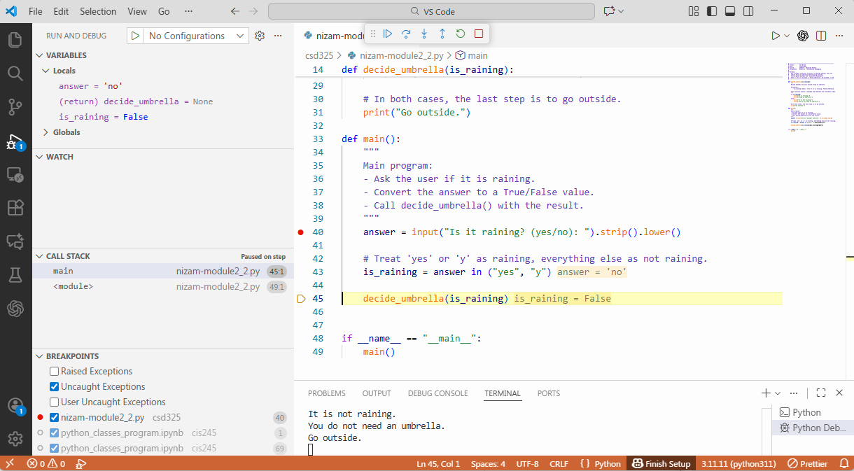
Figure 3 – Debugger showing is_raining value at the selection (if is_raining).
