Name: Zak Nizam
Course: CSD325 – Database Development & Use
Assignment: CSD325 Module 8.2 https://github.com/Letterman93/csd-325
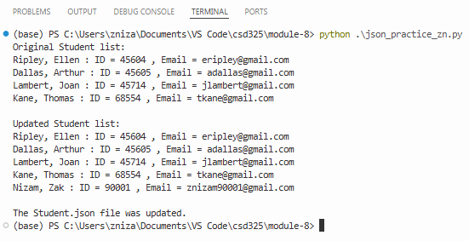
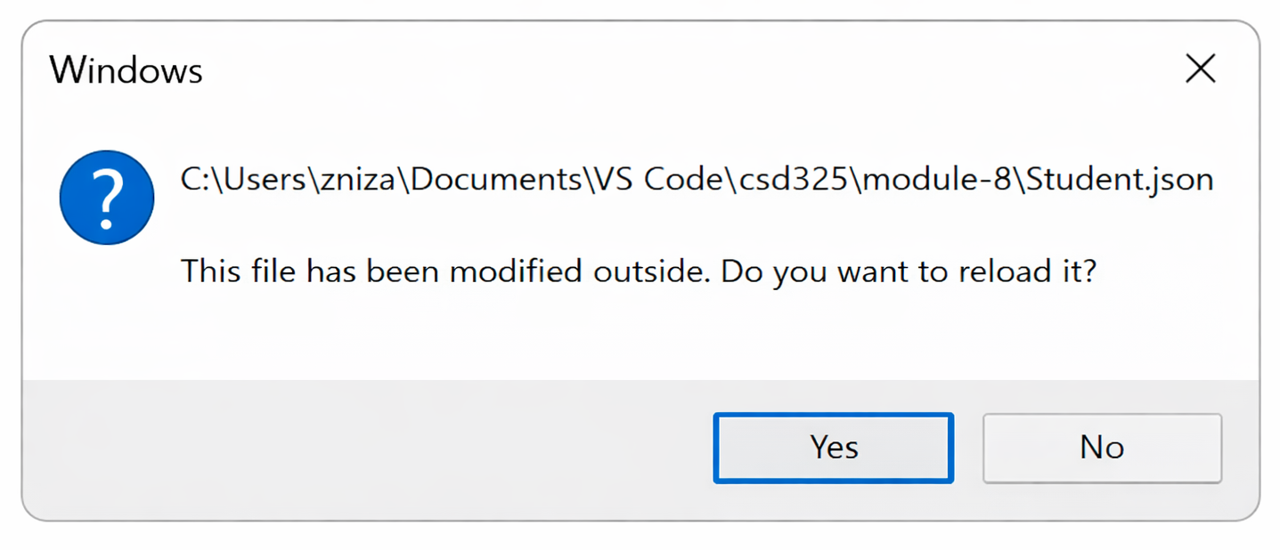

[
{
"F_Name": "Ellen",
"L_Name": "Ripley",
"Student_ID": 45604,
"Email": "eripley@gmail.com"
},
{
"F_Name": "Arthur",
"L_Name": "Dallas",
"Student_ID": 45605,
"Email": "adallas@gmail.com"
},
{
"F_Name": "Joan",
"L_Name": "Lambert",
"Student_ID": 45714,
"Email": "jlambert@gmail.com"
},
{
"F_Name": "Thomas",
"L_Name": "Kane",
"Student_ID": 68554,
"Email": "tkane@gmail.com"
},
{
"F_Name": "Zak",
"L_Name": "Nizam",
"Student_ID": 90001,
"Email": "znizam90001@gmail.com"
},
{
"F_Name": "Zak",
"L_Name": "Nizam",
"Student_ID": 90001,
"Email": "znizam90001@gmail.com"
}
]

