Name: Zak Nizam
Assignment: CSD325 Module 9.2
Screenshot 1: terminal showing test connection status code: 200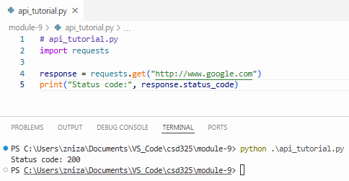
Screenshot 4b: terminal showing status code & formatted list output using the endpoint in the Dataquest walkthrough
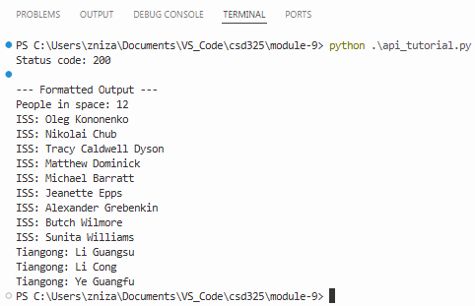
Screenshot 3: terminal showing status code, Json output, formatted output, & simple summary
