Name: Zak Nizam
Assignment: CSD325 Module 7.2
Screenshot 4a: terminal output showing the 3 lines
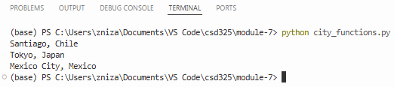
Screenshot 4b: test output showing OK
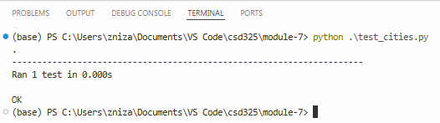
Screenshot 4c – d: failing test output with TypeError about missing population
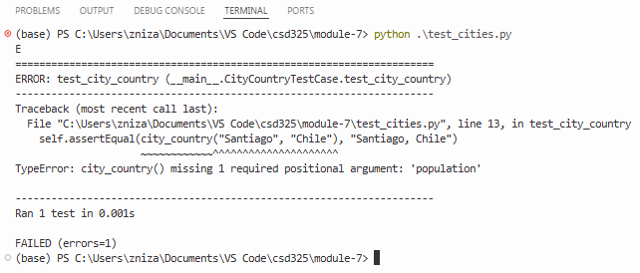
Screenshot 4e – f: test output showing OK with population optional
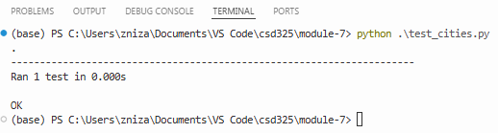
Screenshot 4g – h: failing test output with TypeError about language
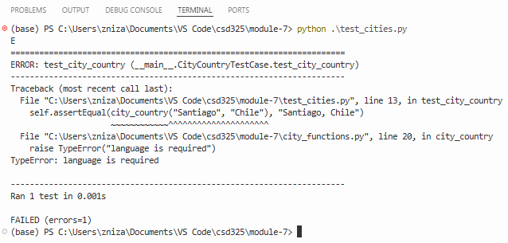
Screenshot 4i – j: test output showing OK with population and language optional
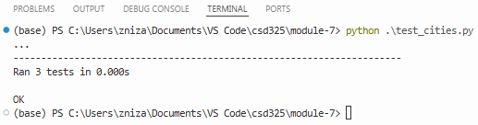
Screenshot 4k: terminal output showing the 3 requested lines
