Name: Zak Nizam
Assignment: CSD325 Module 11.2
Screenshot 1: Django installed successfully and opened in browser window
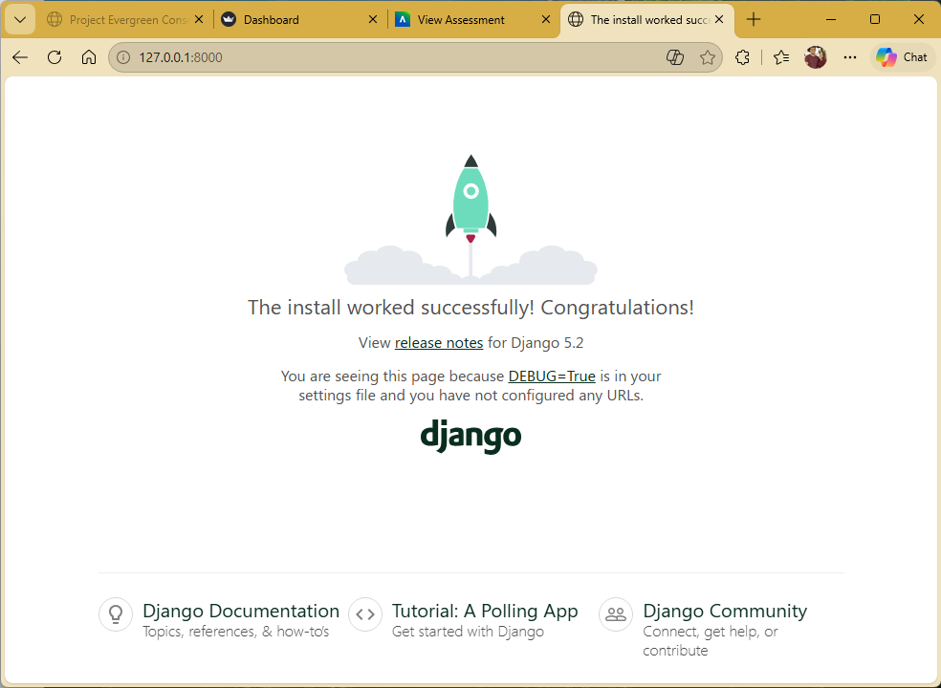
Screenshot 2: Django browser window showing personal hello message
