Name: Zak Nizam
Assignment: Module 1.3 – Building a Web Page Exercise, Part 1
Link: https://github.com/Letterman93/csd-340
Screenshot 1:
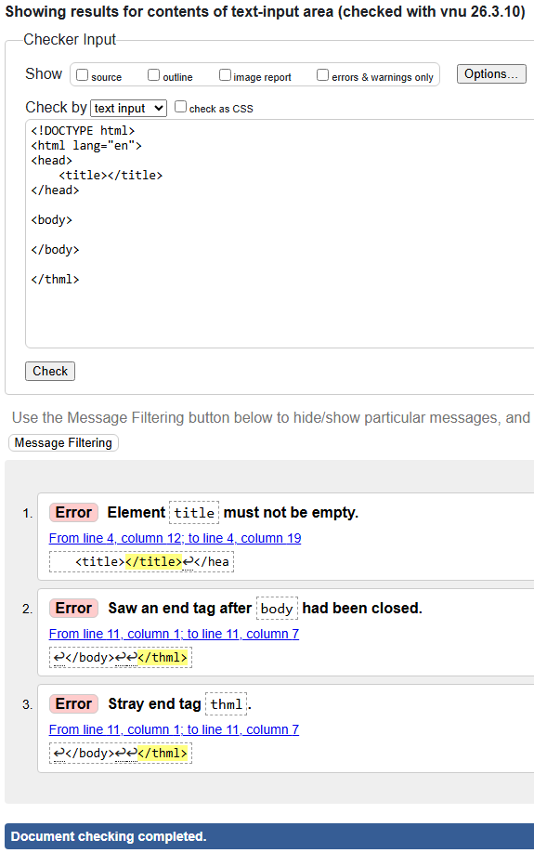
Screenshot 2:
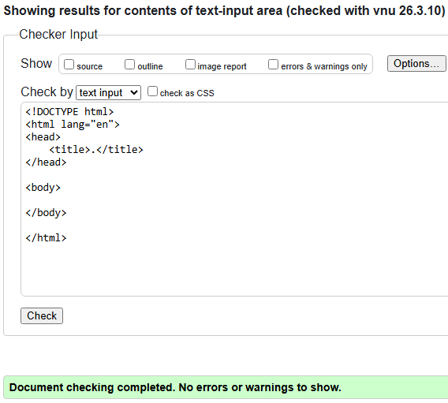

Screenshot 3:
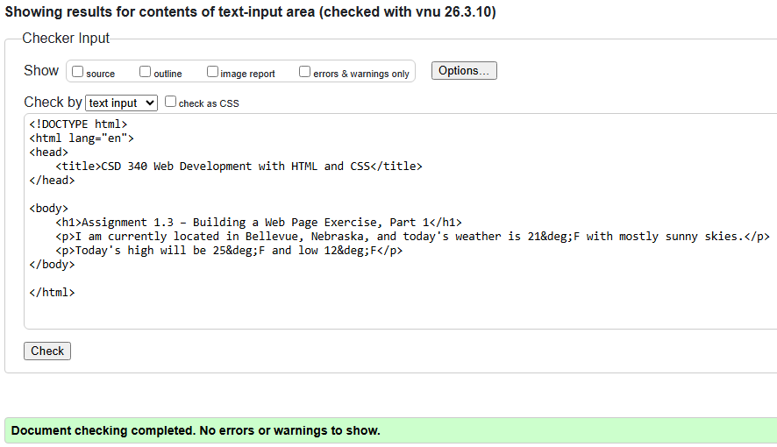
Screenshot 4:
