CSD 420 Advanced Java Programming
Module 1.3 Programming Assignment
Zak Nizam | September 12, 2026

Java and JavaFX Configuration
The installed JDK includes the Java compiler and JavaFX modules required to compile and run the card-display application.
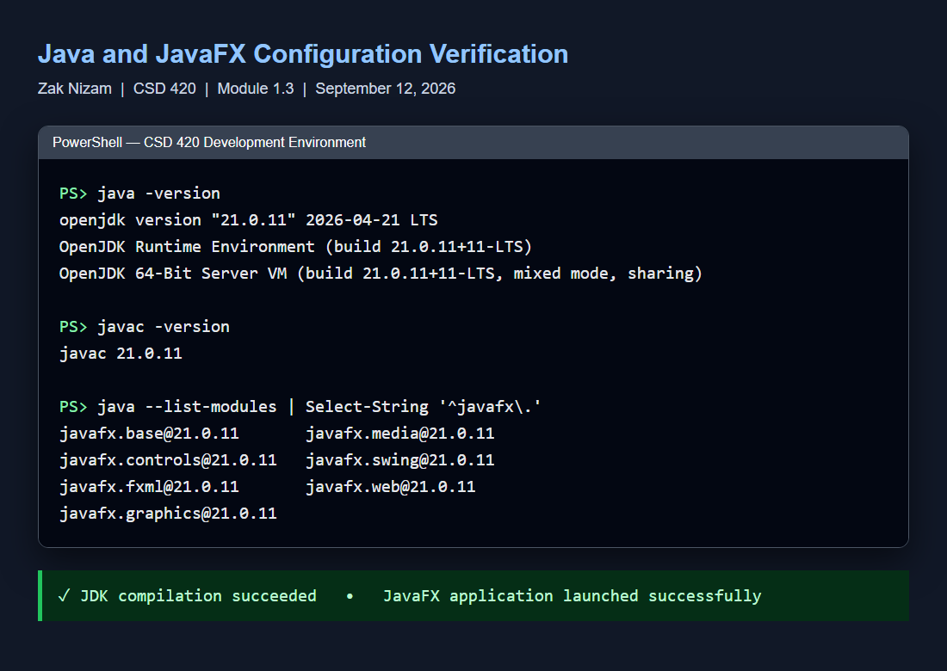
Java 21 and JavaFX 21 installation and configuration verification.

Initial Random Card Display
At startup, the application randomly selects four unique cards from images 1.png through 52.png in the cards subdirectory.
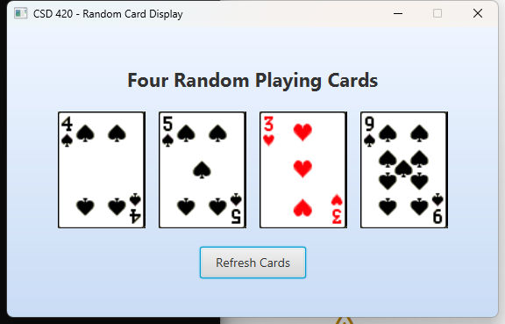
Initial application display containing four randomly selected cards.

Display After Refresh
The Refresh Cards button uses a lambda expression as its action handler. Selecting it replaces every displayed card with a different card.
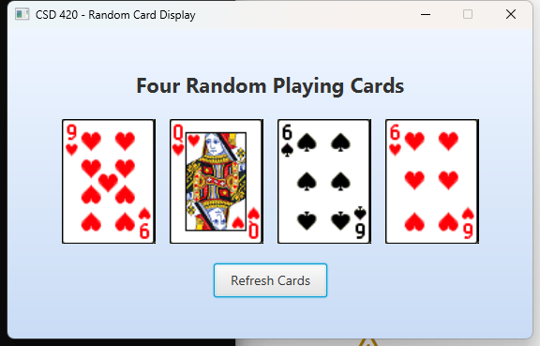
All four card images changed after selecting Refresh Cards.

Source file: NizamCardDisplay.java • Required images verified: 52 of 52

