CSD 420 Advanced Java Programming
Module 8.2 Programming Assignment
Zak Nizam
November 1, 2026

Java and JavaFX Configuration - The screenshot below shows the Java and JavaFX setup I used to compile and run this assignment.
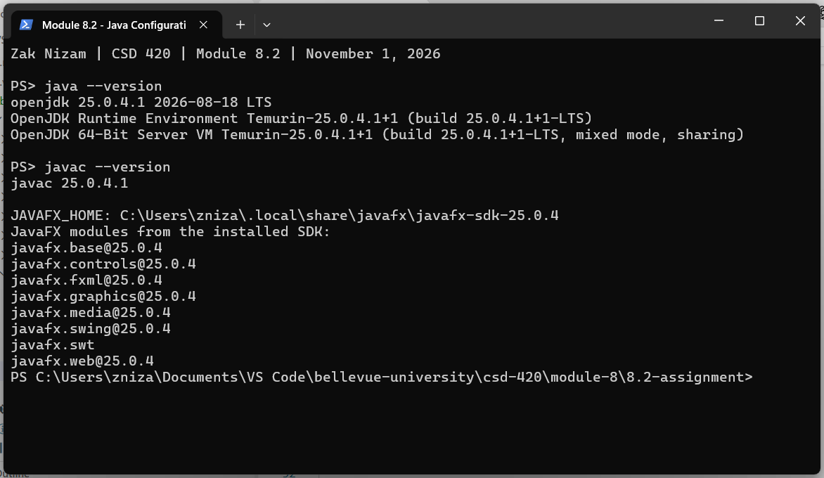
Three Threads - I used three worker threads to generate random letters, digits, and symbols. Each thread produces 10,000 characters and sends them to the text area one at a time. Platform.runLater updates the text area on the JavaFX thread, and each worker waits for that update before continuing. This lets the output mix without saving up a whole thread's characters first.
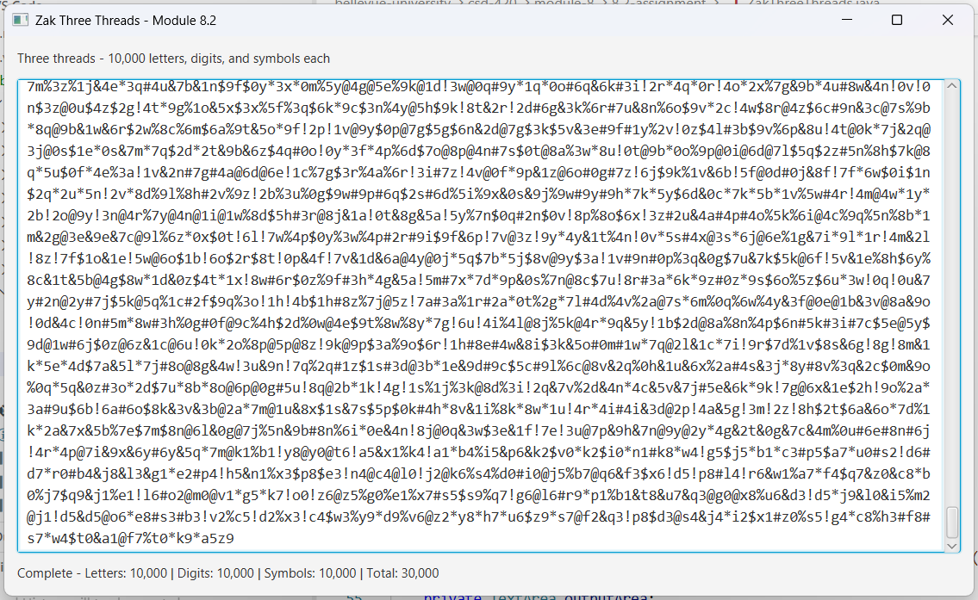
Testing - I tested the character sets, output counts, worker threads, and interruption handling. The full display test also checked that every update adds one character and that all 30,000 characters appear with the correct counts. All 18 tests passed.
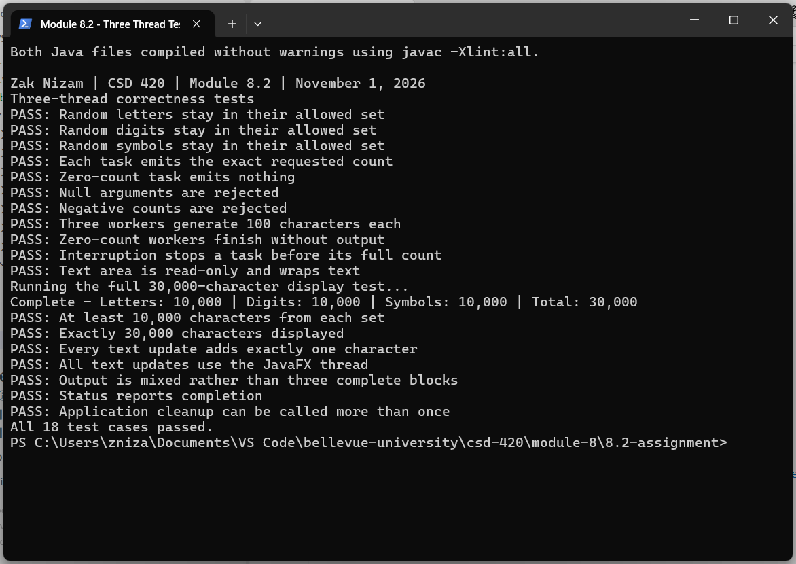
How to Run the Program - Use the steps below to compile the files, run the tests, and open the application.
- Make sure the JDK and JavaFX SDK are installed, and JAVAFX_HOME points to the JavaFX SDK folder.
- Keep ZakThreeThreads.java and ZakThreeThreadsTest.java in the same folder.
- Open PowerShell in that folder.
- Run the commands below in order. They set the JavaFX path, compile the files, run the tests, and open the application.

$fx = "$env:JAVAFX_HOME\lib"
javac -Xlint:all --module-path $fx --add-modules javafx.controls `
ZakThreeThreads.java ZakThreeThreadsTest.java
java --enable-native-access=javafx.graphics --module-path $fx `
--add-modules javafx.controls ZakThreeThreadsTest
java --enable-native-access=javafx.graphics --module-path $fx `
--add-modules javafx.controls ZakThreeThreads

GitHub repository: Letterman93/csd-420

