CSD 420 Advanced Java Programming
Module 2.2 Programming Assignment
Zak Nizam
September 15, 2026
Java and JavaFX Configuration
The PowerShell screenshot shows Java 21, the Java compiler, and the installed JavaFX 21 modules. This assignment uses console input/output and file streams; it does not require a JavaFX interface.
Commands: java -version; javac -version; java --list-modules
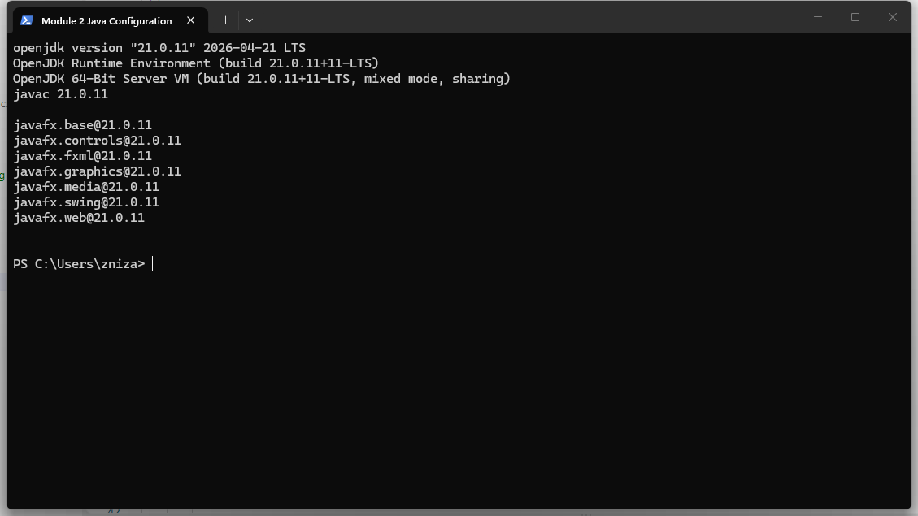

File Creation, Appending, and Reading
RandomDataWriter creates arrays containing five random integers from 0 through 99 and five random doubles from 0 up to, but not including, 100. It writes the integers followed by the doubles to Zak Nizam datafile.dat. The file is created if missing; later runs append data.
Testing: the first writer run created a 60-byte file. A second run appended another 60-byte record, increasing the file to 120 bytes. DataFileReader displayed both records, and all ten values in each record matched the writer output exactly.
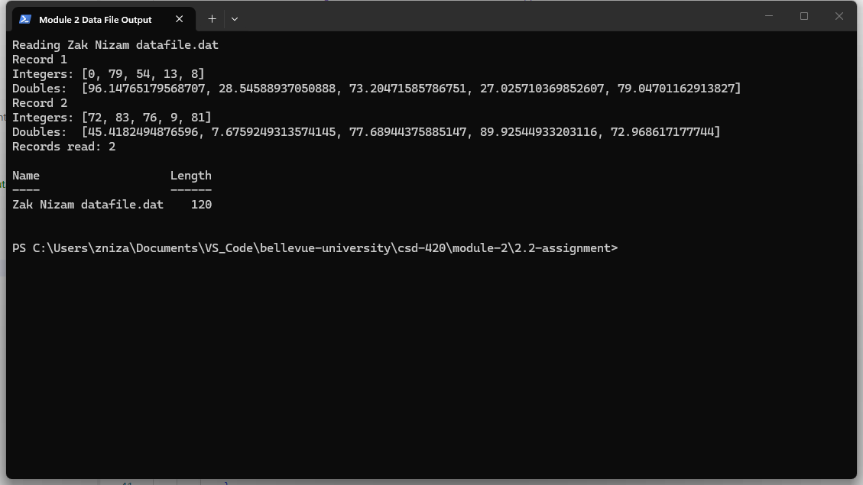
Running the Programs
From the 2.2-assignment folder, run these commands in order:
java RandomDataWriter.java
java DataFileReader.java
The included data file contains two sample records. Running the writer again appends another record without removing the existing data.

