CSD 420 Advanced Java Programming
Module 10.2 Programming Assignment
Zak Nizam
November 14, 2026
Fan Information - I used JavaFX and JDBC to display and update fan records in databasedb using student1 and pass. The program uses the existing fans table. The optional setup-fans.sql file creates sample records separately for testing at home.

Display - I entered ID 1 and clicked Display to load the fan information.
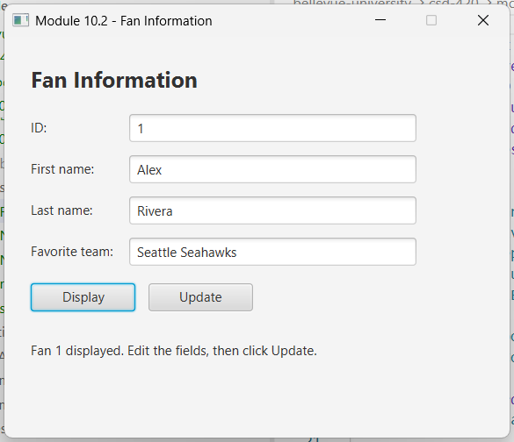

Update - I changed the favorite team and clicked Update. I also checked the database to confirm the change was saved.
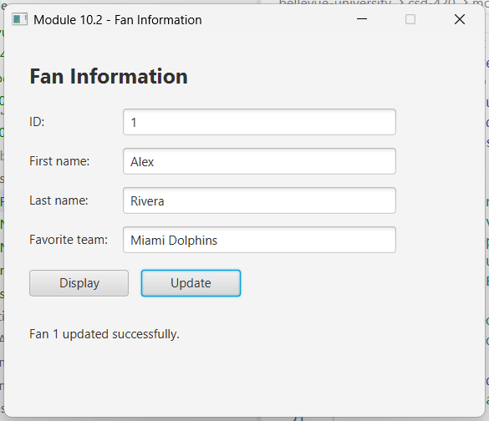

Testing and Configuration - I ran NizamFanManagerTest using my Java, JavaFX, and MySQL setup. All 25 checks passed, including both buttons, invalid input, missing records, and database errors. The test rolls back its changes when finished.
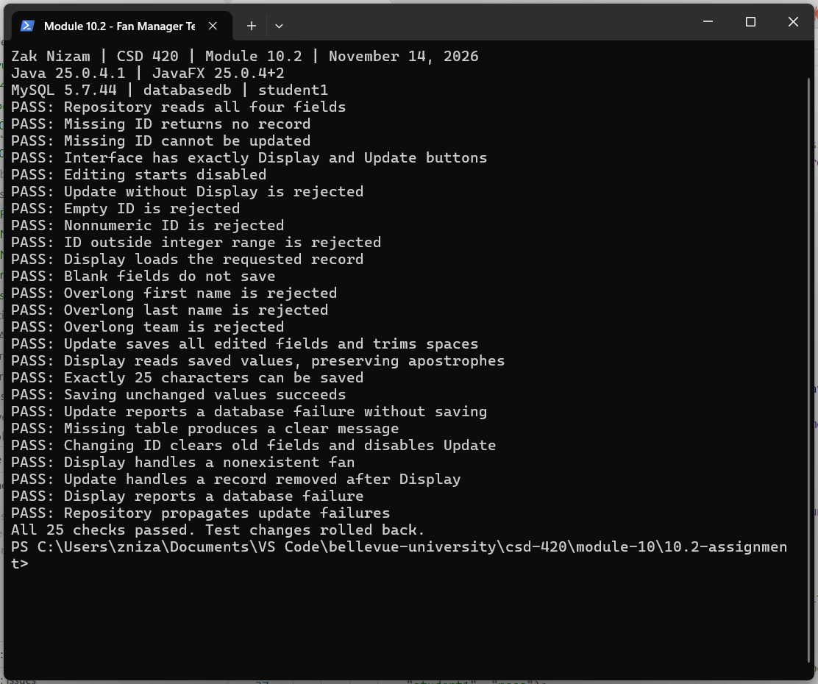

Error Handling - I also checked that run.ps1 reports missing JavaFX, JDBC driver, and source files. The form trims extra spaces and checks the 25-character field limits before saving.

How to Run - Use the steps below from the assignment folder. MySQL must be running, and the fans table must already be populated.
- Set JAVAFX_HOME to the JavaFX SDK folder. Make sure the JDK is on PATH.
- Run the first command below to open the application. Enter an ID and click Display, then edit the fields and click Update.
- Run the second command to check the database operations and interface. Use -MySqlDriver with the JAR path if the driver is stored somewhere else.
powershell -ExecutionPolicy Bypass -File .\run.ps1
powershell -ExecutionPolicy Bypass -File .\run.ps1 -Test
GitHub repository: Letterman93/csd-420

