CSD 420 Advanced Java Programming
Module 6.2 Programming Assignment
Zak Nizam
October 14, 2026
Java and JavaFX Configuration
The local PowerShell screenshot shows Java 25.0.4.1, javac 25.0.4.1, and JavaFX 25.0.4. A temporary JavaFX program loaded controls and displayed a window on this computer. The bubble sort assignment uses console output and does not need a JavaFX interface.
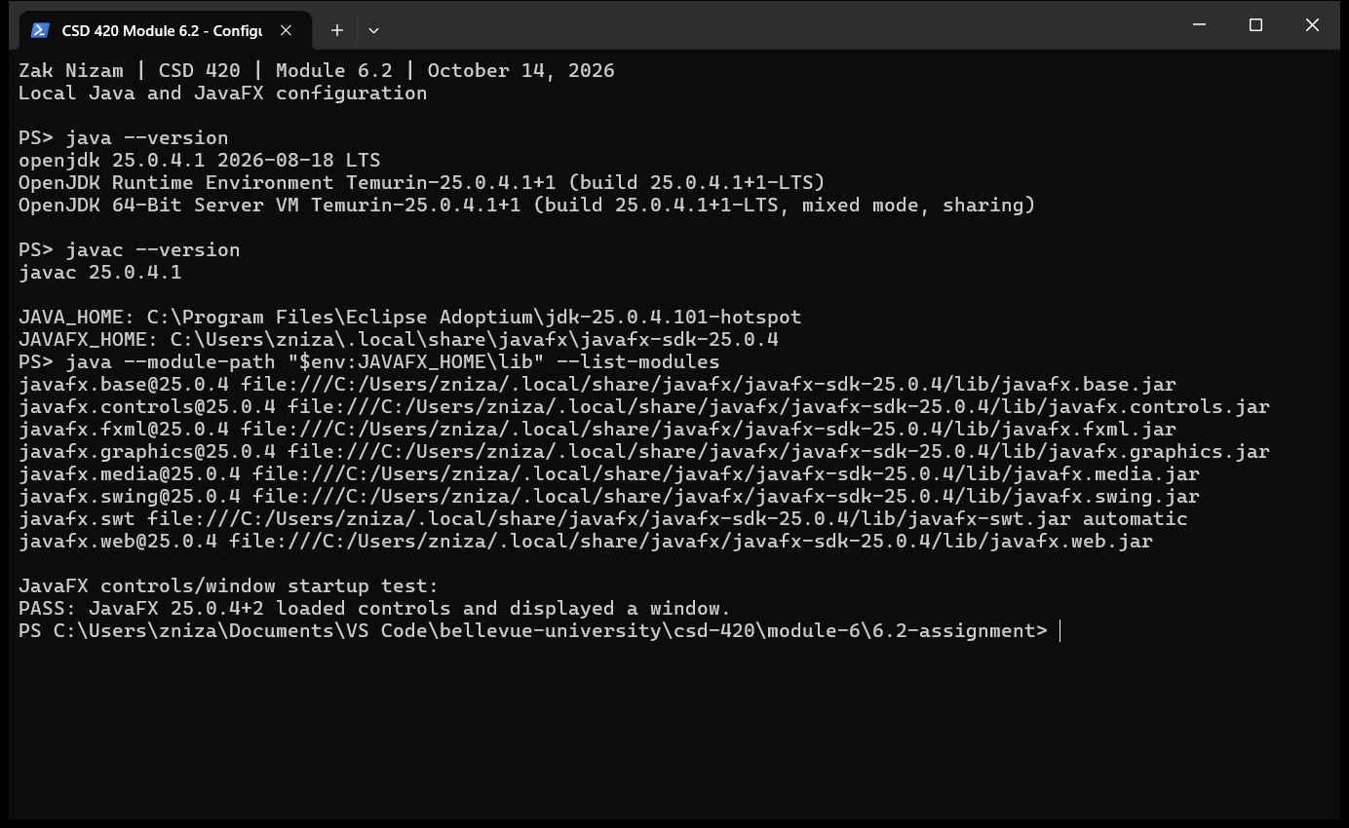
JAVAFX_HOME points to the installed JavaFX SDK in the user tools folder. The SDK lib folder supplies the module path for the JavaFX check.

Bubble Sort Results
NizamBubbleSort provides two generic bubbleSort methods. The first uses Comparable to sort elements in their natural order. The second uses a Comparator to define a separate ordering rule. Both methods sort the supplied array in place using neighboring comparisons and swaps.
Each pass moves the largest remaining element to the end of the unsorted portion. The next pass examines one fewer element, and a pass without swaps ends the sort early. Equal elements keep their original order. Worst-case time is O(n^2), best-case time is O(n), and extra space is O(1).
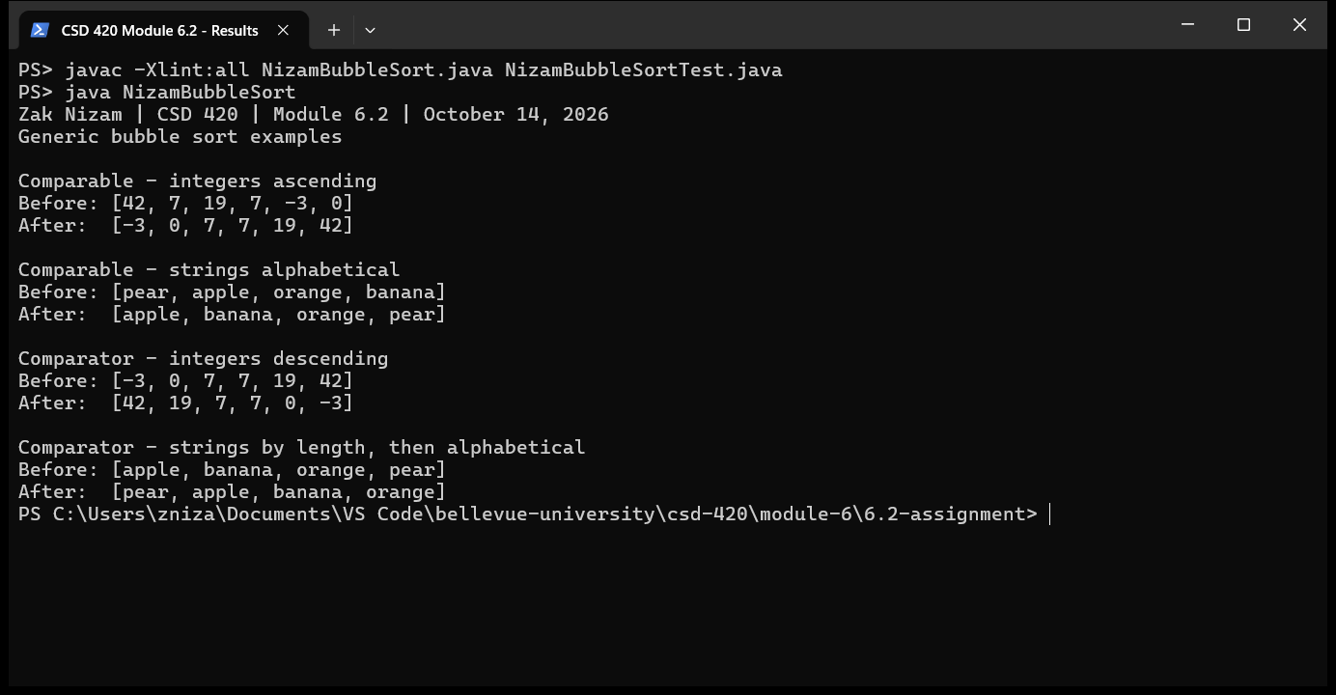
The examples show integers in ascending and descending order, strings in alphabetical order, and strings ordered by length with an alphabetical tie breaker. Both generic methods produce the expected results.

Correctness Testing
NizamBubbleSortTest checks both methods with numbers, strings, duplicates, empty arrays, single elements, sorted inputs, custom objects, and equal keys. It also checks inherited Comparable ordering, null-aware rules, and invalid null arguments. All 23 test groups passed, including 100 random arrays checked through both methods against Arrays.sort. Arrays.sort is used only in the tests.
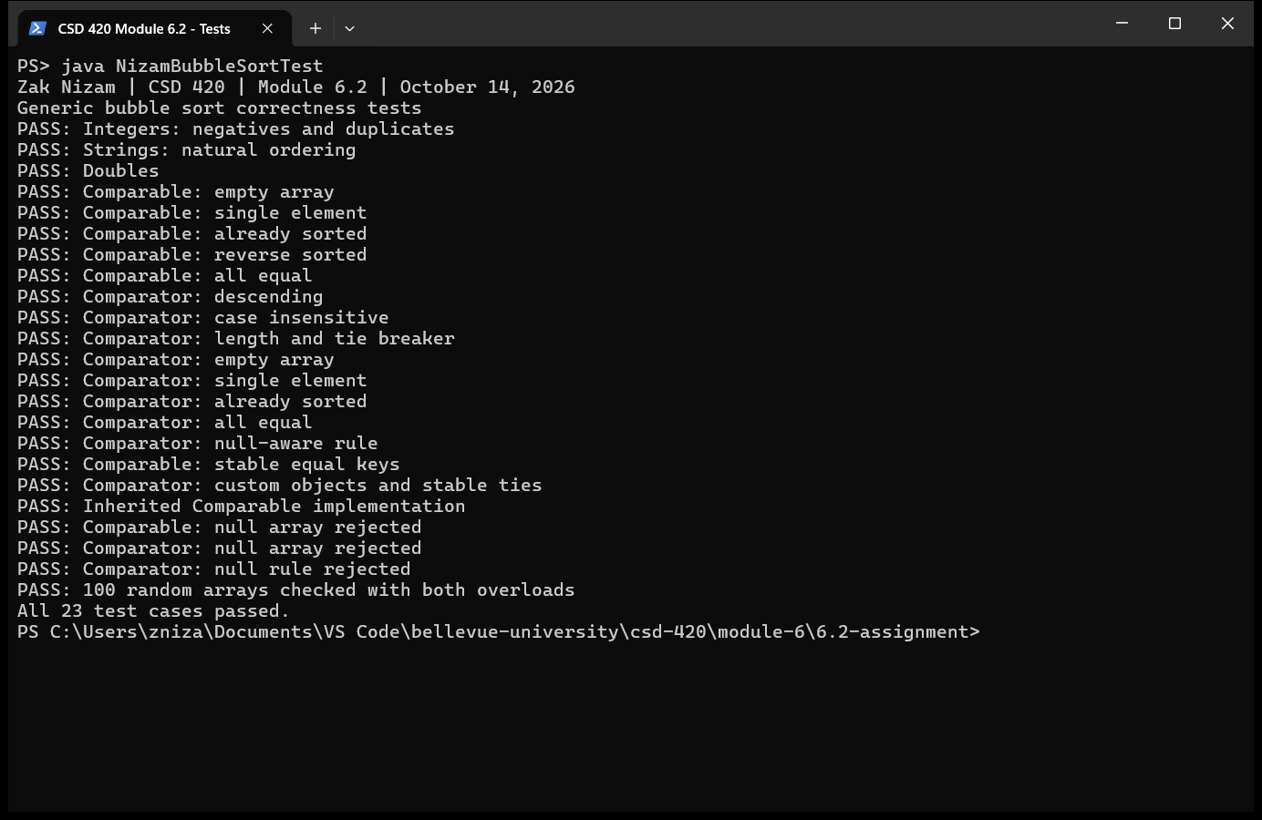
Running the Programs
Open PowerShell in the 6.2-assignment folder. Compile both Java files, run the tests, and run the program:
javac -Xlint:all NizamBubbleSort.java NizamBubbleSortTest.java
java NizamBubbleSortTest
java NizamBubbleSort
No input file or extra Java libraries are needed for this console program. The source files include the name, date, course, assignment, purpose, and method documentation. Failed tests throw AssertionError without requiring the -ea option.
GitHub repository: Letterman93/csd-420

