CSD 420 Advanced Java Programming
Module 9.2 Programming Assignment
Zak Nizam
November 8, 2026

Java and JavaFX Configuration - The screenshot below shows the Java setup I used for this assignment. I also checked that JavaFX could open a window successfully.
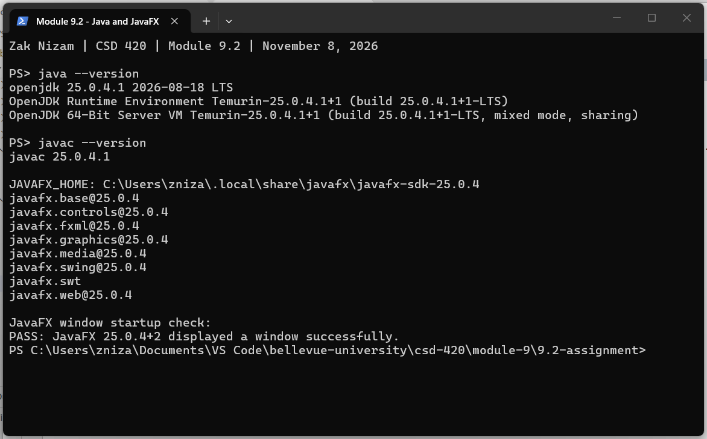
NetBeans Configuration - I installed Apache NetBeans 31 and configured it to use my existing JDK.
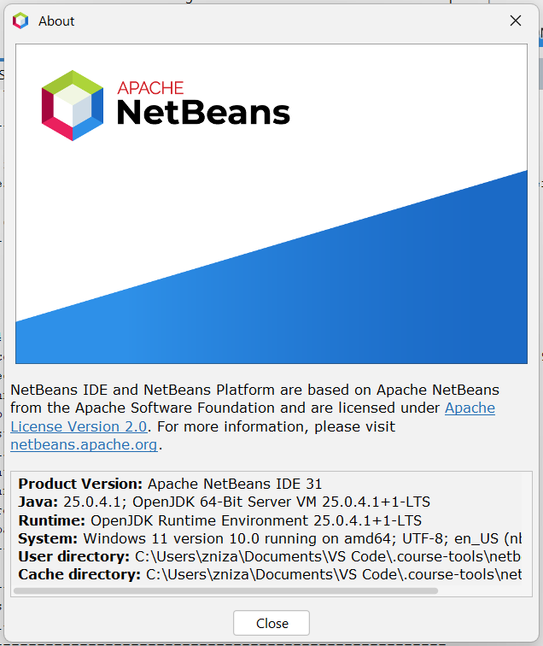
MySQL Configuration - I installed MySQL 5.7.44 and created databasedb. The student1 account uses the required password, pass, and has access to that database.
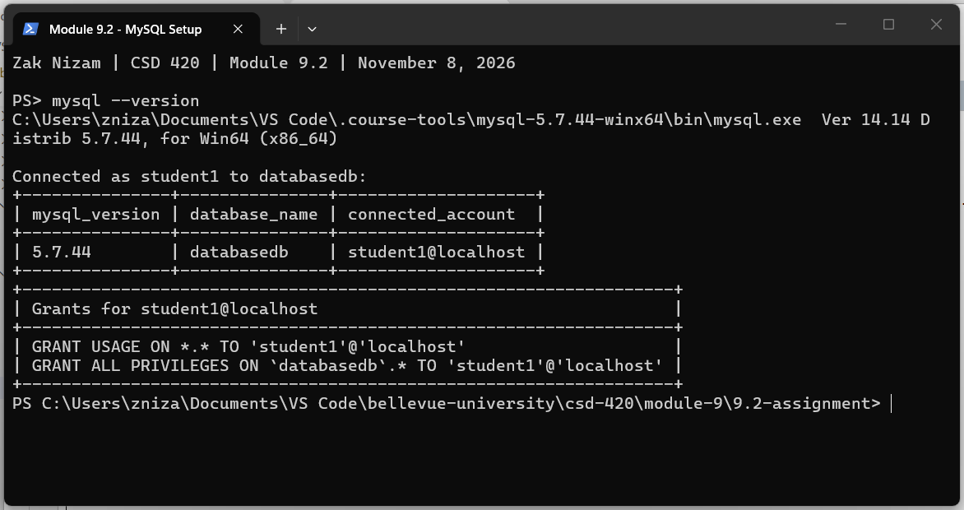
Connection Test - I ran DatabaseSetupTest in NetBeans. It connected as student1, checked the database and server version, and wrote and read back a temporary record. All six checks passed, and NetBeans reported BUILD SUCCESS.
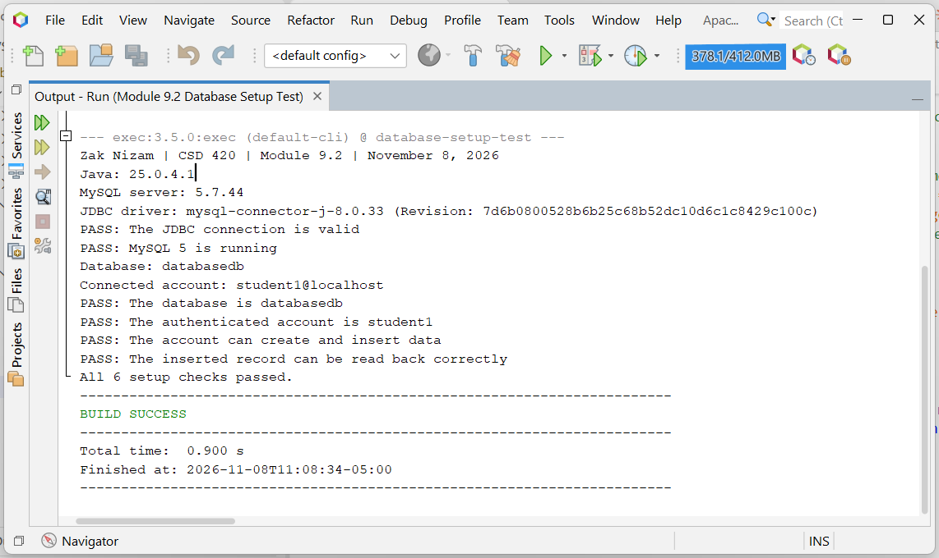
How to Run the Test - Use the steps below to run the project again on this computer.
- Start the local MySQL server with the command below if it is not already running.
- Open Apache NetBeans 31 using the desktop shortcut.
- Choose File > Open Project and select the DatabaseSetupTest folder in this assignment.
- Select the project and press F6. The output should show all six checks passed and BUILD SUCCESS.
powershell -ExecutionPolicy Bypass -File .\start-mysql.ps1
GitHub repository: Letterman93/csd-420

