CSD 420 Advanced Java Programming
Module 4.2 Programming Assignment
Zak Nizam
October 4, 2026
Java and JavaFX Configuration
The PowerShell screenshot shows Java 25.0.4.1, javac 25.0.4.1, and JavaFX 25.0.4 on this computer. A temporary JavaFX program also loaded controls and displayed a local window. The LinkedList assignment uses console output and does not need a JavaFX interface.
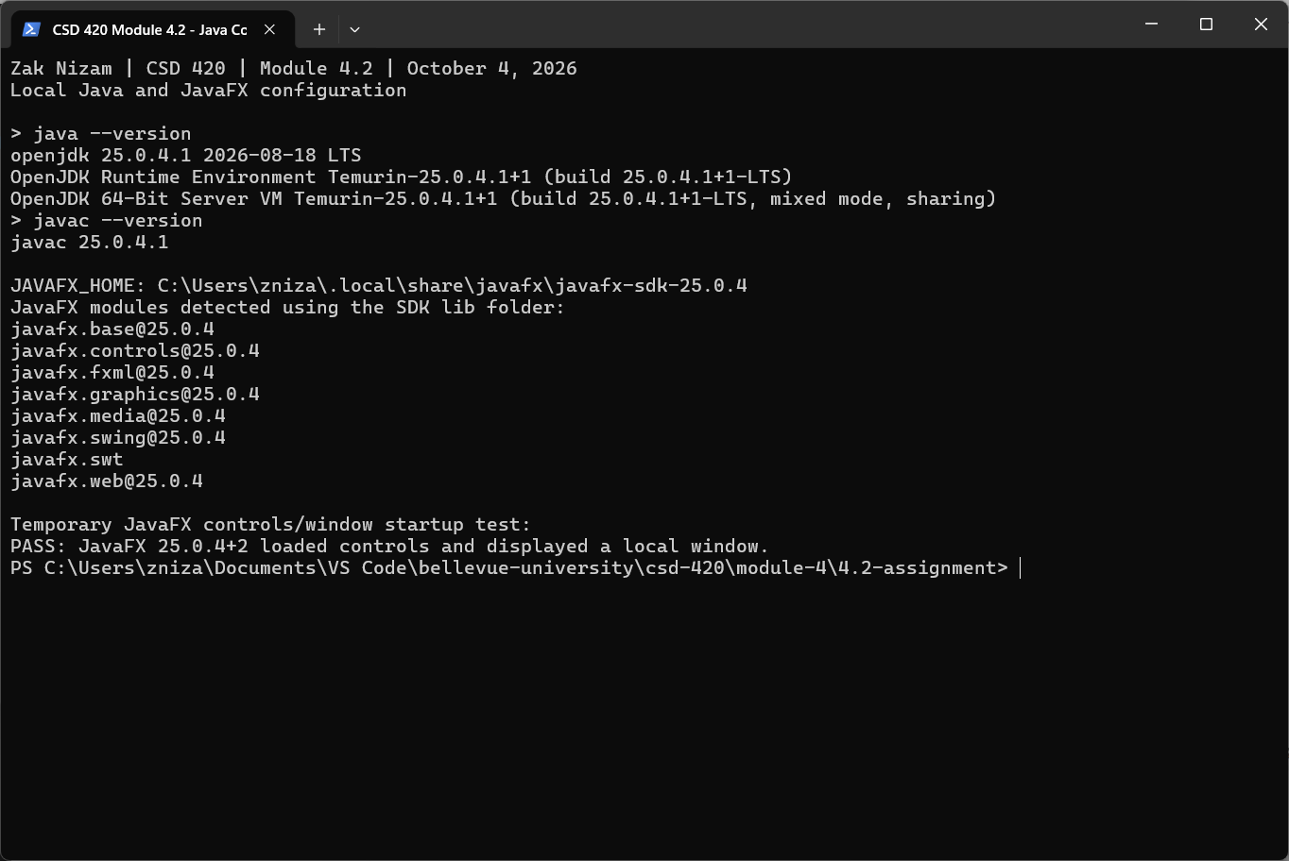
JavaFX is stored in the user tools folder. JAVAFX_HOME points to the SDK, and its lib folder supplies the module path.

LinkedList Traversal Results
NizamLinkedListTraversal first stores 50,000 integers and then 500,000 integers. Each list contains values from 0 through size - 1. Both methods add the values to a long sum so the result can be checked. System.nanoTime() measures traversal only; creating the list and printing the results are outside the timer.
List size | Iterator (ms) | get(index) (ms)
50,000 | 2.221 | 1,263.671
500,000 | 5.881 | 156,301.472

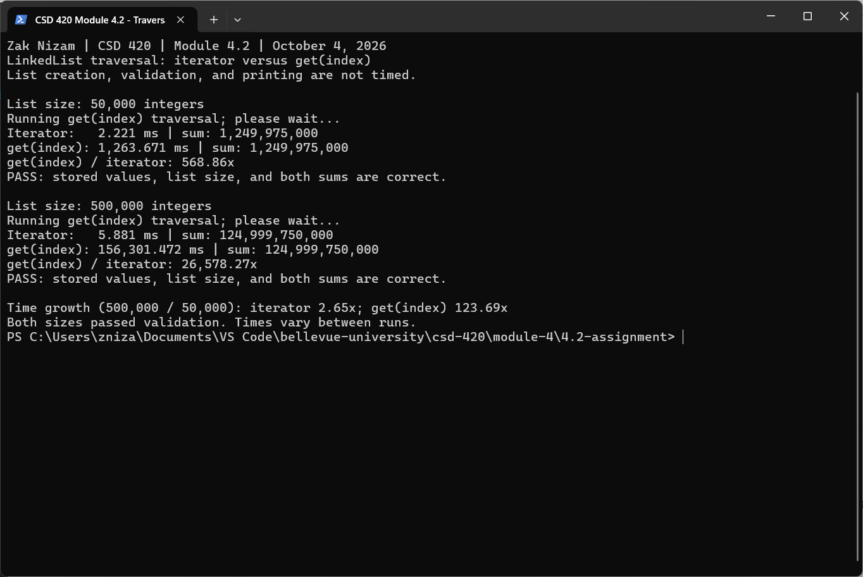
The iterator keeps its place and moves to the next node. get(index) walks from the closer end for every index. For 500,000 values, get(index) took about 156.301 seconds, compared with about 1.264 seconds for 50,000 values. Its time grew about 123.69 times. The iterator time grew only 2.65 times in this run. JVM warm-up and other activity affect small timings, so results vary. An iterator is the better choice for going through a LinkedList in order.
Reference: Oracle, Java SE 25 LinkedList API

Correctness Testing
NizamLinkedListTraversalTest checks empty and single-value lists, duplicates, negative values, a sum larger than Integer.MAX_VALUE, generated values in order, zero-size creation, and rejection of a negative size. It also checks that neither traversal changes the input list. All seven test cases passed. The timing program separately checked every stored value and both sums for the two required sizes.
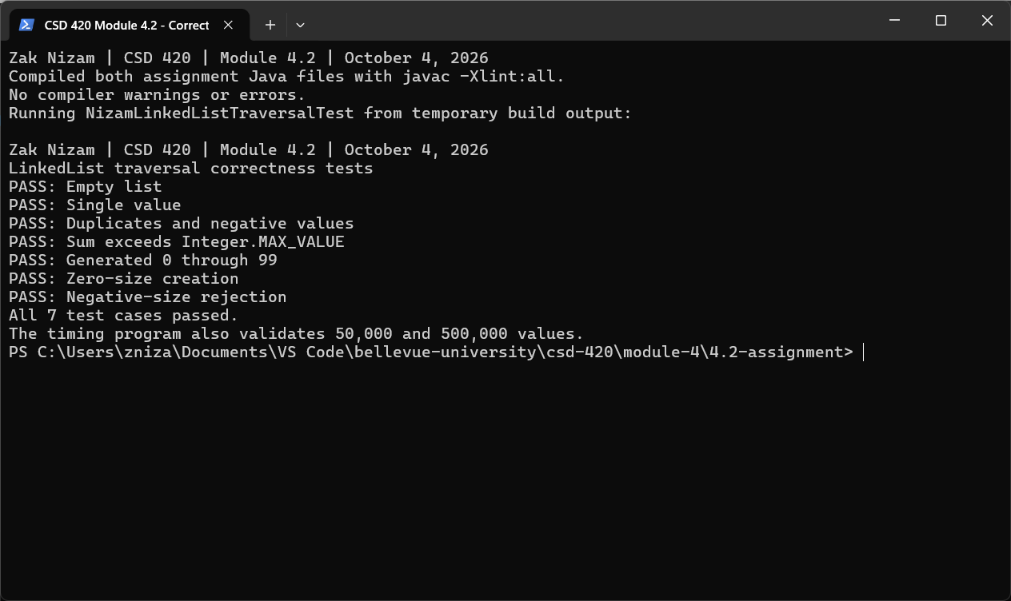
Running the Programs
From the 4.2-assignment folder, compile both files, run the correctness tests, and then run the timing comparison:
javac NizamLinkedListTraversal.java NizamLinkedListTraversalTest.java
java NizamLinkedListTraversalTest
java NizamLinkedListTraversal
The 500,000-value get(index) test may take several minutes. The source comments explain the measured times and why indexed traversal is slower. Each size is timed once after a small warm-up, with the iterator first. Later runs may show different times.
GitHub repository: Letterman93/csd-420

