CSD 420 Advanced Java Programming
Module 3.2 Programming Assignment
Zak Nizam
September 22, 2026
Java and JavaFX Configuration
The PowerShell screenshot shows the installed Java 21 runtime, Java compiler, and JavaFX 21 modules. This assignment is a console application and does not require a JavaFX interface.
Commands: java -version; javac -version; java --list-modules | findstr javafx
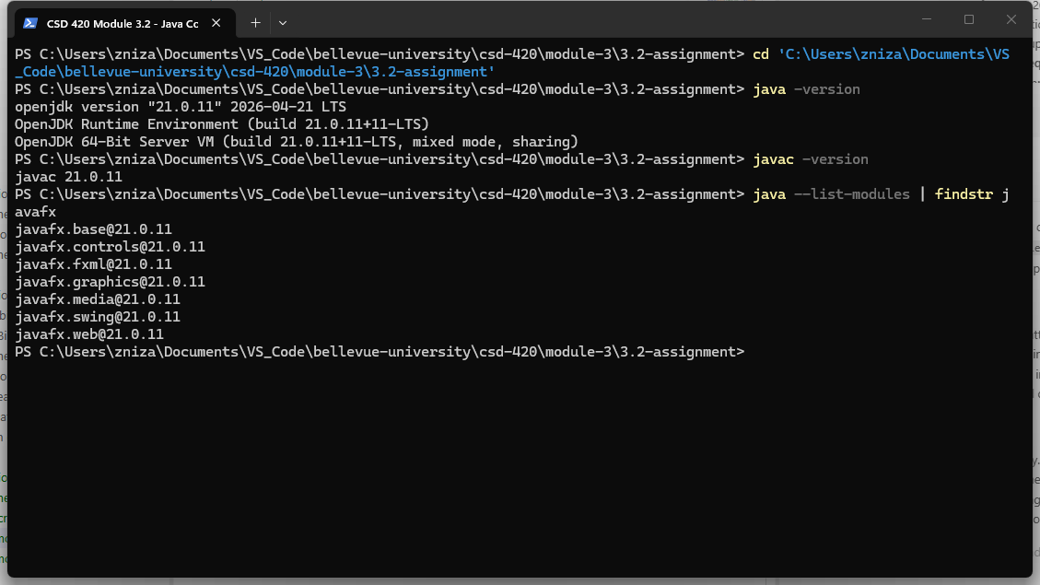

Removing Duplicate Values
NizamRemoveDuplicates fills an ArrayList with 50 random integers ranging from 1 through 20. The generic removeDuplicates method returns a new ArrayList that contains each value only once while preserving the order of its first appearance.
Testing: the program compiled without errors. The output displays the original 50 values, the returned list with duplicates removed, and the size of each list. The original list remains unchanged, and every value in the returned list is unique.
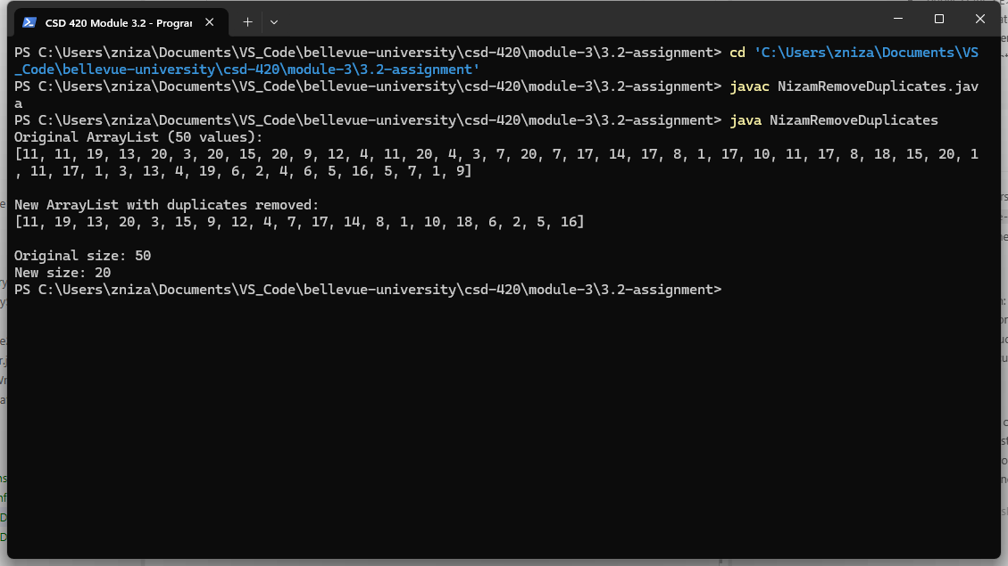
Running the Program
From the 3.2-assignment folder, run these commands in order:
javac NizamRemoveDuplicates.java
java NizamRemoveDuplicates
Each run creates a new set of 50 random values, so the values and the order shown in the output will vary.

