CSD 420 Advanced Java Programming
Module 7.2 Programming Assignment
Zak Nizam
October 24, 2026

Java and JavaFX Configuration - The screenshot below shows the Java and JavaFX setup I used to compile and run this assignment.
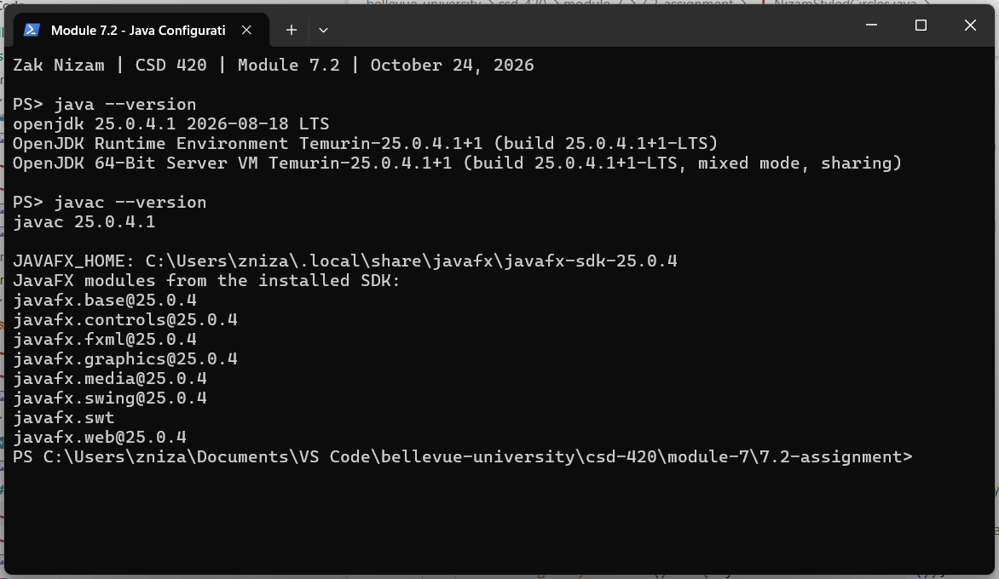
Styled Circles - I used an external stylesheet, mystyle.css, to keep the appearance separate from the Java code. All four circles use the plaincircle class, while the redcircle and greencircle IDs apply the individual color rules. The program loads the stylesheet when it creates the scene. I used an HBox to arrange the circles and a StackPane to hold the circle with the border.
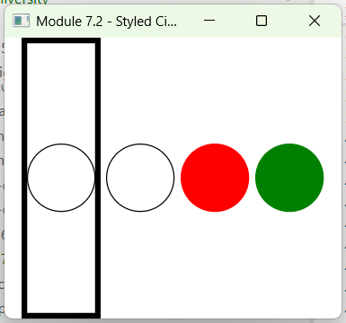

Testing - I checked the CSS rules, colors, and layout using a separate test program. All 15 tests passed, as shown below.
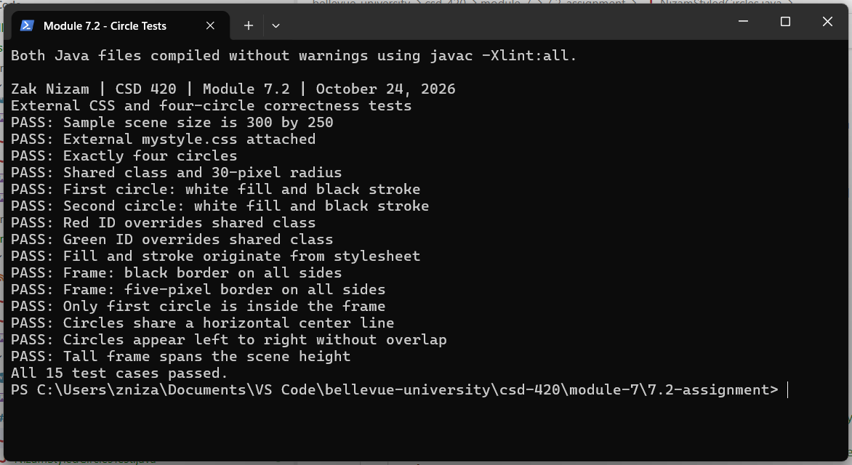
How to Run the Program - Use the steps below to compile the files, run the tests, and open the application.
- Make sure the JDK and JavaFX SDK are installed, and JAVAFX_HOME points to the JavaFX SDK folder.
- Keep NizamStyledCircles.java, NizamStyledCirclesTest.java, and mystyle.css in the same folder.
- Open PowerShell in that folder.
- Run the commands below in order. They set the JavaFX path, compile the files, run the tests, and open the application.

$fx = "$env:JAVAFX_HOME\lib"
javac -Xlint:all --module-path $fx --add-modules javafx.controls `
NizamStyledCircles.java NizamStyledCirclesTest.java
java --enable-native-access=javafx.graphics --module-path $fx `
--add-modules javafx.controls NizamStyledCirclesTest
java --enable-native-access=javafx.graphics --module-path $fx `
--add-modules javafx.controls NizamStyledCircles

GitHub repository: Letterman93/csd-420

