CSD 420 Advanced Java Programming
Module 5.2 Programming Assignment
Zak Nizam
October 9, 2026
Java and JavaFX Configuration
The local PowerShell screenshot shows Java 25.0.4.1, javac 25.0.4.1, and JavaFX 25.0.4. A temporary JavaFX program loaded controls and displayed a window on this computer. The word collection assignment uses console output and does not need a JavaFX interface.
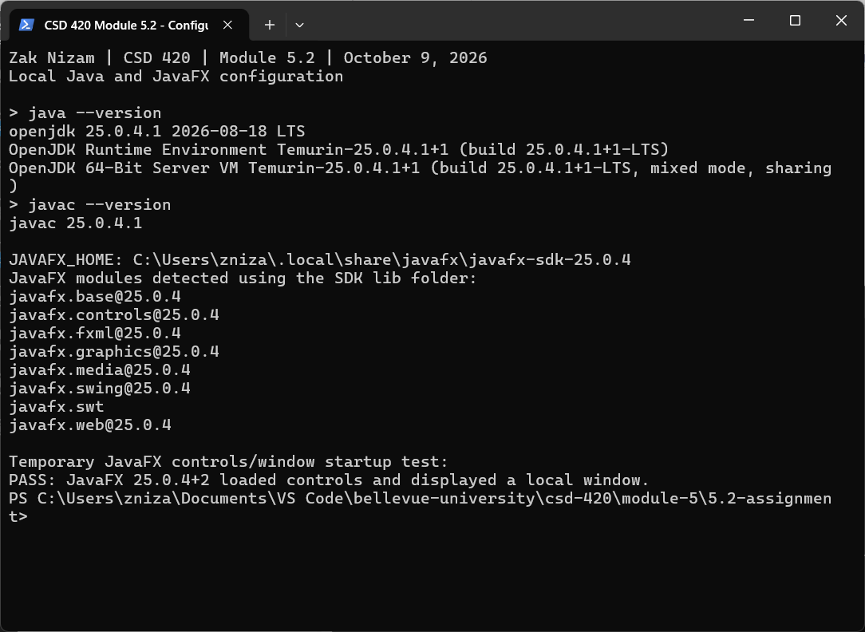
JAVAFX_HOME points to the installed JavaFX SDK in the user tools folder. The SDK lib folder supplies the module path for the JavaFX check.

Word Collection Results
NizamWordCollection reads collection_of_words.txt from the assignment folder. The filename is written in the program, so it does not need to be supplied on the command line. The sample file contains 20 entries, including repeated words and different capitalization. The program finds 12 unique words.
A TreeSet removes duplicate words and keeps them in ascending order. The program changes words to lowercase, so Java and java count as the same word. Punctuation and whitespace separate groups of letters. The descendingSet() method gives the words in reverse order.
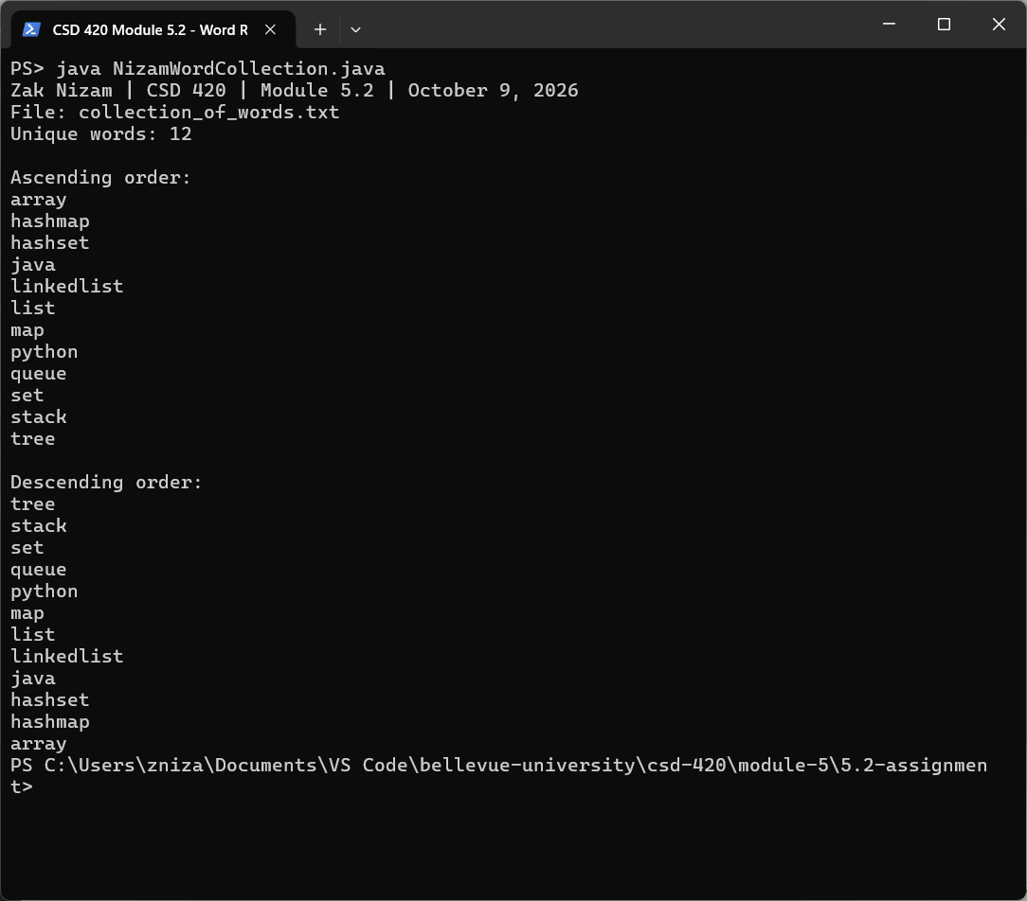
The ascending list starts with array and ends with tree. The descending list starts with tree and ends with array. Each word appears once in each list.

Correctness Testing
NizamWordCollectionTest checks duplicate removal and both word orders. It also checks mixed capitalization, punctuation, an empty file, whitespace only, one repeated word, the submitted word file, and a missing file. The tests use known expected words and check that reading does not change the temporary input files. All eight test cases passed.
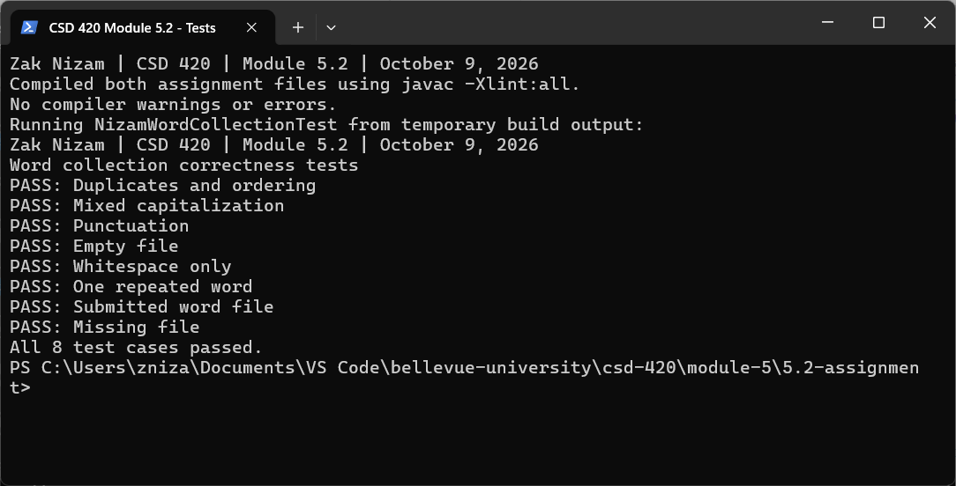
Running the Programs
Open PowerShell in the 5.2-assignment folder. Keep collection_of_words.txt in that folder. Compile both Java files, run the tests, and run the program:
javac NizamWordCollection.java NizamWordCollectionTest.java
java NizamWordCollectionTest
java NizamWordCollection
No filename argument or extra Java libraries are needed for this console program. The source files include the name, date, course, assignment, purpose, and explanations. Temporary test files are removed after use.
GitHub repository: Letterman93/csd-420

