Name: Zak Nizam
Course: CSD420 Advanced Java Programming

- Github Link: https://github.com/Letterman93/csd-420
- Github Repository Screenshot
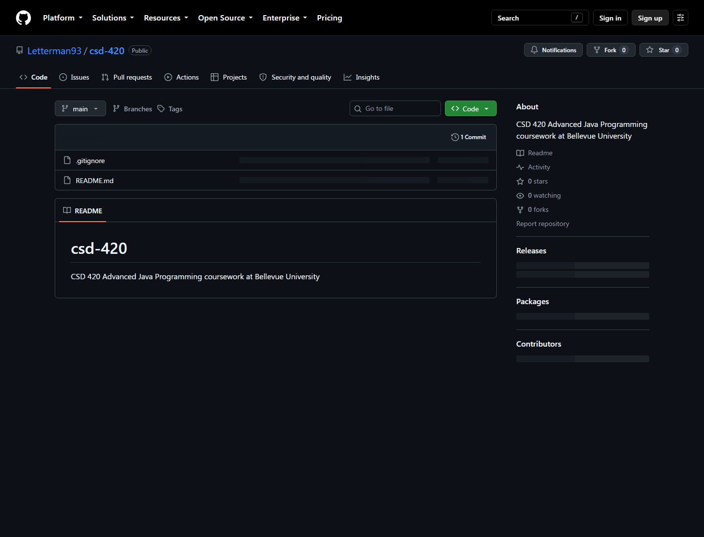

- Local Directory Screenshot –
C:\Users\zniza\Documents\VS_Code\bellevue-university\csd-420
