**Setup Instruction (only perform for the first time Python installation):**

1. Go to the Python Official Website to download python for windows:

<https://www.python.org/downloads/>

1. Run the download .exe file to install python. Before pressing “Install Now” to start the installation, remember to check the box of “Add python.exe to PATH”.
2. open the command prompt, and type “python --version” to check if Python is recognized. If successful, it should show something like “Python 3.12.1” (or later Python versions)
3. Install necessary Python Libraries: In the command prompt window, enter each of the following lines in a new input line to install each of the necessary libraries. Wait until each library automatic installation process finished before entering the new line:
4. pip install pandas
5. pip install reportlab
6. pip install python-barcode
7. python -m pip install --upgrade setuptools
8. pip install openpyxl

**Execute the label generation program:**

1. Download and unzip this “RnFLabelGen” Folder onto the computer (do not change the file name);
2. Copy the folder path of the “RnFLabelGen” Folder on the computer, and update this path to Line 89 of the “LabelMaker.py” Python script (make sure to use “/” instead of “\” in the path, and leave the last “/” at the end):

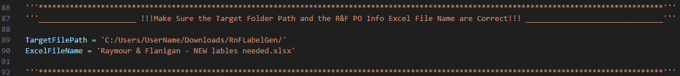

1. Download the Google Sheet file “Raymour & Flanigan - NEW lables needed” as Excel .xlsx file and move to the “RnFLabelGen” Folder (can either replace the original file with the same name or just rename it);
2. Update the Line 90 of the “LabelMaker.py” Python script with the correct Excel file name which is just moved to the “RnFLabelGen” Folder (if needed) like the following:

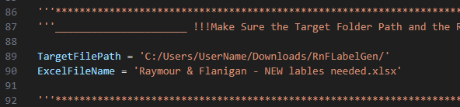

1. Now we are ready to run the python script using the command prompt window. Type “cmd” in the Start Menu Search Bar to open the command prompt. And then type

“cd Path-to-Folder-RnFLabelGen”

(replace Path-to-Folder-RnFLabelGen with actual folder path like the screenshot below)

to change the working directory to the “RnFLabelGen” Folder.

1. Execute the LabelMaker.py Python script to generate all the labels needed by typing

“python LabelMaker.py”..

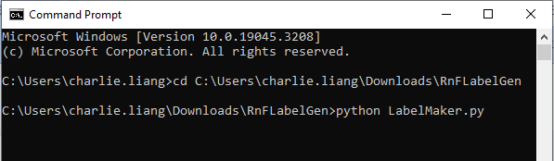

1. Label PDFs are now generated in the folder “Generated_Labels” under “RnFLabelGen”.

Notes: For unnecessary sheets of POs, it is better to delete them from the Excel sheets rather than hiding them. Otherwise, they will be processed and their labels will also be generated upon execution of the LabelMaker.py program every time.