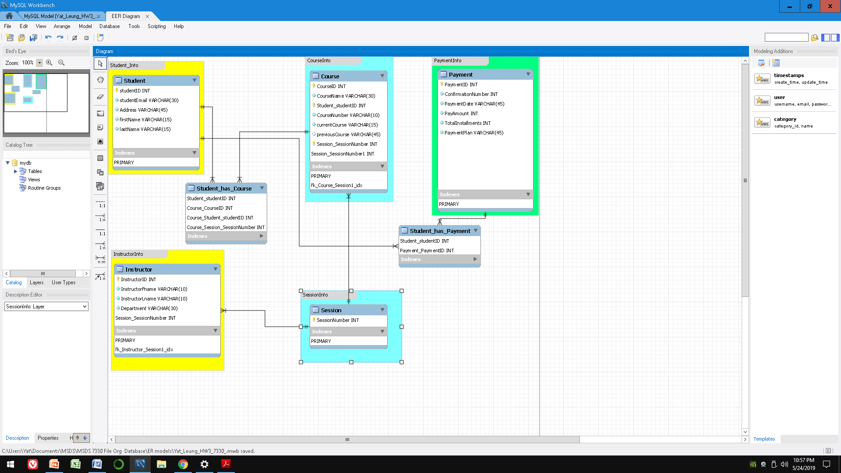

**Students can:**

1. Take multiple courses (Many-Many)
2. Generate multiple payments (Many-Many)

**A course has:**

1. Multiple sessions (1-many)

**Instructor can:**

1. Teach 1 course (1-1)with multiple session (1-Many)