## The infectiousness in children.

Rapid overview: 22/04/2020 M.J. Counotte

Age-dependent differences in infection patterns can be caused by:

* Heteogeneous mixing of age groups
* Bias in sampling/reporting
* 'true' differences in infectiousness

Since we can correct for the first and are interested in the latter, it is important to acknowledge the risk of bias.

### Evidence from surveillance/reported cases

Very weak evidence: reported cases. (High risk of bias: because not at-risk groups are not sampled nor reported).

### Evidence from contact tracing and population-based surveys shows that children are likely less infected

Contact tracing likely starts with an adult (symptomatic) individual. However, contacts are distributed more representative

Population based surveys depend on RT-PCR, or serology, both have their limitations and might have age-depended biases as well?

Fair evidence: Italy RT-PCR during and after lockdown: "No infections were detected in either survey in 234 tested children [RT-PCR] ranging from 0 to 10 years, despite some of them living in the same household as infected people" <https://www.medrxiv.org/content/10.1101/2020.04.17.20053157v1.full.pdf>

Fair evidence: Iceland study ["We also carried out population screening using two strategies: issuing an open invitation to 10,797 persons and sending random invitations to 2283 persons"]  
"In the population screening, no child under 10 years of age had a positive result, as compared with 0.8% of those 10 years of age or older: In the population-screening group, the difference was even more marked: none of the 848 children under the age of 10 years tested positive, as compared with 100 of 12,232 persons (0.8%; 95% CI, 0.7 to 1.0) 10 years of age or older." <https://www.nejm.org/doi/full/10.1056/NEJMoa2006100> (figure)

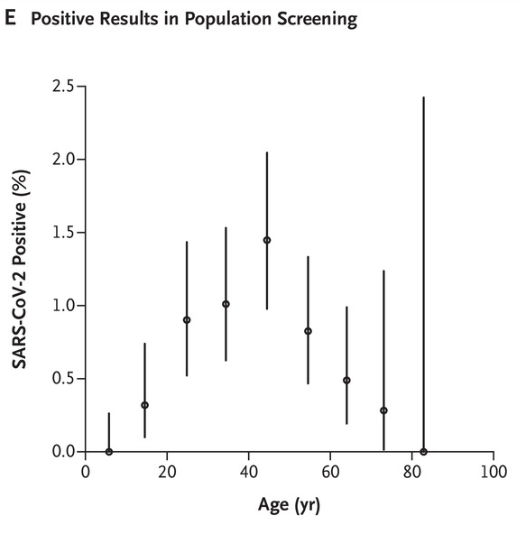

Fair evidence: Japan: Lower attack rates in secondary cases: children <https://www.medrxiv.org/content/10.1101/2020.03.09.20033142v1.full.pdf> (figure)

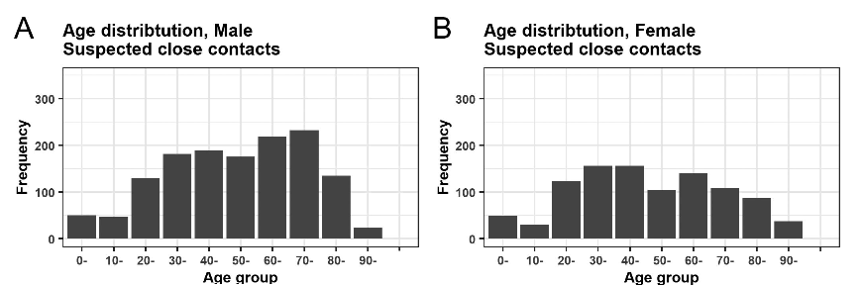

**Both figures provide the least biased estimates available, but do not take into account age-mixing differences**

Sources/additional reports:

|  |  |
| --- | --- |
| **Date** | **URL** |
| 01.04.2020 | <https://www.hiqa.ie/sites/default/files/2020-04/Evidence-Summary_Covid-19_Spread-in-Children.pdf> |
| 08.03.2020 | A mathematical model for estimating the age-specific transmissibility of a novel coronavirus. <https://www.medrxiv.org/content/10.1101/2020.03.05.20031849v1> |
| 04.2020 | <https://www.fhi.no/en/publ/2020/The-role-of-children-in-the-transmission-of-covid-19/> |
| 20.04.2020 | <https://dontforgetthebubbles.com/evidence-summary-paediatric-covid-19-literature/> |
| 15.04.2020 | Household Secondary Attack Rate of COVID-19 and Associated Determinants <https://www.medrxiv.org/content/10.1101/2020.04.11.20056010v1> |
| 21.04.2020 | Twitter <https://twitter.com/apsmunro/status/1252318574204596231> |
| 21-22.04.2020 | Google scholar:  age dependent transmission covid  children transmission covid  child transmission covid  children risk infection covid  attack rate children covid |