LazyDeve: A Cognitive Triad Framework for Human-AI Collaborative Development

Abstract
LazyDeve represents a next-generation Hybrid Cognitive Architecture designed to unify humans, LLMs, and autonomous agents into a cohesive, semantically coherent development ecosystem. Inspired by research from MIT CSAIL and Stanford HAI (2025 roadmap) on Distributed Cognitive Architectures for Human-AI Teams, LazyDeve advances the field by establishing a Cognitive Triad model: a balanced, interactive collaboration between human intent, LLM reasoning, and autonomous execution.

1. Concept Overview

LazyDeve introduces the Cognitive Triad Architecture (CTA) — a symbiotic interaction model uniting human, AI, and operational layers into a single reasoning loop.

Component Role Function
_________________________________________________________________________________________________________
👤 Human (Intent): Goal definition Defines objectives, validates outcomes, and provides contextual feedback.
_________________________________________________________________________________________________________
🤖 LLM (Reasoning): Cognitive synthesis Interprets goals, plans strategies, generates hypotheses, and adapts logic.
_________________________________________________________________________________________________________
⚙️ Agent (Execution): Action execution Executes operations, commits code, validates tasks, and synchronizes system memory.

Each triad forms an independent cognitive node that communicates with others via shared Semantic Context Memory and an Event Bus, creating a distributed cognitive network.

2. Updated Core Architecture

🧠 Centralized Semantic Memory (Task 8 Foundation)
LazyDeve 2.0 replaces file-based .lazydeve/memory.json storage with a centralized semantic database — such as SQLite, PostgreSQL, or DuckDB — to achieve:
- Unified state access: All triads read/write to the same centralized memory.
- Session persistence: Context remains consistent across sessions and restarts.
- Parallel access safety: Thread-safe and transaction-based state management.
- RAG integration: Allows the agent to retrieve and synthesize past experiences and project history.

🧩 RAG Layer (Retrieval-Augmented Generation)
The RAG subsystem extends the LazyDeve memory system into a knowledge experience network, allowing the agent to:
- Retrieve historical task context (past code commits, reasoning chains, logs).
- Reinforce decision-making using previous solutions and test outcomes.
- Enhance semantic understanding and maintain long-term learning across projects.

⚙️ Event-Driven Orchestration (Task 7.7.12)
Every action within the system triggers structured events managed through the internal EventBus. These events automatically:
- Update centralized memory.
- Log operations to the unified JSON log system.
- Notify other agents of context or project changes.

3. Visual System Diagram — Cognitive Triad & Orchestrator Flow
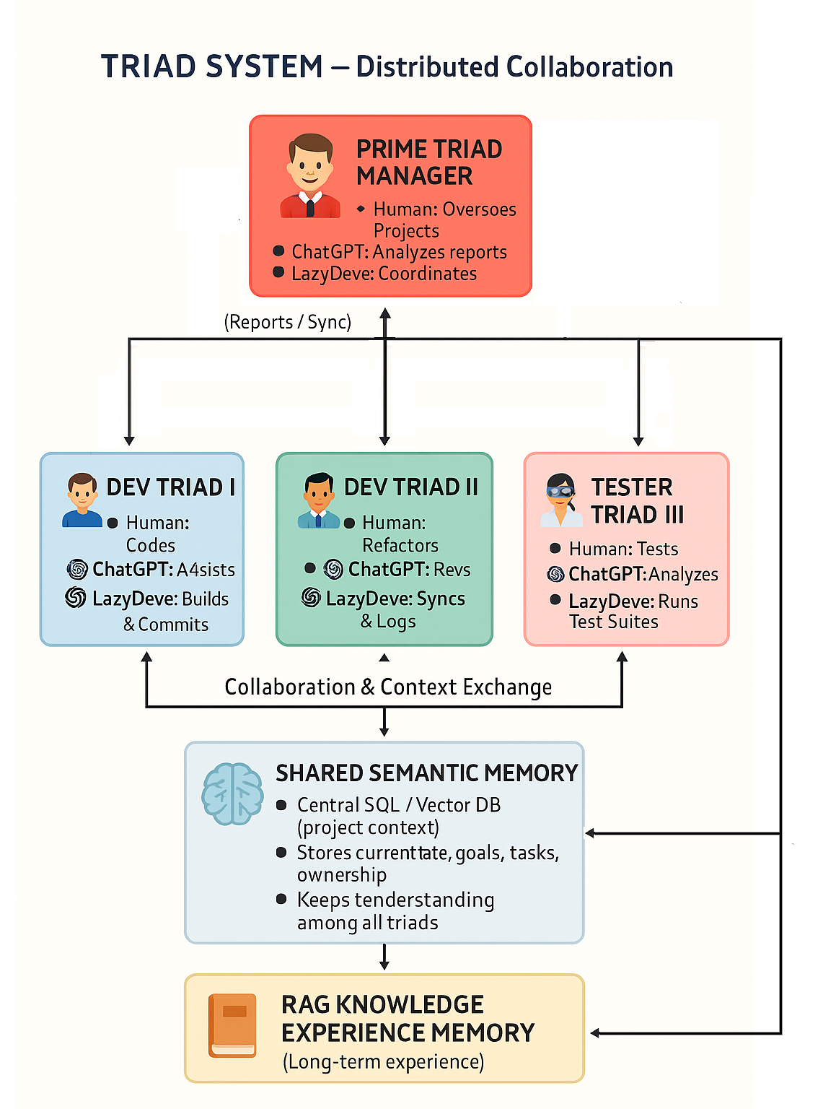
Diagram Explanation:
Each Cognitive Triad (Human + LLM + Agent) acts as a node connected to the Central Semantic Memory. The Event Bus orchestrates actions between nodes, maintaining system-wide synchronization. The RAG Knowledge Module extends reasoning with historical data, improving contextual understanding and strategic decision-making. The Orchestrator Layer monitors and coordinates all triads for optimal collaboration and system integrity.

4. Distinction from Existing Systems

System | Focus | Limitation Compared to LazyDeve
GitHub Copilot X | Pair programming | Lacks persistence, multi-agent coordination, or centralized context
OpenDevin / Devika | AI developer agents | File-based memory, no event-driven intelligence
Microsoft AutoGen | Multi-agent coordination | Lacks triad cognition or shared semantic database
Anthropic TeamSonnet | Research collaboration | Limited for applied multi-human, multi-agent projects

LazyDeve’s differentiation:
- Unified, centralized semantic memory accessible by all agents.
- Integrated RAG subsystem for context retrieval and experience learning.
- Smart routing and adaptive LLM selection for optimal task-to-model matching.
- Human-AI synergy forming persistent, co-evolving knowledge systems.

5. Development Roadmap

Current Implementation (Tasks 7.7.1–7.7.8)
✅ Thread-safe Singleton ContextManager.
✅ EventBus and structured logging.
✅ Secure tokenized API and project pipeline.
✅ MCP server implementation

Upcoming (Tasks 7.7.9–8.0 – 8.1 MPC server)
- Unified Error Handler → consistent error cognition and traceability.
- Smart Router → intelligent endpoint dispatch based on prompt semantics.
- Dynamic LLM Selector → model selection based on context, complexity, and latency.
- Semantic Context Memory (Task 8) → collective cognition and shared reasoning via centralized DB + RAG.
- MCP server implementation to upgrade agent NL translation between ChatGPT and agents modules and global context processing and understanding.

6. Vision: Toward Cognitive Orchestration
Once integrated with the centralized semantic memory and RAG, LazyDeve becomes a Distributed Cognitive Orchestrator:
- Each triad (Human + GPT + Agent) contributes to collective project intelligence.
- Shared memory ensures real-time alignment between triads.
- The orchestrator manages task routing, learning propagation, and semantic consistency.

This architecture evolves LazyDeve from an autonomous development agent to a cognitive ecosystem — capable of self-reflection, adaptation, and long-term reasoning
7. Conclusion
LazyDeve is the foundation for Human-AI Cognitive Collaboration — a living, evolving architecture uniting human intuition, machine reasoning, and autonomous execution through shared semantic memory and RAG-based learning.

This aligns directly with MIT CSAIL and Stanford HAI’s 2025 research roadmap, marking LazyDeve as one of the first applied frameworks to operationalize Distributed Cognitive Triads in a production-ready, extensible form.

Next Phase: Task 8 — Semantic Context Memory Integration (Collective Cognition Layer)

